ANNUAL REPORT

2014-2015

PAKISTAN SCIENCE FOUNDATION
1 - Constitution Avenue
Islamabad

PAKISTAN SCIENCE FOUNDATION

CHAIRMAN

Dr. Khalil Ahmed Ibupoto (07.10.2013 to 23.02.2015)
Prof. Dr. Muhammad Ashraf, S.I., (24.02.2015 to date)

EXECUTIVE COMMITTEE

Dr. Khalil Ahmed Ibupoto Chairman (07.10.2013 to 24.02.2015)
Prof. Dr. Muhammad Ashraf, S.I. Chairman (24.02.2015 to date)
Dr. Khalil Ahmed Ibupoto Member Science (15.04.2011 to 14.04.2015)
Dr. Muhammad Akram Shaikh Member Science (29.05.2015 to date)
Mr. Haider Zaman Khattak Member Finance (19.02.2013 to 20.04.2015)
Mr. Hasnat Ahmed Qureshi Member Finance (21.04.2015 to date)
 |  | BOARD OF TRUSTEES
 |  | Three Whole-time Members (appointed by the President):
Dr. Khalil Ahmed Ibupoto Chairman (Uptill 23.02.2015)
Prof. Dr. Muhammad Ashraf, S.I. Chairman (24.02.2015 to date)
Dr. Khalil Ahmed Ibupoto Member Science (Uptill 14.04.2015)
Dr. Muhammad Akram Shaikh Member Science (29.05.2015 to date)
Haider Zaman Khattak Director (Finance) (Uptill 20.04.2015)
Mr. Hasnat Ahmed Qureshi Member Finance (21.04.2015 to date)

 |  | Sixteen Part-time Members:
 | 1. | Prof. Dr. M. D. Shami, S.I.  Former Chairman, PSF  House No.299, Street No.14, F-10/2  Islamabad
 | 2. | Prof. Dr. M. Aslam Baig, H.I., S.I., T.I.  Consultant (LPP)  National Centre for Physics (NCP)  Quaid-i-Azam University  Islamabad
 | 3. | Prof. Dr. A.Q. Ansari, S.I.  Rector-VC Al-Khair University  Zaki Plaza, Flat #.5, I-8, Markaz  Islamabad
 | 4. | Prof. Dr. Kauser Abdulla Malik, H.I., S.I., T.I.  Former Member Planning Commission of Pakistan  FC College University  Lahore
 | 5. | Prof. Dr. Mudassir Asrar  Chairperson  Pakistan Council for Science & Technology  Constitution Avenue  Islamabad
 | 6. | Prof. Dr. Altaf Ali G. Sheikh  Pro. Vice Chancellor  Isra University  Farash Town, Lehtrar Road, Phase-II,  Islamabad
 | 7. | Prof. Dr. M. Qasim Jan, H.I., S.I., T.I.  Advisor  COMSTECH  Constitution Avenue  Islamabad
 | 8. | Prof. Dr. M. Masoom Yasinzai, S.I., AF.  Rector  International Islamic University  Sector, H-11  Islamabad
 | 9. | Dr. M. Ashraf Poswal  Global Director, Plant wise Programme  CAB International  1-A Data Ganj Bakhsh Road  Satellite Town  Rawalpindi
 | 10. | Prof. Dr. Ikram-ul-Haq, S.I.  Tenure Professor  Institute of Industrial Biotechnology and  Ex-Dean, Faculty of Science & Technology  Government College University  Lahore
 | 11. | Prof. Dr. M. Iqbal Choudhary, H.I., S.I., T.I.  Director  International Centre for Chemical & Biological  Sciences (ICCBS)  HEJ Research Institute of Chemistry  Karachi
 | 12. | Prof. Dr. Nilofar Shiekh, T.I.  Vice Chancellor  Preston University  Majlis-e-Taleem-e-Milli Pakistan  Jamia Millia Malir  Karachi
 | 13. | Prof. Dr. Bhawani Shankar Chowdhry  Dean  Faculty of Electronical, Electronics and Computer Engineering  Mehran University of Engineering & Technology  Jamshoro
 | 14. | Dr. Abdul Hameed Bajoi  Ex-Vice Chancellor  118-C, Rabi Arcade  Bahadurabad, Karachi
 | 15. | Prof. Dr. M. A. K. Malghani  Pro-Vice Chancellor  Baluchistan University of Management Sciences & Information  Technology  Samungli Road  Quetta
 | 16. | Prof. Dr. Khan Bahadar Marwat, S.I.  Vice Chancellor  Shaheed Benazir Bhutto University  Sheringal, Dir Upper  Khyber Pakhtunkhwa

The Board of Trustees of Pakistan Science Foundation was re-constituted vide Government of Pakistan notification No.1(2)/2003-Elect/PSF dated 12.02.2013.

CONTENTS
Chapters Page
EXECUTIVE SUMMARY 1
INTRODUCTION 8
ACTIVITIES AND PROGRAMMES 9
I. PAKISTAN SCIENCE FOUNDATION (PSF) 10
1.0 RESEARCH SUPPORT 10
  - Research Funding 10
    - Research Projects Funded 10
- Under-Process Projects 10
- On-Going Projects 10
- Completed Projects 10
1.1.2 Scientific Publications Produced through PSF Supported Projects 34
1.1.3 Higher Degrees Earned through PSF Supported Projects 34
1.1.4 R&D- Industry Programme 35
a) Under-Process Projects 36
b) Newly Initiated Projects 38
c) On-Going Projects 38
1.1.5 MoU Signed 39
1.1.6 Collaborations/Meetings with Similar Stakeholders 39
1.1.7 Exhibition & Organized 40
1.1.8 Workshops/Seminars/Meetings and Trainings attended 41
1.1.9 Inventions and Innovations Programme 42
1.2 Pak-US Natural Sciences Linkage Programme (NSLP)
Endowment Fund 42
1.2.1 Activities and Programmes 43
1.2.1.1 Research Funding 43
a) Under-Process Projects 44
b) On-Going Projects 44
c) Completed Projects 44
1.2.1.2 On-Site Monitoring of NSLP Project 66
1.1.1.3 Scientific Publications & Patents Produced through NSLP Funded Projects 67
1.2.2 Project Formulation Workshops 67
1.2.3 Meetings of Fund Management Committee of NSLP 67

1.3 Science Promotion 67
1.3.1 Institutional Support Programme 67
1.3.2 Financial Assistance for holding Science Conferences, Seminars, Symposia and Workshops 68
1.3.3 Financial Support to Scientific Societies for holding Scientific Conferences and Publication of Scientific Journals 69
1.3.4 Awards and Fellowships 70
1.3.5 Financial Support for Scientific Survey 70

2.0 SCIENCE POPULARIZATION 70
2.1 Science Popularization Activities 71
2.1.1 Science Caravans (Mobile Science Exhibitions) 71
2.1.2 23rd Intra and Inter Board Science Essay and Poster Competitions 72
2.1.3 Donation of Scientific Literature to High Schools 73
2.1.4 Financial Assistance to High Schools and other Organizations 73
2.1.5 Popular Science Lectures (Cataract Awareness) 73
2.1.6 World Science Day for Peace and Development celebration 75
2.1.7 Inquiry Based Science Education Programme in Pakistan 77
2.1.8 New Activities 79
2.1.9 Science Talent Farming Scheme 79
2.1.10 Participation of Pakistani Students in London International Youth
Science Forum (LIYSE)-2013 79
2.1.11 Collaboration with Intel Education Initiative, Pakistan 80
2.1.12 participation in Pakistan day Parade 82
2.1.13 High School Summer Science Research Programme (HSSSRP) 83
2.1.14 Panel Discussion on “Promotion of Science and Rationality” 83
2.1.15 Other Activities 85

3.0 PLANNING AND DEVELOPMENT 88
3.1 Activities under Development Budget 88
3.1.1 On-going Development Project 88
3.1.2 Activities under Non-Development Budget 89
3.1.3 New Development Project Submitted to MoST 92
3.1.4 PC-V of the completed projects submitted to MoST 92
3.1.5 Monitoring of the ongoing Development projects 93
3.1.6 Other Activities 93

4.0 INTERNATIONAL LIASION ACTIVITIES 95
4.1 International Participation and Visits 95
4.2. Collaborations/Meetings with Similar Stakeholders 96
4.2.1 British Council Executive Officials visited PSF 96
4.2.2 UNESCO Executive Officials visited PSF 96
    - Meeting of Chairman, PSF with US Embassy Officials 97
4.2.4 Meeting of Chairman with the Ambassador of Turkey 97
4.2.5 Meeting of Chairman with Agricultural Counselor (USDA) 98
4.2.6 Meeting of Chairman with Education Attache, Embassy of France 98
4.2.7 Meeting of Chairman with Manager Education and Skills, British Council 98
4.2.8 Austrian Nobel Laureate visited PSF 98
4.2.9 Chairman visited UNESCO, Pakistan office 99
4.2.10 Deputy Head of EU Delegation to Pakistan visited PSF 99

II. PAKISTAN MUSEUM OF NATURAL HISTORY (PMNH) 101
- Natural History Research 103

1.1 Botanical Sciences Division 103
1.1.1 Field Work 103
1.1.2 Laboratory Work 104
    - National Collaborative Projects 104
    - Publications 104
    - Seminars/Workshops Organized 105
    - Conferences/Workshops Attended 106
    - National/International Collaboration/Liaison 106
    - Services Rendered to other Organizations 106

1.2 Earth Sciences Division 107
1.2.1 Field Work 107
1.2.2 Laboratory Work 108
1.2.3 Publications 108
1.2.4 Seminars/Symposia/Trainings/Workshops Organized 108
    - Seminars/Trainings/Workshops Attended 109
    - National/International Collaboration /Liaison 109
    - Display Work 109

1.3 Zoological Sciences Division 110
1.3.1 Field Work 110
1.3.2 Laboratory Work 110
1.3.3 National Research Projects 110
1.3.4 Collaborative Research Projects 110
1.3.5 Publications 111
1.3.6 Seminars/Symposia/Congress Organized 111
1.3.7 Seminars/Symposia/Workshops Attended 112
1.3.8 National/International Collaboration/Liaison 112
1.3.9 Services Rendered to other Organizations 112

1.4 Public Education and Display 113
1.4.1 Exhibits Developed/Organized 113
1.4.2 Important Visits to PMNH 113
1.4.3 Educational Services 113
1.4.4 Number of Visitors to Display Galleries 114

III. PAKISTAN SCIENTIFIC AND TECHNOLOGICAL
INFORMATION CENTRE (PASTIC) 117
1.0 Aims and Objectives 119

2.0 Activities and Services 119
2.1 Document Procurement and Supply Services 120
2.2 Bibliographic Information Services/ Literature Search 120
2.3 Abstracting and Indexing Services (Pakistan Science Abstracts) 121
2.4 Directory of Scientific Periodicals of Pakistan 121
2.5 Union Catalogue of Scientific Periodicals of S&T Libraries of Pakistan 122
2.6 Technology Information Service 122
2.7 PASTIC National Science Reference Library 122
2.8 Reprographic Services 123

3.0 International Liaison Activities 123
3.1 SAARC Documentation Centre (SDC) 123
3.2 Bilateral Cooperation 124

4.0 PASTIC Information Service Stalls 124

5.0 Human Resource Development 126
5.1 Trainings/Workshops/Seminars/Symposia Organized 126
5.2 Trainings/Workshops/Seminars Attended 127
5.3 Lectures/Presentations Delivered 128

6.0 Other Activities 128
6.1 PASTIC Membership 128

IV. ORGANIZATION AND ADMINISTRATION 129
1.0 PSF Sanctioned posts and Organizational Chart 129
2.0 PMNH Sanctioned posts and Organizational Chart 132
3.0 PASTIC Sanctioned posts and Organizational Chart 135
V. PHOTO GALLERY AND PRESS CLIPPING 139
1.0 PSF Photo Gallery and Press Clipping 141
2.0 PMNH Photo Gallery 155
3.0 PASTIC Photo Gallery and Press Clipping 161

VI. AUDITOR’S REPORTS 179
1.0 PSF Financial Statements 181
2.0 PMNH Financial Statements 193
3.0 PASTIC Financial Statements 197
ANNEXURES 213-261

I. Pakistan Science Foundation Act-III, 1973
II. List of Projects Recommended By Technical Committees in 2014-15
III. Detail of Monitoring and Evaluation of On-Going Projects in 2014-15
IV. List of Scientific Publications Produced through PSF Supported Completed
Projects in 2014-15
V. List of NSLP Projects Recommended by Technical Committees in 2014-15
VI. Detail of Monitoring and Evaluation of NSLP On-Going Projects in 2014-15
VII. Detail of NSLP On-Going Projects Monitored On-Site in 2014-15
VIII. List of Scientific Publications Produced through NSLP Supported Completed
Projects in 2014-15
IX. Detail of Science Caravan Exhibitions in 2014-15
X. Detail of 24th Intra-Board Science Essay Competition, 2014-15
XI. Detail of 24th Intra and Inter Board Science Poster Competition, 2014-15
XII. List of Schools/Organizations Provided Financial Assistance in 2014-15
XIII. List of Scientists availed Travel Grants under Development Budget in 2014-15

ACRONYMS
AGR | Agricultural Sciences
AJK | Azad Jammu and Kashmir
AKU | Agha Khan University, Karachi
B | Balochistan
BIO | Biological Sciences
BIOTECH | Biotechnology & Genetic Engineering
C | Capital
CDWP | Central Development Working Party
CEMB | Center of Excellence in Molecular Biology, Lahore
CEME | College of Electrical and Mechanical Engineering, Rawalpindi
CEWRE | Center of Excellence in Water Resources Engineering, Lahore
CIIT | COMSATS Institute of Information Technology
COMSATS | Commission on Science and Technology for Sustainable Development in the South
COMSTECH | OIC Standing Committee on Scientific and Technological Cooperation
DDWP | Departmental Development Working Party
EARTH | Earth Sciences
ENG | Engineering Sciences
ENVR | Environmental Sciences
ILG | Industrial Linkages Group
KPK | Khyber Pakhtoon Khwa
PU | Peshawar University, Peshawar
FJWU | Fatima Jinnah Women University
GCU | Government College University, Lahore
GU | Gomal University, D. I. Khan
KU | Karachi University, Karachi
MED | Medical Sciences
NARC | National Agricultural Research Center
NIBGE | National Institute for Biotechnology and Genetic Engineering, Faisalabad
NNSFC | National Natural Science Foundation of China
NSLP | Natural Sciences Linkage Programme
NSTC | National Science and Technology Commission
P | Punjab
P-AU | Agriculture University, Faisalabad
P-PU | Punjab University, Lahore
PHYS | Physics
PINSTECH | Pakistan Institute of Nuclear Science and Technology, Islamabad
PCCC | Pakistan Central Cotton Committee, Sakrand
PSDP | Public Sector Development Programme
S | Sindh
SALU | Shah Abdul Latif University, Khairpur
SUIT | Sindh Institute of Urology &Transplantation, Karachi
SU | Sindh University, Jamshoro

EXECUTIVE SUMMARY
PAKISTAN SCIENCE FOUNDATION (PSF)
Pakistan Science Foundation (PSF) is apex body for promotion and funding of scientific and technological research and other related activities in the country. The tasks undertaken by the Foundation for the performance of its statutory functions are divided into two broad categories viz., Science Promotion and Science Popularization. Some of these activities pertaining to above mentioned categories are undertaken by Pakistan Museum of Natural History (PMNH) and Pakistan Scientific and Technological Information Centre (PASTIC), the two subsidiary organizations of PSF, while others are performed by PSF Science Wing and are reflected as under:
RESEARCH SUPPORT
To promote basic and applied research relevant to socio-economic development of the country, Research Support Programme is playing a pivotal role in the Foundation. During 2014-15, a total of 435 projects in the fields of Agricultural, Biological, Chemical, Medical, Maths & Computer, Earth, Engineering Sciences, Biotechnology and Genetic Engineering and Physics remained under consideration. Out of these, 329 were under-process projects including 11 newly approved at a total cost of Rs.18,093 million and 107 on-going research projects. An amount of Rs.3.461 million was released on account of first installments of newly approved projects. A total of 34 technical reports (semi-annual/annual/final) of on-going projects were received, of these, annual reports were sent to subject experts for evaluation and an amount of Rs.14.27 million was released on account of due instalments. Final technical reports of 20 on-going projects were presented to relevant Technical Committees and were adopted, accounts of 13 projects were settled and files closed. From these completed projects, a total 25 research papers were published in different national/international journals, and 06 Ph.D. and 17 M.Phil degrees were awarded to the Research Associates enrolled under these research projects.
Focusing on collaborative research and strong industrial linkages, R&D-Industry Programme (previously called Industrial Linkages Programme, ILP) aimed to bring researchers, end-users and the funding institutions together at one platform to create an environment of a unified approach to identify and solve industrial problems through applied research and technology transfer mechanism. During the report period, a total of 15 research proposals were received from various organizations, out of these, 08 proposals were presented in Technical Committees, wherein, 03 were approved at a total cost of Rs.3.732 million. Currently, 03 projects are on-going and an amount of Rs.2.64 million was released on account of due instalments for smooth running of these projects. In addition, under this programme, “Invention to Innovation Summit-2015” was also organized at University of the Punjab, Lahore to establish linkages between Academia and Private Sector.
PAK-US NATURAL SCIENCES LINKAGE PROGRAMME (NSLP) ENDOWMENT FUND
PSF maintains an Endowment Fund under Pak-US Natural Sciences Linkage Programme (NSLP) to boost the research in agriculture sector in the country. During the report period, 240 proposals remained under consideration of the NSLP. Out of these 53 projects were presented in 03 Technical Committee meetings wherein 18 projects were recommended for funding by these Committees at total cost of Rs.50.5 million. A total 69 projects were remained on-going at different Universities and R&D Organizations across the country and 55 progress reports of these projects were received and an amount of Rs.34.4 was released on account of due installments for smooth running of these projects. During the report period, 12 projects were also completed. Two projects formulation workshops were also conducted at University of Haripur, KPK and BUITEMS, Quetta.
SCIENCE PROMOTION ACTIVITIES
During the report period, an amount of Rs.0.6 million was released to various institutions for organizing 10 conferences, seminars and workshops on important scientific topics and Rs.0.5 million were released to 06 scientific societies/journals for their regular activities. However, Institutional Support and PSF Fellowship programmes were not entertained due to paucity of funds.
SCIENCE POPULARIZATION
Popularization of science, increasing science awareness and development of scientific culture in the society are major functions entrusted to Pakistan Science Foundation. During the year 2014-15, a total 126,170 students from 619 schools visited Science Caravan Exhibitions. The 24th annual Intra and Inter Board Science Essay Competition on “Why students feel difficulty in science education” and Poster Competition “Disadvantages of mobile phone and internet for students” were organized for the students of all Boards of Intermediate and Secondary Education (BISE) of the country and winners were awarded cash prizes. In addition, an amount of Rs. 277,000/- was provided to 06 schools for strengthening of their laboratories for carrying out their Science Popularization activities. Moreover, 4,500 copies of monthly and quarterly Popular Science magazines “Global Science” and “Urdu Science” respectively were distributed to 500 schools. Bimonthly Scientific Journal “The Fountain” published by The Light Publishing Turkey was also provided to Caravans, PASTIC and PMNH offices. Seven Popular Science Lectures on different scientific themes were also delivered by subject experts. From PSF platform, 04 students participated in the London International Youth Science Forum (LIYSF-2014) and won the prizes. They were also encouraged by the Foundation by awarding prizes in a ceremony organized at PSF auditorium.

In collaboration with Idara Taleem-o-Agahi and School Assessment for School Improvement two days training workshop on Inquiry Based Science Education (IBSE) for the teachers associated with ITA/SASI was organized on 18-19th Feb, 2015, wherein, 25 teachers participated in the workshop. Resource persons from PSF and FDE conducted the training sessions and carried out interactive hands on activities with the participants.

Under vision 2025, Govt. of Pakistan launched “Science Talent Farming Scheme” which is being implemented through collaborative efforts of relevant organizations and stakeholders. PSF is playing a pivotal role in this scheme. PC-I titled “Science Talent Farming Scheme for 1800 Young Students” amounting to Rs.1395.73 million was prepared and submitted to MoST and approved by the CDWP in its meeting held on 9th June, 2015. PSF has also collaboration with Intel Pakistan. The Intel International Science and Engineering Fair-2015 was held in Pittsburgh, Pennsylvania, USA on 10-15th May, 2015. More than 1700 students from 75 states/countries participated in the International level competition, the Intel ISEF-2015. Eight students from Pakistan with their project (5 in total) also participated in ISEF-2015 along with two PSF officers.

PSF and Pakistan Society for Computational Science/Biology (PSCSB) jointly organized High School Summer Science Research Programme (HSSSRP) on June 9, 2015 in PSF Auditorium to attract students towards science. The purpose of HSSSRP is to promote science at school level and give high school students hands-on research experience by working on research projects with top class research scientists affiliated with public and private universities in different parts of Pakistan during summer vacations.

INTERNATIONAL LIAION
Liaison with Foundations, Academies, Science Centres, Museums and International bodies around the world provides many benefits and opportunities for future collaboration. It may also result in greater awareness of S&T programmes of international organizations, exchange of expertise and professional/organizational development through undertaking collaborative research projects. During the period, 11 proposals of PASTIC and PMNH for S&T collaboration with SAARC Development Fund (SDF), Germany, Italy, Belarus, Korea, Japan and Turkey were forwarded to MoST for consideration under various S&T Protocols/Agreements/MoUs signed by the Government of Pakistan. Some other MoUs were also taken up with MoST/concerned International bodies such as; (i) MoU between Pakistan Science Foundation (PSF), Islamabad and National Science Foundation (NSF), Sri Lanka, (ii) MoU between PASTIC, Islamabad and Korea Institute of Science and Technology (KISTI) (iii) MoU between Pakistan Science Foundation and National Research Foundation of Korea. Joint research collaboration with TIKA and TUBITAK, Turkey, China was also developed.

Currently, International Liaison activities are strengthen and new collaborations were developed along with pursuance of previous co-ordinations with other countries. On the basis of growing linkages with international nations, “International Liaison Wing” has been established at PSF.
To promote international collaborations, the chairman participated in workshop on Inquiry Based Science Education (IBSE) in Kazakhstan, 1st Forum on China-South Asia Technology Transfer and Collaborative Innovation” at Kunming, China and IOSTE Eurasia Regional Symposium & Brokerage Event Horizon 2020”, Istanbul, Turkey. The chairman also held meeting with presidents of Scientific and Technological Research Council of Turkey (TÜBİTAK) and Turkish Cooperation and Coordination Agency (TiKA), Turkey for joint research projects.
Further, a three member’s delegation of British Council visited PSF and met the chairman and discussed priority areas for mutual cooperation and partnership programs in the field of scientific education and research. A meeting was also held with National Professional Officer, UNESCO, Pakistan to develop science kits for science laboratories of rural areas schools jointly by PSF and UNESCO to strengthen science-base in Pakistan. A three-member US Embassy team called on Chairman PSF to discuss Pak-US collaboration for promotion of science and cooperation in scientific research and promotion of science and technology. Mr. Alban Schwerer, Scientific and Higher Education Attache, Embassy of France visited PSF and held a meeting with the chairman to identify priorities and common interests of Pakistan and France in the field of science and discussed collaboration in joint research projects and post-doctorate scholarship programs.Austrian Nobel Laureate Prof. Dr. Pavel Kabat, Chief Executive Officer, International Institute for Applied Systems Analysis (IIASA), Austria, Ms. Vibeke Jenson, Country Director UNESCO Pakistan, Mr. Stenfano Gatto, Deputy Head of EU Delegation to Pakistan also visited PSF and discussed areas of mutual interests with the chairman.
PLANNING AND DEVELOPMENT ACTIVITIES
During the year 2014-15, an amount of Rs.5.0 million were allocated/released under the PSDP and spent mainly for provision of travel grants to scientists/technologists and other heads of the project. A total of 321 requests were received from scientists and technologists of the country. After comprehensive scrutiny as per eligibility criteria, 160 requests were presented in 08 meetings of Travel Grant Award Committee (TGAC), whereas, 56 were recommended and 34 scientists/technologists availed the grant, and 22 could not proceed abroad due to visa problems and other reasons.
PAKISTAN MUSEUM OF NATURAL HISTORY (PMNH)
PMNH has four principal divisions namely Botanical Sciences, Zoological Sciences, Earth Sciences and Public Services. The first three divisions are engaged in the collection, identification and research activities pertaining to plants, animals and mineral resources of Pakistan, respectively; while the latter is responsible for mass education and popularization of natural history. During the report period, PMNH researchers carried out field research studies in Sindh, Gilgit Baltistan, AJK, Punjab, Deosai, Luibhair, Lalohanra areas. To build up the natural history specimens repositories of plants, animals, rocks, minerals and fossils, PMNH researchers conducted field work in many localities of the country throughout the year and collected thousands of specimens, and their curation, identification, preservation, cataloguing and digitization were carried out. The research work carried out in the field and labs was submitted to reputed national and international journals and some 17 research articles were published; 03 in national and14 in international journals. Three popular articles on different topics were also published. PMNH researchers also produced over a dozen of technical reports on their collaborative research projects.

PMNH hosted the 6th meeting of the South and Central Asia MAB Network (SACAM), one day training on dendrochronology, 3-days Training Workshop on Gemology & Computer Aided Jewelry Designing on Matrix Software, and also celebrated 12th International Biodiversity and World Science Days 2015 in which, hundreds of students, other public and national/international organizations/NGOs participated. The Man and Biosphere (MAB) programme is an interdisciplinary effort for providing information for the solution of natural resources and environmental issues aiming at improving the management of natural resources and presents an opportunity for international cooperation. PMNH is the country secretariat of MAB-Pakistan. Under this programme, the collaboration between MAB-Pakistan and UNESCO-Afghanistan for capacity building of Afghanistan was developed and focal person visited Kabul for this purpose. Second National MAB Committee meeting was also held in Islamabad. Two PC-Is were also submitted to ICT-R&D Fund for research grants. Regarding popularization activities, about 273,726 visitors (students and general public) including 554 foreigners from various countries visited display galleries of PMNH.

PAKISTAN SCIENTIFIC AND TECHNOLOGICAL INFORMATION CENTRE (PASTIC)
Pakistan Scientific and Technological Information Centre (PASTIC) is the premier organization in the field of S&T information dissemination in the country. During the report period, 35 stalls and 12 awareness seminars/workshops were organized at various universities and R&D organizations. Updating of in-house databases such as Serial Holdings of Libraries of S&T Institutions, Research Published in Pakistan and Scientific Periodicals of Pakistan remained in progress. A total 4,825 articles were supplied to 1091 researchers under the Document Supply Service and 31,293 documents in digital form to 1,775 users under Digital Document Supply Service, whereas, 723,116 abstracts/references, 5,128 bibliographies by using International Online Databases, HEC resources and LEJ resources of all major disciplines of Science and Technology were supplied to 4,172 researchers/users on their request under the Bibliographic Information Service.
PASTIC also regularly publishes an abstracting journal entitled “Pakistan Science Abstracts” (PSA) in 10 different scientific disciplines. Six issues of bimonthly Trade and Technology news e-bulletin entitled “Technology Roundup” were published online and under the University-Industry Partnership Programme, seminars, symposia and exhibitions were also organized at Karachi, Quetta, Islamabad, Muzaffarabad, Faisalabad, Lahore and Peshawar for building effective coordination between R&D Sector and Industry for the promotion of industrial activities. Further, a total of 7,275 users visited PASTIC library for reference purpose and the library also received 335 issues of national and international journals along with 31 miscellaneous documents in exchange of Pakistan Science Abstracts and other international cooperation activities. Under Reprographic Service, 134 printing jobs of 10 R&D organizations were completed.
PASTIC also acts as the National Focal Point for International/Regional Information Networks like SAARC Documentation Center, WHO/CEHANET and is the national distributor of UNESCO developed library management software “WINISIS and IDAMS”. Under SDC collaboration activities, one day awareness seminar on “Breast Cancer”, 05 days training course on “Range Management, 03 days workshop on “Research Tools and Techniques”, one day seminar on PASTIC Awareness, 03 days workshop on “Digital Content Management” 01-day seminar on “Causes, Symptoms and Early Treatment of Autism”, 02 days workshop on “Essential Skills for New Age Information Professionals”, one day workshop on “Intellectual Property Rights (IPRs): Drafting and Filing of Patent Application”, 01-day seminar on “Access to Global Information Resources through PASTIC S&T Information Services” were organized in different cities of the country.

INTRODUCTION
Pakistan Science Foundation was established on June 30, 1973 under the Pakistan Science Foundation Act No. III of National Assembly (Annexure-I) as an autonomous body to promote and finance scientific and technological activities having a bearing on the socio-economic needs of the country. The tasks undertaken by the Foundation for the performance of its statutory functions are divided into following three broad categories:

- Science Promotion supports basic and fundamental as well as applied research
involving researchers/academia at universities and R&D organizations focusing socio-economic needs/development of the country.

- Science Popularization endeavoring to image scientific ideas to grasp the
concept of fundamental science.

- Science Centers to encourage all segments of society in thinking, understanding and exploring science.

Under the Act, the Foundation has been entrusted to carry out the following functions:

i) | Establishment of comprehensive scientific and technological information and dissemination centers.
ii) | Promotion of basic and fundamental research in universities and other institutions on scientific problems relevant to the socio-economic development of the country.
iii) | Utilization of the results of scientific and technological research including pilot plant studies to prove the technical and economic feasibility of processes found to be promising on a laboratory scale.
iv) | Establishment of science centers, clubs, museums, herbaria and planetaria.
v) | Promotion of scientific societies, associations and academies engaged in spreading the cause of scientific knowledge in general or in the pursuit of a specific scientific discipline or technology in particular.
vi) | Organization of periodical science conferences, symposia and seminars.
vii) | Exchange of visits of scientists and technologists with other countries.
viii) | Grant of awards, prizes and fellowships to individuals engaged in developing processes, products and inventions of consequence to the national economy.
ix) | Special scientific surveys not undertaken by any other organization and collection of scientific statistics related to the scientific efforts of the country.
The Foundation shall also:

i) | Review the progress of scientific research sponsored by it and evaluate the results of such research.
ii) | Maintain a National Register of highly qualified and talented scientists/engineers and doctors both in and outside Pakistan, and to assist them in collaboration with concerned agencies to seek appropriate employment.
iii) | Establish liaison with similar bodies in other countries.

The activities performed under the above mentioned statutory functions are as under, however, the details are given in different chapters:
ACTIVITIES AND PROGRAMMES
The activities and programmes undertaken by the Foundation to perform its statutory functions can be divided into the following four categories:

i. Promotion and Financing of Scientific Research in the Country and the Utilization of the Research Results.
ii. Promotion and Popularization of Science in Society.
iii. International Liaison.
iv. Establishment of Comprehensive Scientific and Technological Information Dissemination Centers.

The main functions of the Foundation i.e., research support and science popularization etc., are performed by the Science Wing of the Foundation and their detail is given as under:

Research Support is performing the following activities:

1. Research Support
a) Grants for Research Projects
b) Grants for Institutional Support
2. Research Evaluation
3. Promotion/funding of Scientific Societies/Learned Bodies
4. Funding of Conferences, Symposia, Seminars & Workshops
5. Travel Grants
6. International Liaison
7. Awards and Fellowships
8. Survey and Statistics
9. Scientists Pool
10. Innovations & Inventions
11. Planning and Development Programme

Science Popularization carries out science popularization activities including Science Caravans, Science Clubs, Science Fairs and holding of Popular Science Lectures, Workshops, Conferences and Symposia.

Pakistan Museum of Natural History (PMNH) is a subsidiary organization of PSF, established in 1979 to serve the national needs in the vitally important areas of research, conservation and education involving Pakistan’s heritage of natural resources. The Museum is a National Repository for permanent storage of plants, animals, rocks, minerals and fossils of the country.

Pakistan Scientific and Technological Information Centre (PASTIC) is another subsidiary organization of PSF, performs as Scientific and Technological Information Dissemination Center with its sub offices in all provincial capitals of the country.
1. PAKISTAN SCIENCE FOUNDATION (PSF)

1.0 RESEARCH SUPPORT
1.1 Research Funding
1.1.1 Research Projects Funded
Research Support (Science Promotion) is the principal programme of Pakistan Science Foundation for the promotion of basic and applied research relevant to the socio-economic development of the country. The criteria for funding of research projects include the availability of basic equipment and laboratory facilities, scientific and technical merit of the proposed research projects and likelihood of completion of the proposed research within the stipulated time and budget. Each proposal after examined from PSF Screening Committee, is reviewed from subject expert in the particular field, and placed before the relevant Technical Committee for technical and fiscal evaluation and recommendations for provision of funds. The proposal, if recommended by the Technical Committee, is then submitted to PSF executive Committee for final approval.

- Under Process Projects
During 2014-15, 435 research proposals remained under active consideration of the Foundation. Out of these, 329 projects were under process and 20 were recommende by relevant Technical Committees at the total cost of Rs.18,093 million Annexure-II). An amount of Rs.3.461 million was released on account of first installments of newly approved projects.
- On-Going Projects
During the report period, 107 research projects were remained on-going and 34 progress report (semi annual, 1st, 2nd annual & final) were received. Semi annual reports were securitized by PSF staff, whereas, the annual and final reports after initial scrutiny were sent for evaluation to the subject experts to assess the interim progress of the projects. The due installments of on-going projects are released only if interim progress of the projects is satisfactory. An amount of Rs.14.27 million released on account of due installments and evaluation fee of ongoing projects. A detail of the semi-annual, annual and final reports is given at Annexure-III.
- Completed Projects:
During the year, 13 research projects were completed. The subject experts evaluated the final technical reports of these projects, which were subsequently placed before the respective PSF Technical Committees for consideration. After adoption of these reports by the Committees, the accounts of these projects were settled and files closed. A list of these completed projects followed by their scientific outcome is given below:

Sr. No | Project No. | Project Title
1. | PSF/Res/P-PMAS.AAU/Agr (373) | Disease Mapping and Characterization of Lentil Wilt Pathogen in Pakistan.
2. | PSF/Res/Biotech/P-NIBGE/Ind (47) | Development of Hyper Producer Cephalosporin C Producing Strain of Acremonium chrysogenum by RNA Interference Technique
3. | PSF/Res/Biotech/C-IBGE/Med (87) | Prevalence and Molecular Genetics Studies of Fragile X Mental Retardation in Pakistan
4. | PSF/Res/S-KU/Biotech (92) | Preconditioning of the Stem and Progenitor Cells to increase their Cardiomyogenic Potential
5. | PSF/Res/P-PU/ Biotech (104) | Production and Characterization of Recombinant Laccase From Locally Isolated Thermophillic Geobacillus Strain SBS-4S.
6. | PSF/Res/P-NIAB/Bio (353) | Studying the Role of Anti-Oxidant Enzymes in Controlling Programmed Cell Death (PCD) Triggered in Plants in Response of Exogenous Stresses.
7. | PSF/Res/P-PU/Bio (410) | Effects of Pesticide Application and Refugia on Pest Control Potential of Spiders Residing Rice Field of Punjab, Pakistan.
8. | PSF/Res/S-SU/Bio (423) | Taxonomy of Tettigonioidea (Ensifera) of Pakistan.
9. | PSF/Res/B-PARC/Bio (439) | Epidemiological, Serological, Haematological and Therapeutic Studies on Ovine Nematodiasis in Three Ecological Zones of Baluchistan.
10. | PSF/Res/KPK-KUST/Chem (409) | Phytochemical Investigation and Biological Activity of Genus Sonchus with Emphasis on Biological Activity Constituents.
11. | PSF/Res/P-SU/Chem (427) | Asymmetric Induction through Wittig Reaction of Phosphonium Salts Carrying Chiral Auxiliaries.
12. | PSF/Res/S-SU/Chem (437) | Detoxification/De-Gradation of Organic Pollutants Using Enzyme Immobilized Organogel-Silica Nanocomposites.
13 | PSF/Res/S-SU/Chem (441) | Analytical Applications of FT-IR Spectroscopy in the Pharmaceutical Formulation.
14. | PSF/Res/R&D/P-PU/Earth (242) | Sedimentology Petroleum Bearing Carbonate Rocks of Paleocene Age Kohat Potwar Area of Upper Indus Basin.
15. | PSF/Res/R&D/S-SU/Earth (251) | Paleoenvironmental Study of Early Cretaceous Lower Goru Formation, Sindh Monocline, Lower Indus Basin.
16. | PSF/Res/F-GU/Envr (90) | Comprehensive Study on the Role of Castor (Ricinus Communis) Cultivars as Phytoremediator.
17. | PSF/Res/ S-DUHS/Med (290) | Toxic Metals Lead (Pb) & Cadmium (Cd) & Trace Elements Zinc, (Zn), Copper (Cu), Iron (Fe) & Aluminum (A1) in Mothers Blood, Cord Blood & Meconium of New Born from Industrial Areas of Karachi.
18. | PSF/Res/S-AKU/Med (242) | Studies on the Lead Detoxifying Effect of Ascorbic Acid in Urban Adolescent Population
19. | PSF/Res/C-PINSTECH/Phys (145) | Fabrication of Nanowires by Electro-chemical Deposition in Porous Membranes.
20. | PSF/Res/P-AU/Phys (153) | Analysis of High Frequency Field in Focal or Caustic Region of an Inhomogeneous Slab of Chiral Medium.

- AGRICULTURAL SCIENCES
Project No: P-PMAS.AAU/Agr (373)
Project Title: Disease Mapping and Characterization of Lentil Wilt Pathogen in Pakistan.
Duration: 3 Years
Date of Initiation: 01.09.2011
Date of Completion: 28.02.2014
Total Expenditure: Rs.1,922,904/-
Principal Investigator: Prof. Dr. Abdul Rauf
Name of Institution: Pir Mehr Ali Shah Arid Agriculture University, Rawalpindi

SUMMARY:

Wilt caused by fungus Fusarium oxysporum is a devastating disease of lentil (Lens culinary Medikus) found in all lentil growing areas and the disease could be visualized at both seedling and adult stages of growth. Field surveys during two crop seasons (2011-12 and 2012-13) and laboratory isolation ascertained F. oxysporum, a destructive pathogen of this crop. Disease was found widespread in all lentil growing districts of Pakistan viz. Sialkot, Narowal, Gujrat, Chakwal, Jhelum, Attock, Faisalabad, Hyderabad, Bhakar and Layyah. Varied percentage of wilt incidence of 31% with mean plant mortality of 13 and 18% was recorded at seedling stage and crucial reproductive stage, respectively. During the second year, 25% average wilt incidence with 11 and 14% mean plant mortality at seedling and adult stage was noted. During both survey, the number of lentil fileds also varied and was found to decrease in the current scenario.

Two and thirteen Fusarium isolates were recorded from wilted samples and morphologically characterized using different parameters including colony colr, growth habit, pigmemtation, days to fill cm dish, concentric rings, septation, shape and size of size of micro and macro-conidia, phialide, shape of apical and basal cells of macro-conidia, diameter and position of chlamydospores and interseptal distance. Based on morphology, all the isolates were characterized as F. oxysporum isolates exhibiting variable morphological characters. These isolates were subjected to in vitro pathogenicity testing in pot experiment using fifteen days old seedlings of line NARC-08-1 and cultivar (cv.) Masoor-93 lentil germplasm through root dip method. The virulence analysis results showed high pathogenic variability among the isolates on the basis of wilt incidence and disease severity index that ranged from 0 to 100%. Other parameter i.e. yield was also recorded by weighing the harvested seeds of plants. Out of the two analyzed lentil germplasm, cv. Masoor-93 was found immune with no infection against all the tested Fusarium isolates and no significant effect on yield i.e. 7.75±0.57 to 13.52±2.32gm seed weight. The control was also observed with 0% infection with 13.98±1.01 gm seed weight. However, the line NARC-08-1 showed significant variable disease response from highly susceptible to immune with seed weight ranged from 0±0 to 10.60±1.64 gm as compared to control with 12.03±0.14gm. The isolates were characterized pathogenically using 0-9 rating scale on the basis of typical wilt disease symptoms (including drooping of lentil plants and yellowing of lower lentil plants leaves on lentil line) such as, highly virulent (13 isolates; 19.40%), moderately virulent (9; 13.43%), low virulent (34;50.74%) and with no infection as immune (11; 16.41%). The incubation period varied from 20 to 25 days. The positive results of re-isolation and confirmation of forma specialis lentils further supported the experiment.

The molecular characterization employing three simple sequence repeat primers also revealed significant and varying degree of genetic variability among the isolates. The primers yielded a total of 63 reproducible bands, out of which 6 bands (9.52%) were polymorphic and 57 bands (90.47%) were monomorphic. The SSR analysis showed that Fusarium isolates FWJ62, FWS13 and FWN2 were found to be most diverse genetically. The value of similarity coefficient generated by similarity matrix ranged from 0.889 (88.9%) to 0.167 (16.7%). This information would be helpful for plant pathologists and breeders in order to develop efficient lentil breeding programs regarding development of wilt resistant varieties taking into account the diversity among the Fusarium pathogens.
This study provides an overall status of the disease in lentil growing areas of the country. It high lightened the areas under current high risk of wilt incidence where by adopting timely management strategies we can avoid any wilt epidemic in the future. The findings also showed that this crop being a poor man’s meat needs to be focused regarding increase in its production in the country because its cultivation is somewhat reduced in lentil regions as a result of diseases and shipment of lentil areas to other crops, so that we can control its low production and availability in the coming years. The identified aggressive and genetically diverse isolates would be helpful in escalating the lentil production through the development of resistant lentil varieties thus providing ultimate benefit to farmers.

- BIOTECHNOLOGY & GENETIC ENGINEERING
 | Project No: | Biotech /P-NIBGE/Ind (47)
 | Project Title: | Development of Hyper Producer Cephalosporin C Producing Strain of Acremonium Chrysogenum by RNA Interference Technique
 | Duration:  Date of Initiation: | 3 Years  12.06.07
 | Date of Completion: | 11.12.2010 (6 months extension)
 | Total Expenditure: | Rs.809,835/-
 | Principal Investigator | Dr. Kalsoom Akhtar
 | Name of Institution: | National Institute of Biotechnology & Genetic Engineering (NIBGE), Faisalabad
SUMMARY:

Cephalosporin C (CPC) is being used as a raw material for a number of semi synthetic antibiotics. Currently, this compound is being produced by a filamentous fungus Acremonium chrysogenum. But during the production of CPC, the hydrolysis of CPC to deacetyl cephalosporin C (DAC) is took place by an enzyme CPC acetylhydrolase. This enzyme is encoded by cahB gene located on chromosome number VIII of A. chrysogenum. The later compound has no commercial value and represents an unwanted side product that interferes with the isolation of CPC from fermentation broth. Therefore, these studies involve the development of a hyper producer A. chrysogenum strain by silencing of CPC acetylhydrolase (cahB) gene using RNA interference technique. For this purpose primers were designed to amplify 360 by fragment of cahB gene in sense and antisense orientations. After that both sense and antisense fragments were cloned in an RNAi vector (pFGC5941) in sense orientation and antisense orientations. The cassette having both sense and antisense fragments of cahB gene in an RNAi vector was digested with Xho1 and Sma1 restriction enzymes and cloned into fungal expression vector (pBARMTE-M) that was transformed to A. chrysogenum cells by protoplast fusion. Characterization of randomly selected transformants by RT-PCR and northern blot analysis revealed 10% of transformants show silencing of cahB gene. Comparative studies show that A. chrysogenum harboring RNAi construct produce 14 to 36 % higher amounts of CPC compared to wild type fungus. However, repeated cultivation of transformed fungus revealed decrease in CPC productions indicating the instability of RNAi construct during storage. Thus prolonged storage of transformants is not recommended.

 | Project No: | Biotech/C-IBGE/Med (87)
 | Project Title: | Prevalence and Molecular Genetics Studies of Fragile X Mental Retardation in Pakistan
 | Duration:  Date of Initiation: | 3 Years  01.09.2008
 | Date of Completion: | 30.09.2011 (Extended for one year)
 | Total Expenditure: | Rs.860,890/-
 | Principal Investigator | Dr. Kehkashan Mazhar
 | Name of Institution: | Institute of Biomedical & Genetic Engineering (IBGE), Islamabad
SUMMARY:

Fragile x mental retardation is one of the most common types of inherited mental retardation worldwide that is associated with mild to moderate mental retardation and developmental delay in the affected males and females. clinical symptoms are generally inadequate for diagnosis of the disease and in most cases the patients give a very normal appearance. in pakistan, inherited disorders are quite prevalent yet there is no diagnostic method available for fragile x syndrome. in fact, apart from mongoloid, rett and children with cerebral palsy most of the mentally subnormal children remain undiagnosed. at the molecular level, fragile x mental retardation is caused by a triplet repeat expansion in the upstream region of the fmr1 gene that leads to hypermethylation and consequent disruption of gene expression. molecular methods provide early detection and identification of patients as well as related carrier individuals whose children have a 50% chance of inheriting the expanded allele. using pcr based technology the males can be excluded for this disease, and by using a combination of more labor intensive southern blot analysis female patients and carriers can be diagnosed. a third method of pcr amplification after dna modification is the alternative for diagnosis. this project was aimed at finding out the magnitude of the problem in our country by establishing a diagnostic method and subsequently estimating the prevalence of fragile x patients and carriers in pakistan. blood samples of approximately 400 mentally handicapped children were collected from various institutes as well as homes following a door to door search from various areas in the country. After DNA isolation, the samples were analyzed for the repeat region expansion status using pcr. The prevalence of fragile x was found similar to the reports from other parts of the world i.e 3.29% among mentally handicapped children of unknown etiology. It was also found that the disease is more prevalent in males as expected from its x linked inheritance pattern. no diagnostic laboratory in the country either in public or private sector provides any diagnostic test for this problem. We have developed the capacity to diagnose male patients afflicted with the mutation and also standardizing screening test for the carrier females who actually pass on the defected gene to their sons. at our institute we are developing the capability of providing genetic counseling for the patients and the families in order to improve the mental health status of the population in general and specifically for the afflicted families.

 | Project No: | S-KU/Biotech (92)
 | Project Title: | Preconditioning of the Stem and Progenitor Cells to Increase their Cardiomyogenic Potential
 | Duration:  Date of Initiation: | 2 Years  01.05.2011
 | Date of Completion:  Total Expenditure: | 30.04.2013  Rs.770,281/-
 | Principal Investigator | Dr. Asmat Salim
 | Name of Institution: | Dr. Panjwani Centre for Molecular & Drug Research, University of Karachi, Karachi
SUMMARY:

Despite advances in cardiovascular medicine and surgical procedures, congestive heart failure or myocardial infarction is one of the most leading causes of death worldwide. Cellular transplantation using stem cell therapy offers potentially a new option for the treatment of damaged heart vasculature and tissue in post myocardial infracted heart. Adult bone marrow stem cells including mesenchymal stem cells (MSCs) and hematopoietic stem cells have shown the potential for myocardial regeneration and cardiomyocyte repair.
The current study is focused in isolating and characterizing stem cell subpopulation in bone marrow that comprises MSCs, ckit+ cells. Scal⁺ cells and endothelial progenitor cells (EPCs). The cells were characterized on the basis of cell surface markers including integrin β1(CD29), Thy-1 (CD90), homing associated cell adhesion molecule (CD44), stem cell antigen (Scal), ckit (CD] 17) through immunostaining or flow cytometry. The microenvironment plays a critical role in differentiation of stem cells, for instance cellular communication and release of soluble factors in the infracted myocardium. Preculturing stem cells under hypoxia prior to transplantation may increase their therapeutic benefits by modulating the expression of various cell survival, homing and engraftment mediators.

In this study, we have explored the approach of culturing of stem cells in the presence of differentiated cardiomyocytes so that stem cells can be reprogrammed to transdifferentiate into cardiac lineage. We analyzed the cell fusion potential of bone marrow derived subpopulations including MSCs, ckit⁺ cells and Sca1⁺ cells when cocultured with CMs for 5, 10 and 15 days. Adherent MSCs were additionally given hypoxia to see whether culturing of these cells in hypoxic environment can improve their fusion efficiency with the cardiomyocytes. The fusion was significantly increased (p_<0.05) when the hypoxic or normal subpopulations of bone marrow stem cells were co-cultured with hypoxic CMs with gradual increase in the number of fused cells as the period of co-culture advances. Hypoxic cells may have stimulated to express more cell adhesion proteins and/or released paracrine factors that trigger the direct intracellular interactions of bone marrow stem cells with cardiomyocytes.

 | Project No: | P-PU/Biotech (104)
 | Project Title: | Production and Characterization of Recombinant Laccase From Locally Isolated Thermophillic Geobacillus Strain SBS-4S
 | Duration:  Date of Initiation: | 2 Years  20.06.2011
 | Total Expenditure: | Rs.1,382,887/-=
 | Principal Investigator  Name of Institution: | Prof. Dr. Naeem Rashid  University of Punjab, Lahore
SUMMARY:
Laccases are multicopper oxidases that catalyze the oxidation of aromatic compounds (especially substituted phenols) by using the molecular. oxygen as the electron acceptor. These are being used in textile industry for decolorization of dyes, for the detoxification of industrial effluents and in food industry for cross linking of monomers. They also have a role in the synthesis of natural products by dimerization of phenolic acids. Laccases are considered very useful biocatalysts for various applications in biotechnology.
Laccases have been isolated and characterized from plants -and fungi and very little is known about bacterial laccases, although recent rapid progress in the whole genome analysis suggests that these enzymes are widespread in bacteria. Although fungal laccases are currently commercialized for industrial application, most of them have narrow substrate specificity and a limited effective pH range, especially in alkaline environments. The amount of fungal laccases does not meet current market requirements due to their expression difficulty in prokaryotic hosts in an active form, but bacterial laccases, unlike fungal ones, do not require any post-transcriptional modification, and are able to express in prokaryotic hosts as a soluble form. Bacterial laccases also act in a wide range of pH, and have wide substrate specificities and good stability.
We have a novel bacterial strain SBS-4S which grows optimally at 65 °C. Strain SBS-4S has been identified as Geobacillus sp. In the present project we have cloned and characterized the laccase gene from this strain. Overexpression, in Escherichia coli, of the cloned gene was achieved. Purification and characterization of the recombinant enzyme were achieved successfully. -Furthermore the purified laccase was also applied to decolorize azo dye. This work will open up new views in enzyme biotechnology for protein engineering and amino acid modifications in order to improve enzyme catalytic properties together with their thermal stability. Furthermore this study would extend our understanding about the potential biotechnological application of these enzymes and optimizing the procedures of the treatment of industrial dyes, hazardous wastes and pollutants by the recombinant laccase as the thermostable enzymes are suitable for the harsh industrial conditions.

- BIOLOGICAL SCIENCES
 | Project No: | P-NIAB/Bio (353)
 | Project Title: | Studying the role of anti-oxidant enzymes in controlling programmed cell death (PCD) triggered in plants in response of exogenous stresses
 | Duration:  Date of Initiation: | 3-Years  01.01.2007
 | Date of Completion:  Total Expenditure: | 31.10.2011(Extension 1-year)  Rs.702,557/-
 | Principal Investigator | Dr. Amjad Hamid
 | Name of Intuition: | Nuclear Institute for Agriculture & Biology (NIAB), Faisalabad
SUMMARY:

Abiotic stresses such as drought, high temperature and frost are .major threats to world food production. The project was focused on exploring antioxidant responses and mechanisms of programmed cell death (PCD) induced by drought and heat stress in wheat. Moreover. objectives were to ameliorate the abiotic stress tolerance by seed priming and to develop screening techniques for reliable and rapid assessment of drought and heat sensitivity in wheat at early seedling stage. Initially, out of nine, six genotypes (Sarsabz, Nesser Sitta, Ingalab, FD-83 and Farid) were selected based on seedling survivability (late and early dying) under drought and then evaluated for seedling growth, antioxidant response and cell death under drought. Six genotypes tested for drought were evaluated for heat tolerance in terms of seedling growth, antioxidant response and cell death. Based on the heat susceptibility index (HSI), response of the genotypes varied from heat tolerant (Ingilab-91) to heat sensitive (Sitta) along with moderately tolerant (Nesser and Sarsabz) and moderatelysensitive (Farid and FD-83).

All these correlations signify that catalase, potease and ascorbate peroxidase can be used efficiently as biochemical markers to assess the relative heat stress tolerance of wheat genotypes at the seedling stage. Different experiments were conducted to ameliorate drought and heat stress by seed priming. Plant growth hormones including auxins i.e NAA, IAA, gibberellins (GA3), cytokinins i.e BAP, Kinetin and chemicals like mannose, mannitol and hydrogen peroxide were applied exogenously as pre-sowing seed treatments. Drought stress reduced the catalase activity in leaves that was replenished after IAA, NAA and hydrogen peroxide treatments. Kinetin and mannitol treatments raised the catalase activity above control under drought stress. All seed treatments raised the reducing sugars in the leaves under drought stress. Detection of genotypic variation in response to drought at seedling stage could help in escalating selection intensity in breeding drought tolerant varieties. In conclusion, a DTI based on biological, physiological and seedling growth indices proved to be an economical and reliable tool for assessing drought tolerance in wheat breeding at seedling stage. Identified drought tolerant and sensitive genotypes can be used to develop strategies for breeding drought tolerance in wheat.

 | Project No: | P-PU/Bio (410)
 | Project Title: | Effects of Pesticide Application and Refugia on Pest Control Potential of Spiders Residing Rice Field of Punjab, Pakistan
 | Duration:  Date of Initiation: | 3 Years  01.08.2009
 | Date of Completion:  Total Expenditure: | 31.07.2013(Extension 1Year)  Rs.1,515,464/-
 | Principal Investigator | Dr.Abida Butt
 | Name of Institution: | University of the Punjab, Lahore

SUMMARY:

Approximately 11,000 specimens of spiders were collected during the study which belonged to 15 families, 31 genera and 45 species. The specimens were studied to the species level using different keys. In the collection, Lycosidae and Tetragnathidae were the most dominant families comprising 55 percent and 20 percent of the total sample, respectively. The dominant families wre Salticidae, Linyphiidae, Araenidae, Oxyopidae and Thomisidae while all other families were rare. Of the total speices, two were most dominant, ten dominant, six agrophile and other rare. The most dominant species of overall data were lycosa terrestris (38.77 percent) and Tetragnatha javana (13.41 percent). During the study, effect of microhabitat on the density and diversity of the spider species present in the rice fields of Punjab, Pakistan was assessed. Three districts of Punjab were selected for the collection of data i.e Sheikhupura, Lahore and Kasur where basmati rice is the major crop. Trapping of spiders was done from September through November, 2010 and 2011.Five trapping sessions were carried in 2010 and three trapping sessions in 2011. For the collection of specimen, sampling was done using pitfall traps and de-vac suction. The overall densities of insect pests remain low from economic threshold level during the two study years. An evaluation of the effects of pesticides on spiders revealed that Lambda Cyhalothrin being a spray preparation had the most pronounced effect on the densities of foliage spiders. Promotion of generalist predators in agricultural fields via habitat manipulation has gained interest in biocontrol research. One objective of present study was to check the effect of refugia on the population dynamics of spiders residing the ground of rice crop. Nonlethal effect of spiders on prey population is scarcely studied. Study was designed to assess the effect of spiders on the dispersal of plant hopper and leaf folder larvae.

During the project, information was also transferred to the farmers. For this purpose, different sites were selected in districts where work of project was going on. To communicate with the farmers, posters, preserved and live specimens, computer simulations, filed survey, experiments and discussion was used during the training session. During the first day of program, the number of farmers was less as compared to second and third day. During the program it was noted that educated and experienced farmers were more vocal as compared to uneducated and young farmers. Farmers were more interested in field observation and experiments. They were eager to tell their different problems about their crop including insect pests. They appreciated such type of activity.

 | Project No: | S-SU/Bio (423)
 | Project Title: | Taxonomy of Tettigonioidea (Ensifera) of Pakistan.
 | Duration:  Date of Initiation: | 2-Years  01.11.2011
 | Date of Completion:  Total Expenditure: | 30.10.2013  Rs.927,752/-
 | Principal Investigator | Dr. Riffat Sultana
 | Name of Institution: | University of Sindh, Jamshoro
SUMMARY:

The present co-operative project was started during the month of November 2011 with the prime object the study the Taxonomy of Tettigonioidea (Ensifera) from Pakistan and their distribution in the various provinces of the Pakistan. Tettigonioidea are phytophagous insects some of the spices are important pests of agriculture crops while many species are ecologically associated with forest biocenoses, damaging trees and shrubs. In addition to herbaceous plants, these facts extend the range of injurious plants to forest, fruit orchards, berry shrubs and grasses. Tettigonioidea occupies a large area but it is very faunistic that, their taxonomic studies are very limited from this area. It is therefore, felt necessary to identify them correctly so that diagnosis of an economic problem can be properly made. Many more species of Tettigonioidea probably occur in Pakistan but survey of long horned grasshoppers from all the provinces of Pakistan have not done before this. So, in order to full filling these objectives thee extensive trips were made to the various provinces of Pakistan. The field sites included the agriculture land, forests fruit orchards, grapevine, berry shrubs, hilly, semi desert and desert areas, trees, shrubs, herbs and grasses. These trips were made once in four months time. A total of 1057 adults were collected. The collected material was sorted out into 13 species of Tettigonioidea of them 07 belong to subfamily phaneropterinae, 03 each to Conocephalinae and Tettigoniinae. Overall percentage of Concephalinae was recorded significantly highest 57.14% followed by 42.57% of phaneropterinae while significantly least percentage i.e 0.28% was recorded for Tettigoniinae. During the present study one new species namely Gampsocleis akbari is described which is new to science. Female of Calopterusa balucha (Uvarov, 1932) described for the first time. Ducetia japonica, Thunberg 1815, Trigonocorypha unicolor, Stal 1873 and Platycleis intermedia (Serville, 1839) are reported as the new records. It was also observed that the most widely distributed species are Conocephalus maculates (Le Guillou, 1841 0 and Euconocephalus incertus Walker 1869 of Conocephalinae and Phaneoptera spinosa B. Beienko 1965 and P. roseate Walker, 1869 of Phaneropterinae. In addition to this, simplified taxonomic keys based on the easily recognizable morphological characters and supported by appropriate illustrations are provided for the separation of families, sub-families, tribes, genera and species of Tettigonioidea occurring in Pakistan. The correct identification of species obtained from this study are instrumental in understanding and devising the population management strategies to adopt control measures at appropriate time.

 | Project No: | B-PARC/Bio (439)
 | Project Title: | Epidemiological, Serological, Haematological and Therapeutic Studies on Ovine Nematodiasis in Three Ecological Zones of Balochistan.
 | Duration:  Date of Initiation: | 1.5 Years  01.07.2011
 | Date of Completion:  Total Expenditure: | 31.12.2012  Rs. 641,872/-
 | Principal Investigator  Name of Institution: | Dr. Abdul Razzaq  PARC, Quetta
SUMMARY:

The main theme of this research study was to assess the prevalence, hematological and serological aspects of sheep nematodes. For this purpose four main experiments were conducted in three districts of Baluchistan. First experiment was conducted to find out the prevalence of sheep major nematodes at three districts i.e Quetta, Loralai and Ziarat during during July 2011 to June 2012. For this purpose 100 faecal samples per month from three sites (over a period of one year) were collected and analyzed. The faecal analysis of these sheep showed overall 32.44% prevalence of five nematodes. The higher prevalence was recorded in Bibrik (43%) followed by Harnai (28%) and Balochi-sheep (27%). However, mean higher faecal egg counts (819 ±326) was recorded in Balochi, followed by Bibrik (757±427) and Harnai-sheep (539±169). The nematode prevalence was higher in one and five year old female-sheep with peaked during early spring and late summer. The climatic factors like high temperature, rainfall and humidity during these seasons may be associated for higher prevalence. Second experiment was on diagnosis of sheep nematodiasis through Enzyme-linked innnunosorbent assay (ELISA). The sera samples of sheep being infected with H contortus and T. ovis based on excreting eggs in their feaces were also confirmed 100% and 92% positive sensitivity with ELISA based on crude somatic and excretory antigen, respectively. Third experiment was conducted to determine the hematological values and total serum protein indices in healthy and nematode infected sheep. The statistically significant (P<0.05) difference in PCV, Hb, RBC, WBC, Eosinophil, ESR and Total serum protein values while no difference in TLC, Lymphocytes, Neutrophil, Monocytes and Basophils counts was observed among healthy and nematode infected sheep groups. Fourth experiment was conducted on assessing the comparative efficacy of synthetic (Oxfendazole and Ivermectin) and locally manufactured herbal medicine (Deedani, Kirmar and Atreefal Deedan) anthelmintics against sheep nematodes. The results showed that Atreefal deedan among herbal products and Ivermectin among synthetic were found effective against sheep nematodes. The assessment of synthetic and locally manufactured herbal medicine against sheep namatodes was repeated for confirmation. The results showed similar findings that Atreefal deedan among herbal products (Deedani and kirmar) and Ivermectin than Oxfendazole was found effective against sheep nematodes.
iv) CHEMICAL SCIENCES:

1. Project No: KPK-KUST/Chem (409)
Project Title: Phytochemical Investigation and Biological Activity of Genus Sonchus with Emphasis on Biological Activity Constituents
Duration: 2 Years
Date of Initiation: 01.07.2008
Date of Completion: 30.06.2010
Total Expenditure: Rs.950,408/-
Principal Investigator: Dr. Javed Hussain
Name of Institution: Department of Chemistry
Kohat University of Science and Technology
Kohat
SUMMARY:

The information obtained from this investigation would open new avenues for synthesizing or biosynthesizing such compounds on broader scales in the laboratories. These useful natural products will serves as lead compounds for synthetic organic chemist to design and synthesized a variety of analogues synthetic compounds laboratories. The searches for more effective-cheaper and globally available medicinal agents are on the "drug discovery and design" research projects in the research laboratories. The scientific knowledge acquired through this academic activity has been transferred to generate trained manpower in this area of specialization. Our systematic research work will pave basis to develop a system where these plants will be grown on bulk scale to meet the commercial requirements lor the chemical constituents possessing medicinal value. It will encourage folk use of medicinal plants for treatment of various ailments. The technique used for process of investigation can be transformed into a marketable business in terms of indigenous herbal preparations to save millions of dollars in foreign exchange.

This project describes the planned application Of the medicinal importance of the, Genus Sonchus and the development of a comprehensive program to improve the isolation techniques and methodology of the bioscreening of the chemical constituents of the species of Genus Sonchus in different parts of Pakistan. This project is seen as a proactive initiative to develop methodology and gather data to demonstrate the likely impact of medicinal plants on the one term health in the areas where more than 80 % people rely on the medicines obtained from herbal plants.

Project No: P-SU/Chem (427)
Project Title: Asymmetric Induction through Wittig Reaction of Phosphonium Salts Carrying Chiral Auxiliaries
Duration: 2-Years
Date of Initiation: 24.11.2011
Date of Completion: 23.11.2013
Total Expenditure: Rs.1,357,058/-
Principal Investigator: Dr. Humaira Yasmeen Gondal
Name of Institution: University of Sargodha
Sargodha
SUMMARY:

In this course of study, a novel rout was designed for synthesis of aloxy methyl triphenylphosphonium salts from dioxacetals. Reaction conditions were studied in detail with variations in solvents, temperature and additive to optimize conditions for the preparation of this rarely reported class of carbon substituted phosphonium salts. Moreover a new, facile and effective method for preparation of phosphonium salts under solvent free conditions has been developed. Method was found equally efficient for primary, secondary, cyclic, acyclic and benzylicalkoxy methyl phosphnium salts. Besides the preparation, conditions for metalation of these phosphonium salths to generate C-alkoxy methylide was also established and subsequently new C-C bond has been successfully achieved during this research work.

Project No: S-SU/Chem (437)
Project Title: Detoxification/De-Gradation of Organic Pollutants Using Enzyme Immobilized Organogel-Silica Nanocomposites
Duration: 2 Years
Date of Initiation: 01.10.2011
Date of Completion: 30.11.2013 (extended)
Total Expenditure: Rs. 1,114,171/-
Principal Investigator: Dr. Najma Memon
Name of Institution: NCE in Analytical Chemistry
University of Sindh, Jamshoro.

SUMMARY:

The objective of the current project was to immobilize enzymes in silica-hardened organogel nanocomposites and apply them for detoxification of organic pollutants.The target of study was to prepare the enzyme immobilized organogel silica hardened nanocomposites and to characterize the material using SEM and FT-IR and then apply them for the degradation of organic pollutants. Phenol, 2-chlorpheol, 2,4-dicholrophenol, 2,4,6-trichlorphenol, 5-amino-2-naphthalensulphonic acid; an azo dye, diclofenac sodium and hydrochlorthiazide; Two non-steroidal anti-inflammatory drugs were chosen for degradation/ detoxification. To achieve the objectives, enzyme immobilized into silica hardened CTAB surfactant based organogel was prepared. The best conditions for immobilization of pure horseradish peroxidase (HRP) enzyme and glutathione peroxidase enzyme (GPx) in microemulsion based organogel system were studied.

The prepared material was used to degrade the above discussed pollutants into less toxic products in the aqueous phase and some parameters such as contact time, pH, peroxidase gel dose, hydrogen peroxide concentration and substrate concentration were optimized for the degradation of above said pollutants. The material shows promising results for one step removal and degradation from aqueous samples. In this connection, it was observed that phenol and phenol derivatives are very toxic compounds which dreadfully contaminant our environment. The novel material play very exemplary role to remove phenol, chlorophenols, dye, and non-steroidal inflammatory drugs from aqueous system. In the presence of hydrogen peroxide and immobilized enzyme organogel, phenol, 2-chlorophenol, 2,4-dicholrophenol, 2,4,6-trichlorphenol get oxidized/degraded simultaneously into para-benzoquinone and muconic acid within 3 hours of contact time while degradation product of 5-amino-2-naphthalensulphonic acid was tentatively identified as hydroxyl quinoline-2-carboxylic acid within 3 hours of contact time and for diclofenac sodium and hydroholrothiazide the degradation product were identified as muconic acid within 2 hours of contact time by running the standard of muconic acid at HPLC-DAD.Under the optimized conditions, some statistical parameters were also calculated. RSD was less than 5%, deviations were found to be very small indicating reasonable repeatability and intermediate precision of the proposed method.
Project No: S-SU/Chem (441)
Project Title: Analytical Applications of FT-IR Spectroscopy in the Pharmaceutical Formulation
Duration: 2 Years
Date of Initiation: 04.10.2011
Date of Completion: 03.10.2013
Total Expenditure: Rs.722,132/-
Principal Investigator: Prof. Dr. Tufail Hussain Sherazi
Name of Institution: NCE in Analytical Chemistry
University of Sindh, Jamshoro

SUMMARY:

Newly developed methods for the assessment of analgesic and antibiotic drugs by FT-IR spectroscopy are very simple, inexpensive and environmental friendly eliminating the consumption of toxic chemicals; it can be widely applied in pharmaceutical industry as it has potential of a rapid and economical method to fulfil the core requirement of GMP. This new approach of using transmission FTIR for direct determination in pharmaceutical preparations where several recipients are present provides an alternate far the expensive and lengthy procedures used for quality control analysis routinely performed in pharmaceutical industry.
This new assay method aimed for the assessment of azithromycin in tablets by FT-IR transmission spectroscopy is simple, inexpensive and environmental friendly eliminating the consumption of toxic chemicals; it can be widely applied in pharmaceutical industry as it has the potential of a rapid and economical method to fulfil the core requirement of CiMP This may be the potential alternate for rapid quality monitoring of azithromycin in the pharmaceutical formulations. This new approach of using transmission FTIR for direct determination of two components in pharmaceutical preparations where several excipients are present provides an alternate for the expensive and lengthy procedures used for quality control analysis routinely performed in pharmaceutical industry. The proposed method for the determination of Erythromycin in tablets using FTIR spectroscopy for quality control analysis is straightforward analytical method which is very simple as it does not require complex procedures. This is cheap and environmental friendly method avoiding the use of⁻ hazardous chemicals or solvents and could be effectively used in pharmaceutical industry because for good GMP as a rapid and green method. This may be applied as a capable method for the speedy quality assessment/quality control (QA/QC) of the active ingredients like erythromycin in the pharmaceutical preparations.Based on the above observations our research describes an improved method for clarithromycin analysis while monitoring quality as well as quantity of the specific analyze, It is a rapid and straightforward analytical method as it does not require complex procedures. It is also economical and environmental friendly method avoiding the use of hazardous chemicals saving lot of time and labour hence could be effectively used in pharmaceutical industry because for achieving target of GMP. This may be applied as a capable method for the speedy quality assessment of API like clarithromycin in the pharmaceutical preparations.

The present study described development of green, sensitive and rapid method for accurate quantification of paracetamol in pure drug and solid formulations i.e. tablets and capsules using transmission FT-IR spectroscopy. Analytical performance of this FT-IR method is found to be better than the previously reported methods. This method can be frequently carried out as it has made the procedure of analysis simple by eliminating the complex step of extraction. This method seems to have the potential to replace the existing laborious and expensive methods for the analysis of paracetamol.

V) EARTH SCIENCES
Project No: S-SU/Earth/ (251)
Project Title: Paleoenvironmental Study of Early Cretaceous Lower Goru Formation, Sindh Monocline, Lower Indus Basin, Pakistan
Duration: 3 Years
Date of Initiation: 01.10.2006
Date of Completion: 30.09.2009
Total Expenditure: Rs.635,482/-
Principal Investigator: Prof. Dr. Sarfraz Hussain Solangi
Name of Institution: University of Sindh, Jamshoro.

SUMMARY:

This study investigates the depositional environments of upper sands of early cretaceous lower goru formation in the subsurface of the Sindh monocline, Lower Indus Basin. In this study the Lower Goru Formation is being investigated for textural, lithologic, mineralogic, petrographic, wireline log techniques and biostratigraphic analysis. These included subsurface facies analysis, which is based on 476 well cuttings samples of nine (9) wells of Basin block as well as the wireline logs. Detailed study of well cuttings samples using Binocular investigations and grain size analysis techniques were carried out to identify mineral content and textural signatures of Upper sands of Lower Goru Formation. The Lithofacies of Upper sands of Lower Goru have generally been occurring into A, B, C, and D (from top to bottom) layers in Badin block.

Petrographic study indicates that the Upper-sands of the Lower Goru Formation in the subsurface of Sindh monocline are fairly mature as the samples comprise predominantly of quartz grains with occasional grains of feldspar, and muscovite. The fine grained sandstones exhibit a slight increase in the percentage of feldspar grains. The XRD analysis confirms that the sandstone samples predominantly contain quartz as the major mineral constituent while the cementing material is calcite. Scanning Electron Microscope and Energy Dispersive Spectrometer SEM/EDS were used for investigating for elemental and mineralogical composition of the minerals in general and within the pore fillings. The results of SEM/EDS indicated that the major mineral constituent is quartz and other clay minerals also seen in the Upper sands of Lower Goru Formation. The study of wireline logs were carried out and the results were tied to the lithological logs. The correlation of the wireline logs of Sindh monocline along the north-south section line indicates that the Basin was deepening towards northwest and nearshore conditions existed in southwest where most of the oil and gas discoveries have been made in Upper sands in the subsurface of Badin Block. The occurrences of the planktonic forams confirm Aptain – Albian age for the Lower Goru Formation. The planktonic foram assemblages further suggest mainly open and oxygenated shallow marine conditions of deposition. Benthic formaminifera species occurrences in certain horizons indicate relatively deeper environment conditions of deposition. The occurrence of Ostracodes from Goru formation is a new finding and has been reported in this study. The ratio of occurrence of Benthic forams is found greater then that of planktonics.

Project No: P-PU/Earth/ (242)
Project Title: Sedimentology Petroleum Bearing Carbonate Rocks of Paleocene Age Kohat Potwar Area of Upper Indus Basin
Duration: 3 Years
Date of Initiation: 03.03.2007
Date of Completion: 02.03.2010
Total Expenditure: Rs.576,469/-
Principal Investigator: Dr. Nazir Ahmed
Name of Institution: University of the Punjab, Lahore

SUMMARY:

The term “Lockhart Limestone” is introduced by Davies (1930a) for a Paleocene limestone unit in the Kohat area. In the Samana range, a section exposed near Fort Lockhart has been designated as type locality of the limestone. Lithology of the unit, in the Salt Range and Trans-Indus ranges is grey to light grey, medium bedded, nodular with minor amounts of grey marl and bluish grey calcareous shale in the lower part, in the Kohat area, is grey to medium grey, medium to thick bedded, massive, rubbly and brecciaed in places, the basal part dark grey to bluish grey and flaggy. In the Hazara and Kala Chitta areas, the limestone is dark grey and black in colour and contains intercalations of marl and shale. Generally, gives off bituminous odour on a fresh surface.

It is well–developed throughout Kohat-Potwar Province. It is 60 m thick in type locality, 36 m at Darsamand and 40 m Thai in the Kohat area. It is 70 m thick at Nammal Gorge in the Salt Range. It is 260 m thick in Kala Chitta and 90 m to 242 m thick in Hazara. The formation conformably and transitionally overlies and underlies the Hangu Formation and the Patala Formation respectively. The limestone contains abundant foraminifers, corals, mollusks, echinoids and algae’s etc. Fossils indicate a Paleocene age for Lockhart limestone. The Lockhart Limestone is correlated with the Bara formation, the lower parts of the Dungan and Rakhshani formations of the Lower Indus Basin, Axial Belt and Baluchistan Basin respectively.

vi) ENVIRONMENTAL SCIENCES

Project No: F-GU/Envr (90)
Project Title: Comprehensive Study on the Role of Castor (Ricinus communis) Cultivars as Phytoremediator
Duration: 1-Year
Date of Initiation: 10.07.2010
Date of Completion: 09.07.2011
Total Expenditure: Rs.596,408/-
Principal Investigator: Dr. Muhammad Jamil Khan
Name of Institution: Gomal University, Dera Ismail Khan

SUMMARY:

Two Castor (Ricinus communis) cultivars DS-30 and Local variety were used for phytoextraction of heavy metals (Cu, Cr, Fe, Mn, Ni, Pb and Zn) in the soil spiked by known concentrations of the heavy metals in the Research Area of Department of Soil & Environmental Sciences, Faculty of Agriculture, Gomal University, D.I. Khan, Pakistan. During the experiment non-contaminated soil were spiked by adding known concentration of heavy metals (Cu, Cr, Fe, Mn, Ni, Pb and Zn) for each cultivar. Plant samples were collected for analysis at different growth stages, separately for each cultivar. Soil samples collection and analysis before and after plant harvest were done according to the methods as described by Page et al., 1982. Plant analysis was carried out by wet digestion to know the metal content in roots, shoots and leaves (Page et al., 1982). The experiments were laid out in Completely Randomized Design (CRD) and heavy metals extracted in root, shoot and soil samples.

The data regarding heavy metals accumulation in different parts (leaves, shoots and roots) of the two castor cultivars showed that considerable amount of the metals were accumulated in the biomass of the plants, which ultimately remediated the soil. It was further observed that both of the Castor cultivars DS-30 and Local performed well and can be successfully used for the phytoremediation of heavy metal contaminated sites.

vii) MEDICAL SCIENCES:
 | Project No: | S-AKU/Med (232)
 | Project Title: | Molecular Epidemiology of AIDS in Pakistan
 | Duration:  Date of Initiation: | 2- Years  01.07.2008
 | Date of Completion:  Total Expenditure: | 30.06.2010  Rs.820,900/-
 | Principal Investigator: | Dr. Syed H. Ali
 | Name of Institution: | The Aga Khan University , Karachi
SUMMARY:
In most cases, Infection with Human Immunodeficiency Virus (HIV) leads to death, especially because it has not so far been possible to design an effective treatment or vaccine to eradicate this virus. HIV is capable of rapidly changing its genetic makeup, because of which drugs or vaccines against HIV are rendered ineffective after a while. It is therefore imperative to gain better understanding of the genetic epidemiology of HIV, i.e. the nature of prevalent subtypes, among HIV positive populations. Knowledge of the prevalent subtypes is critical in identifying possible initial geographic foci of the outbreaks, to monitor the epidemic's geographic spread, and also to obtain data that will be necessary for choosing the most effective vaccine antigen for use in Pakistan, when a vaccine becomes available.
When this project was started in 2008, in Pakistan there were no data available regarding the prevalent types and subtypes of HIV. The intentions of this proposal were to study the molecular epidemiology of HIV in selected regions of Pakistan, especially in relation to the prevalent HIV subtypes using the already internationally established molecular biology tools. During the course of this study, we published several reports on the genetic makeup of the prevalent HIV subtypes in high risk communities of Pakistan, including intravenous drug users (IDs) , men who have sex with men (MSM), and Afghan refugees.

 | Project No: | S-DUHS/Med (290)
 | Project Title: | Toxic Metals Lead (Pb) & Cadmium (Cd) & Trace Elements Zinc (Zn), Copper (Cu), Iron (Fe) & Aluminum (A1) in Mothers Blood, Cord Blood & Meconium of New Born from Industrial Areas of Karachi.
 | Duration:  Date of Initiation: | 1-Year  01.11.2011
 | Date of Completion: Total Expenditure: | 30.10.2012  Rs. 1,062,300/-
 | Principal Investigator: | Dr. Sina Aziz
 | Name of Institution: | Dow University of Health Sciences, Karachi
SUMMARY:

This research was done in pregnant mothers and their newborns residing in the areas of Karachi where environmental pollution due to toxic metals such as, lead (Pb), cadmium (Cd), Zinc (Zn), Copper (Cu), Iron (Fe) and Aluminum (Al) was anticipated. These industrial areas were identified (S.I.T.E area, F.B. Industrial area and Korangi industrial area) and the tertiary care hospitals (Civil hospital Karachi and Abbasi Shaheed hospital) near the industrial areas where the pregnant women were esiding were included in the study. The pregnant women were from the low socio-economic group. These pregnant women when presenting to the obstetric unit of the respective hospital at the time of the delivery were included. A total of 320 pregnant women were included from these areas. The blood sample of the pregnant women (n=320), cord blood (n=320) and meconium (first stool passed by the newborn) n=320 was collected. Hence a total of 320 paired samples were collected. This finally included 320+320+320=960 total samples. Each sample was analyzed quantitatively for the respective toxic metal by specialized methods.

The collection of the samples was done after written consent of the mother and if she decided not to be part of the study, she was excluded. Cord blood was taken at the time of delivery of the baby and the most difficult in terms of collection of the sample was meconium, as babies tend to pass meconium anywhere between birth to seven days of age. Hence the baby had to be followed carefully till the meconium was passed and collected in an appropriate container.
This is an important study as environmental pollution is a worldwide problem, especially so in the developing world, where proper precautions are not taken and rules and regulations for disposal of the industrial waste may not be done in a proper maner. Toxic metals such as lead have already been found in the blood of adults residing in the city of Karachi. However, this study was important to emphasize that the toxic metals may be present in the mother and its newborn baby residing in an industrial area of Karachi. However, this study was important to emphasize that the toxic metals may be present in the mother and its newborn baby residing in an industrial area of Karachi thus indicating that we are exposing the unborn child also to the toxic metals. The results of this study show that toxic metals are present in the mother in quantities higher than normal, and to some extent in the newborn also, but not in toxic levels. Hence we need to take precautions to dispose of industrial waste in a proper manner, to prevent further environmental hazards to our population.

 | Project No: | S-AKU/Med (242)
 | Project Title: | Studies on the Lead Detoxifying Effect of Ascorbic Acid in Urban Adolescent Population
 | Duration:  Date of Initiation: | 3-Years  15.08.2009
 | Date of Completion:  Total Expenditure: | 30.06.2013 (Extended)  Rs.695,041/-
 | Principal Investigator:  Name of Institution: | Prof. Dr. Anwar-ul-Hassan Gilani  The Aga Khan University, Karachi
SUMMARY:

There is no safe range for Blood Lead Levels (BLL) in humans. Lead is associated with many adverse health outcomes in children because of more susceptibility to environmental lead. We aimed to explore a convenient and cost effective strategy for decreasing BLL among adolescent with the objective to assess the effect of Ascorbic acid on BLL among school going adolescent of Karachi. A cluster randomized trial was conducted in schools, randomized to 250mg or 500mg of Ascorbic-acid (four clusters each). BLL was measured at baseline and after four weeks of intervention. Lead exposure was assessed through a questionnaire at baseline and dietary Vitamin-C through Food Frequency Questionnaire (FFQ) at follow-up. The cluster adjusted difference between the groups calculated through independent t-test and within group difference through paired t-test. A multiple linear regression model was built for adjusting residual confounders.

A total 144 individuals were recruited in 8 clusters. The overall mean BLL at baseline was 12.9mg/dl (95%CI; 12.2-13.8). For Ascorbic acid 250mg and 500mg it was 13.4mg/dl (95%CI; 12.1-14.7) and 12.5mg/dl (95%CI; 11.7-13.4) respectively. The mean decline in BLL was 2.7mg/dl (p=0.002) 3.3mg/dl (p<0.001) in 250mg and 500mg respectively. The mean difference in BLL decline between two group was 0.6mg/dl (p=0.824). On an average, for one mg/dl increase in baseline BLL, the decreased was 0.8mg/dl after adjusting for chipping-off of school paint and intervention group (p<0.001). The overall mean baseline BLL of our sampled population was above the acceptable level recommended by CDC (10 mg/dl). Oral supplementation of ascorbic acid in both 250mg & 500 mg significantly decreased BLL. However, the dose dependent decline was statistically insignificant. In adolescent who had initially elevated BLL showed greater decline at follow up. Thus, using ascorbic acid 250 mg or 500mg daily could be a safe, economical and easily available strategy to lower BLL among adolescent particularly those living in highly exposed areas. Registration # of Trial: ACTRN12612000640808

viii) PHYSICS
Project No: C-PINSTECH/Phys (145)
Project Title: Fabrication of Nanowires by Electro-chemical Deposition in Porous Membranes.
Duration: 2-Years
Date of Initiation: 01.06.2010
Date of Completion: 31.05.2012
Total Expenditure: Rs.2,101,862/-
Principal Investigator: Dr. Shafqat Karim
Name of Institution: PINSTECH, Islamabad

SUMMARY:

The template synthesis method is a widely used approach for fabrication of nanowires. In this method, prefabricated pores in a solid material are used as templates, and wires are created by depositing materials in these holes. Diameter and shape of the wires are predetermined by size and shape of the pores. These fabricated structures can remain inside the templates or can be freed and collected as an ensemble. This report briefly describes how we have developed this synthesis method in our laboratory. We have successfully synthesized nanopores in polycarbonate and used these membranes as mould to fabricate Ni, Co, alloy and multilayered nanowires. Different characterizations of these nanowires were performed. Three MS Physics students have completed their research project on fabrication of nanowires using the setup established in this project. Two international papers have been published and third is submitted.
Project No: P-AU/Phys (153)
Project Title: Analysis of High Frequency Field in Focal or Caustic Region of an Inhomogeneous Slab of Chiral Medium
Duration: 2- Years
Date of Initiation: 18.06.2011
Date of Completion: 17.06.2013
Total Expenditure: Rs.316,000/-
Principal Investigator: Dr. Abdul Ghaffar
Name of Institution: University of Agriculture, Faisalabad

SUMMARY:

The research project was started in June, 2011 and since then we have developed the laboratory infrastructure and working on the analysis of high frequency filed in caustic region of an inhomogeneous slab of chiral medium. Up till now, the research on the proposed project is carried out with breakneck pace and most of the aims and objects have either been achieved or under final discussion. After the completion of laboratory infrastructure, the said research was commenced and since then all the efforts are fruitful and adorable. The three students among of 11 students working on this project have completed their M.Phil Degree. One paper has been accepted in international journal of applied electromagnetic and mechanics.
1.1.2 Scientific Publications Produced through PSF Supported Projects

One of the main achievements and usefulness of any research is the publication of its results in scientific journals. Based upon the results of completed projects, 25 research papers were published in different national / international journals. Details are at Annexure-IV.
1.1.3 Higher Degrees Earned through PSF Supported Projects

One of the major goals of the Foundation is the development of scientific human resource in the country. This results in strengthening of R&D infrastructure of various scientific organizations. The Foundation has been developing scientific manpower through its research projects and the Research Associates employed in the PSF supported research projects to register for higher degrees. Following students working on PSF supported research project were awarded Ph.D/M.Phil/M.Sc. (Hons) degrees:

S. No. | Project No. | Name of the Researcher | Degree awarded
 | P-NIAB/Bio (353) | Zaheer Ahmad | M.Phil
 | P-PU/Bio (410) | Kumail Hassan Jaffry | M.Phil
 | S-SU/Bio (423) | Waheed Ali | Ph.D
 | B-PARC/Bio (439) | Abdul Razzaq | Ph. D
 | Biotech /P-NIBGE/Ind (47) | Mr. Muhammad Mudassar | M.Phil
 | Biotech/C-IBGE/ Med (87) | Ms. Sadia Ilyas  Madiha Kanwal | M. Phil  M. Phil
 | S-KU/Biotech (92) | Nazia Ahmed | Ph.D
 | KPK-KUST/Chem (409) | Mr. Farman ullah  Mr. Zia Muhammad  Ms. Samina Ali  Ms.Sadia Tul Munna  Mr. Adnan Haider  Mr. Tanvir Hussain | M.Phil  M.Phil  M.Phil  M.Sc (Hon)  M.Sc (Hon)  M.Sc (Hon)
 | P-SU/Chem (427) | Mr. Zain Maqsood Cheema  Mr. M. Imran Jamil  Ms. Taqveem-un-Nisa  Ms. Shazia Yasmeen | M.Phil  M.Phil  M.Phil  M.Phil
 | S-SU/Chem (437) | Miss Rabel Soomro | Ph.D.
 | S-SU/Chem (441) | Mr. Muhammad Ali  Mr. Masood Hussain | Ph.D.  M.Phil
 | S-AKU/Med (232) | Mr. S. Hani Hassan Abidi | Ph.D
 | S-AKU/Med (242) | Mr. Mohammad Ilyas | M.S

1.1.4 R&D-Industry Programme
Focusing on collaborative research and strong industrial linkages, R&D-Industry Programme (previously called Industrial Linkages Programme) is bringing together researchers, end-users and the funding institutions at one platform to create an environment of a unified approach to identify and solve industrial problems through applied research and technology transfer mechanism.

- Under-Process Projects
During 2014-15, the following project proposals were remained under-process at different stages of approval process;
- The project entitled “Design and Development of a Remotely Operated Underwater Vehicle (ROV) for Water Quality Monitoring and Marine Applications” from Ghulam Ishaq Khan Institute of Engineering Sciences & Technology, Topi, District Swabi.
- The project entitled, “Enhance Production of Protease by Using Agro-Industrial Residue and Gene Expression for Industrial Demand” received from Kohat University of Science & Technology, Kohat. This project idea was conceived through the Invention to Innovation Summit organized each year by R&D-Industry Programme of the Foundation in-collaboration with PASTIC & Institute of Research Promotion at University of the Punjab, Lahore.
- The project entitled, “Development of Eco-Friendly, Energy Efficient, Indigenous Sizing Machine” received from National Textile University, Faisalabad. This machine is presently been imported in Pakistan and the P.I claims this indigenous version much cheaper and easily affordable for small and medium size textile units. This project is in review process now.
- The project entitled, “Design, Manufacturing and Installation of Gravitational Water Vortex Turbine at Mardan, KPK” received from GIK Institute of Engineering Sciences & Technology, Topi. The purpose of this project is to produce 20kW of electrical energy from a low head (1.5m) and a high flow rate (2.3 m³/s) using a gravitational water vortex turbine. The basic aim is to provide a technology to the local community to produce cheapest electrical energy from the running water streams. Hydrolink Engineering & Equipment Company (Pvt.) Ltd., expressed hope that this project would prove as a milestone in the micro-hydel industry in Pakistan and consented to develop its commercial version after its successful completion.
- The project entitled, “Development of Microbial based Feed Supplement and Evaluation of its Efficiency on Growth, Production and Health of Dairy Cattle” received from Quaid-e-Azam University, Islamabad.
- The project entitled, “Development of Finishing Techniques for the Improvement of Defective & Low Grade Leather” from Leather Research Centre, Pakistan Council of Scientific & Industrial Research, Karachi. The objective of this project is to create indigenous techniques of value addition in leather manufacturing to make it internationally competitive. Al-Rehman Processing, Karachi has consented to be its end-user after successful completion.
- The project entitled, “Easy Maintainable Leather with Upgraded Properties through Advanced Nanomaterials” from Leather Research Centre, Pakistan Council of Scientific & Industrial Research, Karachi. The use of nanomaterials in leather have showed improved properties of leather, such as tensile strength, elasticity, wear resitance, stain resistant and fire resistant antimicrobial hydro etc. Aururms Chemicals Ltd., Karachi has consented to be its end-user after its successful completion.
- The project entitled, “Synthesis and Evaluation of Doped Phototoxic Nanoparticles based Topical Skin-Care Cream as Novel, Cheap Substitute to Current Treatment for Leishmania Infection” from Quaid-i-Azam University, Islamabad. The use of nanotechnology has been observed as more effective over skin when used as ointment. This project is envisaged to utilize doped phototoxic nanoparticles for preparation of skin-care to treat Leishmania.
- The project entitled, “Geological Signal Processing and Classification through Advanced Machine Learning Methods” from Pakistan Navy Engineering College, National Unviersity of Science & Technology, Islamabad. The objective of this project is to use advanced machine learning methods to process and classify geological signal which could further be utilized for useful identifications about earth.
- The project entitled, “A Test bed for Residential Smart Grids” from Lahore University of Managemnet Sciences (LUMS), Lahore. The objective of this project is to experiment smart grids in residential sectors to set aside line losses. Sunvolts (Pvt.) Ltd. has consented to be its end-user after successful completion.
- The project entitled, “Development of an Indigenous Gasifier for Lignite Coal” form Mehran University of Engineering & Technology, Jarnshoro. The team of KRL scientists headed by Engr. Muhammad Salem Akhtar made presentations in the Foundation on 10.04.2015 and shared technologies which they can develop indigenously at their research laboratories for subsequent commercialization in Pakistan. Four different technologies were presented before PSF screening committee members headed by the Chairman, PSF and four were approved for funding by the Foundation. These projects have been registered under R&D-Industry Programme (i) “Permanent Magnet DC Generator” from Ibn-e-Sina Institute of Technology, KRL, Islamabad, and (ii) “Indigenous Development of Alumina Ceramic Faucets” (iii) “Nickle Metal Hydride (NiMH) Batteries” and (iv) “Low Cost Ni-Cr based Dental Alloy Development for Commercial Usage” from Dr. A. Q. Khan Research Labs., Kahuta, Rawalpindi.
- Newly Initiated Projects:
- Amount of Rs.365,700/- released on account of 1st Installment to project entitled, “Design and Fabrication of Solar Flash Desalination System under Hydrostatically Sustained Vacuum” from Pakistan Navy Engineering College (PNEC), NUST, Karachi for its initiation. The P.I has informed that he has won the extension of this project worth Rs. 2.0 million from the university resources subject to completion of this project.
- An amount of Rs.2,277,000/- released on account of 1st Installment to project entitled, “Pilot Scale Studies & Commercialization of Indigenous Deflouridation Technology for Drinking Water” from Pakistn Council of Scientific & Industrial Research (PCSIR), Karachi for its initiation. This project is the pilot level extension of PSF funded project completed by PCSIR, Karachi.
- On-Going Projects
Following projects remained on-going during the report period with given progress;
- Second Annual Technical Report of the Project Entitled, “Molecular Characterization, Mass Production and Formulation of Entomopathogenic Nematodes” has been received. This project was approved under the 17th Protocol of S&T Cooperation between Pakistan and China (2012-16) and is being conducted in collaboration with National Nematological Research Center, University of Karachi, Karachi and Guangdong Entomological Institute, Guangzhou, China.
Local Agriculture industry is its end-user. The research activity is being conducted both at Guangdong Entomological Institute Guangzhou (GEI), China and National Nematological Research Center, Karachi. Pakistani isolate 1139 and other nematode isolates (Chinese isolate H06, All, X-7, MEX and L1V2) were analysed for the control of Formsan Subterranean termite. Morphological and molecular identification of 1139 strain/bacterial symbiont has been conducted which ensured that the studied nematode is a valid new species. So far, two new species of nematodes have been identified from Pakistan and two research papers have also been submitted for publications.
The ultimate objective of this project is mass production and formulation of EPNs at pilot plant level. The P.I. published 6 research papers (4 international & 2 national), obtained 30 accession numbers from National Center for Biotechnology Information (NCBI), USA, submitted 3 patents and developed 4 products as biopesticides Pak Nema 1, 2, 3 and 4. An amount of Rs.1,599,400/- has been released to the P.I. during 2014-15 on account of 3rd and 4th Installments of the project funds.
- An amount of Rs.1,445,200/- on account of remaining partial 1st installment and the 2nd Installment of the project entitled “Development of Technology for the Synthesis of Pharmaceutical Raw Materials”. This project was initiated with mutual collaboration of Commercialization Cell of Minsitry of Science & Technology (MoST).
- An amount of Rs.687,422/- on account of the partial 1st installment and 2nd installment of the project entitled, “Development of Eco-Friendly Products as Larvicidal/Insecticidal against Dengue Vector”. 1st Semi-Annual Technical Report of this project has also been received during the report period. This project was initiated with mutual collaboration of Commercialization Cell of Minsitry of Science & Technology (MoST). M/s Waste Busters (Pvt.) Ltd. has also invested Rs. 200,000/- of the total project cost as seed money and expected to be the end-users of its outcome.
    - MoUs Signed:
MoU signed with University of Sargodha, Sargodha:
An MoU was signed between PSF and University of Sargodha on May 15, 2015. Under this MoU, the projects of commercial importance would be conducted with mutual collaboration of PSF, University of Sargodha and the industrial partners.
    - Collaborations/Meeting with Similar Stakeholders:
- Dr. Mirza Habib Ali, Team Leader, R&D-Industry Programme and Mr. Irfan Ahmad, Scientific Officer, R&D-Industry Programme have conducted meeting with Mr. Rahmat, Chief Coordinator, IRP to discuss research ideas of national importance solicited from Annual Invention to Innovatin Summit. Three research ideas have been finalized after throrough discussion with Mr. Rahmat, mentioned below:-
- Lab Scale Extraction of Steviosides from Stevia.
- Production of Protease through enhanced expression of the protease genes for industrial demand
- Indigenous Production of Food additives like Stearic Acid, Oleic Acid, Ascorbic Acid, Calcium Propionate and Potassium Sorbate.
The relevant competent researchers are being contacted by R&D-Industry Programme to solicit research proposals for consequent review, presentation to TC and funding.
- Dr. Mirza Habib Ali, Team Leader, R&D-Industry Programme and Mr. Irfan Ahmad, SO-R&D Industry Programme conducted meeting with Dr. Ayesha Mohyuddin, Assistant Professor, Univeristy of Management & Technology, Lahore to discuss project on food additives like Stearic Acid, Oleic Acid, Ascorbic Acid, Calcium Propionate and Potassium Sorbate etc. These additives have distinct importance for the food industry of Paksitan. M/s Shafi Resochem, Lahore is on-board as its end-user to commercialize these five additives once indigenously developed. The project proposal for funding will soon be submitted to PSF.
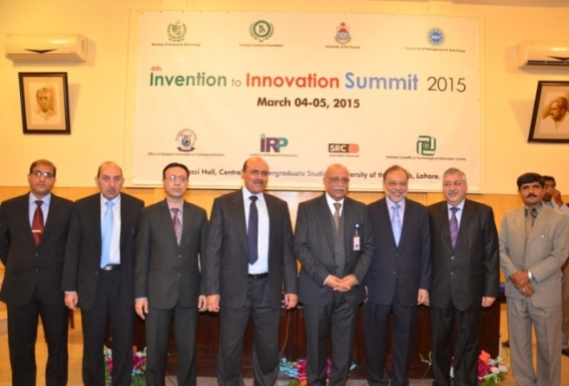
1.1.7 Exhibition Organized:
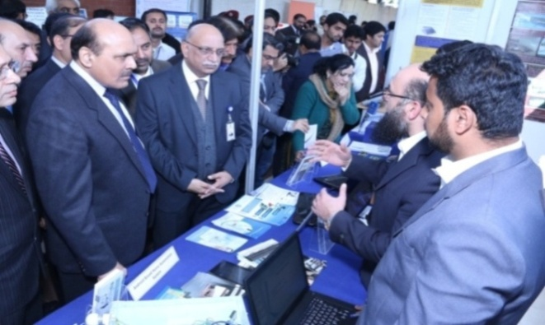
Pakistan Science Foundation (PSF) organized two days “Invention to Innovation Summit-2015”, wherein hundreds of indigenous technologies, varieties, products, processes, posters presentations and documentaries etc were presented in the Summit. This event is an annual activity of the joint collaboration of R&D-Industry Programme of Pakistan Science Foundation (PSF) and Pakistan Scientific & Technological Information Center (PASTIC), University of the Punjab and Institute of Research Promotion (IRP).
Eight different workshop sessions of industry, academia & R&D experts were also arranged in the summit from different technology sectors like Metals & Materials, Food & Healthcare, Electric & Electronics, Agriculture Engineering, Information Communication Technologies, Industrial Chemicals, Renewable Energy and Textile Processing. The industrial issues identified during this summit will be taken up jointly by Pakistan Science Foundation, Academia and the Industry. The most innovative technologies, finalized by the panel of judges, were awarded with the Innovation Award.
1.1.8 Workshops/ Seminars/ Meetings and Trainings:
- The Chairman PSF and Team Leader, R&D-Industry Programme participated in the “International Conference on Bio-Energy: Bio-Hydrogen, Bio-Methane as Alternative Fuel and its Conversion into CNG from Waste Water Programme” on August 26, 2014. The Chairman PSF chaired the first technical session. He shared the brief of the presenters’ work and proclaimed that the Energy Crisis in Pakistan is linked with management lacunas rather purely being the resource scarcity and that we can overcome a major chunk of this crisis by introducing effective management of the power sector. Chairman, PSF also briefed the audience about various programmes and invited research projects on energy related issues.
- The Principal Scientific Officer and Team Leader, R&D-Industry Programme attended the “Best Project Presentations and Open House” at PAF College of Aeronautical Engineering (CAE), PAF Academy, Risalpur on August 19, 2014. The students displayed their innovative prototypes in the fields of Aerospace and Avionics. At the end, the successfully completed projects at CAE were handed over to their sponsoring organizations for their commercialization and production at mass scale.
- Dr. Mirza Habib Ali, Team Leader, R&D-Industry Programme participated on behalf of the Chairman, PSF in the consultative meeting on “Establishment of CIIT Technology Part” at COMSATS Institute of Information Technnology, Islamabad on November 21, 2014.
- Dr. Mirza Habib Ali, Team Leader, R&D-Industry Programme and Mr. Irfan Ahmad, SO-R&D Industry Programme visited Business Incubation Centre at Office of Research Innovation & Commercialization (ORIC), University of the Punjab, Lahore. Dr. Amir briefed about the SOPs of ORIC office for Technology Incubation. Imran Niaz Khan, CEO, ENVIRAM Chemicals Ltd. who is the graduate of Institute of Chemical Engineering and Technology, University of the Punjab, Lahore shared his experience, as an entrepreneur with Business Incubation Centre of ORIC.
1.1.9 Inventions and Innovations Programme
The Foundation has initiated programme to translate the concepts into Innovations and Inventions and their movement toward commercialization for the benefit of the national economy. The scientists, researchers and students with innovative ideas are awarded with cash prizes. Students of different universities participate in different international events with their indigenously manufactures prototypes. During the report period, following two proposals were received for funding of small grants under Inventions & Innovations Programme of the Foudnation:-
- Entitled, “Design study of leather shaving blades” from University of Engineering & Technology, Peshawar.
- Entitled, “Geo-Tag Videography and Playback System” from CIIT, Abbottabad.
None of these projects were approved for funding due to lack of innovation.

1.2 Pak-US Natural Sciences Linkage Programme (NSLP) Endowment Fund
Natural Sciences Linkage Programme (NSLP) Endowment Fund is an important component of Pakistan Science Foundation (PSF) which is aimed at enhancement of agricultural production through effective research. The outcome of this research will benefit the end user by uplifting the life standard and income of the farmers. The Fund is being managed by PSF through Board of Governors (BoG) and Fund Management Committee (FMC). The Chairman, PSF is the Chief Executive of the Programme/Fund.
Aims ad Objectives:
- To enhance cooperation among scientists from Pakistan and the United States of America, in areas of significant mutual interest and benefit relating to natural sciences as applicable to agriculture.
- To increase the contact and collaboration among scientists and institutions of biological research, development and higher learning between the two nations.
- To provide researchers and institutions with opportunities to exchange information, ideas, skills and techniques.
- To enhance opportunities to collaborate in solving problems of common interest relating to natural sciences and to utilize special research and development facilities or opportunities available.
- To identify the researchable areas in natural sciences especially agricultural sciences with aim to increase farmers profitability
Research Priority Areas
Selected priority areas for collaboration may include, but are not limited to; Collection, Evaluation and Exchange of Germplasm, Plant Genomics, Plant Biotechnology, Stress Biology, Bio-Informatics, Application of Information Technology in Agriculture, Identification and Control of Animal/Plant Diseases, Dryland/Sustainable Agricultural Production System; Integrated Pest and Disease Management, Biotechnology, Microbiology, Agribusiness Development, Biophysics, Chemistry, Environment, Energy, Water Resource Management and Climate Change particularly with reference to Agriculture.
Project proposals which highlight main problems of agricultural sector are invited from Universities and R&D organizations across the country. Research work is emphasized on the food production & food security issues in Pakistani scenario. Currently 69 projects are being funded in different Universities and R&D organizations around the country under this programme.

Projects are received from researchers throughout the year; they undergo tough scrutiny and peer review before presenting to the Technical Committee, which comprises of eminent scientists from different specialized areas of agriculture and natural sciences. The target areas of these projects include germplasm screening of different crops, insect and pest management for the disease free crop production, nutrition management of crops and post-harvest technology. All these research issues are vital component of today’s agriculture and are imperative in bringing the value added products in the market. Apart from this, many projects from specialized fields of animal sciences are also being funded. These projects include research in genetic screening of different animal breeds, feed technology and milk quality areas. In future, the fund aims to maintain focus on applied research projects related to Energy, Water resources management, Environment and Climate Change.

1.2.1 Activities and Programmes
1.2.1.1 Research Funding
Research funding is the principal activity of Natural Sciences Linkage Programme (NSLP) efforts are being made to establish linkages between end-users and scientists of different R&D organizations and Universities throughout the country. Projects of applied nature are selected for funding and research proposals received undergo the strict process of scrutiny before the funding. The criteria include the competence of the scientific personnel to carry out the research, institutional capabilities i.e availability of the basic equipment and laboratory facilities, scientific merit of the proposed research proposals and likelihood of completion of proposed research work within the stipulated time and funds requested. The proposals are reviewed by two Pakistani experts along with US experts. The proposals cleared by experts are placed in the Technical Committee for technical evaluation and recommendation. Technical Committee on NSLP comprises of the renowned scientists from various fields of agriculture and natural sciences. The proposals recommended by the Technical Committee are then submitted to NSLP Fund Management Committee (FMC) for administrative and budgetary approval, before the release of funds.

- Under process Projects:
During the report period, 240 proposals remained under consideration of the NSLP. Out of these 53 projects were presented in three different Technical Committee meetings held during the report period. Technical Committee recommended 18 new projects for funding at total cost of Rs.50.5 million. List of projects recommended for funding during the report period is given in Annexure V.

- On-going Projects
During the year, there were 69 ongoing research projects and the progress reports of 55 projects (semiannual, 1st and 2nd annual & final reports) were received. The NSLP staff scrutinized the semiannual reports before releasing of next due installment. Whereas, annual and final reports after initial scrutiny by NSLP team were sent for evaluation to the subject experts to assess the interim progress of the projects before next due installment was released. It is worth mentioning that due installment of the on-going projects are released only if the interim progress of the projects at the end of each year is rated as satisfactory by the subject expert. An amount of Rs.32.4 million was released on account of due installments of ongoing projects. A list of semiannual and annual reports is given in Annexure VI.

- Completed Projects
During the year 12 projects were completed. The subject experts evaluated the final technical reports of the projects which were subsequently placed before the Technical Committee for adoption. The accounts of these projects have been settled. Details of the projects along with the scientific output are given below.

Project No | PSF/NSLP/P-UAAR(74)
Project Title | Pre and Post Harvest Treatments of Food Grade Chemicals to Improve Peach Fruit Quality and Shelf-life.
Duration | 3-Years
Date of initiation | 01-10-2010
Date of completion | 30-09-2013
Total Expenditure  Principal Investigator  Name of Institution | Rs.2,340,388/-  Prof. Dr. Nadeem Akhtar Abbasi  PMAS Arid Agriculture University, Rawalpindi
SUMMARY:

Peach (Prunus persica L. Batsch) are second to apricots in production among stone fruits in Pakistan. Peaches are one of the most liked fruits in the world because of their flavor, dietary value, attractive colour and medicinal worth. Peach fruit is enriched with ascorbic acid, carotenoids (pro-vitamin A), phenolic compounds and is considered prime source for antioxidants. In Pakistan peach is being cultivated in temperate regions of KPK and Baluchistan. However, low chilling cultivars are introduced in Pothwar region of Punjab, giving good returns to farmers. These low chilling cvs. have issues of low quality fruit and shorter shelf life to be transported to distant marks. Peach deteriorates quickly at ambient temperature. Therefore, cold storage is used to extend its shelf life, but extended cold storage period leads abnormal fruit ripening and causes chilling injury. The disorder can manifest itself as mealy, woolly or hard textured fruit, flesh browning, and hence limiting fruit’s potential postharvest quality and market. Present study was carried out to extend postharvest life and to improve quality of fruit through application of food grade chemicals at different concentrations.

The study comprised of two phases i.e. pre-harvest application of food grade chemicals like calcium chloride, putrescine and salicylic acid on two cultivars of peach i.e. ‘Flordaking’ and ‘Early Grand’, and postharvest dips of the fruits of these varieties. Pre-harvest sprays were applied at three different stages of the fruit growth i.e. cell division, pit hardening and cell enlargement stage. While for the post-harvest application, physiologically mature and uniform size peach fruits were harvested. The fruit was packed in cardboard cartons and brought to Postharvest Laboratory, Department of Horticulture, PMAS, AAUR. The fruit was then dipped in different concentrations of calcium chloride, putrescine and salicylic acid. Each treatment was replicated three times. After application of treatments the fruits were packed in cardboard corrugated boxes and then placed in cold storage (1+1 ºC, 90-95 % relative humidity). Data was recorded on weekly intervals for physical, chemical and sensory evaluation.

All the treatments significantly affected the fruit physical characteristics like fruit size, weight and pulp to stone ratio at the time of harvest. Clear changes in weight loss, decline in firmness and increase in soluble solids were noticed among all treatments during storage at low temperature for six weeks. While, titratable acidity, ascorbic acid showed decreasing trend. However, sugars (reducing, non-reducing and total sugars) showed increasing trend with the passage of storage time. Skin colour and organoleptic values also decreased as the time passed in the storage. Fruits treated with 2 mM putrescine in ‘Flordaking’ and 3 mM putrescine in ‘Early Grand’ (both pre and postharvest treatments) showed minimum loss in weight, firmness, ethylene production and least decline in acidity, ascorbic acid contents and sensory characteristics with delayed changes in skin colour during whole storage period as compared to control ones. It was concluded that putrescine and calcium chloride are the best edible chemicals to improve peach fruit quality on tree and to maintain its quality for longer period of time in storage at low temperature. The data that control fruit was almost unacceptable after three weeks of storage (both in ‘Early Grand’ and ‘Flordaking’), while putrescine 3 mM and 2 mM treatments maintained the acceptability till the last sampling date, hence improving storage life more than two weeks as compared to control.
Project No. | PSF/NSLP/P-AU(78)
Project Title: | Escalating the Feed Value of Wheat Straw through Ensiling with Rumen Digesta as an Inoculant in Ruminant Animals
Duration: | 3-Years
Date of Initiation: | 27-08-2010
Date of Completion: | 26-02-2014
Total Expenditure:  Principal Investigator:  Name of Institution: | Rs.2,626,662/-  Prof. Dr. Muhammad Sarwar  University of Agriculture, Faisalabad
SUMMARY:
This study was aimed to examine the influence of feeding different levels of urea-molasses treated wheat straw fermented with rumen digesta as replacement of concentrate on performance of post weaned and growing lambs in a randomized complete block design. Five isocaloric and isonitrogenous diets were formulated. The control (C) diet contained 50% unfermented wheat straw, whereas FWS50, FWS60, FWS70 and FWS80 diets had 50, 60, 70 and 80% fermented wheat straw, respectively. In two different experiments 15 Lohi lambs (approximately 3 months of age in post weaned experiment and 6 months of age in 2nd experiment) were randomly divided into five groups, 3 lambs in each group. Diets were randomly allocated to these five groups. Animals were fed twice a day at ad libitum and fresh water was made available round the clock. The 1st experiment lasted for 3 months; first 4 week served as pre-adaptation period. The findings of this study revealed that dry matter, crude protein and neutral detergent fiber intake and digestibility were higher in lambs fed FWS50. FWS60, FWS70 and FWS80 diets than those fed C diet. Similar trend was observed for nitrogen balance. Weight gain was higher (P<0.05) in both post weaned and growing lambs fed FWS50, FWS60 and FWS70 diets than those fed UNFWS50 and FWS80 diets. Lambs fed FWS50, FWS60 and FWS70 diets ingested more feed, utilized nutrients more efficiently, retained higher nitrogen and gained more weight than those fed UFWS50 and FWS80 diets.

In conclusion, lambs fed diets containing 70% fermented wheat straw performed efficiently and result of these studies could be propagated among farming community provided some other studies involving large number of animals be conducted.

Project No. | PSF/NSLP/KP-NIFA (128)
Project Title: | Breeding for Bruchids Resistance in Mungbean Vigna radiata (L) Wilczek
Duration: | 3-Years
Date of Initiation: | 01.06.2011
Date of Completion: | 31.05-2014
Total Expenditure:  Principal Investigator:  Name of Institution: | Rs.2,156,142/-  Dr. Gul Sanat Shah  Nuclear Institute For Food & Agriculture (NIFA), Peshawar
SUMMARY:
The main objective of the research project was to transfer bruchids tolerant gene from reported exotic mungbean bruchids tolerant lines i.e., V1128, V2709, V2802 and V2817 into local well-adapted mungbean genotypes i.e., Ramzan and NM 2006 through cross breeding. The reported four bruchids tolerant lines along with two local well-adapted varieties were evaluated for some important morphological and agronomic traits in field during 2011 (only in kharif season- July to October) and 2012 (both in summer –March to June and kharif seasons) under the agro-climatic conditions of Peshawar. The exotic bruchids tolerant lines showed adaptability problems in Peshawar’s agro-climatic conditions and were found susceptible to Mungbean Yellow Mosaic Virus (MYMV), prone to lodging, high flowers shedding, pods shedding and shattering at maturity, dull green and small seed size, and exhibited bushy plant type. They also showed delay flowering, more plant height, high biomass, more number of pods per plant, high seed yield per plant and large seed size during summer season as compared to kharif season. Sufficient hybrid seed of eight cross combinations i.e., V1128 x Ramzan, V2709 x Ramzan, V2802 x Ramzan, V2817 x Ramzan, V1128 x NM 2006, V2709 x NM 2006, V2802 x NM 2006, and V2817 x NM 2006 was picked during summer 2012. The F₁ generations of these cross combinations were planted along with their parents and all hybrid plants were harvested individually, threshed separately and bagged individually during kharif 2012. The exotic parents and their F₁s were susceptible for MYMV whereas the local parents were resistant to MYMV.

F₂ populations of the eight cross combinations were raised during summer 2013. Vegetative growth of the mungbean crop during this season was normal but the sudden rise in temperature above or near to 40°C during reproductive stage caused drastic flowers shedding associated with adverse effects on pods formation. The grains formed in pods were less in number and also shriveled due to this high temperature. 877 single plant selections were made on the basis of more number of pods per plant from all cross combination. The saved seed of 877 selected recombinants and the bulk populations of all the crosses were planted in April 2014 as plant progeny rows along with their respective parents for selecting recombinants with more pods per plant and good plant type.

Out of 877 recombinant selections, 28 had more seeds and therefore, their seeds were also screened for resistance to bruchids along with the seeds of six parents (V1128, V2709, V2802, V2817, Ramzan and NM 2006) used in crosses under lab conditions from June to August, 2013. All evaluated recombinants were found susceptible to bruchids. The reason could be that the reported bruchids tolerant parent (V2802) used in this cross was also not showing tolerance to bruchids in Peshawar agro-climatic conditions. Only a genotype V1128 showed tolerance to bruchids whereas the same genotypes had shown susceptibility to bruchids in earlier screening. This indicates that adaptability improvement of this genotype by repeatedly planting in Peshawar agro-climatic conditions may have played important role in bruchids tolerance of this genotype. The other three genotypes i.e., V2709, V2802, V2817 and the segregating populations generated from their crosses may show tolerance to bruchids in future when their adaptability to the local environment is improved and enhanced by repeatedly planting under Peshawar agro-climatic conditions.

Project No. | PSF/NSLP/KP-AU (161)
Project Title: | Production of Genetically Engineered Oilseed Rape for Enhanced Disease Resistance
Duration: | 2-Years
Date of Initiation: | 01-06-2012
Date of Completion: | 31-05-2014
Total Expenditure: | 21-07-2014
Principal Investigator:  Name of Institution: | Dr. Muhammad Sayyar Khan  The University of Agriculture, Peshawar
SUMMARY:
The local production of edible oil in Pakistan is very low and there is a wide gap between production and consumption, which is mainly bridged through import of edible oil at the cost of a huge amount of foreign exchange. Among the various oilseed crops that are grown in Pakistan, Brassica napus has a high potential, however, its per acre yield is far below the agriculturally developed countries. Among the various constraints that have limited crop productivity, fungal diseases serve as a major cause of crop losses. Since the agrochemicals and conventional breeding approaches that are often used to control the spread of the diseases, have certain limitations, the utilization of genetic engineering approaches therefore have emerged as a promising alternative. The main focus of the project was to transform selected genotypes of Brassica napus i.e. Abasyn 95 and Durre-e-NIFA with antifungal chitinase gene.

Efforts to transform Brassica napus genotypes in Pakistan are generally hampered due to lack of prior characterization and recalcitrant nature of Pakistani commercial canola (Brassica napus) genotypes. Here we report successful transformation and regeneration of the major Brassica nupus cultivars i.e., Abasyn-95 and Durre-e-NIFA of Khyber Pakhtunkhwa with chitinase gene. The optimization of methodology for callus induction and regeneration reported in this project will provide base line information for future.

From the studies it can be concluded that hypocotyls and cotyledons as explants from young seedlings are the most suitable explants in terms of producing transgenic calli and shoot regeneration. Our studies further suggest that medium containing 2 mgL-1 2, 4-D, 0.5 mgL-1 BAP and 0.1 mgL-1 NAA is the best combination of plant growth regulators for callus induction especially for the cultivar Abasyn-95.

Moreover, it was observed that 0.01 mgL-1 GA3, 0.4 mg L-1 kinetin, 0.4 mgL-1 BAP, 4 mgL-1 NAA produced better results in terms of callus formation in case of Durre-e-NIFA. Similarly, 2 mgL-1 2, 4-D in combination with BAP at a concentration of 0.5 mgL-1 supplemented with 20 μM AgNO3 was found to be the most suitable combination for shoot regeneration. However, 3 mgL-1 BAP, 0.3 mgL-1 NAA, and 15 μM AgNO3 also showed comparable results in terms of shoots regeneration. The above mentioned concentrations and combinations of hormones therefore, can be used as base line information for future transformation programs of Brassica napus. Moreover, tissue culture and transformation responses were genotype dependent as evident from our observations that the second cultivar Durre-e-NIFA behaves differently from Abasyn-95 in terms of producing transgenic calli and shoots. Modifications in floral dip method reported in this project leads to unprecedented high transformation efficiency (approx.50%) in B. napus, and thus open up new frontiers to transform Brassica napus (and probably other Brassica species as well) with ease comparable to that of Arabidopsis transformation. Over expression of the particular chitinase gene (used in this project) in Brassica napus provided resistance against the most common and prevalent fungal pathogen of Brassica species i.e. A. brassicicola. Although the primary focus of this project was on Brassica napus, but the same over expression strategy can be extended to other crop plants of interest to test the suitability of this approach. Apart from A. brassicicola, the anti fungal activities of the over expressing lines against other fungal pathogens are needed to be evaluated.

Project No. | PSF/NSLP/S-KU (134)
Project Title: | AM Fungi as Potential Biocontrol Agent for Crop Improvement and Bioprotectant against Root-Knot Nematodes
Duration: | 3-Years
Date of Initiation: | 01.07.2011
Date of Completion: | 30.06.2014
Total Expenditure:  Principal Investigator:  Name of Institution: | Rs.1,688,789/-  Dr. Firoza Kazi  National Nematological Research Centre, Karachi
SUMMARY:
Arbuscular mycorrhizal (AM) fungi are important group of soil-borne microorganisms which play an important role in the establishment, productivity and longevity of natural ecosystems. The establishment of AM fungi in the plant roots has been shown to reduce the damage caused by soil-borne plant pathogens with the enhancement of resistance in mycorrhizal plants. The present research aims to gather the information that is generated on plant mycorrhizal association and to evaluate the occurrence and AM fungi community diversity in different vegetation types within Sindh province of Pakistan. Moreover, efficacy of arbuscular mycorrhizal (AM) fungi as biocontrol agent against root-knot nematode Meloidogyne incognita was evaluated in tomato, brinjal and sponge gourd.

Due to the importance of the symbiotic association and uptake of phosphorus in nutrient deficient regions, detail surveys were carried out from Sindh province and a total of 500 soil and root samples were collected from infected and diseased plants for the detection of these endophytes (AM fungal spores) and root-knot nematodes (RKN) in 10 different regions of Sindh. The detailed soil and root analysis revealed the widespread presence of arbuscular mycorrhizal species throughout the Sindh province whereas two species of root-knot nematodes viz., Meloidogyne incognita and M. javanica were more frequently recovered from the study areas. Other types were identified as Gigaspora gigentea, Scutellospora spp., and Sclerocystis spp. However, their frequency was low as compared to Glomus. In RKN species, M. incognita was found dominating. The overall frequency of occurrence of root-knot nematodes was 82% while it was 74% for AM fungal spores.

Characterization of the root-knot nematodes and AM fungi encountered during the study were also given. The root-knot nematode species were identified on perineal pattern and cultured on brinjal plants at green house of National Nematological Research Centre, University of Karachi to maintain the pure culture of RKN species for pot and green house experimentations. AM characterization was based on the morphological characteristics of AM fungal spores. Furthermore, the mature and healthy fungal spores were propagated in vitro and in vivo on sudan grass.

The effect of AM fungi (Gigaspora gigentea and Glomus intraradices) and root-knot nematode (Meloidogyne incognita) was studied on tomato and brinjal, respectively under green house conditions. It was found that inoculation of AM-fungi before nematodes limit the infestation by root-knot nematode and a better growth of host plants were noticed. Experiments were also conducted under green house conditions to evaluate the efficacy of arbuscular mycorrhizal (AM) fungi (Glomus intraradices) as bioprotectant against root-knot nematode Meloidogyne incognita in sponge gourd Luffa cylindrica (L.) Roem. Growth parameters were estimated in roots, shoot and leaves of mycorrhizal and non mycorrhizal plants. Physical/biochemical, carbon and nitrogen profile were also taken into account. Comparative study clearly indicated the significant variations in all parameters of sponge gourd. Leaf area and plant height were increased in mycorrhizal plants than non-mycorrhizal, while it showed a sharp decrease in nematode infected plants, same plants also showed less water content due to xylem vessels damage. However, in mycorrhizal plants, roots had large amount of carbohydrates indicating transfer of photosynthates to fungal partner. Nematode infected roots have least amount of carbohydrates showing a great sink of carbon to rhizosphere. Effect of AM fungi as stress producing organism was evaluated against other biotic and abiotic organisms. Results clearly indicate that no stress was produce by AM fungi especially when compared stress indicator metabolites. The protective nature of AM fungi as biocontrol and bioprotectant of plant against root-knot nematodes on bottle gourd showed that AM fungi increased the nutrient uptake and modify plant metabolism which leads to a reduced response to stress and increased resistance to pathogen attacks.

Another experiment was carried out to estimate of damage caused by root-knot nematodes in root, hypocotyle and stem of luffa plant and their alleviation by AM fungi. Results showed that the damage caused by root-knot nematodes was limited up to a certain extent by the addition of AM fungi. However, the alleviation of damage depends on the time of inoculation of both organisms i.e., AM fungi and nematodes. During the present research studies it was observed that increase in plant growth after colonization of root by AM fungi may be due to the improvement in the mineral nutrient status of host plant. The growth’s response of nematode-infected plant as a result of mycorrhiza assisted nutrition is to improve plant’s health, give protection, increase host tolerance against the nematode pest.

Project No. | PSF/NSLP/S-SAU (252)
Project Title: | Population Biology and Management of Papaya Mealybug, Paracoccus marginatus- A Threat to Papaya Cultivation in Coastal Areas of Pakistan
Duration: | 1-Year
Date of Initiation: | 15-09-2013
Date of Completion: | 14-09-2014
Total Expenditure:  Principal Investigator:  Name of Institution: | Rs.625,777/-  Prof. Dr. Tajwar Sultana  Sindh Agriculture University, Tandojam
SUMMARY:
The papaya mealybug, Paracoccus marginatus severely infesting papaya, Caricus papaya (L.) is an alien papaya mealybug pest which was detected at coastal areas of Sindh and Balochistan, Pakistan since, 2008. It needs an instantaneous and effectual IPM strategy to put off this pest insect from overwhelming papaya orchards of Pakistan. Therefore, this research study was conducted. The female of papaya mealybug, P. marginatus showed higher fecundity and fertility of eggs during summer season compared with winter season. There was a significant (F= 70.82; DF= 3, 9; P<0.001) difference in developmental time of different life stages such as eggs, larval instars, pupae and adult of mealybug on papaya fruits under laboratory conditions. The use of natural enemy, Acerophagus papayae to control P. marginatus through biological control program is necessary. This exploration on its biology and growth supports its amenability and suitability for further intensive utilization of this parasitoid for biological control of papaya mealybug.

During the life table study of papaya mealybug, P. marginatus the apparent mortality, survival fraction, survivor mortality ratio, indispensable mortality and k-value were ascertained. The results indicated that the apparent mortality in eggs of P. marginatus was 12.00 %, while 15.72 % mortality was recorded in first instar and 12.13 % was noted in second instar and lowest apparent 7.16% mortality was observed in third instar and (0.35%) in pupae of P. marginatus. The adult female mealybug is soft bodied, oval in shape, bearing caudal filaments around the body, a pair of anal filaments, an egg mass or ovisac on under side of the abdomen and whitish cottony mealy wax covered the whole body. The incubation period observed was 5.35, first instar 6.55, second instar (5.55), third instar 6.10 and an adult longevity 14.95 days, whereas, the duration of life cycle was 38.50 in summer season of 2014. The data further indicated that the first peak of pest population was observed in the month of May, 67.84±63.87 mealybugs / leaf per plant and second peak in July, 69.96±45.53 with overall mean population of 39.06±23.18 / leaf. Then parasitoid Acerophagus papayae Noyes & Schauff: Encyrtidae was the major parasitoid attacking P. marginatus. The peak population of papaya mealybug parasitoid, A. papapae was observed in July, 15.84±3.64 parasitoids / leaf. There were four hyperparasitoids: Pteromalidae: Pachyneuron sp., Encyrtidae: close to Gahaniella, Eulophidae / Tetrastichinae: Aprostocetus sp., and Aphelinidae: Marietta sp. Associated with Acerophagus papayae.

The predators’ population observed was: Chrysoperal carnea, (2.61±2.02), Spalgius sp. (2.59±1.87), Coccinillid beetles (2.04±1.76) and spiders (2.56±1.88) / plant at Belli Farm from the starting of December, 2013 to August, 2014. The results of Linear Regression showed that the population development of mealybugs and parasitoid was positively significant (F= 21.15; DF= 1, 14; P= 0.001; R²= 0.6017). The predators and pest populations were also observed positively significant (F= 17.10; DF= 1, 14; P= 0.001; R²= 0.5498) at University of Karachi, Belli and Windar Farms. The data showed the significant (F= 45.07; DF= 14, 2; P<0.001) difference in percent parasitization.

Project No. | PSF/NSLP/P-AU(120)
Project Title: | Studies on the Effect of Estrogen and Progesteron along with Insulin on Invitro Gonadotrophin Secretion from Buffalo Adenohypophysis
Duration: | 2-Years
Date of Initiation: | 01-07-2011
Date of Completion: | 30.06.2013
Total Expenditure:  Principal Investigator:  Name of Institution: | Rs.1,380,000/-  Dr. Nafees Akhtar  University of Agriculture, Faisalabad.

SUMMARY:
The project was planned to enhance the secretion of gonadotrophins i.e. FSH and LH by treating in vitro culture of buffalo adenohypophysis with estrogen (0.5, 1.0 mg) and progesterone (2.5, 5.0 mg). Insulin and liver extract were also added in the culture medium as growth promoting factors. The amount of FSH and LH produced were estimated by ELISA and HPLC techniques. Results showed significant (P<0.05) increase in the secretion of FSH and LH compared with control. The FSH and LH obtained were estimated to be 33.0 IU/ml and 68.67 IU/ml, respectively, in proportionate to standard of FSH being 100.0 IU/ml and LH being 1500.0 IU/ml. Experiment was repeated and sufficient amount of FSH and LH was obtained. Repeated procedure proved that the technique can be used for further production of FSH and LH.
Bioactivity of the FSH and LH obtained was studied by injecting them in male/female rabbits and dairy buffaloes. In the first experiment four groups of pre-pubertal female rabbits were treated with in vitro produced FSH≈4.0, 40.0 IU; LH≈8.5 and 85 IU (s/c), twice daily in divided dose at an interval of 12 hours for five days. Similarly, one group of rabbits was treated with placebo as control-1 and one was untreated kept as control-2. In the second experiment one group of adult male rabbits was treated as placebo/control, second group was treated with in vitro produced FSH/LH being 4.0:8.5 IU and rabbits of third group was treated with ten time high dose of FSH/LH being 40.0:85.0 IU. In third experiment, nine healthy but acyclic dairy buffaloes kept in three groups’ viz., A, B and C was used. Buffaloes in group A were treated with in vitro produced FSH≈500 IU (s/c) daily in divided dose at an interval of 12 hours for five days. Buffaloes in group B were treated with Folltropin-V≈5mg (s/c), twice daily and buffaloes in group C were treated with placebo/control.

There was no treatment-related mortality; no hypersensitivity or toxic sign was seen in any of the experimental rabbit/buffalo. None, of the experimental rabbits showed change in general behavior, aggressiveness/lethargy and weight. The in vitroproduced FSH≈4.0, 40 IU, LH≈8.5 and 85 IU did not affect body weight and most of the blood parameters i.e. RBC and WBC count, PCV, hemoglobin (Hb) concentration, MCH and of female rabbits. Moreover, FSH≈40 IU resulted (P<0.05) increased ovarian activity showing developing GF’s along with (P<0.05) increased mean length, width, weight and volume compared with those treated with FSH≈4 IU, LH≈8.5, 85.0 IU and control. The in vitro produced FSH≈40 IU, LH≈85.0 IU resulted in significantly (P<0.001) increased serum FSH 260 - 470 Vs 4 - 6 mlU/ml and serum LH 28 - 48 Vs 4 - 5 mlU/ml. Treating male rabbits with in vitro produced FSH:LH≈4.0:8.5 IU and 40.0:85.0 IU, did not affect weight and most of the blood parameters i.e. RBC and WBC count, PCV, hemoglobin (Hb) concentration, MCV and MCH, whereas, platelet count in group B (514.40±37.40 xl0³/µL) and in group C(515.00±59.21 xl0³/µL) was significantly (P<0.001) higher than of (321.20±27.41 xl0³/µL) group A.

However, there was no difference between group B and C. In male rabbits use of in vitro produced FSH:LH ≈4.0:8.5 IU or 40.0:85.0 IU, resulted in (P<0.001) increased serum FSH from 72.30±5.66 to 172.38±5.66 mIU/ml and 64.82±5.66 to 209.34±5.66 mIU/ml, whereas, non-significant change was observed in placebo/control group in respect of serum FSH being 62.44±5.66 Vs 54.41±5.66 mIU/ml. The serum total cholesterol was also raised significantly (P<0.01) after treatment(29.40±8.17 to 82.20±11.35 mg/dl and 19.80±2.13 to 54.40±10.07mg/dl) in group B and C, whereas no change was observed in control group. Moreover, testes weight was also higher in group B and C (538.40 ± 11.91 and 574.00 ± 13.86 mg) than of group A (500.00 ± 11.47 mg). No difference was observed in the cytology of testes collected from group A, B and C.

Treating buffaloes with in vitro produced FSH and Folltropin-V resulted in significantly (P<0.01) high serum FSH, LH and estrogen concentration at day 5 to 6, whereas progesterone concentration was decreased (P<0.01). Day to day increase in serum FSH was also significant (P<0.01). Increase in serum LH was observed at day 5 to 6. Though the size of ovaries was increased showing numerous small GF’s, however, no one attained ovulatory capability. Hormones obtained from the culture materials showed bioactivity in the experimental animals without any toxicity. However, purified and concentrated form of FSH and LH may be prepared using prep-LC system.
Project No. | PSF/NSLP/KP-NIFA (160)
Project Title: | Improvement of Stevia (Stevia rebaudiana Bertoni) through Induced Mutations and in Vitro Somaclonal Variations
Duration: | 3-Years
Date of Initiation: | 15.06.2011
Date of Completion: | 31.10.2014
Total Expenditure:  Principal Investigator:  Name of Institution: | Rs.2,010,909/-  Shahid Akbar Khalil  Nuclear Institute For Food & Agriculture (NIFA), Peshawar
SUMMARY:
The first objective of the present study was to optimized indirect regeneration system via callus culture in economically important plant, Stevia rebaudiana Bertoni. Leaf explant from lathe house grown Stevia plants was selected for the whole experiment. Best calli (83.26%) were obtained on Murashige & Skoog (MS) medium augmented with 2.0 mg/L 2, 4-D while similar calli (83.25%) was also obtained on medium containing higher concentration of 2, 4-D (4.0 mg/L). No callus was observed on MS0 (control) medium without any plant growth regulators (PGRs). It was also observed that medium containing auxins produced yellowish green and granular callus, while medium containing combination of auxins and cytokinins produced green and compact callus. The green callus was shifted to shooting medium.

Organogenesis was successfully achieved on medium containing different combinations of PGRs. The best and maximum % shooting (96%) was recorded on medium containing 2.0 mg/L BAP. In contrast, 90% shooting response was observed on medium containing BAP (1.5 mg/L) and GA₃ (0.5 mg/L). Similar combination of PGRs also influenced maximum number of shoots (106) per explant. However, 96 numbers of shoots/explants were observed when the growth medium contained 2.0 mg/L BAP alone. Maximum mean shoot length (23.5 cm) was recorded on medium containing BAP (1.5 mg/L) and GA₃ (0.5 mg/L). Furthermore, the transferring of developed shoots to half strength MS medium containing IBA and NAA (0.5 mg/L) produced more than 85% rooting with 19 roots per plantlet. However, full strength MS-medium containing similar PGRs produced 73% rooting response.

As compared to indirect regeneration, direct regeneration system was also established from shoot tip explants. Shoot tip explants showed 100% survival on medium supplemented with different concentrations of BAP (0.5, 1.5 and 2.0 mg/L). BAP in lower concentration (0.5 mg/L) produced the longest shoot of 3.6 cm from shoot tip explants. Highest % rooting was observed when MS-medium was supplemented with IBA, NAA and IAA (0.5 mg/L). Plantlets from both experiments were first acclimatized in pots and then successfully transferred to field condition.

The second objective of the project was the induction of in vitro mutagenesis for creation of genetic variability to enhance the mother compound stevioside. For this purpose selected doses of gamma rays have been applied on seeds (2.5, 5.0, 7.5 and 10 Gy) and callus cultures (5, 10, 15, and 20 Gy) to enhance germination and to get healthy mutant plants adaptable to the agro-climatic conditions with improved growth parameters and Steviol glycosides content. After LD₅₀ calculation for callus cultures, 13.33 Gy dose was selected for creation of somaclonal variation and raising of MV₁ generation. The irradiated callus cultures were shifted to fresh medium containing different PGRs for shoots and root organogenesis. These micro-propagated plants were successfully acclimatized in soil and seven mutant plants with maximum number of leaves, branches and plant height were subjected to HPLC for Steviosides and rebaudioside-A content analysis. Briefly, out of seven mutant plants, five mutant plants (MSIC-1, MSIC-2, MSIC-3, MSIC-5 and MSIC-7) obtained from irradiated callus showed higher Steviosides contents (2.436±0.09, 2.232±0.04, 2.1414±0.07, 2.087±0.19 and 1.982±0.20 mg/g-DW) than control (1.937±0.72 mg/g-DW). As compared to Steviosides contents, one mutant plant (MSIC-1) out of seven showed higher Rebaudioside-A contents (1.638±0.43 mg/g-DW) than control (1.636±0.41 mg/g-DW).

In the field conditions, above ground parts of irradiated callus derived plants (MV₁) were removed in order to get MV₂ generation. Before flowers initiation data were collected on different growth parameters. Highest plant height (108.2 cm) was observed in MSIC-2 but number of branches, leaves, inter nodal length and yield was lower than some other plants. Highest inter nodal length (3.567 cm) was observed in MSIC-3. Maximum number of branches (24) and leaves (1462), and yield (180.6 g/FB) were recorded in MSIC-5. Therefore in MV₂ generation, 4 plants were selected for steviosides content on the basis of best growth parameters. Steviosides content was determined in dry biomass and higher steviosides content (6.076±0.40 mg/g-DW) was observed in the dried leaves (8.461±0.421 DB) of MSIC-5 as compared to other selected plants and control (3.015±0.60 mg/g-DW).
In this project, different doses of gamma rays have been applied on seeds to enhance germination and to get healthy mutant plants adaptable to the agro-climatic conditions with improved Steviol glycosides content. Seeds were germinated in three different medium and the LD₅₀ value was determined on the basis of germination percentage. Best dose for creation of genetic variability in seeds was found 8.75 Gy. Seeds were irradiated with 8.75 Gy dose and M₁ plants were raised. The M₁ seed will be bulked and sown in the soil to raised M₂ generation. Seed was collected from irradiated seed derived mutant plants (8.75 Gy dose) of M₁ generation. The seeds were sorted out for selection of black coated and viable seed having mature and complete embryos. A total of 500 plastic bags were filled with soil, sand and manure (2:1:1). Before seed sowing, sprinkle irrigation was applied on plastic bags to retain humidity. Five seeds were sown in each plastic bag and placed for germination in glass-house at Nuclear Institute for Food and Agriculture (NIFA). After successful growth in plastic bags, 120 plantlets were shifted to field conditions for survival and development. After establishment in the field conditions, 50 plants with good appearance were selected for different growth parameters. However, we select 5 plants from M₂ generation on the basis of higher yield per plant. Plant 10 contain maximum fresh yield (316.45 g/FB) with highest number of branches (36) and leaves (1896) as compared to control. This plant also contains optimum height (94.10 cm) and inter nodal length (3.23 cm). Leaves from these five plants were exposed to HPLC for steviosides analysis. HPLC analysis revealed that higher steviosides content (10.2±0.70 mg/g-DW) was observed in MSIS-24 with optimum dry biomass of 7.459±0.372 g/DB as compared to control (3.01±0.60 mg/g-DW and 5.532±0.276 g/DB). The current results suggest that gamma irradiation enhances steviosides content in seed-derived plants. Moreover, plants of M₂ generation showed higher profile of steviosides content than irradiated calli derived plants of MV₂ generation.

Moreover, stem cutting were dipped in different hormones solution for rooting and survival, and maximum survival rate of 33% was observed when cuttings were dipped in an IBA solution (1000ppm). After obtaining 33% survival, 102 stem cutting with uniform length and 3-4 leaves were dipped in the same solution and subsequently planted in plastic bags. After 8 weeks of plantation, 63 out 102 plants with luxuriant green leaves were selected for further propagation in the field conditions. In field conditions, 50 vigorous and uniform plants were selected for yield and quality parameters. The highest yield per plant (271.56 g/FB) was observed in plant 30. As compared to other selected plants, this plant contained good plant height (95.37cm), optimum internodal len2gth (2.42cm) and higher number of leaves per plant (1942).
Project No. | PSF/NSLP/P-PU(196)
Project Title: | Development of Gluten Free Flour  from Indigenous Sources and its Biological Evaluation on Celiec Patients
Duration: | 3-Years
Date of Initiation: | 01-01-2012
Date of Completion: | 31-12-2014
Total Expenditure:  Principal Investigator:  Name of Institution: | Rs.867,339/-  Prof. Dr. Saeed Nagra  University of the Punjab, Lahore
SUMMARY:
Local wheat varieties of Punjab were procured and tested for their proximate principles and gluten content using AOAC and AACC methods, respectively. Wheat verity, Fd-08 was selected for the production of gluten free wheat starch due to its low protein content, good gluten index and abundant availability. Mechanical, chemical and microbiological methods were employed for gluten extraction from this wheat variety. Starch samples produced from Fd-08, having least protein contents were further assessed for the residual gluten level through sandwich ω-gliadin ELISA. Dough batter method using 200 mesh sieve resulted in starch with least gluten content of approximately 700 ppm. It was however, observed that chances of contamination were high during processing. Chemical method was not considered suitable as it resulted in starch with high gluten contents of more than 5000 ppm. In case of probiotics a combination of Lactobacillus acidophilus, Bifido bacterium, Streptococcus thermophillus and Lactobacillus bulgaricus was found to be most effective in reducing the gluten content of wheat starch.

Recipes of gluten free flour were formulated using local gluten free grains including rice, corn, sorghum, millet, grams and pulses with and without the addition of safe quantities of wheat starch. Xanthan gum (0.5% by weight) was added to induce cohesiveness to the flour product. Nutritional evaluation of the all recipes was carried out. Sensory evaluation revealed no difference between the wheat starch containing recipes and those containing gluten free grains alone Recipe 7, comprising exclusively of gluten free grains (30g rice flour, 20g mung bean flour and 10g de hulled and degermed corn flour), was chosen owing to its best sensory and nutritional characteristics.

Human subjects (study sample) were selected from the Gastroenterology and Pediatric Department of Sheikh Zayed Medical Complex and Mayo Hospital Lahore. Improvement in the nutritional status and GI symptoms after the administration of GFF for four months was quite obvious in all age groups of the celiac patients. It was however more prominent in young celiac patients. Stature for age percentiles revealed that more than half of the patients were stunted. These percentiles, however, did not significantly improve with GFF use in a four months trial period.

Biochemical evaluation revealed a high incidence of hypochromic anemia (56%), indicative of iron deficiency both before and after treatment. Intensity of most of the clinical signs and dehydration reduced after the feeding trial. Significant (P<0.05) reduction occurred in diminished fat, dyspigmentation, easy pluckibility and sparseness of hairs, diffuse de pigmentation of the skin, angular stomatitis, cheilosis, history of bone pains, pallor and dry itchy skin. Reduction in GI symptoms was also observed after the GFF use. Significant (p<0.05) reduction occurred in abdominal pain, heart burn, sucking sensation, nausea and vomiting, distension, increased stools, loose stools, hard stools, urgency and steatorrhea.

Caloric and macronutrient consumption of the study sample was according to the recommended dietary guidelines before and during the feeding trial. Maximum GFF consumption, its percentage of caloric, carbohydrate and protein contribution was observed in the patients of 9-13 years. Significant (p<0.05) correlation was observed between wheat intake and GI symptom scoring. It was observed that the intake of gluten free cereals including rice (used almost regularly before the administration of GFF) was reduced in all age groups. Intake of milk, meat/meat substitutes, fruit and vegetable was found to be less than the quantities recommended. An increase in vegetable intake was observed with GFF administration. Fat intake was highest in the age groups of 19 to 30 years both before and after treatment. Majority of the patients were using banaspati ghee (hydrogenated fat) for cooking food. Reduction in the consumption of carbonated beverages, packaged juices, chocolates and processed snacks was conspicuous. Lunch and dinner meals were regularized with GFF use. Improvement in compliance and appetite was noticeable in all age groups but the change was more prominent in children. Improvement in satiety and meal satisfaction was also reported in almost all patients. GFF was rated reasonably well for palatability, acceptability, ease in preparation and improvement in general wellbeing.

Project No. | PSF/NSLP/C-CIIT )
Project Title: | Biological Control of Blast & Bakanae  Diseases of Rice by using Improved  Formulation of Native Bio-antagonists
Duration; | 3-Years
Date of Initiation: | 01.07.2011
Date of Completion: | 30-06-2014
Total Expenditure:  Principal Investigator:  Name of Institution: | Rs.3,727,498/-  Dr. Muhammad Nadeem Hassan  COMSATS Institute of Information  Technology, Islamabad
SUMMARY:
Rice (Oryza sativa L.) is an important crop which is being used as staple food throughout the world. It is a good source of energy and provides 15% protein to humans. Blast and Bakanae diseases of rice are the destructive factors causing significant annual yield losses worldwide. Biological control using native bio antagonists is an emerging management strategy that could be used independently as well as in context of integrated pest management strategy.

In present study, virulent strains of economically important pathogens Pyricularia oryzae and Fusarium moniliforme causing blast and bakanae diseases of rice respectively were isolated from the symptomatic plants of rice varieties 385 and varieties super basmati growing in different areas of Punjab, Pakistan. The virulence of isolated strains was verified by conducting pathogenicity test under field conditions and used as test fungi.

Rice associated rhizobacteria were isolated and screened for their ex-planta antagonistic activity in vitro by dual culture assay. The antagonistic rhizobacteria were characterized for their morphological traits such as Gram reaction, cell shape and biochemical traits such as phosphate solubilization, indole acetic acid production, protease production and hydrogen cyanide production. Five potent strains KFP-5, KFP-7, KFP-12, KFP-17 and KFP-18 showing 63-65% in vitro antagonism, producing the biocontrol determinant siderophores, hydrolytic enzyme proteases and solubilizing phosphorous in variable conditions of media, temperature etc were tested for their in vivo antagonism and survival in commercial humic acid and a liquid formulation consisting of 0.85% saline,0.5% glycerol. Among the tested strains, two strains KFP-7and KFP-17 showed best survival in both formulations by maintaining 8.56-8.63 log CFU in humic acid and 8.33-8.83 log CFU in liquid formulation until six months. These two strains also suppressed the blast and bakanae diseases of rice and enhanced yield under field conditions. The strains also induced activity of defense related enzymes indicating their ability to protect the plants from aerial pathogens by inducing systemic resistance. i. e. increasing the natural immunity of rice plants. These potent strains could be used as candidate to develop biopesticide for rice crop and potential use in sustainable agriculture.
Project No. | PSF/NSLP/P-FCCU(179)
Project Title: | Phytochemical and Biotechnological  Studies on Antioxidant and  Antimicrobial Compounds in  Lagenaria Siceraria (Molina) Standl
Duration: | 2-Years
Date of Initiation: | 01-03-2012
Date of Completion: | 31-12-2014
Total Expenditure:  Principal Investigator:  Name of Institution: | Rs.2,461,931/-  Dr. Dildar Ahmed  Forman Christian College (A  Chartered University), Lahore

SUMMARY:
The fruit of Lagenaria siceraria, which is commonly used as a vegetable, is considered to have diverse medicinal benefits. The aim of the present work was to explore the fruit cultivated in Pakistan for its bioactivities including antimicrobial, antioxidant, and anti-enzymatic, and isolation and identification of its chemical constituents. Chemical constituents of various parts of L. siceraria fruit were isolated by column chromatography (CC) and thin layer chromatography (TLC). GC-MS, HPLC and LC-MS techniques were used for their identification. Antimicrobial activities were evaluated against a number of clinically important standard and isolated microbial strains including Pseudomonas aeruginosa ATCC9027, Escherichia coli ATCC8739, Bacillus subtilis ATCC6633, Staphylococcus aureus ATCC6538 and Candida albicans ATCC10231, Achromobacter xylosoxidans, Pseudomonas aeruginosa, Bacillus megaterium and Escherichia coli. In general, mesocarp was more potent than peel. P. aeruginosa was most susceptible and methanolic extracts of both peel and mesocarp showed higher activity than antibiotic Amoxil. Ethyl acetate fractions of both the fruit parts and n-butanolic fraction of mesocarp showed highly significant activity against P. aeruginosa. Hexane fractions of peel and mesocarp and ethyl acetate fraction of mesocarp showed higher activity against C. albicans than Amoxil. Methanolic extract of the seeds pulp exhibited moderate to good efficacy against Achromobacter xylosoxidans, Pseudomonas aeruginosa, Bacillus megaterium and Escherichia coli. It showed better potency than antibiotic Amoxil against Enterobacter aerogenes, Pseudomonas aeruginosa and Bacillus megaterium. It displayed highly significant efficacy against Bacillus megaterium and, Salmonella typhi. The methanolic extract of pedicles showed prominent efficacy against Achromobacter xylosoxidans, Pseudomonas aeruginosa and Citrobacter freundii. The methanolic extract also exhibited considerable potency against Bacillus megaterium, Stenotrophomonas maltophilia, Klebsiella pneumoniae, Enterobacter cloacae and Enterobacter aerogenes. Ethyl acetate fraction came out to be most potent against Achromobacter xylosoxidans, Bacillus megaterium, Pseudomonas aeruginosa and Citrobacter freundii. Of all the microorganisms tested, Achromobacter xylosoxidans was most susceptible.

This study suggests that various parts of Lagenaria siceraria fruit could be a potential source for new antibiotics against a variety of microorganisms. The present study will add to the scientific database on the plant and will provide and rational background for future studies which may include pharmacological and in vivo evaluation of bioactivities of the plant.

Project No. | PSF/NSLP/S-PARC (187)
Project Title: | Occurrence and Control of Nematodes Associated with Fruit Nurseries in Balochistan
Duration: | 2-Years
Date of Initiation: | 01.06.2012
Date of Completion: | 01-02-2015
Total Expenditure:  Principal Investigator:  Name of Institution: | Rs.740,461/-  Dr. Aly Khan  Crop Diseases Research Institute, Pakistan Agricultural Research, Karachi
SUMMARY:
A total of 256 pomegranates and 220 Almond rhizosphere soil samples were collected from twelve different localities of Khuzdar and Kalat districts, Balochistan. Pomegranate soil samples were collected from Ornach, Wadh, Piromal, Khuzdar, Kork and Musiani from Khuzdar district and Alat, Surab, Ali Dasht, Kalat, Kohing and Mangochar from Kalat District. A total of 16 nematodes were identified from pomegranate rhizosphere soil viz. Aglenchus sp.,Basiria graminophila, Ditylenchus bilqeesae, helicotylenchus digonicus, H. Indicus, Longodorus sp., Meloidogyne incognita, M. javanica, Merlinus brevidens, M. khuzdarensis, Pratylenchus penetrans, Psilenchus hilarulus, psilenchus khuzdarensis, Tylenchorhynchus brassicase, Tylenchus spp and Xiphinema basiri. The most dominant species was Meloidogyne incognita. Species diversity was highest in Wadh while lowest in Ali Dasht. Equitability component of diversity was highest in Kork and lowest in Ali Dast, while species richness component was highest in Piromal. The soils associated with Pomegranate orchards were coarse structured, alkaline with low water holding capacity. In most cases there were similarities between the localities. The localities from where Almond soil samples were collected included Ornach, Wadh, Khuzdar, Kaley, Muhammad Ibrahim, Kork, Zehri farm from Khuzdar distcit and Surab, Rodinjo, Mugalzai, Kalat, Zehri Khand and Mangochar from Kalat district.

A total of 9 nematodes were identified from almond rhizosphere soil viz. Aphelenchus avenae, Heliocotylenchus digonicus, H. handooi, Longidorus pisi, Macroposthonia curvata, Meloidogyne incognita, M.javanica, Psilenchus hilarulus and Tylenchus sp. Helicotylenchus handooi is the new species. The most dominant species were, M. javanica and Helicotylenchus digonicus. Species diversity was highest in Ornach and lowest in four localities where only one species was recorded. The soils associated with the almond orchards were mostly coarse textured and alkaline with lower water holding capacity.

The efficacy of mustard and castor oil cake at 14.6kg/tree were evaluated against parasitic nematodes associated with pomegranate and almond orchards in Khuzdar and Kalat Districts, Balochistan. The population densities of nematodes Heliocotylenchus indicus were significantly affected in the Kalat town site. However, the yield was not significantly increased by treatments. In almond orchard M. javanica, Macroposthonia curvata and Psilenchus hilarulus were found significantly different in size and were markedly decreased by castor oil and mustard cakes and carofuran at Kalat site. However, the yield was not significantly increased by the treatments. In the final year trails the population of Meloidogyne javanica was relatively less effected by oil cakes as compared to Helicotylenchus indicus and Xiphinema basiri associated with Pomegranate at Wadh, district Khuzdar. The yield however, was significantly elevated as compared to control. The population of Meloidogyne javanica, Helicotylenchus handooi and Longidorus pisis associated with Almond at Ornach, Distrct Khuzdar was most significantly reduced by carbofuran followed by mustard and castor oil cakes. However, the yield of Almond was not significantly increased by oil cakes.

The population density of Meloidogyne incognita, Merlinus brevidens and Tylenchorhynus brassicase associated with Pomegranate at Surab, district Kalat showed certain degree of tolerance to the synthetic as well as phytonematicides. Mustard was less effective than castor cake. The yield of pomegranate at Surab, Distct Kalat however, was significantly elevated by oil cake. The population density of nematodes associated with Almond at Zehri Khand, District Kalat was more effectively controlled by carbofuran as compared to oil cakes. The yield of Almond at Zehri Khand, district Kalat was not significantly elevated.

Project No. | PSF/NSLP/C-CIIT (79)
Project Title: | Field Evaluation of Biopesticides/ Bioinoculants for Red Rot (colletotrichum falcatum Went) Suppression & Enhanced Sugarcane (Saccharum officinarum L) Production
Duration: | 3-Years
Date of Initiation: | 01-10-2010
Date of Completion: | 31-09-2013
Total Expenditure:  Principal Investigator:  Name of Institution: | Rs.3,662,044/-  Dr. Fauzia Yusuf Hafeez  COMSATS Institute of Information Technology, Islamabad
SUMMARY:
Sugar cane is one of the major cash crops and provides raw material for sugar and paper industry. Red rot disease of sugar cane caused by Colletotrichum falcatum Went., is the most disastrous disease which not only decreases the sugarcane yield but also deteriorates the quality. Fungicides and resistant varieties are the general approaches to arrest this disease but emerging of new patho-types and virulent strains make these strategies unsuccessful. Biological control using plant growth promoting rhizobacteria is a promising strategy to control the soil borne diseases. These antagonistic bacteria become active participants in biocontrol either by producing toxic metabolites like mycolytic enzymes, antibiotics or through competition for space and nutrients.

In present study, two surfactin producing strains Bacillus subtilis NH-100 and Bacillus sp NH-217 possessing an excellent potential to survive in unsterilized sugarcane filter cake by maintaining cell population of 9.0 log CFU up to a period of nine months were applied to the sugarcane crop at three locations of Shakarganj sugar research institute (SSRI), Jhang. The applied formulation suppressed red rot disease 60-62% over negative control and 43-45% over fungicide on two sugarcane varieties SPF-234 and Co-1148 under field conditions. The formulation also enhanced yield of crop by 149-291% over negative control and 31-34% over fungicide which advocates its potential to be registered as biopesticide against red rot disease of sugarcane.

1.2.1.2 Onsite Monitoring of NSLP Projects
Natural Sciences Linkage Programme supports the scientific research throughout the country by funding projects of applied nature. The projects are ongoing at different Universities and R&D organizations across the country. Onsite monitoring of NSLP funded projects is regularly conducted by PSF-NSLP team and members of PSF Technical Committees. Chairman, PSF/Chief Executive, NSLP Dr. Muhammad Ashraf, Dr. Mirza Habib Ali, Principal Scientific Officer visited PSF funded projects at NIFA and University of Agriculture, Peshawar on March 30-31, 2015 and University of Karachi on April 16, 2015 to evaluate their technical progress and address any issues pertaining to project execution.

During these visits the projects were monitored onsite and issues regarding implementation were discussed with Principal Investigators. The team observed that all the projects are running smoothly without any major hurdle. Onsite monitoring helped to improve the research quality for better results and in managing the issues related to management and execution of project. Chairman PSF also explained the priorities of Foundation to researchers for submitting research projects under NSLP. The list of projects monitored is placed at Annexure VII.

1.2.1.3 Scientific Publications and Patents Produced through NSLP Funded Projects

One of the main achievements and usefulness of any research is the publication or patents of its results in scientific journals. Based upon the results of completed research projects twenty (20) research papers were published in peer review journals the details of which are given at Annexure VIII.

1.2.2 Project Formulation Workshops

Two Project Formulation Workshops were organized to enhance the capacity of the researchers for writing project proposals. The workshops were organized at University of Haripur, Haripur on September 17-18, 2014 and Balochistan University of Information Technology, Engineering and Management Sciences (BUITEMS), Quetta on October 23-24, 2014. A total of 107 researchers from 05 different R&D organizations and Universities benefitted from these workshops. Scientists were trained on different aspects of writing a good quality research proposal by renowned agricultural researchers.

1.2.3 Meetings of Fund Management Committee of NSLP
During the year two meetings of the Fund Management Committee (FMC) were held on 11.09.2014 and 19.02.2015 to review the financial matters of NSLP. The meeting were chaired by the Chairman, PSF/Chief Executive, NSLP and attended by members of the Fund Management Committee. The FMC approved budgets of 12 new projects of worth Rs.51.8 Million, recommended by the NSLP Technical Committee.

1.3 SCIENCE PROMOTION
1.3.1 Institutional Support Programme
One of the functions of the Foundation is to support the emerging R&D Organizations/Universities to strengthen their laboratories. During the report period, no case was entertained due to shortage of funds.
1.3.2 Financial Assistance for Holding Science Conferences, Seminars, Symposia and Workshops

Another function of the Foundation is to provide funding for holding conferences/seminars/ symposia/workshops etc. In 2014-15, an amount of Rs.0.60 million was released to various institutions for organizing 10 conferences, seminars and workshops on important scientific topics. The detail is listed below:
Sr.  No | Title of Conference | Name of Organizers | Amount  Released (Rs.)
1. | “2nd International Conference on Biotechnology for Sustainable Development” on 24-26 June, 2014  at Institute of Industrial Biotechnology, Lahore. | Prof. Dr. Ikram –ul- Haq  Director  Institute of Biotechnology GC University  Lahore. | 50,000/-
2. | “4th International and 13th National Conference of Botany” on 26-28 August, 2014 at Shaheed Benazir Bhutto University of Sheringal, Dir. | Prof. Dr. Khan Bahadar Marwat  Shaheed Benazir Bhutto University Sheringal Dir Upper KPK. | 100,000/-
3. | “International Conference on Plant Sciences” on 22-24, September, 2014 at Bukhari Auditorium, G. C. University, Lahore. | Dr. Ghazala Yasmeen Butt Chairperson & Associate Professor, Department of Botany, G C University  Lahore. | 50,000/-
4. | “5th International Syposium-cum-Training course on Molecular Medicine and Drug Research” on 12-15 January, 2015 at University of Karachi, Karachi. | Prof. Dr. Muhammad Iqbal  Director  ICCBS, University of Karachi  Karachi | 50,000/-
5 | “3rd International Conference on Environmental Horizon” on 09-11, January, 2015 at University of Karachi | Prof. Dr.Syed Azhar Ali  University of Karachi  Karachi. | 50,000/-
6. | “National Conference on Advances in Health Sciences and Clinical Proteomics” on 09-11 January, 2015 at Ziauddin University, Karachi. | Dr. Nikhat Ahmed Siddique  Dean Research and  Ziauddin University  Karachi. | 50,000/-
7. | “1st National Conference on Metallurgy & Materials” on 4th February 2015 at Mehran University of Engineering and Technology, Jamshoro. | Dr. Muhammad Baloch  Department of Metallurgy & Materials  Mehran University of Engineering & Technology  Jamshoro. | 50,000/-
8. | “International Conference on Crop Production for Food Security” on 09-11 February, 2015 at University of Agriculture, Faisalabad. | Prof. Dr. Asif Ali  Director ORIC  University of Agriculture Faisalabad. | 50,000/-
9. | “35th Pakistan Congress of Zoology” on 01-04 March, 2015 at University of Karachi. | Dr. Prizada J. A. Siddiqui Center of Excellence in Marine Biology  University of Karachi  Karachi. | 50,000/-
10. | “2nd International Conference on Agriculture and Food and Animals” on 25-26 Febraury, 2015 at Sindh Agriculture University, Tandojam. | Dr. Maqsood A. Rustamani  Department of Entomology  Sindh AgricultureUniversity  Tandojam. | 100,000/-
Total: |  |  | 600,000/-

1.3.3 Financial Support to Scientific Societies for Holding Scientific Conferences and Publication of Scientific Journals

The Foundation provides funds for Scientific Societies for holding their regular conferences, meetings and publication of scientific journals in various disciplines. During the period, an amount of Rs.0.5 million was released to 06 societies/journals:
Sr.No | Name of the Society | Title of Activity | Funds Released  (Rs)
1. | Pakistan Thalassaemia Welfare Society | Publication of News Latter, Pamphlets/Posters | 50,000/-
2. | Pakistan Association for the Advancement | Symposium | 100,000/-
3. | Pakistan Society of Nematologists | Publication of Pakistan Journal of Nematology, Conference | 100,000/-
4. | Pakistan Botanical Society | Publication of Journal of Botany and other Activites | 100,000/-
5. | Weed Science Society of Pakistan | Publication of Weed Science Research, Conference and other Activities. | 100,000/-

Scientific Journals

S.No | Name of the Journal | Correspondence Address | Funds Released  (Rs)
1. | Pakistan Oral & Dental Journal | Prof. Dr. Ahmed Iqbal  Editor  Pakistan Oral and Dental Journal 19,Street 63,F-7/3 Islamabad | 50, 000/-
Total |  |  | 500,000/-

1.3.4 Awards and Fellowships
PSF provides a limited number of research fellowships to those M.Phil and PhD scholars who do not have any other source of income. During the year, no new request was accepted because of shortage of funds.

    - Financial Support for Scientific Survey

The Foundation also provides funds for the scientific surveys to collect data on important scientific issues/problems. During the year, no new request was entertained because of shortage of funds.
2.0 SCIENCE POPULARIZATION

Need of promotion and popularization of science and technology for economic growth and improving the quality of life of a nation can never be denied. Although, an irrational use of science and technology has also contributed to the current environmental, social and economic problems faced by humanity in the 21st century. The dream of scientific and technological development leading to economic self-reliance cannot come true unless all the segments of the society realize the importance of science and technology. Popularization of science through non-formal science education activities can play an important role for creating science awareness among the masses. There is a need to initiate sustainable and mega programs for motivating the students of our formal schools to study science from the grass roots level.

Under the action plan of the National Science Policy 1984 and National STI Policy 2012, the Government has assigned the task of popularization of science at grass roots level to Pakistan Science Foundation. Most of the PSF science popularization programs were initiated in 1987-88. These programs are organized outside the formal education system particularly for the students to motivate them towards science education. The primary objective of the activities is to increase society’s awareness of science. Popularization of Science is broadly understood as the system of measures aimed at the dissemination, appropriation and valuing of science and technology goods, which include critical thought, ideas and values, the history and sociology of scientific knowledge, how science is practiced, and the results of scientific research and technological development. It aims to involve individuals in the excitement of Science, in order to increase the public understanding of science through the use of interactive exhibits and every day life examples. Science Popularization enables people to see the link between science and technology that has penetrated into every aspect of our life.

To achieve the objective of enhanced science awareness, PSF is undertaking a number of programs including:
- Science Caravan (Mobile Science Exhibition).
- Establishment of Science Centre, Museums, Herbaria & Planetaria.
- Strengthening of the Laboratories of the Govt. High School of rural areas.
- Organization of S&T Fairs and Traveling Expos.
- Organizing Science Poster, Essay and Quiz Competitions.
- Holding Popular Science Lectures.
- Donation of Popular Science Magazines and Scientific Books to Schools,
Universities and S&T Organizations.
- Preparation and Dissemination of Scientific Literature in the form of Leaflets, Posters, Booklets and Brochures.
- Financial Assistance for Science Popularization activities of the other organizations.
- Use of Inquiry Based Science Education “la main a la pate”-LAMAP for motivation of students towards science education.
- Establishment of Science Clubs in High Schools.
- Participation of Pakistani students in International moots.

These activities play a significant role in capacity building of the students for adapting and thinking upon the modern scientific inventions and technologies. In addition, popularization of science also helps to enhance personal satisfaction and self-esteem in the population. At present, with the growing importance of science and technology in all arenas of social life, the popularization of science is increasingly becoming significantly strategic issue. Detail of the activity is given below;

2.1 Science Popularization Activities
2.1.1 Science Caravans (Mobile Science Exhibition)

Science Caravans are meant for organizing Mobile Science Exhibitions for the students and general public. Science Caravan is a specially designed truck which carries a consignment of scientific and technological concepts displayed through simple exhibits, colorful diagrams, photographs, specimens along with their write-ups, inflatable Planetarium system and working models on various subjects. The science exhibition is installed in a central school/college and the students from the neighboring schools as well as general public visit these exhibitions. The visits are arranged in collaboration with the relevant Directorate of Education. Through these exhibitions, efforts are made to develop the skills of students to think and solve every day problems by application of science and technology in their daily life.
All narration are bilingual (Urdu and English) and accompanied with simple illustrations. Microscopes, computers, laser holograms and working models reflecting various phenomena of physics, chemistry, mathematics and biology through simple exhibits, Planetarium/film shows are the main components of Caravan Exhibitions. At present nine Science Caravan Units are in operation. Eight units are stationed in the four provinces (two for each) and one is stationed at Islamabad.
[
All Caravan Units continued their activities throughout the report period and organized Caravan Exhibitions in various schools countrywide. Summary of exhibitions is given below:

Summary of Exhibitions by PSF Science Caravans

Caravan Unit | No of Schools  covered | No of students & teachers/general Public
Federal Unit | 94 | 19,949
KPK Units | 165 | 27,600
Punjab Units | 71 | 21,282
Sindh Units (Sukkur,Tandojam) | 203 | 36,324
Balochistan Units (Quetta, Jaffarabad) | 86 | 21,015
Total | 619 | 126,170

Detail of the Caravan Exhibitions carried out by all Caravan units is placed at Annexure-IX.

2.1.2 24th Intra & Inter Board Science Essay and Poster Competitions
Organizing Science Essay & Poster Competitions are regular and very successful activities of the Foundation. PSF in collaboration with all Boards of Intermediate and Secondary Education (BISE) of the country organizes the competitions among the students of high schools each year. So far the Foundation has conducted 24 Essay & Poster contests in which thousand of students have participated from all over the country.

In the first phase, the Boards of Intermediate & Secondary Education arrange Science Essay and Poster Competition within their jurisdiction on the theme approved by PSF and submit the results of the Intra Board level to the Foundation. After receipt of the results from all Boards, PSF organizes “Inter Board Contest” (the final) at PSF Head Office, Islamabad each year. Judges consisting of professors, scientists and artists evaluate the essays and posters received from all over the country for best three positions (winner of the winners). To encourage the students, PSF awards merit certificates and cash prizes to the winner students. The amount of prize money for the best three students of Intra Board level is Rs.5,000.00, Rs.3,000.00 & Rs.2,000.00 and that for Inter Board level (Final) is Rs.10,000.00, Rs.6,000.00 and Rs.4,000.00 respectively.

This year, Essay Competition was on theme titled “Why Students feel Difficulty in Science Education” and for Science Poster Competition the theme was “Disadvantages of Mobile Phones & Internet for Students”. Thousands of students from all over the country participated in these competitions and 113 winner students were awarded cash prizes. Detail of the winner students is placed at Annexure-X and XI respectively.

2.1.3 Donation of Scientific Literature to High Schools
Donation of Popular Science Magazines and Scientific Books is one of the regular and important activities for science popularization. 4500 copies of Monthly “Global Science” and Quarterly “Urdu Science Magazines” were distributed to 500 schools during the report period. In addition, more than 12000 copies of scientific brochures were also distributed among the students through science caravans. Bimonthly Scientific Journal “The Fountain” published by Harmony Publication, a Turkish Publication House in Pakistan, was provided to Caravan offices, PASTIC offices and PMNH.
2.1.4 Financial Assistance to High Schools and Other Organizations
In addition to its own Science Popularization activities, PSF provides financial assistance to high schools/other institutions for their science propagation activities. PSF also helps the schools in strengthening of the Science Laboratories. During the report period, an amount of Rs.277,000/- was sanctioned to 06 schools and S & T organizations. List of the schools and organizations provided with financial assistance is placed at Annexure-XII.
2.1.5 Popular Science Lectures

PSF arranges series of lectures where eminent Scientists and educationists express their views on important scientific issues. The audience comprised scientists, scholars, students and the general public. During 2014-15, following lectures were conducted;

- Science Awareness Lecture on “Water” organized at Quetta

PSF Science Caravan, Quetta Unit organized the Science Awareness lecture on Water at Govt. Boys High School Hazara Society, Quetta. 65 students and science teachers attended the program. Mr. Maqbool Ahmad (Assistant Director Caravan) gave lecture on water, its importance, sources and availability. The Principal of the said school lauded the efforts of PSF for the promotion and popularization of science among the young students especially in Govt. Institutions of Balochistan.
- Lecture on “From Effectiveness to Greatness” at Islamabad
Dr. Awais e Siraj, Managing Director, Genzee Solution Pvt. Ltd, which is a capacity building and management consulting company, delivered a lecture titled “From Effectiveness to Greatness” on 20th November at PSF Auditorium. The lecture was attended by large number of scientists, students and PSF, PASTIC and PMNH officers/officials.
- Lecture on “Motivation”
Dr. H. U. Khan, CSO, PSF gave valuable talk on motivation on 20th Nov, 2014, which was appreciated by students and teachers. The lecture was meant for motivating PSF Officers towards conducive working conditions for better output of their capabilities. During the lecture, he gave valuable tips and shared some experiences which can lead us towards success.
- Special Talk on “Teaching Farmers the Science of Sustainable Irrigation” on the occasion of WSDPD-2014
Dr. Hassan Abbas, UNESCO Chair on Water at COMSATS Institute of Information Technology, Wah Campus gave presentation on Teaching Farmers the Science of Sustainable Irrigation at occasion of WSDPD on November 10. During his talk he said that agriculture is still the world’s most prevalent occupation. It accounts for 70% of humanity’s water consumption. Current dilemma in water management is that we need still more water in irrigation sector to feed the increasing population on the planet whereas water resources around the world have already been exploited to their limits. The question arises how we can produce more food without diverting more water into the agriculture sector? Based on this concept, he told that scientists at COMSATS Wah Campus devised an irrigation methodology and developed an irrigation system which eliminates deep drainage and significantly cuts down evaporation. A prototype of the system, nicknamed ZiZAK, was installed in an open field. ZiZAK has surpassed the water productivity of the best irrigation systems in vogue by about three folds, and holds a huge promise for minimizing the requirements of water in the agriculture sector. This talk was highly appreciated by the audience.
- Talk on “New Science of Managing River Water”
Dr. Hassan Abass, UNESCO Chair on Water, CIIT-Wah Cantt delivered his talk on “New Science of Managing River Water” and shared a number of modern techniques for managing water related issues. He discussed the Indus river irrigation system and described important aspects of natural, biological and physical phenomenon of river ecology, which are disturbing water balance. He also introduced new techniques of managing water to cope the water conservation issues. The students and teachers showed keen interest in the presentation and appreciated the ideas.
- Lecture on “Rehabilitation Medicine”
Maj. Dr. Tariq Malik from AFIRM (Armed Forces Institute of Rehabilitation Medicine) introduced Rehabilitation Medicine during his talk. He discussed different types, symptoms and treatment of amputee limbs and physical disabilities. He also showed facilities available within AFIRM. He disclosed a number of special therapies and equipment present in the institute.
- Lecture on “Leadership and Change”
Dr. H.U. Khan, CSO, who involved the students in his discussions on leadership and change. In his opinion, curiosity is the base of change. To do something innovative, curiosity is always behind it. He advised the students to think positively for a prosperous Pakistan. He exemplified his talk by mentioning some renowned personalities, famous all over the world due to their curiosity and vision for change. He concluded that positive change is essential for progress and prosperity of our country.

2.1.6 World Science Day for Peace and Developmen Celebrations:
The WSD is observed all over the world on November 10 and PSF observes this day every year in a befitting manner. PSF in collaboration with other organizations like UNESCO, Intel, and Federal Directorate of Education organized various activities for students and scientists to commemorate the world science day like Convention of Scientists, Science Caravan Exhibitions, Panel Discussions on TV and Prize Distribution to the winners of PSF Annual Inter Board Science Essay and Poster Competitions etc. The theme selected by UNESCO for this year was “Quality Science Education: Securing a sustainable future for all”. Federal Minister for Science & Technology Mr. Zahid Hamid, Ms. Beverly Jones, Representative UNESCO, Dr. Rai Niaz Ahmed, Vice Chancellor Arid Agriculture University Rawalpindi, and renowned scientist Dr. Ashfaq Ahmed shared their views.

Federal Minister for Science & Technology, while talking to the audience designated this day very special and considered science & technology pivotal for international peace and development. He said, Today’s event the “World Science Day for Peace and Development” is very right step to convey a positive message from the scientists to the masses that the science has played a pivotal role in achieving peace and progress in the world.

The Member Science, PSF expressed that the whole world is celebrating November 10 as WSDPD. Pakistanis’ gathering at this occasion is not only encouraging; instead it’s a guarantee to our prosperous future. Ms. Beverly Jones, Representative, UNESCO also shared UNESCO’s objective to inculcate the need and importance of science in every human being. UNESCO has the vision of science education as promoting the economic, social and cultural development of nations and fostering the prospects for peace and a sustainable future, she said. The VC, PMAS Arid Agriculture University Rawalpindi highlighted the agricultural potential of the country and said that Scientific & Technical endeavors are essential components of a country’s development efforts which is primarily governed by the public awareness of the need to expand scientific knowledge and acquire technical skills. Dr. Ashfaq Ahmed, N.I., H.I., S.I., a renowned scientists and Initiator of World Science Day threw light over history of WSDPD celebrations and his efforts for declaration of this day. He applauded the continued interest of PSF and the way they have sustained their interest in this day. On the occasion, students from different schools of Islamabad also displayed their projects. Federal Minister and Chairman, PSF along with distinguished guests also visited their projects and appreciated their efforts. Furthermore, students also made colorful posters to highlight the importance of the day. Students from different schools of Islamabad also displayed their projects. Furthermore, students also made colorful posters to highlight the importance of the day. Moreover, Dr. Hassan Abbas, UNESCO Chair on Water. Medals, cash prizes and certificates were also distributed among the winners of PSF’s 24th Science Essay & Poster Competitions. Science Caravan units also highlighted World Science Day in different areas of the country as;
Sindh: Sukkur unit organized speech competitions on World Science Day “Quality Science Education” on 12th Nov, 2014. 150 students and teachers of 03 schools participated in this program. In the end prizes were distributed among winner students and Urdu Science Encyclopedia, DVD, posters, brochures and book sets were presented to Muhammad Ismail Khoso, Principal, Govt. Boys High School Jaffarabad Muhalla and Muneer Ahmed Khoso, Headmaster, Govt. Hameedia High School Jacobabad. They appreciated this activity of PSF in rural areas.
Science Caravan Tando Jam Unit also celebrated World Science Day at Govt. Boys High School Kunri District Umerkot during their Science Exhibition and organized science promotion activities, in which large number of students and teachers participated.
Punjab: Science Caravan Punjab Unit marked the World Science Day (WSD) by organizing a special event on November 11, 2014 at Govt. Pilot High School, Multan and elaborating this year’s theme as declared by UNESCO “World Science Day for Peace and Development-Towards Quality Science Education”. 415 students and teachers participated in the event.
Balochistan: Science Caravan Balochistan Unit Quetta arranged Science awareness programme on “World Science Day for Peace and Development” on 10th November 2014, at Iqra Residential School & College, Quetta. Mr. Maqbool Ahmad (Assistant Director) highlighted the importance, history and purpose of celebrating World Science Day and that how we can use the knowledge and inventions of Science for Peace and Development of our country. He also delivered a detailed lecture on “Quality Science Education” 125 students and teachers participated in the event. At the end Mr. Maqbool Ahmad presented Scientific literature i.e. Urdu Encyclopedia, scientific booklets on different topics, Disaster master kit with DVD and Scientific posters to the Vice Principal Iqra Residential School & College Quetta. The Vice Principal and science teachers appreciated the activity. Science Caravan Jaffarabad Unit organized a lecture to highlight the importance of the theme for World Science Day on 14th Nov, 2014 at Govt. Middle School, Hub. Mr. Abdul Khalique, Unit Incharge delivered the lecture. 185 teachers and students attended the lecture.
KPK: Science Caravan KPK Unit arranged walk for science and Science Exhibition on the occasion. To highlight the importance of the day a walk for Science was arranged from main gate of School to Pajjagi road Peshawar. In this walk the students of Govt. High School Barbar Opazai participated. In this walk 429 students and 12 teachers took part. The exhibition at GHS- Barbar Opazai was attended by a large number of students and teachers. The Head Master and teachers of the schools highly appreciated this event.

2.1.7 Inquiry Based Science Education Programme in Pakistan

PSF has initiated Inquiry Based Science Education Program in collaboration with Academy of Sciences France, Embassy of France in Pakistan and Federal Directorate of Education. As part of its Science Popularization programs and creating science awareness at grassroots level, PSF in collaboration with Idara Taleem-o-Agahi (ITA) and School Assessment for School Improvement (SASI) organized two days training workshop on Inquiry Based Science Education (IBSE) for the teachers associated with ITA/SASI on 18-19th Feb, 2015. 25 teachers participated in the workshop. Resource persons from PSF and FDE conducted the training sessions and carried out interactive hands on activities with the participants. The workshop was inaugurated by Member Science, PSF Prof. Dr. Khalil Ahmed Ibupoto. Dr. H. U. Khan, CSO PSF gave his introductory remarks about the IBSE. Mr. Fahad Zafar, Regional Coordinator, SASI also addressed the participants and shared SASI’s aims and objectives. Dr. Khalil Ahmed Ibupoto in his closing remarks of the inaugural session briefly highlighted PSF activities and its network for promotion and popularization of science.

On the first day of the workshop, Dr. Naushaba Nadeem, Principal Scientific Officer conducted introductory session. She introduced the IBSE approach and gave presentation to highlight the difference between traditional and inquiry based teaching. Some activities were also performed during the session for clear understanding of the theme. Mr. Abdul Rauf, SSO and Ms. Zaiban Farooq, AD Caravan also conducted hands on sessions with the participants. The training sessions included activities related to environmental science, Physics and biological sciences. The resource persons familiarized the participants with hands on activities under IBSE. The participants showed keen interest and found the training modules very effective for the students learning science at early age. On the next day, resource persons from FDE and PSF presented some class room activities on different topics of elementary and secondary levels. The participants were briefed about lesson plans under IBSE and some brain storming activities on chemistry, biology and energy were also performed.

In the closing ceremony, Federal Minister for S&T, Mr. Rana Tanveer Hussain distributed the certificates among the participants of the training workshop. Mr. A. G. Niazi, Dy. Director General PSQCA also distributed the certificates. The participants appreciated the activity for capacity building of the teachers. Dr. H. U. Khan, CSO, PSF gave the closing remarks in the session. He thanked all teachers especially ITA/SASI for the support and contribution for making the training successful and he assured that PSF will strive for implementation of IBSE at national level in the country. Mr. Fahad zafar, Regional Coordinator SASI also addressed the audience and thanked PSF management and all resource persons for capacity building of the teachers associated with SASI. Science Caravan Federal Unit arranged orientation sessions on IBSE for the teachers of Murree, Wah Cantt, Abbotabad, Batrasi, Thoba, Bharakahu, Parial, Rawalpindi and Chakwal. In which more than 250 teachers participated.

2.1.8 New Initiatives

2.1.9 Science Talent Farming Scheme
Under vision 2025, Govt. of Pakistan launched “Science Talent Farming Scheme” which is being implemented through collaborative efforts of relevant organizations and stakeholders. PSF is playing major role in this regard. After a number of meetings at various levels including consultative meeting on 2nd Dec, 2014, a PC-I titled “Science Talent Farming Scheme for 1800 Young Students” amounting to Rs.1395.73 was prepared and submitted to MoST for onward submission to the Planning Commission. The project was approved, with some revisions by the CDWP in its meeting held on 9th June, 2015 under the chairmanship of Federal Minister for Planning, Development and Reforms, Prof. Ahsan Iqbal.

During the meeting, the Chairman, PSF Dr. Muhammad Ashraf, S.I. explained the various aspects of the project which were appreciated by the honorable members of the CDWP and the project was approved. The Minister also desired to establish scientific learning institute having boarding facilities in the premises of the Capital. The name of the institute was proposed as “National Science School”. The project is envisaged to support 1800 students selected through specialized tests for their grooming upto higher level. The project was revised accordingly and approved with an amount of Rs.1514.499 millions. Afterwards the Chairman, PSF appreciated the efforts of Planning & Development and Science Popularization sections, PSF on conceiving the project.

2.1.10 Participation of Pakistani Students in London International Youth Science Forum (LIYSF)-2014

To create science awareness in students and to engage them in creative activities, PSF selected four students for London International Youth Science Forum (LIYSF-2014). The students successfully participated in this forum and flew the Pakistani Flag in Imperial College London, giving the message to the international community from this important forum that we are an enlightened nation and not behind from anyone in any way. During the inaugural ceremony, the students sung “Milli Nagma Dil Dil Pakistan”, which was highly appreciated and liked by the other students from more than 60 countries.

The students were led to the forum by Dr. H.U. Khan, CSO, PSF held at Imperial College, London on 23rd July to 6th August, 2014. For two weeks, the participants living together as international community exchanged their ideas and experiences to give a greater insight into science and its applications for the benefit of the mankind. LIYSF is an educational forum regularly organized each year since 1959. It is an excellent opportunity for students from all over the world to assemble at a single platform to discuss science and its applications in our daily life. Pakistani students are participating in this forum since 2012 under the joint venture of Pakistan Science Foundation and British Council, Islamabad. LIYSF 2014 included the scientific lectures and demonstrations from leading scientists on different themes including Exploiting the immune system for the diagnosis on cancer and other diseases, Nanopores, Galactic Archeology, the changes in earth and understanding earthquakes, Energy in the low carbon world and number of others. Various other activities, meetings, seminars, debates and discussion on scientific themes of international importance were also included. Presentation of participant’s projects and researches was another important component of this forum.

2.1.11 Collaboration with Intel Education Initiative, Pakistan
Since 2003, PSF and Intel Education Initiative, Pakistan have been joining hands in organizing Science Fairs at Provincial and National levels. Major objective is to motivate the young students towards science education, which is the ultimate ladder for socio economic development of the nation. The grand winners of the Science Fairs get an opportunity to showcase their research projects in Intel International Science and Engineering Fair (ISEF) at USA. Each year, approximately 7 million high school students around the globe develop their research projects and present their work at local science competitions with the hope of making it to the Intel International Science and Engineering Fair at USA. About 1,800 winners of these competitions are invited to share ideas, showcase cutting-edge research, and compete for more than USD 5 million in awards and scholarships.

The procedure for initial screening of the students starts all over the country by involving Provincial Education Departments, Science Caravan offices, teachers and scientists. Training workshops and mentorship sessions are also organized. For the year 2014-15, the first phase of the Intel Science Fair was started in May-June 2014 and continued till January 2015. Orientation sessions and science excel camps were arranged by PSF in coordination with Intel Pakistan, Federal Directorate of Education, Provincial Education Departments and other stakeholders. Initially, more than 12,000 students took part in the Provincial Science Fairs arranged at Karachi, Quetta, Peshawar, Lahore and Islamabad. For the final i.e. National Science Fair, about 100 group and individual projects, prepared by 193 students were selected and showcased at Sir Syed Memorial Complex, Islamabad on 27-31st January, 2015. In addition hundreds of students, teachers and scientists from the twin cities also visited the Science Fair. In this National Science Fair a number of officers from PSF, PMNH and PASTIC performed duties as volunteer judges for assessment of the best projects.

By the end of the National Science Fair, Intel Pakistan and PSF selected 9 students with three individual and two group projects for participation in the Intel ISEF 2015 held in USA in May, 2015. Additional Secretary CA&DD, Country Manager Intel Pakistan, Member Science PSF and a number of other scientists & dignitaries were present in the closing ceremony. The enthusiasm of the winner students was worth seeing. Cash prizes and certificates were announced for the outstanding projects. The Chairman, PSF highly appreciated the motivation and devotion of the students.

Three individual Projects of Mr. Habab Idrees (Dewan Daram Jethmal Sindh Govt. School Karachi); Mr. Shadab Rasool Buriro (PakTurk International School and Colleges Khairpur) and Mr. Muhammad Ahsan Nawaz (Govt. Higher Sec. School, Vehari) were selected for the Intel ISEF. In addition, two group projects of Mr. Amir Hussain Khan, Mr. Ali Ahmed Karim & Ms. Kiran Karim (Agha Khan Higher Secondary School, Karachi) and Mr. Aurengzeb Ahmed, Mr. Tohami Bin Shafiq, Mr. Syed Ali Ahsen & Muhammad Jafery (Beaconhouse School system, Lahore) were also among the lucky winners for showcasing their project in USA. Mr. Naveed Siraj, Country Manager and Ms. Khadija Bashir, Project Manager, Intel Pakistan lauded the role of PSF and its support in organizing Provincial and National Science Fairs and acknowledged the services of Mr. Abdul Rauf, SSO/Coordinator PSF by giving appreciation certificate and Intel Memento. The awardee thanked Intel and PSF management on this occasion and vowed his best possible services for joint science promotional activities. During the Fair, PSF arranged presentations and lectures for the “young scientists” on 30th Jan, 2015. Visit to the Pakistan Museum of Natural History and a Cultural Show was also held.

The Intel International Science and Engineering Fair-2015 was held in Pittsburgh, Pennsylvania, USA on 10-15th May, 2015. More than 1700 students from 75 states/countries participated in the International level competition, the Intel ISEF-2015. Eight students from Pakistan with their project (5 in total) participated in ISEF-2015 along with two officers (Dr. Ghazala Roohi, Curator, PMNH and Mr. Abdul Rauf, SSO, PSF) and the Project Manager Intel Education, Pakistan, Ms. Khadija Bashir. By the grace of Almighty Allah, one student from Pakistan namely, Mr. Habab Idrees got special prize in the field of Energy and was awarded with certificate and cash prize during the Grand Winners Prize Distribution ceremony held on 15th May, 2015 at David Lawrence Convention Centre, Pittsburgh, Pennsylvania-USA. PSF wishes all the best and success for the winner in his future endeavors.

2.1.12 Participation in Pakistan Day Parade
Pakistan Day was celebrated on 23rd March, 2015 after a gap of seven years with the pledge to work for progress and stability of the country. The event, presided over by Honorable President of Pakistan Mr. Mamnoon Hussain. Different regiments of Pakistan Army, Pakistan Navy and Pakistan Air Force marched past the saluting dais. Besides showcasing military achievements in the Parade, Floats depicting culture of the four provinces, Azad Jammu and Kashmir and Gilgit Baltistan, achievements in Science and Technology were also part of the parade. PSF was designated as Focal organization for preparation and necessary arrangement for MoST float for Pakistan Day Parade. Sr. Graphic Artist, PSF was the Focal person. He in coordination with MoST and S&T organizations prepared S&T float. The S&T Float was appreciated by the guests and audience. PSF displayed its story boards and two animated dinosaurs’ models and stuffed animals from PMNH which attracted attention of the crowd.
A ceremony was held on 9th April, 2015 at PSF to award certificates and shields to the officers and staff of MoST and its attached S& T organizations for preparation of the Float. Federal Secretary MoST was the chief guest. Prof. Dr. Muhammad Ashraf, Chairman PSF was also present. The Secretary, MoST addressed the audience and acknowledged the services of the officials of MoST and its subsidiary organizations for putting their valuable efforts for the said event. Prof. Dr. Muhammad Ashraf acknowledged the efforts of the staff of MoST and its attached departments including PSF who worked day and night for preparation of the float in the shortest possible time. Dr. Zaheer Hussain, Assistant Scientific Advisor MoST briefed the participants about fabrication of the float. At the end, the Chief Guest, Mr. Kamran Ali Qureshi and Chairman PSF, Prof. Dr. Muhammad Ashraf awarded appreciation shields and certificates to the officers and staff.

1.1.13 High School Summer Science Research Programme (HSSSRP)

PSF and Pakistan Society for Computational Science/Biology (PSCSB) jointly organized High School Summer Science Research Programme (HSSSRP). On June 9, 2015, Inaugural Ceremony of HSSSRP was held in PSF Auditorium. Prof. Dr. Muhammad Ashraf, Chairman was the chief guest. Representatives from Intel Pakistan and ECO Science Foundation also participated in the event and interacted with the students. It was a great way to attract our students towards science. Member Science PSF delivered welcome address and gave brief introduction of the similar motivational programs for the students from PSF platform. Prof. Dr. Bushra Mirza, Quaid-i-Azam University interacted with young students and highlighted the importance of event. She said that purpose of HSSSRP is to promote science at school level and give high school students hands-on research experience by working on research projects with top class research scientists affiliated with public and private universities in different parts of Pakistan during summer vacations.

Dr. Mahmood-ur-Rehman Ansari General Secretary, PSCSB, also spoke on the occasion and gave motivational talk for the students. He also invited students for participation in the program. Few students gave motivational talks on their experiences learned during participation in international forums and discussed the details of their projects. While talking to audience, Chairman, PSF motivated the young students for participation in science related activities and he emphasized on inquiry based learning. He also congratulated the organizer for the successful activity. At the end, shields and certificates were distributed among the winner students who participated in HSSSRP-2014. During the event, students were registered for HSSSRP-2015.

2.1.14 Panel Discussion on “Promotion of Science and Rationality” Jointly organized by PSF and SPO

A panel of scientists discussed “Promotion of Science and Rationality” in a gathering of students and scientists, researchers and educationists at Pakistan Museum of Natural History (PMNH) on 25th September, 2014. This discussion was arranged in collaboration with Strengthening Participatory Organization (SPO) to emphasize the importance of rationality and promotion of science for national development. PSF and SPO have recently inked MoU for cooperation to arrange joint activities for capacity building of the youth. Member Science, PSF chaired the first session. Member Science delivered welcome address. Mr. Naseer Memon, Chief Executive Officer, SPO during his key note address said that rationality in science is the dire need of the country as science is serving for the benefit of mankind. Promotion of science is necessary outside the laboratory work so that masses may become aware of the scientific facts and can take part in the war of rationality. He added that people have sacrificed their whole lives in search of scientific knowledge and rationality of science.
The technical session was chaired by Dr. Anwar Nasim, Secretary General, Pakistan Academy of Sciences. There were three speakers namely Dr. Aslam Baig, Dr. N. M. Butt and Shamsa Aziz in panel discussion. Dr. Anwar Nasim thanked PSF for giving an opportunity to speak on the important aspects of science. He said we all believe that for science, most important thing is to share it with the society. In this regard, PSF is playing major role in popularization of science. Arranging panel discussion by PSF and SPO is very positive and constructive initiative to address this issue. He stressed that rational approaches are of vital importance. Our country is facing challenges, controversies and differences in opinion, so rationality is a key to resolve the matters. Dr. M. Aslam Baig, National Centre for Physics, during his talk said that rationality comes when we separate the religion from science. In religion we believe while science always needs proofs. He elaborated his talk by giving different examples from science. He further added that scientific knowledge keeps on changing with some reasoning, until and unless it is accepted by scientific community, as far as religion is concerned, it remains the same.

Dr. N. M. Butt, Former Chairman, PSF brought attention of the audience towards remote areas of country and emphasized that science awareness programs may be initiated in the in the remote areas of the country. He also appreciated the role of PSF for having very effective programme in shape of “Science Caravan” for this purpose. During his discussion he said that many scientific aspects are there in The Holy Quran. In his opinion no controversy exists in science and religion. Such contradictions occur due to lack of education and ignorance. He also shared his life experiences with the audience.

The last speaker of the technical session was Dr. Shamsa Aziz, Assistant Professor, IIUI. She thanked the organizers and defined rationality and science in a very simple way. She said rationality means reasoning, logical thinking while science means knowledge so science involves reasoning and searching for truth through an analytical and sequential manner. At the end, there was open discussion and all speakers gave valuable answers to the questions raised by the audience.

    - Other Activities

- PSF stall in S&T Expo/Symposium at Lahore
The Ministry of Science & Technology in collaboration with S&T organizations and regional chambers of Commerce and Industry organized S&T Exhibition and symposium at PCSIR Complex, Lahore on 13th April, 2015. The main theme of the Symposium was “The Role/Linkages of Research, Academia & Industry for National Development”. Federal Minister for S&T, Mr. Rana Tanveer Hussain was the chief guest. PSF set up its stall in the exhibition. Mr. Rana Tanveer Hussain, Minister for S&T along with Prof. Dr. Muhammad Ashraf, S.I., Chairman PSF visited the stall. Dr. Ashraf also addressed during the inaugural session of the symposium. In the end, Federal Minister S&T presented appreciation shield to the Chairman PSF. All the visitors took keen interest in PSF stall.

- S&T Pavilion in Islamabad Expo-2015
Pakistan Science Foundation (PSF) and its subsidiary organizations including Pakistan Scientific and Technological Information Centre (PASTIC) and Pakistan Museum of Natural History (PMNH) in collaboration with Women Chamber of Commerce and Industry Islamabad organized a Science & Technology Pavilion at Jinnah Convention Centre Islamabad on April 18-19, 2015 under 5th Islamabad Expo 2015. The main objectives of the event were to promote Science and Technology in public, bridge the gap between science and society, develop Public-Private Partnerships and build a knowledge-based economy. During the event, PSF arranged a Planetarium Show to demonstrate the night sky, astronomy, constellations and planets. The S&T Pavilion attracted a large number of students and general public.
- 10th ISMO Award Ceremony
PSF has signed MoU with Pak Turk Foundation to collaborate in different activities for promotion of Science. Inter Schools Maths Olympiad (ISMO) is a major activity in which PSF is a partner. ISMO is the MCQ-based Mathematics contest conducted for the students of class 5-8. PakTurk International Schools & Colleges conducts this contest once in a year since 2005. Around 9000 students from 18 cities across the country participated in the 10th National ISMO 2014. Award distribution ceremony for was held on 24th Dec, 2014 at Serena Hotel, Islamabad. Member Science, PSF was the guest of honor at the occasion. Minister for Education and Professional Training, Mr. Muhammad Baligh Ur Rehman was the chief guest. Chairman PakTurk Foundation Mr. Ünal Tosur, delivered welcome address. He acknowledged the cooperation of Pakistan Science Foundation for this event. He also congratulated all award winners and organizing committee. At the end, the President PakTurk Foundation and Director Education PakTurk presented appreciation award to Prof. Dr. Khalil Ahmed Ibupoto. All winners were awarded certificates and cash awards. Al-Khwarizmi of Pakistan 2015 was given to Raja Shahmeer Ahmed from Siddeeq Public School.

- PTV team interacted with the students at PSF
PSF liaise with print and electronic media for promotion and awareness of its science popularization activities. In this regard, PTV news team visited PSF on 6th Jan, 2015. The team interacted with students who were invited from different universities/educational institutes. They were interviewed for a programme “Youth Voice”. The opinion of young generation for National Security Action Plan was obtained. Students also highlighted the role of science and education for eradication of ignorance in the society. The team recorded perspective from PSF’s Member Science, Prof. Dr. Khalil Ahmed Ibupoto and other PSF officials. The program was telecasted on PTV News on 9th Jan, 2015.
- PSF participated in “SASI Launch & Educational Marketplace”
The School Assessment for School Improvement (SASI) program is designed to help low-cost private schools by enabling them to invest in improving the quality of education. With an emphasis on showcasing SASI's one year journey, SASI's 7th Marketplace event was held on 26.03.2015 at Ramada Hotel, Islamabad. They also invited PSF for placing its stall over there. Accordingly, a stall pertaining to some scientific literature was arranged. The purpose of the marketplace event is to facilitate engagement between low cost private schools and the many organizations that would like to work with them in one easily accessible location.
- Speaker Balochistan Assembly visited Science Caravan at Jaffarabad
Speaker Balochistan Assembly Mir Jan Muhammad Jamali alongwith District Education Officer Mr. Akhtar Muhammad Khetran, Jaffarabad visited PSF Science Caravan Jaffarabad Unit on 2nd Feb, 2015. Mr. Abdul Khalique, Unit Incharge briefed him about the activities of PSF and Science Caravans. He also presented Annual Report of the Unit. DEO Education assured his full support for the noble cause of science awareness in the all corners of the Balochistan. Speaker Balochistan Assembly appreciated the efforts of PSF and Caravan Unit for popularization and awareness of Science in remote areas of the country.

- Independence Day Celebration
Science Caravan KPK Unit celebrated Independence Day at GHSSS Garam Chashma, Chitral in collaboration with Community Based Schools. National Flag Raising Ceremony was carried out. In the formal ceremony, Mr. Khalifa Arif Director, CBS and Pamir Public School and College Izh, Chitral was the chief guest and addressed the audience. During his address, he stressed upon science education and also highlighted the importance of Independence Day. Other distinguished guests also addressed the audience and share their views. Mr. Sher Ali Baz, AD, KPK Unit also highlighted the role of PSF in promotion of science. He shared his thoughts about the freedom and conveyed his message to the youngsters to play their role in the development of the country. Independence Day celebration was also observed in PSF Science Centre, Faisalabad. The building of Science Centre, Faisalabad was beautifully decorated on the occasion.
- PSF sponsored Pakistan Education Foundation to organize Science Exhibition
Pakistan Education Foundation Balochistan Chapter arranged Science Exhibition on “Water” at Ahmad Girls High School, Quetta from 26-28th May 2015. The event was sponsored by Pakistan Science Foundation. The Chief Minister Balochistan, Dr. Abdul Malik Baloch was the chief guest at opening ceremony of the Science Exhibition. Science Caravan Quetta Unit participated in Science Exhibition with Planetarium show. 17 Girls Schools participated in Science Exhibition with their models. 750 students, teachers, and different officers of education department visited this exhibition. All the distinguished guests appreciated the idea of Science exhibition by PSF and they also appreciated the arrangement of planetarium show which is very informative for the students.

In the closing ceremony, Mr. Tahir Mehmood Khan, Member Provincial Assembly was the chief guest. He visited the Science Exhibition and Planetarium Show. The Assistant Director briefed the chief guest about the activities of PSF in the country. He appreciated the activities of PSF. At the end, the chief guest gave certificates and prizes to the winner students. The Assistant Director also received the certificate of participation from the honorable chief guest.
- Science Model Competition at GGHSS, Parial, Chakri
During the Science Caravan Exhibition at GGHSS Parial, Rawalpindi, Science Model Competition was conducted among the students of Parial. The Model Competition was inaugurated by Principal Scientific Officer, PSF, Dr. Naushaba Atta on 16th May, 2015. She visited the stalls along with the Principal of GGHSS, Parial. In this competition students of GGHSS Parial and its surrounding schools prepared 40 models on the different scientific themes. The judges evaluated the projects of students and announced best four projects. The efforts of the students were appreciated by the guests.

- PSF signed MoU with PakTurk ICEF
PSF signed MoU with PakTurk International Cag Educational Foundation (Schools and Colleges)-ICEF, Islamabad on 22.12.2014 at PSF to carry out mutual collaborative activities for promotion and popularization of Science. Prof. Dr. Khalil Ahmed Ibupoto, Member Science, PSF and Mr. Mustafa YILMAZ, Chairman, ISMO Organizing Committee/Deputy Director Education, PakTurk International Schools and Colleges, Islamabad signed MoU on behalf of their organizations. Mr. Haider Zaman Khattak, Secretary PSF and Dr. H.U. Khan, CSO PSF witnessed the MoU. Dr. Naushaba Atta, PSO and Mr. Abdul Rauf, SSO were also present on the occasion. Through this MoU, it is mutually understood and agreed that both organizations will work together for science popularization activities and will collaborate in conducting joint activities such as Inter Schools Maths Olympiad.

2.1.15 Future Plans/Targets
- Organizing International Traveling Expo on Climate Change in Pakistan
- Training of PSF officers from Centre Sciences-Orleans, France
- Strengthening of Science Centre, Faisalabad
- Strengthening and up gradation of Science Caravans
- Enhancement of all Science Popularization activities in collaboration with National and International Organizations
- Implementation of IBSE at Provin
- PLANNING AND DEVELOPMENT ACTIVITIES
3.1 Activities under Development Budget
3.1.1 On-going Development Project
An amount of Rs.5.00 million was received under an on-going Development Project titled “Participation of Scientists and Technologists in International Science Conferences, Seminars, Workshops and Trainings Abroad (Phase II)” and the same was utilized for payment of travel grants to scientists/technologists for their participation and presentation of research papers in international forums/attending training courses and other miscellaneous expenses.
3.1.2 Activities under Development Budget:
a) On-going Development Project “Participation of Scientists and Technologists in International Science Conferences, Seminars, Workshops and Trainings Abroad (Phase II)”
The project is aimed at providing financial assistance to Pakistani scientists, technologists, doctors and engineers working in R&D organizations and educational Institutions. The objectives of the project are as under:
  - To provide financial assistance to Pakistani Scientists, Technologists, Doctors and Engineers working in R&D organizations and educational institutions as well as Ph.D students for,
- participation and presentation of research papers in International Conferences, Seminars & Workshops abroad;
- attending short term (1-2 weeks) specialized training course or obtaining training on specialized laboratory equipment in laboratories of the advanced countries;
- undertaking part of research work for which facilities are not available in Pakistan,
  - To keep Pakistani scientists and technologists updated about the latest research trends & techniques, enable them to share their experiences, exchange views with scientists in advanced countries.
During the year 2014-15, an amount of Rs. 5.00 million was allocated / released under the PSDP and spent mainly for provision of travel grants to scientists/technologists/ other heads of the project. A total of 321 requests were received from scientists and technologists of the country. After comprehensive scrutiny as per eligibility criteria 160 requests were presented in 08 meetings of Travel Grant Award Committee (TGAC). A total of 161 requests were dropped due to non-confirmation to the eligibility criteria, non-provision of requisite documents by the scientists and paucity of funds. Out of the 160 requests presented to the TGAC, only 56 were recommended by the committee whereas 34 scientists/technologists availed the grant (Annex-I) and 22 could not proceed abroad due to visa problems and other reasons. However, 104 requests were not recommended by the Committee. Final extension has been granted to the project till 30th June 2016. Case for the conversion of the project activities to recurring side will be taken up with MoST in December 2015 as per directives of the DDWP forum.
b) New Project “Science Talent Farming Scheme (STFS) for 1800 Young Students” Approved
The project was approved by the CDWP meeting held on 9th June 2015 at the cost of Rs. 1395.730 Million and 72 months duration. However CDWP forum directed the PSF to modify the PC-I in light of the discussions made in the CDWP meeting, observations of the working paper of CDWP and making provision for establishment of National Science School. PC-I revised in light of the above forwarded to MoST in July and August 2015 which was further revised as per directions of the Secretary MoST and forwarded to M/o Planning, Development & Reforms with the title “Science Talent Farming Scheme (STFS) for Young Students (Phase-I)” and at the cost of Rs. 2971.143 Million and 72 months duration for its final approval by Minister for Planning, Development & Reforms.
Primarily, the project is meant to achieve knowledge based economy through capacity building of the youth, having aptitude towards science education. Major objectives of the STFS are;
- To identify the young students, interested and passionate towards science through appropriate selection criteria like 3rd Party evaluation via written test, computer based IQ test and interview.
- To groom and support the selected students all the way to the highest degrees by progressively exposing them to advancements in science and mathematics through inquiry based learning approach.
- To provide opportunities to the toppers from the selected students to visit to the world leading science and technology institutes and universities.
- To arrange training sessions for teacher on Inquiry Based Science Education.
- To create a nationwide pool of science popularizers.

- Modernization of PASTIC National Science Reference Library for effective Resource Sharing among S&T libraries in Pakistan
The project was approved in the DDWP meeting held on 26th March 2015 at the cost of Rs. 54.30 Million and 24 months duration with some observations regarding rationalization of cost, deletion of vehicle and consultation with PCST for data acquisition. However the same has not been included in the PSDP 2015-16 for funding. The case will be taken up with MoST in December 2015 for its inclusion in PSDP 2015-16.
Following are the main objectives of the project,
- Development of Information Communication Technologies (ICT’s) infrastructure for PASTIC National Science Reference Library
- Development of Consortium of S&T and R&D libraries of Pakistan
- Creation of digital repository of indigenous literature.
- Creation of Union Online Public Access Catalogue (Union OPAC) for books and monographs of literature.
- Generation of union list of International scientific research databases subscribed by S&T and R&D organizations of Pakistan.

- Capacity building of library information scientists (librarians) for Library Automation, Digital Library & Library Management, etc.
- Revamping and strengthening of PNSR library.
- Organizing awareness seminars for research scholars to promote / utilize the developed information resources.
- Financial Support to Scientific Societies in Pakistan (Phase-II)
The project was approved in the DDWP meeting held on 26th March 2015 at the cost of Rs. 38.44 Million and 36 months duration. However the same has not been included in the PSDP 2015-16 for funding. The case will be taken up with MoST in December 2015 for its inclusion in PSDP 2015-16.
The project proposes to strengthen the role of Scientific Societies in Pakistan by providing them financial assistance for:
  - Holding National and International Conferences, Seminars, Workshops, Lectures on important scientific topics
  - Publication of Scientific Journals / Periodicals
  - Development of Linkages with their Counterpart Societies in advanced countries and to remain updated in the contemporary Science and Technology.

The long term objective of the project is to strengthen the scientific/research base and to develop a culture of science in society which would ultimately result in development of Science & Technology in the country.

3.1.3 New Development Project submitted to MoST:
PC-I of following PSDP projects were submitted to MoST for the consideration/approval of DDWP / CDWP forum.
(Rs in Million)
Project Title | Duration  (Months) | Amount  (Million) | Status
Establishment of Technology Development Fund at Pakistan Science Foundation (PSF) | 60 | 5000 | The PC-I was submitted to MoST in May 2015. The PC-I was then further revised as per directions of the Secretary MoST and finally submitted to M/o Planning, Development & Reforms in June 2015. PC-I has not been considered in the CDWP meeting yet.
Completion of the Remaining Six Blocks and Strengthening of Research and Display Activities of the PMNH, Islamabad | 36 | 1023.33 | The PC-I was forwarded to MoST in May 2015 for the signatures of the Secretary MoST for onward submission to M/o Planning, Development & Reforms for consideration by CDWP forum. Response of the MoST is still awaited.
Establishment of Five Science Centres in Various Cities of Pakistan | 24 | 824.466 | PC-I revised in light of reviewers comments was submitted to MoST at the cost of Rs. 824.466 Million in September 2014. In response, MoST advised to establish one Science Centre at Gilgit-Baltistan. The case for the establishment of same facility has been taken up with Karakoram International University and draft MoU has been forwarded for their consent. Response is still awaited.

3.1.4 PC-V of the completed projects submitted to MoST:
- Automation of PSF Research Support Programme and Other Activities
- Completion of Block-II and Strengthening of Display Activities of PMNH Islamabad
- Strengthening & Enhancement of Reprographic Services of PASTIC

3.1.5 Monitoring of the ongoing Development projects
- Participation of Scientists & Technologists in International Science Conferences, Seminars, Workshops and Trainings Abroad (Phase-II)
- Strengthening of Security and Safety Measures at PMNH, Islamabad
4th Session of Pakistan Turkmenistan Joint Governmental Commission scheduled on 7th and 8th August 2014 at Islamabad.
- Request for views/ comments on Pakistan joining to Open Government Partnership (OGP) Network
- 1st Meeting of Appraisal Committee for the projects to be funded by SAARC Development Fund (SDF), April 14-15, 2014
- CPTM Smart Partnership Way for Leveraging Technology Change
- Following MoU’s were taken up with MoST for signing with concerned International bodies
- MoU for Scientific & Technological Cooperation between Pakistan Science Foundation (PSF), Islamabad and National Science Foundation (NSF), Sri Lanka
- Collaboration between Pakistan Scientific & Technological Information Centre, PASTIC and Korea Institute of Science & Technology Information (KISTI)
- MoU to be signed between Pakistan Science Foundation and National Research Foundation of Korea (NRF), Daejeon
3.1.6 Other Activities:
a) Submission of important reports to MoST/ Planning Commission:
- Fixing of Targets and Submission of Regular Report on Achievements of the Same
- Monthly Progress Report (Short Term and Long Term Targets/Action Plan)
- Monthly Monitoring Report of the R&D activities
- Analysis/ Recommendations for Cabinet Committee on Restructuring (CCOR)
- Report of the Ex-Joint Scientific Adviser, M/o Science & Technology
- Road Map of PSF and its subsidiary organizations
- Preparation of Project Profile/ Brief reflected in proposed Development Budget Demand by MoST during PSDP 2015-16
- Preparation of Annual Plan 2015-16
- Establishment of Technology Park at Islamabad
b) Technical Views/ Comments on the PC-Is received from MoST
Technical views/comments on the following project was submitted to MoST.
Balochistan Education Project (BEF) funded by Global partnership for Education (World Bank)
- Replies to the National Assembly Question:
Starred National Assembly Question No.237, 8th Group, 18th Session Moved by Dr. Nafisa Shah, MNA
Will the Minister for Science & Technology be pleased to state:
- The steps being taken by the Government for promoting scientific and technological research in Pakistan, and
- The proposed plans and commitments of the Government for the promotion of science & technology?
- Compilation of Presentation and later on notes for the National Assembly Standing Committee Meeting on Science & Technology scheduled to be held on 14th July 2014 at 10:30 am in the Committee Room No.07 Fourth Floor, Parliament House, Islamabad
- Actions taken on the following recommendations made by the National Assembly Standing Committee on Science & Technology in its meeting held on 14th July 2014,
- Ministry may establish a Science Museum in Jhang / Chiniote subject to availability of land in coordination with the local representatives to create awareness among the masses about the modern technologies
- Ministry may move a summary regarding enhancement of budget for research activities by comparing with the neighboring country; so that they could contribute to strengthen the economy of the country.
- PSF may give preference to the rural & far-flung areas while sending their Science Caravans so that people of those areas could be benefited.
- Ministry may maintain the record of those students who were awarded cash prizes and certificates from M/o Science & Technology and its attached Departments also support them for employment so that their services could be utilized in relevant fields of S&T.

4.0 INTERNATIONAL LIAISON ACTIVITIES OF PSF:
Pakistan Science Foundation (PSF), a premier organization for the promotion and popularization of science and scientific culture in the country, established in 1973 under the Act-III, of Parliament. As per PSF act, clause no. 4(2) iii, PSF has mandate to “Establish liaison with similar bodies in other countries”. in the last 6 months under the current leadership, International Liaison activities are strengthen and new collaborations were produced along with pursuance of previous co-ordinations with other countries. On the basis of growing linkages with international nations, “International Liaison Wing” has been established at PSF.

  - International Participation and visits:
- Prof. Dr. Muhammad Ashraf, Chairman, PSF represented Pakistan in workshop on Inquiry Based Science Education (IBSE) in Kazakhstan from 22-25, June, 2015. The workshop was jointly organized by ECO Science Foundation (ECOSF), Committee of Science under the Ministry of Education and Science, Government of Republic of Kazakhstan, La main a la pate Foundation France, UNESCO (ISTIC) Kuala Lumpur and the Inter-Academy Partnership (IAP). The workshop was aimed at recognizing the philosophy of IBSE Science and Technology , experiencing the process of inquiry-based science teaching and learning, problem solving skills through hands-on, minds-on activities. IBSE programme was evaluated as successful and that it had spread to over 55 countries around the world including Pakistan.
- Prof. Dr. Muhammad Ashraf, Chairman, PSF participated along with Federal Minister, MoST and Executive official of NIE in “The 1st Forum on China-South Asia Technology Transfer and Collaborative Innovation” from June 12-14, 2015 at Kunming, China. Purpose of this Forum is to improved communication, coordination and collaboration among the science and technology, “Innovation incubators” at each major institution of Science and Technology and Medicine to help entrepreneurs and Setting up of Technology Parks to facilitate to strengthen Academia-R&D and Industry Linkage.

- Chairman, PSF visited Turkey to participate in an international event “IOSTE Eurasia Regional Symposium & Brokerage Event Horizon 2020” on April 24-26, 2015. The major aim of the IOSTE Symposium & Brokerage event was to provide information about EU Horizon 2020 calls for proposals related to science, technology and to promote partnerships and develop fruitful networking environment. Educationists, scientists and researchers from 30 countries around the world participated in this event. “Inquiry Based Science Education” was also designated as a priority area of working for the promotion of science in this 3 days event. PSF has been declared as the Focal Organization for EU Research and Innovation Programme Horizon-2020 in Pakistan by the Ministry of Science and Technology (MoST) on behalf of Government of Pakistan. Being the Focal organization for Horizon - 2020, participation of PSF in this event granted an opportunity to explore more opportunities of cooperation and coordination with Turkey and other EU countries in the different disciplines of science.

- Pakistan Science Foundation (PSF) and The Scientific and Technological Research Council of Turkey (TÜBİTAK) signed a Protocol on 17th of September, 2013 at Ankara, Turkey to strengthen scientific and technological co-operation among both countries. In order to implement the protocol in letter and spirit, the Chairman, PSF visited office of TÜBİTAK, Ankara in April 28, 2015. As per mutual consent a Joint Committee was constituted for implementation of the Protocol. The Call for joint Research Projects between PSF and TUBITAK was launched for the period from July 1 to September 15, 2015 and as a result, 104 Research Projects were submitted to PSF and 91projects to the TUBITAK.
- The Chairman, PSF visited Turkish Cooperation and Coordination Agency (TiKA), Turkey on April 28, 2015 and held formal meeting with Dr. Rahman Nurdun, Head of Department East and South Asia, Pacific and Latin America, TiKA, Turkey. Both the sides briefed each other about programs of their respective organizations and thoroughly discussed various areas of collaboration.
  - Collaborations/Meetings with Similar Stakeholders:

British Council Executive officials meeting with Chairman, PSF and senior members on May 29, 2015
A three member’s delegation of British Council comprising of Representative British Council UK, Manager Higher Education and Skills, British Council Pakistan, Project Coordinator, British Council Pakistan meet Prof. Dr. Muhammad Ashraf, Chairman on May 29, 2015 at PSF. In this meeting, officials of PSF and British Council thrashed out priority areas for mutual cooperation and partnership programs in the field of scientific education and research. Both the sides discussed the partnership program in detail. Both the sides discussed the activities to be undertaken as partners through equal funding. Prof. Dr. Muhammad Ashraf, Chairman PSF chairs a meeting of PSF and British and Council teams on partnership programs at Pakistan Science Foundation on May 29, 2015.
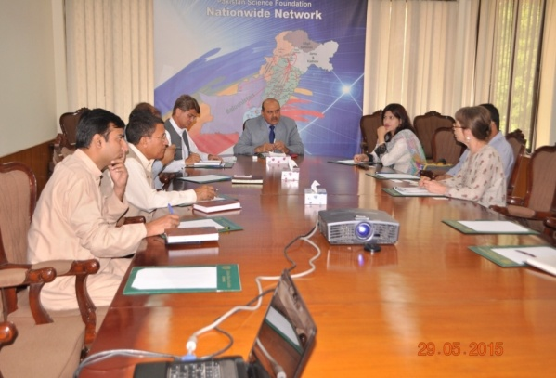
    - PSF-UNESCO Executive officials meeting for the collaboration in science education
Prof. Dr. Muhammad Ashraf, Chairman PSF held meeting with Mr. Muhammad Raza Shah, National Professional Officer, UNESCO, Pakistan at PSF office on May 29, 2015. Senior officials of PSF and Director PMNH/Focal Person for UNESCO’s Man and Biosphere (MAB) Program in Pakistan were also present on this occasion. During this meeting matters pertaining to developing science kits for science laboratories of rural areas schools jointly by PSF and UNESCO to strengthen science-base in Pakistan, MAB program and the project of biosphere conservation in Afghanistan jointly by UNESCO and PSF also came under discussion.

    - Meeting of PSF and US Embassy officials for the strengthening of Pak-US Cooperation in Science and Technology

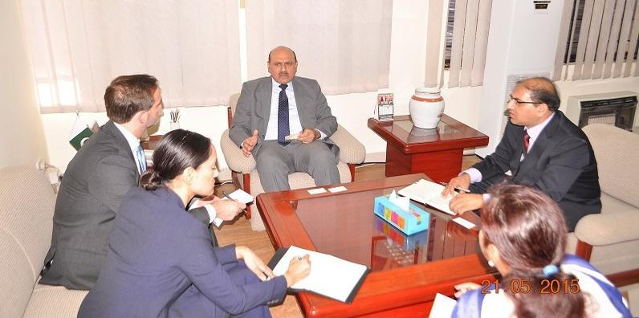
A three-member US Embassy team called on Prof. Dr. Muhammad Ashraf, Chairman PSF on May 21, 2015 to discuss Pak-US collaboration for promotion of science and cooperation in scientific research and promotion of science and technology. Dr. Ashraf informed the US Embassy officials about the mandate and spectrum of PSF for international collaboration. He briefed them about PSF’s different programs such as Research Support, R&D Industry and Natural Sciences Linkages Program (NSLP). The matters pertaining to cooperation between PSF and US National Science Foundation, National Academy of Sciences and the Rockefeller Foundation etc. came under discussion.

    - Chairman PSF visited Ambassador of Turkey office for meeting

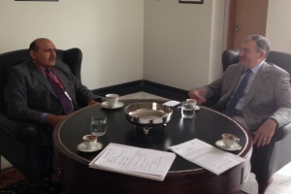
Prof. Dr. Muhammad Ashraf, Chairman PSF, held a meeting with H.E. Sadik Babür Girgin, Ambassador of Turkey at the Turkish Embassy on April 17, 2015, i.e. Friday. Dr. Mirza Habib Ali, PSF’s Focal Person for International Linkages and R. Demet Sekercioglu, Deputy Head of Mission also attended the meeting. The PSF Chairman and the Turkish Ambassador discussed initiation of joint research projects by the Foundation and TUBITAK. The Turkish Ambassador assured the PSF Chairman that he would extend his full support in developing and strengthening the science and technology linkages between the two brotherly countries.

    - Agricultural Counselor, (USDA) meet Chairman PSF
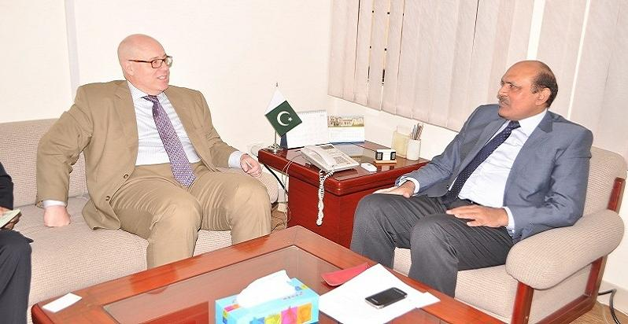
Agricultural Counselor, Mr. David J. Williams, Agricultural Counselor, Foreign Agricultural Service, US Department of Agriculture (USDA), Embassy of United States of America, visited chairman PSF on 3rd of April, 2015 and had a formal meeting with Prof. Dr. Ashraf, Chairman, PSF aimed at launching some new joint initiatives in the various fields of science. Dr. Ashraf briefed him about PSF’s different programs such as Research Support, R&D Industry and Natural Sciences Linkages Program (NSLP) and appreciated the US contribution for promotion of science in Pakistan, especially in the field of agriculture. Mr. William extended his full support to the visit saying that they would facilitate it by figuring out the right persons for meetings in the US in order to boost the cooperation in S&T.
    - Meeting of Chairman PSF with Scientific and Higher Education Attache, Embassy of France
Mr. Alban Schwerer, Scientific and Higher Education Attache, Embassy of France visited on PSF and held a meeting to identify priorities and common interests of Pakistan and France in the field of science with Chairman, PSF on March 27, 2015. Both sides discussed collaboration in joint research projects and post-doctorate scholarship programs. They also discussed announcing calls for research proposals and post-doctorate scholarship programs through the platform of PSF so that the information may reach to maximum people.
    - Meeting of Manager Higher Education and Skills, British Council, Pakistan with Chairman, PSF

Prof. Dr. Muhammad Ashraf, Chairman, PSF conducted a meeting with Ms. Sarah Parvez, Manager Higher Education and Skills, British Council, at Pakistan Science Foundation on March 27, to discuss about the joint venture in research and other areas of collaborations. Possibilities to increase in number of Pakistani students participating in London International Young Scientists Forum (LIYSF) held annually in UK was also came under the consideration during the meeting. It is also decided during that discussion that Prof. Dr. Muhammad Ashraf, Chairman, PSF, will join the British Alumni Association as an Ambassador.

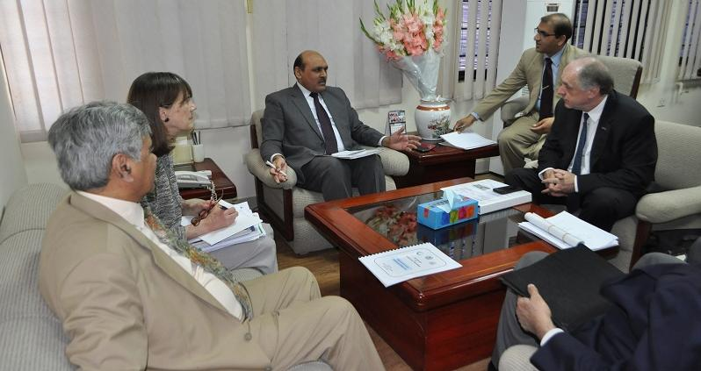
Austrian Nobel Laureate visited Pakistan Science Foundation
Austrian Nobel Laureate Prof. Dr. Pavel Kabat, Chief Executive Officer, International Institute for Applied Systems Analysis (IIASA), Austria, who is a co-recipient of Nobel Peace Prize 2007 and a Member of Steering Committee for EU Research Program Horizon 2020, visited Chairman, PSF office along with Dr. Margaret Goud Collins, Secretary IIASA on March 19, 2015 and meet Pr. Dr. Muhammad Ashraf, Chairman, PSF. Prof. Dr. Ashraf briefed the Chief Executive Officer IIASA about the PSF activities and scope. PSF’s Natural Sciences Linkage Programme and R&D Industry Programme also came under discussion. The Foundation’s international collaboration with France, UNESCO and Science Academies was also discussed. It was decided during the discussion that PSF will focus on internationalization. It was also decided that PSF and IIASA will jointly work for capacity building of Pakistani scientists through international trainings.

Chairman PSF, visited UNESCO, Pakistan Office
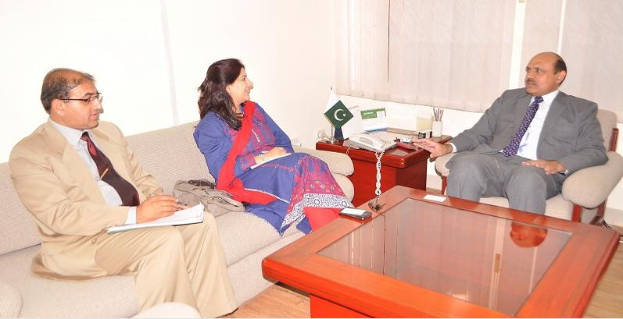
Prof. Dr. Muhammad Ashraf, the new Chairman of PSF, visited UNESCO Pakistan on March 17, 2015 to hold a formal meeting with Ms. Vibeke Jenson, who also has recently joined as the Country Director UNESCO Pakistan. Pakistan Science Foundation and UNESCO have a longstanding collaboration to promote science culture in the country. Different aspects were come under consideration during the meeting. During their meeting it was decided that UNESCO will provide science kits for rural area schools to strengthen their laboratories. These kits will be distributed to schools through PSF. Both the sides also reviewed the ongoing collaborative initiatives such as Man and Biosphere (MAB) programme and celebrations of World Science Day etc. The UNESCO Country Director assured the Chairman PSF of her full support to promote cause of science popularization in Pakistan.
4.2.10 Deputy Head of EU Delegation to Pakistan visited Chairman PSF office
Mr. Stenfano Gatto, Deputy Head of EU Delegation to Pakistan, visited Pakistan Science Foundation to hold formal meeting with Prof. Dr. Muhammad Ashraf, Chairman PSF on March 11, 2015. Both the sides discussed future plans such as establishment of PSF as a National Contact Point (NCP) by the Ministry of Science and Technology (MoST), arranging awareness seminars for scientists, engineers and techno-preneurs at Peshawar, Quetta and Karachi as well as submission of joint research proposals to EU. They also discussed other areas of cooperation to promote science in the country.

II. PAKISTAN MUSEUM OF NATURAL HISTORY (PMNH)

Pakistan Museum of Natural History (PMNH), a subsidiary organization of Pakistan Science Foundation. It has four principal divisions namely, Botanical Sciences Division, Zoological Sciences Division, Earth Sciences Division and Public Services Division. The first three divisions are engaged in the collection, identification and research activities related to plants, animals, fossils, rocks and minerals resources of Pakistan respectively; while the latter is responsible for mass education and popularization of natural history.
- Natural History Research
Pakistan Museum of Natural History (PMNH) has four principal divisions namely Earth Sciences Division, Botanical Sciences Division, Zoological Sciences Division and Public Services Division. First three scientific divisions are engaged in the collection, identification and research activities pertaining to plants, animals, fossils and mineral resources of Pakistan, while the fourth one is responsible for mss education and popularization of natural history through various displays, exhibits and dioramas. Researchers of PMNH carried out extensive field works from the Coast of Arabian Sea to the Alpine regions, roamed through barren areas for the collection of Flora & Fauna, Rocks, Fossils and minerals not only for research work but also for the purpose of education because education is also one of the main objectives of PMNH. For this purpose, PMNH regularly organized trainings, workshops, seminars, symposiums and other educational interactive activities related to natural history, environment and Biodiversity of Pakistan. International days also been observed. PMNH has formed many national and international liaisons with the other research institutes in the country and from abroad. Due to these collective efforts of scientific and technical staff of PMNH and relations with other research institutions, PMNH has 650,000 natural history specimens in its repositories. Research outcome of these field works and National and International projects are published in the form research papers in reputed national and international journals.

  - Botanical Sciences Division
1.1.1 Field Work:

- Field visit to Changa Manga area for the collection of the higher plants including the medicinal and economically important plants from 26-02-2014 to 07-03-2014.
- Collected, Identified and curated 204 higher plants from GilgitBaltistan area during the field visit to the GB area from 17-10-2014 to 24-10-2014.
- Collection, identification and Curation of the higher and lower plants flora from AJK and Sindh area in the months of August and September 2015.
- Carried out 3 days’ field work in Sargodha and adjacent areas and collected 90 plant specimens.

1.1.2 Laboratory Work:

- Identification, Cataloguing and Curation of 3500 higher plants (Angiosperms), 6000 mycology and 4000 phycology specimens at the higher and lower plants herbarium respectively.
.
1.1.3 National Collaborative Projects:

- Baseline studies of CKNP (Central Karakoram National Park, Gilgit-Baltistan) under the MAB program.
- Baseline studies of algae/phytoplankton and aquatic vegetation of Jhelum and Neelum Rivers, AJK through HaglerBailly Pvt. Ltd.

    - Publications:
International:

- Gilani S.A., Khan A. M., Qureshi R.A., Sherwani S.K., Khan R. U &Bokhari T. Z. (2014). Ethno-Medicinal Treatment of Common Gastrointestinal Disorders by Indigenous People in Pakistan. ADVANCES IN BIORESEARCH Volume 5(1) march 2014. ISSN 2277-1573 Print ISSN0976-4585.
- Shabeena, Khan R. U., Mehmood S., Sherwani S. K., Khan S. U.,Gilani S. A. &Ullah H. ( 2014)Morpho-Anatomical Study & Classification Of Trichomes In Prominent Selected Plants Of University Of Science And Technology, Bannu. ADVANCES IN BIORESEARCH. Volume 5(1) march 2014. ISSN 2277-1573 Print ISSN0976-4585.
- Ullah H., Khan U.R., Khan S.A., Mehmood S., Sherwani S.K., Muhammad A., Gilani S.A., Ullah H. & Muhammad Y. (2014)Estimation of Induced Variability of Yield Contributing Traits in M1 gamma Irradiated Germplasm of Okra (AbulmoschusEsculentus L.). South Asian Journal of Life Sciences. 2 (1): 4 – 7. http://dx.doi.org/10.14737/journal.sajls/2014/2.1.4.7.
- SumairaSahreen, Khan MR, Khan RA. 2014. Effects of Carissa opaca fruits extracts on oxidative pulmonary damages and fibrosis in rats. BMC Complementary and Alternative Medicine, 14:40 (impact factor 2.08).
- SumairaSahreen, Khan MR, Khan RA. 2014. Comprehensive assessment of phenolics and antiradical potential of Rumexhastatus D. Don. Roots.BMC Complementary and Alternative Medicine, 14:47 (impact factor 2.08).
- Khan RA, Khan MR, SumairaSahreen,Bokhari J.2014. Protective effects of Launaeaprocumbensagainst oxidative adrenal molecular, hormonal and pathological changes in rats Journal of Medicinal Plants Research, 8(3):162-166 (impact factor 0.879).
- SumairaSahreen, Khan MR, Khan RA, Alkreathy H. 2014. Cardioprotective role of leaves extracts of Carissa opaca against CCl4 induced toxicity in rats. BMC Research Notes. 7:224 (impact factor 1.39).

Popular articles:
- Articles published in “Technology Times” entitled “Edible Mushroom in Pakistan” by Ms. SaadiaMunir, published in 1-April: vol. 5, issue 13.

    - Seminars/Trainings/Workshops/Organized:

- Organized and conducted one day training on dendrochronology on 22-04-2014 at PMNH organized by botanical sciences division. Chairman PSF was the guest of Honour. 50 students and faculty members participated in the event. The participants were from NUST, Quaid-i-Azam University, Islamic International University, PMAS Arid University and Abdul Wali Khan University, Mardan. Prof. Dr. Moinuddin Ahmed (Foreign faculty professor at department of botany federal Urdu university of arts, science and technology, Karachi) was the resource person of the workshop he guided the students about the field of dendrochronology along with the collection of the dendro sample from the field.
- Attended the 4th National Conference on Training of Trainers titled “Botanical Gardens-A Vehicle for Implementation of Convention on Biological Diversity (CBD)” as resource person held at Baragali Summer Campus, University of Peshawar from June 10-12, 2014.
- Attended the one day science excel camp in collaboration with PSF and Intel Education initiative at IMCG as mentor/resource person for biology.
- Attended as invited participant the Pathways to sustainable development (17th sustainable development conference) organized by Sustainable Development Policy Institute SDPI at Best Western Hotel Islamabad from 09-11 Dec. 2014.
- Attended and presented the paper entitled “Floral Diversity of Changa Manga Forest and Surroundings with special reference to the species having medicinal and socio-economic benefits.” At the 3 days International Conference on Plant Sciences from 22-24 Sept. 2014 at GC. University, Lahore as invited / guest speaker.
1.1.6 Seminars/Trainings/Workshops/Attended

- PMNH organized and Celebrate 12th International Biodiversity Day on 22nd May, 2014 in which 160 students from Rawalpindi and Islamabad participated along with international organizations/NGOs.
- Earth Science Division arranged training program “Relief Map Study Activity” in connection with Celebration of Biodiversity Day on 22nd May, 2014. 120 students from eleven Schools of Islamabad and Rawalpindi participated in this event.
1.1.7 National/international collaboration /Liaison

- Display being prepared at BSD donating Ms. KhajistaFarhat Ghazi at BSD display gallery.
- Held discussions with the official and personnel from Shijiazhuang Yiling Pharmaceutical Co. Ltd. China headed by Mr. Danny Gao (Regional Manager) International Business Dept.
1.1.8. Services Rendered to Other Organizations
- Dr. S. AneelGilani attended the GEC meeting of the Ph.D scholar Ms. Sadia Malik at ASAB, NUST as External Member.
- Identified 80 algal species for Department of Botany, University of Azad Jammu and Kashmir.
- Identified 15 higher plant specimens for a student of Hazara University, Mansehra, and 40 for a student of Punjab College for Information Technology, Rawalpindi.
- Guided one M. Phil. student as co-supervisor from PMAS Arid Agriculture University, Rawalpindi.
- Identified 103 higher plant specimens for 3 B. Sc. students from Punjab College of Information Technology, Rawalpindi.
- Facilitated students from Hazara University about collaborative research on macro fungi.
- Guided one M. Phil and two Ph.D. research scholars from NUST, University Islamabad.
- Participated in 2 days’ event of Alumni Association Network AAN farmer share Mela jointly organized by FAO and NARC Islamabad.
- Continued supervising an internee of BS level student on the subject of “popular article and research paper writing”.
- Evaluated answer books of 104 M.Sc. Botany students of Peshawar University.
- Participated in 2 days’ event of Alumni Association Network AAN farmer share Mela jointly organized by FAO and NARC Islamabad.
- Continued supervising an internee of BS level student on the subject of “popular article and research paper writing”.
- Evaluated answer books of 104 M.Sc. Botany students of Peshawar University.
- Provided training to an internee of BS level student from COMSATS on “popular article and research paper writing”.
- Guided a team of American academicians through the PMNH galleries.
- Facilitated M. S. students from INAM, Islamabad.
- Briefed FAO representatives visiting PMNH.
- Guided International delegates from National Testing Service Pakistan
- Briefed visitors in PSF stall at National University of Science and Technology, Islamabad.
- Guided two professors from Sindh University Jamshoro through the display galleries and Herbaria.
- Guided 150 M.Sc. students of University of Peshawar along with their teachers on PMNH display/ Herbaria.
  - Earth Sciences Division
1.2.1 Field Work:

- Scientists of Earth Sciences Division carried out field works in different areas of Salt Range, Hazara, lower Indus basin and Kala Chitta Ranges, collected almost 1200 rocks, minerals and fossils specimens for ESD Reference Collection and Display.
- Carried out one day field work on 27th June, 2014 in the Muzaffarabad, Azad Kashmir and have collected 70 specimens of hard rocks
- Mr. Hamad-ur-Rahim provided a guided tour of Muzaffarabad and adjoining areas of Azad Kashmir to the 57 students and newly appointed Faculty of Department of Geology, University of Haripur from 20-04-2015 to 24-04-2015 in connection with MoU signed between the two organizations

1.2.2 Laboratory Work:

- Identified and catalogued 1665 fossil samples and 250 rock samples.
- Catalogued and digitized 55 Brachiopod and 30 Gastropod fossils.
- Took digital photographs of 412 fossil specimens.
- Entered data of 893 fossils and10 hard rock specimens in BGN data base.
- Prepared tables for Comparative studies on Enamel Hypoplasia data of Rhinocerotidae from the Neogene Siwaliks of Pakistan.

1.2.3 Publications:

National:
      - Kamran Mirza, ShahidJamilSameeni, SohailAkram and *AamirYaseen. 2014. Nummulites from the kohat formation, Northern Kohat basin, Himalayan fold and thrust belt, northern Pakistan. Sci. Int.(Lahore), 26(5),3039-3043,2014 ISSN 1013-5316; CODEN: SINTE 8 3039.
      - Research Paper entitled “Upper Paleocene Larger betnonic foraminifers of Lockhart Limestone from Western and Central Salt Range, Pakistan” has been published in Science international Journal Lahore by Mr.AamirYaseen, Associate Curator, ESD. Vol 27(2), pp1315-1319, 2015.

International:

      - Abstract published: G. Roohi, S. M. Raza, and M. Akhtar. 2014. Dental hypoplasia in Siwalik Rhinos: additional information on Neogene climate of South Asia. Proceedings/Abstract Book of 29th Himalayan-Karakorum-Tibet (29 HKT) Workshop Lucca, Italy, 2-4 September 2014.
      - Dr. Ghazala Roohi paper published in International Jouranal titled “ vegetation history across the Permian-Triassic boundary in Pakistan( Amb Section, Salt Range). 2015. ElkeSchneebeli-Hermanna , Wolfram M. kurschner, Hans Kerp, Benjamin Bomfluer, Hugo Bucher , David Ware, Ghazala Roohi. Gondwana Research 27(2015) 911-924.
Popular article:
- Article entitled “Reservoir rocks play an important role to economy” published in Technology Times Weekly newspaper.

1.2.4. Seminars/Symposia/ Training/Workshop Organized:

- Earth Science Division organized 3 Days Training Workshop on Gemology & Computer Aided Jewelry Designing on Matrix Software from 17th to 19th of November, 2014. This 3 days Training Workshop is organized by the Pakistan Museum of Natural History, Islamabad in collaboration with Jewelers Association, Rawalpindi, Pakistan Gems & Jewelry Development Company (PGJDC) and University of Haripur, Hazara (UoH). 75 participants from jewelers, professionals and organizations along with the students of University of Haripur, Hazara (UoH) participated in the workshop.
- Arranged one day training for students on Relief Map Study in connection with Celebration of Biodiversity Day on 22ndMay, 2014. 120 students from eleven Schools of Islamabad and Rawalpindi participated in this event.
- All ESD, BSD, ZSD Scientists organized and attended symposium on “Biodiversity for sustainable development” on occasion of International Biodiversity Day Celebrations on 22 May 2015.

1.2.5. Seminars/Symposia/ Training/Workshop Attended:
- Dr. Ghazala Roohi Attended and presented research work entitled “Dental hypoplasia in Siwalik Rhinos: additional information on Neogene climate of South Asia” in 29th Himalayan-Karakorum-Tibet (29 HKT) Workshop Lucca, Italy, 2-4 September 2014.
- Mr. Khalid Ahmed Mirani and Mr. AshfaqSolangi received training of advance equipment and Field at University of Sindh, Jamshoro from 16-06-2014 to 15-07-2014.
- Arranged Paleontology/Geology seminar and earth quake activity program by ESD scientists for students of Department of Geology, University of Haripur under the umbrella of MOU signed between two organizations on 26th Feb 2015.
- Dr. Ghazala Roohi , Visited USA as a team leader of 8 talented Pakistani Students for participation in Intel Science and Engineering Fair 2015, in Pittsburgh , Pennsylvania from 09May 2015 to 17 May 2015. One of Pakistani student Mr. Habab got 3rd position on his project entitled “Multipurpose Smart Solar System” in the category of Physical and Energy.

1.2.6. National/international Collaboration /Liaison

- Pakistan Museum of Natural History and Centre for Pure and Applied Geology, University of Sindh, Jamshoro have signed a Memorandum of Understanding on 31 May 2014 for cooperation in the field of Geology/Paleontology for mutual collaboration on research and education, training of scientists, information sharing, holding of exhibition/ workshop/ conferences/ symposia/ seminars and joint research projects.
- MOU has been signed between Geology Department, University of Haripur and ESD, PMNH on 31st October 2014 at PMNH for research collaboration.
1.2.7. Display Work:
- Rock Garden, which displayed the different types of rocks founds in Pakistan in different regions, is inaugurated by the Vice Chancellor of University of Haripur, Hazara on 31st October, 2014.
- Displayed wood fossils and minerals in the galleries of Earth Science Division.
- Prepared brochure for Baluchitherium.
- Prepared display write-ups of rock & mineral specimens for display in Urdu & English.
- Rearrangement of Gemstone Gallery was done by replacement of previous showcases and addition of new collection in the newly built Showcases.

1.3. Zoological Sciences Division
1.3.1. Field Work
- A joint team of ZSD scientist and French researcher from French Entomological Society, Paris get started a field work at Deosai National Park, Skardu, from 15th June-15th July, 2015.
- Carried out one week field work of LalSohanra Biosphere Reserve in September, 2013 under UNESCO-MAB Pakistan Programme.
- Collected 160 specimens of beetles and butterflies from Neelum valley, AJ&K.
- Collected30 fish,16 marine snakes and 45 insects.
- Received heads of Urial and Black buck, one specimen of Pelican.Received and cataloged one dead specimen of Hog Deer,Barking Deer fromMaraghzar Zoo, Islamabad and one dead specimen of Lion from Lui-Bhair Wildlife Park, Rawalpindi.
- Skinned a Lion, Hog Deer and Leopard.
- Prepared GIS distribution data of 59 species and Journal MAP developed.
- Collected 148 Carabid beetle specimens from pitfall traps and collected onother24 insects/butterflies from Islamabad. Collected 20 insects from local area Islamabad.

    - Laboratory Work
- Identified100 butterflies, 90 larger benthic foraminifera, 83 fruit flies, 45 lizards and snakes, 25 mammals, 08insects, 60 fishes,23 crabs, 13 beetles, 11 insects.
- Identified and catalogued 200 lizards/ snakes, 03 birds and 29 small mammals, 25 rodent specimens.
- Catalogued2000 butterflies, 612 insects, 15 mammals, 83 fruit flies, 75 lizards, 10 snakes
- Digitized 50 fishes, 1410 insects, pinned 120 insets, 70 lizards, 90 snakes, 10 marine fishes.
- Identified and prepared checklist with IUCN and CITES status of avian fauna recorded from Central Karakuram National Park.
- Took morphometric data of 65 specimens of Laudakia species.
- Preserved skin of Shark and Elephant.
- Entered data of 1765 insects and 74 other animal samples in the BGN database.
- Computerized tagging of 500 beetles, arranged 750 photographs of insects.
- Stuffed 02 Blackbucks, 01 Pelican; 01 pigeon; processed 3 skeleton heads and prepared 3 mammals for study skin; cleaned and tanned a zebra skin, 5 birds and 2 large animals, worked on the skin of elephant and 40 ftWhale Shark.

1.3.3 National Research Project
  - Carabidae of Northern Pakistan (continued).

1.3.4 Collaborative Research Project
- Organized 2nd National MAB Committee meeting held in PSF, Islamabad on 27th August, 2013.
- Submitted nomination form for hosting regional node by PMNH for Future Earth programme.
- Attended scientific conference on Karakoram Resources and Climate Change: Glacier, Water and Ecosystem” dated 10th September 2013 organized by Ev-K2-CNR
- Participated in an ongoing project to revise FAO fish identification guide of Pakistan at Karachi during 7-12 October 2013 with the collaboration of Marine Fisheries Department of Pakistan.
- Gave comments on proposed rule to reclassify Straight-Horned Markhor by United States Fish and Wildlife Services requested by Climate Change Division, Cabinet Secretariat.
- Submitted the report to MoST regarding MoUto be signed between PMNH and Natural History Museum of Florence University, Italy

1.3.5. Publications:
National:
- Amir, S. A., Siddiqui, P. J. A., and Masroor, R. 2014. A New Sparid Fish of Genus Sparidentex (Perciformes: Sparidae) From Coastal Waters of Pakistan (North Western Indian Ocean). Pakistan Journal of Zoology, 46 (2): 471-477.

International:
- Siddique P.J., Amir S. A. and Masroor R. (2014). The Sparid Fishes of Pakistan, With New Distribution Records” in Zootaxa3857 (1): 071–100.
- Siddiqui, P.J.A., Amir, S.A. and Masroor, R. 2014. The sparid fishes of Pakistan, with new distribution records. Zootaxa, 3857 (1): 071-100.
- Natalia B. Ananjeva, Evgeny A. Golynsky, SeyyedSaeedHosseinianYousefkhani, and RafaqatMasroor. 2014. Distribution and Environmental Suitability of the Smallscaled Rock Agama, Paralaudakiamicrolepis (Sauria: Agamidae) in the Iranian Plateau. Asian Herpetological Research, 5(3): 161-167.
- Schutze, M.K., Mahmood, K., Pavasovic, A., Bo, W., Newman, J., Clarke, A.R., Krosch, M., and Cameron, S. 201.4 One and the same: integrative taxonomic evidence that the Bactrocerainvadens (Diptera: Tephritidae), is the same species as the Oriental Fruit Fly Bactroceradorsalis. Systematic Entomology. DOI: 10.1111/syen.12114:1-15.
- Schutze M.K., Aketarawong N., Amornsak W., Armstrong K.F., Augustinos A., Barr N., Bo W., Bourtzis K., Boykin L.M., Cáceres C., Cameron S.L., Chapman T.A., Chinvinijkul S., Chomič A., De Meyer M., Drosopoulou E.D., Englezou A., Ekesi S., Gariou-Papalexiou A., Hailstones D., Haymer D., Hee A.K.W., Hendrichs J., Hasanuzzaman M., Jessup A., Khamis F.M., Krosch M.N., Leblanc L., Mahmood K., Malacrida A.R., Mavragani-Tsipidou P., McInnis D.O., Mwatawala M., Nishida R., Ono H., Reyes J., Rubinoff D.R., San Jose M., Shelly T.E., Srikachar S. Tan K.H., Thanaphum S., Ul Haq I., Vijaysegaran S., Wee S.L., Yesmin F., Zacharopoulou A. and Clarke A.R.2014. Synonymization of key pest species within the Bactroceradorsalis species complex (Diptera: Tephritidae): taxonomic changes based on a review of 20 years of integrative morphological, molecular, cytogenetic behavioural, and chemoecological data. Systematic Entomologydoi: 10.1111/syen.12113:1-16.

1.3.6 Seminars/Symposia/ Training/Workshop Organized
- ZSD organized 6th SACAM meeting on 3rd-5th December 2014.
- Organized training workshop on Taxonomy and Biology of fruit flies (Diptera: Tephritidae) on 25-02-2015 at PMNH
- ZSD scientists including Dr. Muhammad Rafique, Dr. Khalid Mahmood, Dr. Syed Aneel Ahmad Gilani, Mr. Rafaqat Masroor gave presentation on Illegal trade of different animal, plants and fossils groups at the technical session of World Wildlife Day Celebrations on March 3rd 2015
- Celebrated the 12th International Biodiversity Day on 22nd May, 2014 in which 160 students from Rawalpindi and Islamabad participated along with international organizations/NGOs.

1.3.7 Seminars/Symposia/ Training/Workshop Attended
- Dr. Khalid Mahmood, Curator ZSD delivered a presentation entitled “Resolution of Oriental Fruit Fly Complex and Fruit Fly Situation in Pakistan” in a seminar held at BahauddinZakariya University Multan on 14th April 2015.
- All ESD, BSD, ZSD Scientists organized and attended symposium on “Biodiversity for sustainable development” on occasion of International Biodiversity Day Celebrations on 22 May 2015.Director, ZSD delivered presentation “Biodiversity in Pakistan the Post-2015 discussions” on National Youth Forum on Mountain Issues and Post 2015 Development Agenda, program organized jointly by the APYTF/ICIMOD, and MGPO in Islamabad Hotel.
- Attended 12 days training course on Project Identification, Appraisal and Approval, Implementation Methodologies/MS Project/Development of KPI’s”organized by Ministry of Planning, Development and Reform (Planning Commission of Pakistan) at Pakistan Planning and Management Institute (PPMI), Islamabad.
1.3.8. National/international collaboration /Liaison
- Collaboration is being in progress between MAB-Pakistan and UNESCO-Afghanistan for capacity building of Afghanistan’s National Environmental Protection Agency regarding activation of MAB Programme is Afghanistan.
- Country Focal Person MAB-Pakistan / Director ZSD participated in Training workshop as resource person on “UNESCO’s Man and Biosphere Programme-Processes, Challenges and Opportunities for Sustainable Development” held at UNESCO Office, Kabul Afghanistan from 7th -11th June 2015. This training workshop was arranged for capacity building of NEPA Afghanistan regarding Man and Biosphere Program.

1.3.9 Services Rendered to Other Organizations
- Participated for review of Identification guide of Field guide of fishery purposes of Pakistan with FAO consultant.
- Assisted French scientist Dr. Pages in identification of butterflies of insect repository of PMNH.
- Working on a publication on Oriental fruit fly Bactroceradorsalis in collaboration with Dr Mark Shultze of QUT, Brisbane.

1.4 PUBLIC EDUCATION AND DISPLAY (Public Sciences Division)
1.4.1 Exhibits developed/organized
- Rock Garden Display Work: conducted one day tour to Bagh Area, AJK for collection of different Rocks samples
- Designed Banners (stage, road side, smart banner and AV Hall) and invitation card for celebration of International Biodiversity Day on 22nd May 2014.
- Virtual Orientation Gallery (VOG) Kaosic has been prepared and uploaded in PMNH Website. (www.pmnh.gov.pk)
- Designed MAB (Pakistan) logo & website design.
- Carried out composing and layout designing of PSF Newsletters.
- Designed Invitation card, backdrop for MoU signing Ceremony between PMNH and University of Haripur.
- Renovation/Retouching of worn out paintings in Palaeo Gallery.
- Designed stage banner, smart banner, hanging banner and invitation card for MoU signing Ceremony between PMNH and French Museum of Natural History on July 2014.
- Participated in the Science & Technology Exhibition 2014 along with PSF and PASTIC arranged by the Ministry of Science & Technology (MoST) in association with Punjab Sports Board held in the Expo Centre, Lahore.

1.4.2 Important Visits to PMNH

- 14 Members Chinese Delegation of Chinese Academy of Sciences visited PMNH on 21st December 2014
- 7 Members Foreign Delegation of 6th SACAM meeting MAB programme visited PMNH on 5th December, 2014
- Participant of 3-days Workshop on “Gemology and Computer Aided Jewelry Designing on Matrix Software” also visited display galleries.
- V.C University of Haripur along with senior officers visited PMNH display galleries in November, 2014.
- Pakistan Atomic Regulatory Authority (International delegation) visited PMNH display galleries on 04-05-2014.
- Vice Chancellor, University of Sind, Jamshoro visited PMNH displays on 15-05-2014.
- Mr. Shabbir Khan, Advisor to PM for Science & Technology, visited PMNH on 20th March, 2014.
- Two members of Netherlands delegation comprising on Mr. MarthRurrda and Mr. MenhMoelauds visited PMNH on 18th January 2014.
- Mr. Mohamed Masud Khan Honorary Consul General of Lithuania visited PMNH display galleries.
- Mr. KimmoLeva, Secretary General Finnish Museum Association visited PMNH displays.
- Representatives of Japanese Embassy visited PMNH in connection with Audio-visual Equipment.
- ECOSF BOT members visited PMNH display galleries.
- A Chinese delegation headed by President of Lanzhou University, China, Prof. Dr. Wang Cheng visited PMNH display galleries on September 30, 2015.
- A Turkish delegation visited PMNH display galleries on 15-10-2015.
- American Embassy Pakistan delegation visited display galleries on 30-10-2015.
- Secretary MoST visited PMNH display galleries on 16-11-2015.
- A Chinese media person’s delegation visited PMNH display galleries on 24-11-2015.
- Senator Ch. Tanveer Khan visited PMNH display galleries on 27-11-2015.
- A total 2, 73,726 persons visited the museum galleries including 1, 36,537 students, 93,525 general public 554 foreigners and 43,113 children’s less than 12 years.

    - Educational Services

- Briefed PTV on PMNH display and research activities.
- Facilitated the students of International Karakorum University, Gilgit-Baltistan.
- Guided teachers group from PMAS Arid Agriculture University, Rawalpindi.
- Guided a group of 04 members from Wheat Research Institute.
- Facilitated Geo TV team during preparation of PMNH documentary on 14th September 2013.
- During this quarter student groups from various Universities, Schools & Colleges from all over Pakistan visited PMNH display galleries. PMNH provided them technical guidance and arranged film shows.
- Helped COMSATS internee students regarding the fish repository of PMNH. Preparation of Brochure for PMNH Service Promotion Desk for Incubation Centre is in progress. Developed and Uploaded new web of MAB project and updated MAB web regarding the schedule of meetings (www.mab-pak.org).
- Updated PMNH News at PMNH web portal. (www.pmnh.gov.pk).
- MAB Pakistan Website has been developed and uploaded in PMNH Website. (www.pmnh.gov.pk).
- Facilitated the visit of staff/students of Punjab University Lahore.
- Guided teachers Educators of Rawalpindi Division of Punjab Education department through display galleries of PMNH.
- Facilitated PhD student from Quaid-e-Azam University, Islamabad.
- Briefed about the PMNH galleries to groups of students from Fatima Jinnah Women University Rawalpindi and University of Gujarat students/staff.
- Students from various schools, colleges and universities of maony parts of the country visited PMNH. Some of these are Institute of Geology Kashmir University Muzffarabad, Fauji Foundation Model School Abbottabad, Imperial International School & College, Islamabad, Fauji Foundation Model School Kohat, Faran Academy Mardan, New Age Scholars Science College Kotly AJK, Tamir-e-Millat School Peshawar, Balochistan Residential College Khuzdar, Balochistan, Punjab Group of college Haripur, Punjab Group of Colleges Gujar khan, NFC IEFR Faisalabad, AmnaBint-ul-Huda Educational Institute Murree, Govt. Girls High School SainthaKallarSyedan, The Citizen Foundation School Dhok Choudrian Rawalpindi, Holy Family School of Nursing, Rawalpindi, The Lasanians School Rawalpindi, Fauji foundation Model School Kahuta, Fauji Foundation Model School Mang (AJK), Iqra Education Academy Peshawar, Peshawar, Dar-e-Arqam High School Samundri, Faisalabad, PMAS-Arid Agriculture University, Rawalpindi, University of Hiripur, University of Wah, WahCantt., Quaid-i-Azam Public Sec. School Hazro, Attock, Govt. Vocational Training Institute for Women, Daska, Dawah Academy, Unique Educational Academy Rawalakot AJK, Women branch International Islamic University, Islamabad Startwell Education Rawalpindi, GDGC No1 Abbottabad. These students were facilitated with the guided tour and video documentaries shown on a large screen.

1.4.5 Number of Visitors to Display Galleries
- During the year a total of a total 2, 73,726 persons visited the museum galleries including 1, 36,537 students, 93,525 general public 554 foreigners and 43,113 children’s less than 12 years.

III. PAKISTAN SCIENTIFIC & TECHNOLOGICAL
INFORMATION CENTRE (PASTIC)

PASTIC is an ISO 9001: 2000 Certified S&T Information Provider and is the oldest organization in the field of S&T information management and dissemination serving as a gateway for access to and delivery of global S&T information catering to the needs of the researchers in all areas of Science and Technology. Users of PASTIC services include researchers, entrepreneurs, academicians, scientists, engineers, industrialists, policy makers and planners. Collaboration with different organizations and agencies enhances the scope of information that is offered to clients and helps PASTIC to respond to the diverse needs of a broad community of users.
PASTIC National Centre is housed in its own building at Quaid-e-Azam University Campus, Islamabad with comprehensive information resources in different fields of Science and Technology. Its six Sub-Centres are working in different cities, viz. Karachi, Lahore, Peshawar, Quetta, Faisalabad and Muzaffarabad all having access to global information resources and capable of disseminating information to their users. Its sanctioned strength is 163 including Technical and Administrative Staff.
1.0 Aims & Objectives
- To acquire, process and disseminate scientific and technological information to the researchers.
- To provide bibliographic information service and document supply service.
- To interact with regional and international S&T information agencies/networks.
- To develop inter-library cooperation, resource sharing at national level.
- To train information personnel in contemporary techniques and methods of information handling.
- To develop and strengthen the National Science Reference Library.
- To compile and publish reference information publications.
2.0 Activities and Services
PASTIC is a multidisciplinary national S&T information centre and its services and activities are aimed at fulfilling needs of its users by providing the latest information in all fields of Science & Technology. The information services provided by PASTIC are those which are essential for undertaking research and development for socio-economic uplift of the country. The activities undertaken during the period, July 2013 to June 2014 are briefly described below:
PASTIC is an ISO 9001: 2000 Certified S&T Information Provider and is the oldest organization in the field of S&T information management and dissemination serving as a gateway for access to and delivery of global S&T information catering to the needs of the researchers in all areas of Science and Technology. Users of PASTIC services include researchers, entrepreneurs, academicians, scientists, engineers, industrialists, policy makers and planners. Collaboration with different organizations and agencies enhances the scope of information that is offered to clients and helps PASTIC to respond to the diverse needs of a broad community of users.
2.1 Document Procurement and Supply Service
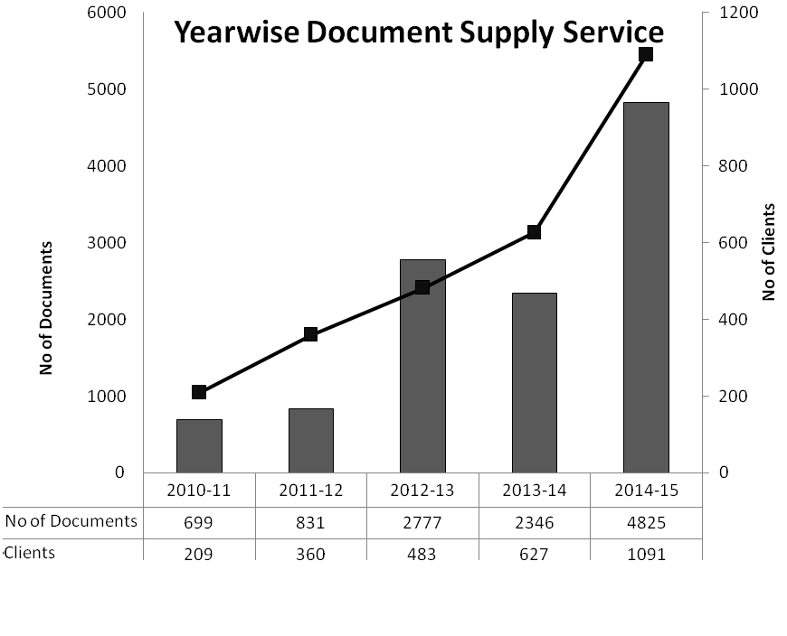
Under the Document Procurement and Supply Service, requests were received from 1091 individuals of R&D organizations for supply of reprints of research articles, conference papers, reports, etc. 4825 articles were acquired either from local sources or from abroad, and supplied to them during the year 2014-15. Under digital document supply 31292 documents in digital form (soft copies) were supplied to 1775 users.
The Union Catalogue of the S&T libraries of Pakistan compiled by PASTIC resources of HEJ, Karachi and HEC, Islamabad were mainly used for locating literature from local libraries.
For foreign procurement of articles mainly the National Library of Medicine, USA, National Library of Australia and NISCAIR, India were used. To expedite the procurement process PASTIC uses e-mail contacts so that information delivery is quick and delays are minimized. Major break up of the types of user organizations is as follow:

2.2 Bibliographic Information Service/Literature Search
Literature search is carried out for searching articles/abstracts/references by using online databases for supply to users on their request according to their research topics. A total of 723116 abstracts/references, 5128 bibliographies on various S&T topics were supplied to 4172 researchers and other users during the period under review for 2014 and 2015. PASTIC has access to international online bibliographic and full text databases through subscription and agreements with some organizations like HEJ and HEC. The subscription of bibliographic databases of PASTIC was renewed for 2015-16 for strengthening the bibliographic information service and information resources of PASTIC.
- Wilson Applied Science and Technology (Full Text)
- Biological & Agricultural Index Plus
- Wilson Social Sciences (Full Text)
- Green file
- Library & Information Science and Technology Abstracts
The following online digital resources of other organization are accessible by PASTIC and are used for this service.
- a) HEC Digital Library Resources
- Wiley-BLackwell Journals
- Taylor & Francis Journals
- Springer
- Project Muse
b)LEJ Resources, Karachi (Under MoU)
- Science Direct
- Science Finder
2.3 Abstracting and Indexing Service
a) Pakistan Science Abstracts (PSA)
PASTIC provides abstracting and indexing service by publishing an abstracting journal entitled “Pakistan Science Abstracts” in ten different scientific disciplines, which serves as a secondary information source to give support to research and development activities in the country. The scientific information generated in Pakistan or abroad and published in Pakistani S&T journals is documented in the form of abstracts along with detailed author index and keyword index in this secondary journal.
- Digitization of old data of Pakistan Science Abstracts (PSAs):
The old data of Pakistan Science Abstracts (PSA) comprising 16012 abstracts along with indexes from the Pakistan Science Abstracts of year 2003 to 2010 was entered into the database after processing. 4469 abstracts for the year 2013 and 2000+ for the year 2014 were downloaded, processed and entered into the database. Downloading and processing of abstracts for the year 2015 remained in progress. Total 21578 abstracts were uploaded over the PASTIC website for online search. 789 online searches were made by the users through this database.
  - Directory of Scientific Periodicals of Pakistan
Data of the Directory of Scientific Periodicals of Pakistan was updated and uploaded on PASTIC website for online searching. The new version of Directory of Scientific Periodicals of Pakistan 2015 was printed and published covering information of 480 periodicals of Pakistan.
2.5 Union Catalogue of Scientific Periodicals of S&T Libraries of Pakistan

PASTIC collects data of S&T journal holdings of Pakistani libraries. This data is standardized, computerized, verified and published in the form of Union Catalogue. This valuable catalogue helps the researchers the locating any S&T Journal in the Libraries of Pakistan for finding research article of their choice. This information is updated regularly. This database is also available online and during this period 16143 online searches were undertaken by the users through this database. The digitization process of printed data of the Union Catalogue of 2005 version remained in progress.
2.6 Technology Information Service
This service is rendered by Technology Information Section which is meant for dissemination of Technological Information Services to R&D Workers, Engineers, Entrepreneurs, SMEs and the Industrialists. The aim is to facilitate growth, potential and competitiveness among SMEs at national and international level, build effective coordination between R&D Sector and Industry for enhancing innovations, competitiveness and development & promotion of indigenous technologies.
During 2014-15 the following activities were carried out.
- One day Training workshops series on “Developing Industry Driven Technologies” were organized at Lahore, Faisalabad, Multan. Abbottabad, Karachi, Sargodha, Jamshoro and Nawabshah.
- PASTIC participated in 4th Invention to Innovation Summit, 2015 organized by IRP in collaboration with Pakistan Science Foundation and University of Punjab on March 4-5, 2015 at Punjab University, Lahore.
- PASTIC in collaboration with Women Chamber of Commerce and Industry Islamabad organized a Science & Technology (S&T) Pavilion under 5th Islamabad Expo 2015 at Jinnah Convention Centre, Islamabad from 18-19 April, 2015.
- A bimonthly Trade and Technology news bulletin entitled “Technology Roundup” was regularly published and six issues of this news bulletin were brought out online.
2.7 PASTIC National Science Reference Library
PASTIC National Science Reference Library is aimed at providing reference and referral services to the users and strengthening of all the services of PASTIC particularly document supply service, bibliographic information service, abstracting and indexing service, technological information service, etc. In this context strengthening of library resources, acquisition of published library material and library automation activity remained in progress. PASTIC library has built up a collection of more than 9,075 books on science and allied subjects, over 1,575 titles of national & international journals and 9,300 miscellaneous documents and reports.
During 2014-15, 7275 users/researchers visited PASTIC library for reference purpose, reading, photocopying and internet browsing. Besides, the library received 335 issues of different national and international journals, 31 miscellaneous documents, reports, etc. All this library material was processed and shelved for use. 12 issues of the library bulletin “Fresh Arrivals” of PASTIC library were regularly published on monthly basis during the period under review and distributed among relevant circles. Records of the books of the libraries of PASTIC, PMNH, and PSF were uploaded on Union Online Public Access Catalogue (OPAC) prepared by PASTIC.
A development project (PC-1) namely “Modernization of PASTIC National Science Reference Library for Effective Resource Sharing among S&T Libraries of Pakistan” was prepared and submitted, which has been approved by the DDWP at a total cost of Rs. 54.30 Million. The duration of the project is 24 months.
2.8 Reprographic Service
The Reprographic Section of PASTIC has facilities ranging from photocopying to offset printing for its own printing requirements and for providing printing services to other S&T organizations. During the year 2014-15, 134 printing jobs were carried out for 10 R&D organizations.
3.0 International Liaison Activities
PASTIC is the National Focal Point of some Regional/International Information Centres and Networks viz. SAARC Documentation Centre, WHO/CEHANET, IFAP and National distributor for UNESCO developed library management software WINISIS and IDAMS.
3.1. SAAC Documentation Centre (SDC)
SDC is a regional centre of SAARC established in 1994 at New Delhi, India for developing an effective information system of Member States for exchange of information in various fields of S&T and for developing human resource in the Member States in the area of information science, technology, management systems and services.
In this regard following activities were undertaken during the period under review
- Activities of exchange of information with SAARC Documentation Centre were carried out for fulfilling the information requirements of Scientists and R&D workers.
- The project proposal prepared for Networking and Capacity Building of Women Entrepreneurs (SMEs) of SAARC Countries was amended and got cleared from Finance Division, Government of Pakistan and forwarded to SAARC Secretariat for including the same in the forthcoming meeting of Board of Directors of SAARC Development Fund (SDF) for approval.
- Efforts were made for availing the training opportunities offered by SDC under its Human Resource Development Programme. 2 officials of Ministry of Foreign Affairs and 2 officers of PASTIC availed the training under the training opportunities offered by SDC.
- Different titles of research and abstracting journals of 2013 covering major disciplines of science and technology published by National Institute of Science Communication and Information Resources (NISCAIR) were acquired and received in PASTIC free of cost under the facility provided by SDC.

3.2 Bilateral Cooperation
A proposal for development of bilateral cooperation between National Centre for Scientific and Technical Information (NCSTI) of Kazakhstan and PASTIC is under consideration.

4.0PASTIC Information Service Stalls
Thirty five PASTIC Service Stalls were arranged at Faisalabad, Peshawar, Karachi, Quetta, Muzaffarabad (AJK), Islamabad and Lahore at various departments of different Universities and R&D Institutions on different occasions. The aim of organizing the service stalls was to provide S&T information services at the doorstep of the Universities and other institutions to facilitate faculty members, researchers and R&D workers.
Detail of these Stalls is as follows:
FAISALABAD
Sr.# | Date | Venue
1. | 20-08-14 | Ayub Agriculture Research Institute, Faisalabad
2. | 24-09-14 | Main Library, University of Agriculture, Faisalabad
3. | 27-10-14 | Faculty of Agriculture, University of Agriculture, Faisalabad
4. | 12-11-14 | Faculty of Animal Husbandry, University of Agriculture, Faisalabad
5. | 13-11-14 | Faculty of Agriculture, University of Agriculture, Faisalabad
6. | 27-11-14 | Faculty of Science, University of Agriculture, Faisalabad
7. | 03-12-2014 to 04-12-2014 | NFC Institute of Engineering & Fertilizer Research, Faisalabad
8. | 21-01-2015 to 22-01-2015 | Faculty of Agriculture, University of Agriculture, Faisalabad
9. | 28-01-15 | ORIC, Government College University, Faisalabad
10. | 11-02-15 | Faculty of Animal Husbandry, University of Agriculture, Faisalabad
11. | 12-02-15 | Faculty of Food Sciences, University of Agriculture, Faisalabad
12. | 26-02-15 | Faculty of Sciences, University of Agriculture, Faisalabad
13. | 07-04-15 | Faculty of Agriculture, University of Faisalabad, Faisalabad
14. | 08-04-15 | Faculty of Veterinary Sciences, University of Faisalabad, Faisalabad
15. | 14-04-15 | UET Lahore, Faisalabad Campus, Faisalabad.
16. | 16-04-15 | University of Faisalabad, Faisalabad
17. | 06-05-15 | National Institute of Food Science & Technology, University of Agriculture, Faisalabad
18. | 07-05-15 | Faculty of Agricultural Engineering & Technology, University of Agriculture, Faisalabad
19. | 08-05-15 | Amin Campus, University of Agriculture, Faisalabad

PESHAWAR
Sr.# | Date | Venue
20. | 21-10-14 | Institute of Biotechnology & Genetic Engineering (IBGE), Agriculture University, Peshawar
21. | 28-10-14 | Home Economics College, The Agriculture University, Peshawar
22. | 02-04-15 | Shaheed Benazir Bhutto Women University, Larama Campus- Peshawar
23. | 09-04-15 | Department of Social Work, University of Peshawar, Peshawar
24. | 12-05-15 | One day Science and Technology Exhibition at PCSIR Labs Peshawar

KARACHI
Sr.# | Date | Venue
25. | 22-10-2014 to 24-10-2014 | Mehran University of Engineering & Technology, Jamshoro
26. | 05-05-15 | Department of Applied Chemistry, University of Karachi, Karachi
27. | 19-05-15 | Dawood University of Engineering and Technology, Karachi
28. | 26-05-15 | DOW International University of Medical & Health Sciences, Karachi
29. | 03-06-15 | Sindh Madersah Tul Islam University, Karachi

QUETTA
Sr.# | Date | Venue
30. | 22-10-14 | Balochistan University of Information Technology Engineering & Management Sciences, Takatu Campus, Baleli, Quetta
31. | 17-03-15 | Department of Physics, University of Balochistan, Quetta
32 | 07-05-15 | Institute of Biochemistry, University of Balochistan, Quetta

MUZAFFARABAD
Sr.# | Date | Venue
33. | 09-10 Sept., 2014 | University of Poonch, Rawalakot

ISLAMABAD
Sr.# | Date | Venue
34. | 18-19 April, 2015 | 5th expo 2015 organized by Women Chamber of Commerce & Industry, Islamabad at Jinnah Convention Centre Islamabad.

LAHORE
Sr.# | Date | Venue
35. | 20-21 Nov., 2014 | University of Punjab, Lahore

5.0 Human Resource Development
Another important activity of PASTIC is to impart training to information professionals on computer applications for library automation and information management as well as organization of workshops and seminars on related diverse topics.
In this regard following training workshops / seminars were organized.
5.1Trainings/workshops/seminars/symposia organized:
- Peshawar Sub-Centre collaborated with IRNUM Hospital Peshawar in organizing a one day “Breast Cancer” Awareness Seminar at Bionor-Bannu on October 27, 2014.
- PASTIC Sub Centre, Peshawar collaborated with Pakistan Forest Institute, Peshawar organized a Training Course on “Range Management” from December 16th - 20th, 2014.
- A three days basic hands-on Training Workshop on “Research Tools and Techniques” (SPSS, EndNote, Research Methodology) was organized from 18-20 February, 2015 at PASTIC National Centre, Islamabad.
- PASTIC Sub Centre, Quetta arranged one day PASTIC Awareness Seminar at Faculty of Chemical Sciences, University of Balochistan Quetta, on March 10, 2015.
- A three days basic hands-on Training Workshop on “Digital Content Management” was organized from 18-20 March, 2015 at PASTIC National Centre, Islamabad.
- PASTIC Sub Centre Peshawar organized one-day awareness seminar on “Causes, Symptoms and Early Treatment of Autism” in collaboration with Shaheed Benazir Bhutto Women University, Peshawar on April 2nd, 2015 at SBBWU, Peshawar
- PASTIC organized 4th Meeting of Society for Promotion of Science on “Scientific Information Searching in Digital Age –Emerging Challenges” on April 7th, 2015 at PASTIC, National Centre, Islamabad in collaboration with Pakistan Academy of Sciences.
- A two-days workshop on “Essential Skills for New Age Information Professionals” was organized in collaboration with Mehran University of Engineering & Technology on April 15-16, 2015 at MUET, Jamshoro.
- A one-day workshop on “Intellectual Property Rights” was jointly organized by PASTIC Sub Centre, Faisalabad and University of Sargodha on May 15, 2015 at UoS, Sargodha.
- PASTIC Sub-Centre, Peshawar in collaboration with ASHRAE, UET chapter Peshawar, organized a three-days “CheMech Nova 15 Event” from May 18-20, 2015 at UET, Peshawar.
- A one day workshop on “Intellectual Property Rights (IPRs): Drafting and Filing of Patent Application” was organized by PASTIC Sub Centre, Peshawar and ORIC-University of Peshawar on June 04, 2015.
- A one day seminar on “Access to Global Information Resources through PASTIC S&T Information Services” was organized by PASTIC Sub Center, Muzaffarabad in collaboration with Mirpur University of Science & Technology at Bhimber Campus on June 17, 2015.
5.2 Meetings/Workshops/Trainings/Seminars Attended
- Dr. Muhammad Akram Shaikh, Director General, PASTIC attended a meeting at KOICA (Korean International Cooperation Agency), Islamabad on March 19, 2015.
- Prof. Dr. Muhammad Ashraf, Chairman, PSF and Prof. Dr. Muhammad Akram Shaikh, Director General, PASTIC had a meeting with the Vice Chancellor of AJK University and also visited PASTIC Sub Centre, Muzaffarabad on May 28, 2015.
- Dr. Raja Razi-ul-Husnain, Additional Director (A&F) attended a two week course entitled “Country Focus Training Program: Policy Making and Implementation for Science and Technology (Pakistan)” from October 19 to November 1, 2014 at Seoul, Korea under the technical assistance programme of Korean International Cooperation Agency (KOICA). The training course was aimed at providing government officials with insight into core elements of Science, Technology and Innovation (STI) policy planning and implementation to improve efficiency and effectiveness of public policy management
- Mrs. Rahila Khurram, Scientific Information Officer, PASTIC attended two days seminar on “Women Empowerment” at Pakistan Manpower Institute, Islamabad on February 9-10, 2015
- Mr. Usman, Web Manager, PASTIC participated in training on “Project Management” at PPMI, Islamabad on February 18-20, 2015
- Ms. Nageen Ainuddin, Director PASTIC attended a course on “Science & Diplomacy” at Trieste, Italy on June 8-12, 2015
- Prof. Dr. Muhammad Akram Sheikh, Director General, PASTIC/Member Science-PSF attended Eight one day “Consultative Workshop on Policies for Creating Enabling Environment for Encouraging Problem Solving Research” on June 11, 2015.
- Prof. Dr. Muhammad Akram Sheikh, Director General, PASTIC/Member Science-PSF attended a 42nd meeting of Board of Governors of National Center of Excellence in Analytical Chemistry at University of Sindh, Jamshoro on June 18, 2015.

5.3 Lectures/Presentations Delivered
- Dr. Muhammad Akram Shaikh, Director General, PASTIC participated as Keynote Speaker and chaired the session in 4th International Multi Topic Conference on 12-13 February, 2015 at Mehran University of Engineering and Technology, Jamshoro.
- Mr. Muhammad Usman, Web Manager, PASTIC, conducted three sessions in five days Training Workshop titled “Survey Data Analysis and Report Writing Techniques” was organized by AKH National Centre for Rural Development (AHKNCRD), Islamabad on June 11-15, 2015.
- Presentations on PASTIC activities were given to the following students and faculty members who visited PASTIC.
- 40 students and 2 faculty members of Faculty of Agriculture Sciences, Sindh Agriculture University, Tandojam visited PASTIC on November 12, 2014.
- Students and Faculty Members of Islamia University, Bahawalpur visited PASTIC on June 10, 2015.
6.0 Other Activities
- MoUs signed between PASTIC and Mehran University of Engineering and Technology, Jamshoro on October 17, 2014.

- Prof. Dr. Saleem Raza Samo, Pro Vice Chancellor, MUET, Jamshoro visited PASTIC on October 28, 2014.
- Federal Minister of Science & Technology, Mr. Zahid Hamid visited PASTIC on November 19, 2014.
- Prof. Dr. Asadullah Shah, Dean, Faculty of Information & Communication Technology, International Islamic University of Malaysia (IIUM) visited PASTIC on January 14, 2015.
- Prof. Dr. Muhammad Ashraf, Chairman, Pakistan Science Foundation visited PASTIC on February 26, 2015
6.1 PASTIC Membership
2019 new members joined PASTIC and were added to PASTIC Services Users Membership Database.

IV. ORGANIZATION AND ADMINISTRATION

The organizational structure of Pakistan Science Foundation, Pakistan Museum of Natural History and Pakistan Scientific & Technological Information Centre is given in the forthcoming pages. The staff position in the Foundation, PMNH and PASTIC during the report period is as under:

- PSF Sanctioned Posts and Organizational Chart

Sr. No | Name of Post | BPS | Total
1. | Chairman | 22 | 1
2. | Member Science | 21 | 1
3. | Member Finance | 20 | 1
4. | Secretary | 20 | 1
5. | Director (P&D) | 20 | 1
6 | Chief Scientific Officer | 20 | 1
7. | Director (RS) | 20 | 1
8. | Additional Director (F&A ) | 19 | 1
9. | Principal Scientific Officer | 19 | 4
10 | Deputy Secretary | 19 | 1
11. | Sr. PS to Chairman | 19 | 2
12. | Sr. Scientific Officer | 18 | 4
13. | Sr. Science Promotion Officer | 18 | 1
14. | Dy. Director (F&A ) | 18 | 1
15 | Dy. Director (Admn/Estt ) | 18 | 2
16. | Internal Audit Officer | 18 | 1
17. | Asstt. Director (Finance) | 18 | 1
18 | Librarian | 17 | 1
19. | Scientific Officer | 17 | 7
20. | Scientific Officer (IT) | 17 | 1
21 | Asstt. Director (Coord)/Coordination | 17 | 2
22. | Accountant | 17 | 4
23. | Asstt. Director (Caravan) | 17 | 6
24 | Science Promotion Officer | 17 | 1
25 | Web Manager | 17 | 1
26. | Sr. Graphic Artist | 17 | 1
27. | Sr. Mechanic for Instruments | 17 | 1
28. | Cashier-cum-Accountant | 17 | 1
29. | Asstt. Scientific Officer | 16 | 10
30 | Superintendent | 17 | 1
31. | Audit & Accounts Assistant | 16 | 2
32 | Graphic Artist | 16 | 1
33 | Asstt. Private Secretary | 16 | 10
34 | Photographer | 16(S.S) | 1
35. | Planetarium Assistant | 16(S.S) | 4
36. | Driver-cum-Mechanic | 16(S.S) | 5
Sub Total :- |  |  | 85
37. | Science Assistant (Caravan) | 14 | 14
38. | Science Assistant | 14 | 5
39. | Technical Assistant (IT) | 14 | 1
40. | Assistant | 14 | 6
41. | Stenotypist | 14 | 2
42. | Planetarium Assistant | 11 | 5
43. | Driver-Cum-Mechanic | 11 | 4
44. | Calligrapher | 11 | 1
45. | UDC | 9 | 5
46. | Carpenter | 9/11 | 1
48. | LDC/Typist | 7 | 9
49. | Electrician | 7/11 | 1
50 | Driver/D.R | 4/5/6/7 | 18
51. | DMO | 5 | 1
54. | Naib Qasid | 1/2/3/4 | 19
55. | Mali | 1/2/3/4 | 2
56. | Caravan Attendant | 1/2/3 | 9
57 | Security Guard | 1/2/3/4 | 15
58 | Sanitary Worker | 1/2/3 | 4
S. Total :- |  |  | 122
G. Total:- |  |  | 207

PAKISTAN SCIENCE FOUNDATION
ORGANIZATIONAL CHART
2014-15
Board of Trustees
Chairman (BS-22)
Technical Committees
Executive Committee
Sr. PS to Chairman
(BS-19)-2
Asstt. Dir. (Caravan)
(SU-II) BS-17
Audit Officer
(BS-18)
Admn Wing
Science Wing
Finance Wing
Member Finance (BS-20)
Additional Director (F&A) BS-19
Asstt. Director
BC. GP (BS-18)
Dy. Director (F&A) BS-18
Secretary
(BS-20)
Deputy Secretary (BS-19)
Dy. Dir.
Admin (BS-18)
Dy. Dir.
Estt. (BS-18)
Librarian (BS-17)
Assistant Director (A) BS-17
Member Science (BS-21)

Director (P&D) BS-20
Chief Scientific Officer (BS-20)
SSO (BS-18)
PSO (BS-19)
SO (BS-17)-2
SSO (BS-18)
SO (BS-17)-2
Sr. Graphic Artist (BS-17)
Sr. SPO (BS-18)
SPO
(BS-17)
Asstt. Dir. (Caravan)
(FU) BS-17
Asstt. Dir. (Caravan)
(KPK U) BS-17
Asstt. Dir. (Caravan)
(S. U) BS-17
Asstt. Dir. (Caravan)
(P. U) BS-17
Asstt. Dir. (Caravan)
(B. U) BS-17
Director
Res. Support (BS-20)
PSO (BS-19)
SO (BS-17)
SO (BS-17)
SSO (BS-18)
SO (BS-17)
Asstt. Dir (Coord) BS-17
SSO (BS-18)
PSO (BS-19)
SO (BS-17)
Asstt. Dir (IT&G) BS-17
Sr. Mechanic for Instruments
(BS-17)
Accountant
(BS-17) -3
Web Manager (BS-17)
PSO (BS-19)
Cashier-Cum-Acctt. (BS-17)
PSO (BS-19)

2.0 PMNH Sanctioned Posts and Organizational Chart
Sr. No. | Designation | BPS | Number of Posts
 |  |  | No. of Posts | Filled | Vacant
 | Director General | 21 | 1 | - | 1
 | Director | 20 | 4 | 2 | 2
 | Curator | 19 | 2 | 2 | -
 | Operational Manager | 19 | 1 | - | 1
 | Associate Curator | 18 | 10 | 5 | 5
 | Exhibit Designer | 18 | 1 | - | 1
 | Deputy Director (Admin) | 18 | 1 | 1 | -
 | Assistant Director (Accounts) | 18 | 1 | - | 1
 | Manager Data Base | 18 | 1 | - | 1
 | Assistant Director (Admin) | 17 | 1 | 1 | -
 | Accountant | 17 | 2 | 1 | 1
 | Research Associate | 17 | 18 | 12 | 6
 | System Analyst | 17 | 1 | 1 | -
 | Librarian | 16 | 1 | 1 | -
 | PA to D.G | 16 | 1 | 1 | -
 | Sr. Modeler | 16 | 1 | 1 | -
 | Superintendent | 16 | 1 | 1 | -
 | Assistant Research Associate | 16 | 2 | 2 | -
 | Casting Staff | 16 | 1 | 1 | -
 | Teacher Guide | 16 | 1 | 1 | -
 | Associate Artist | 16 | 2 | - | 2
 | Taxidermist | 16 | 2 | - | 2
 | Fossil Technician | 16 | 1 | - | 1
 | Assistant Private Secretary | 16 | 3 | 3 | -
 | Accounts Assistant | 16 | 1 | 1 | -
 | Calligrapher | 16 | 1 | 1 | -
Total Officer |  |  | 62 | 38 | 24
 | Children Education Programer | 15 | 1 | 1 | -
 | Office Assistant | 14 | 1 | 1 | -
 | Purchase Assistant | 14 | 1 | 1 | -
 | Computer Operator | 14 | 1 | 1 | -
 | Data Control Assistant | 14 | 1 | - | 1
 | Sr. Skeleton Preparator | 14 | 1 | 1 | -
 | Sr. Drying & Fumigating Assistant | 14 | 1 | - | 1
 | Repository Assistant | 14 | 2 | - | 2
 | Sr. Collection Incharge | 14 | 2 | 2 | -
 | Sr. Incharge Embalming | 12 | 1 | 1 | -
 | Drying & Fumigating Assistant | 12 | 1 | - | 1
 | Collection Incharge | 12 | 2 | 1 | 1
 | Photographer | 11 | 1 | - | 1
 | Carpenter | 9 | 1 | 1 | -
 | Museum Guide | 9 | 2 | - | 2
 | U.D.C | 9 | 2 | 2 | -
 | Store Keeper | 9 | 1 | 1 | -
 | Electrician | 7 | 1 | 1 | -
 | Painter | 7 | 1 | 1 | -
 | Tracer | 7 | 1 | 1 | -
 | L.D.C | 7 | 2 | 2 | -
 | L.M.O | 7 | 1 | - | 1
 | Skelton Preparator | 7 | 1 | 1 | -
 | Field Assistant | 5 | 12 | 12 | -
 | Dispatch Rider | 4 | 1 | 1 | -
 | D.M.O | 4 | 1 | 1 | -
 | Driver | 4 | 5 | 5 | -
 | Security Guard | 1 | 14 | 10 | 4
 | Naib Qasid | 1 | 7 | 7 | 0
 | Sanitary Worker | 1 | 5 | 5 | -
 | Gardener | 1 | 1 | 1 | -
 | Helper | 1 | 5 | 4 | 1
Total Staff |  |  | 80 | 65 | 15
Total Officers & Staff |  |  | 142 | 103 | 39

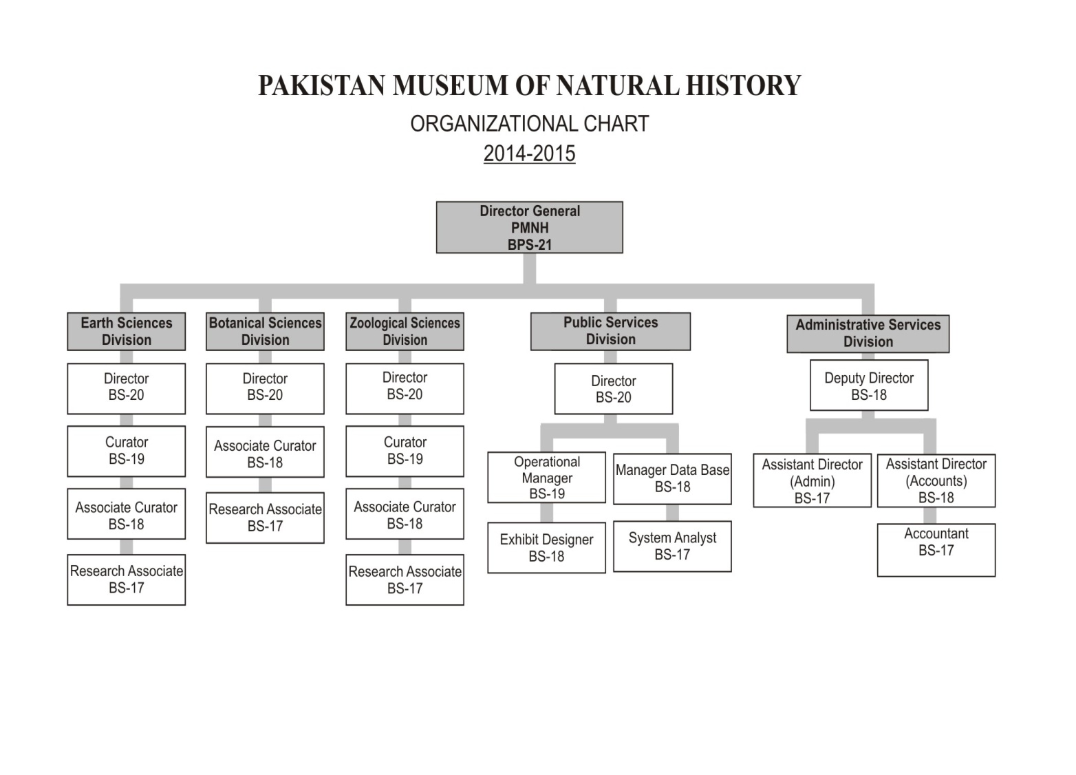

3.0 PASTIC Sanctioned Posts and Organizational Chart
Sr.# | BS | Designation | Number of Posts
 |  |  | Total | Filled in | Vacant
1 | 21 | Director General | 1 | 1 | 0
2 | 20 | Director | 1 | 1 | 0
3 | 19 | Additional Director (A&F) | 1 | 1 | 0
4 | 19 | Additional Director (STI) | 1 | 1 | 0
5 | 19 | Principal System Analyst | 1 | 1 | 0
6 | 19 | Principal Librarian | 1 | 1 | 0
7 | 18 | Deputy Director (STI) | 5 | 5 | 0
8 | 18 | Manager Reprographic Unit | 1 | 1 | 0
9 | 18 | Senior Scientific Information Officer | 9 | 8 | 1
10 | 18 | Deputy Director (Admin) | 1 | 1 | 0
11 | 18 | Assistant Director (Accounts) | 1 | 1 | 0
12 | 18 | PS to D.G | 1 | 1 | 0
13 | 18 | Senior Manager Technology Information | 1 | 1 | 0
14 | 17 | Scientific Information Officer | 3 | 2 | 1
15 | 17 | System Analyst | 1 | 1 | 0
16 | 17 | Web Manager | 1 | 1 | 0
17 | 17 | Printing Officer | 1 | 0 | 1
18 | 17 | Graphic Artist | 1 | 1 | 0
19 | 17 | Assistant Director (Admn) | 2 | 2 | 0
20 | 17 | Technology Information Officer (Marketing) | 1 | 0 | 1
21 | 17 | Editor | 1 | 1 | 0
22 | 17 | Assistant Accounts Officer | 1 | 1 | 0
23 | 17 | Accountant | 1 | 1 | 0
24 | 17 | Superintendent (Admin) | 2 | 2 | 0
25 | 16 | Assistant Scientific Information Officer | 3 | 1 | 2
26 | 16 | Assistant Documentation Officer | 1 | 1 | 0
27 | 16 | Assistant Programmer | 2 | 1 | 1
28 | 16 | Assistant Web Manager | 1 | 1 | 0
29 | 16 | Assistant Manager Reprographic Unit | 1 | 0 | 1
30 | 16 | Assistant Printing Officer | 5 | 4 | 1
31 | 16 | Assistant Private Secretary | 2 | 2 | 0
32 | 16 | Assistant Accounts | 1 | 1 | 0
Sub Total |  |  | 56 | 47 | 9

Sr.# | BS | Designation | Number of Posts
 |  |  | Total | Filled in | Vacant
1 | 15 | Senior Data Control Assistant | 2 | 1 | 1
2 | 14 | Data Control Assistant | 7 | 6 | 1
3 | 14 | Layout Artist | 1 | 1 | 0
4 | 14 | Marketing/Field Assistant | 1 | 0 | 1
5 | 14 | Graphic Assistant | 1 | 0 | 1
6 | 14 | Senior Offset Printer | 2 | 0 | 2
7 | 14 | Assistant | 7 | 6 | 1
8 | 14 | Stenotypist | 2 | 2 | 0
9 | 12 | Library Assistant | 1 | 1 | 0
10 | 12 | Data Entry Operator | 2 | 0 | 2
11 | 11 | Technician | 1 | 1 | 0
12 | 11 | Offset Printer | 3 | 2 | 1
13 | 11 | Technical Assistant | 1 | 0 | 1
14 | 11 | Senior Carpenter | 1 | 1 | 0
15 | 9 | Upper Division Clerk | 9 | 8 | 1
16 | 7 | Electrician | 1 | 1 | 0
17 | 7 | Assistnat Offset Printer | 2 | 2 | 0
18 | 7 | Lower Division Clerk | 11 | 8 | 3
19 | 7 | Driver | 1 | 1 | 0
20 | 6 | Driver | 1 | 1 | 0
21 | 5 | Bindery Assistant | 2 | 2 | 0
22 | 5 | Driver | 2 | 2 | 0
23 | 5 | Offset Machine Assistant | 1 | 1 | 0
24 | 4 | Drivers | 4 | 4 | 0
25 | 4 | Duplicating Machine Operator | 1 | 1 | 0
26 | 4 | Dispatch Rider | 1 | 1 | 0
27 | 3 | Head Mali | 1 | 1 | 0
28 | 3 | Record Sorter | 1 | 1 | 0
29 | 4 | Photo Attendant | 1 | 1 | 0
30 | 3 | Patent Attendant | 1 | 1 | 0
31 | 3 | Security Guard | 5 | 5 | 0
32 | 3 | Qasid | 8 | 8 | 0
33 | 2 | Qasid | 1 | 1 | 0
34 | 2 | Photo Attendant | 1 | 1 | 0
35 | 2 | Patent Attendant | 1 | 1 | 0
36 | 2 | Library Attendant | 2 | 2 | 0
37 | 1 | Bindery Helper | 1 | 1 | 0
38 | 1 | Sanitary Workers | 3 | 3 | 0
39 | 1 | Mali | 2 | 2 | 0
40 | 1 | Security Guard | 3 | 3 | 0
41 | 1 | Naib Qasid | 9 | 9 | 0
Sub Total |  |  | 108 | 93 | 15
GRAND TOTAL |  |  | 164 | 140 | 24

Library Services
Publication Section
DIRECTOR GENERAL, BS-21, PASTIC
Reprography

S& T Info Services
IT/MIS
Section
DIRECTOR, BS-20
Administration & Accounts
Pr. Sys Analyst
BS-19
M.R.U.
BS-18
Sr.S.Inf.Off. Off BS-18
Addl. Dir (STI) B-19
Pr. . Lib.
BS-19
Dy. Dir (Admn)
BS-18
Asst. Dir (Acctts) BS-18
System Analyst/ BS-17
AAO BS-17
Printing Off
BS-17
Sr. S. I. O BS-18
Dy. Dir (STI) BS-18
Sub Centre, Lahore
Dy. Dir (STI)BS-18)
Sub Centre, Karachi
Dy. Dir.(STI) BS-18
Sub Centre Peshawar
Dy. Dir. (STI) BS-18
Sub Centre Faisalabad
Dep. Dir. (STI) BS-18
Sub Centre Muzaffarabad
Tech Info Section
Sr. S. Inf. Off BS-18
Liaison & Coord.
Tec. Inf. Off BS-17
Sr. S. Inf. Off. BS-18
Sr.S.Inf.Off BS-18
Graphic Artist B-17
Editor
BS-17
Sr. S. I. O BS-18
ORGANIZATIONAL STRUCTURE OF PASTIC
TECHNICAL WING
MANAGEMENT WING
SM.T.I .
BS-18
Addl.Dir (A&F)
BS-19
A. D (Admn)
BS-17
Accountant BS-17
Web Manager
BS-17
Supdt:: (Admn)
BS-17
S. Inf. Off BS-17
S. I. O
BS-17
S. Inf. Off. BS-17
Sr. S. I. O
BS-18
PS to D.G.
BS-18
S I O (BS-17)
Sub Centre Quetta
A.D (Admn) BS-17)
Sr. S. Inf. Off. BS-18
Sr. S. Inf. Off. BS-18
Supdt: (Admn)
(BS-17)

V. PHOTO GALLERY AND PRESS CLIPPING

- PSF Photo Gallery & Press Clipping

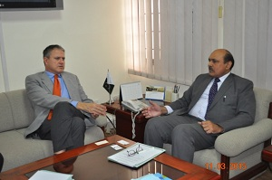
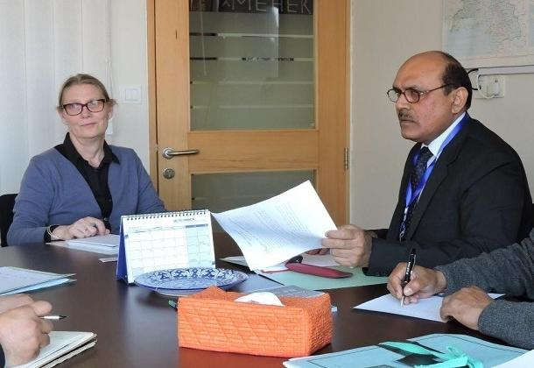

Prof. Dr. Ashraf, chairman PSF discussing with Mr. Stenfano Gatto, Deputy Head of EU Delegation to Pakistan, about the Road Map of Awareness on Innovation, Research Program

Chairman PSF, Prof. Dr. Muhammad Ashraf and Country Director UNESCO Pakistan, Ms. Vibeke Jenson, discussing the collaborative programs between PSF and UNESCO

Group photo of Dr. Orkun Hasekioglu, Vice President of TUBITAK, Turkey and Harkan Karatas, Director International Cooperation, TUBITAK with Prof. Dr. Muhammad Ashraf, Chairman PSF and Dr. Mirza Habib Ali, Focal Person International Linkages, PSF, during their visit to Turkey in last of week of April 2015.

Prof. Dr. Ashraf, Chairman PSF conducting a meeting with Mr. Alban French Attaché for Science and Technology in Pakistan
Dr. Rahman Nurdun, Head of Department East and South Asia, Pacific and Latin America, the Turkish Cooperation and Coordination Agency (TIKA), Turkey, presents a souvenir to Prof. Dr. Muhammad Ashraf, Chairman PSF during the latter’s visit to TIKA, in last week of April 2015.

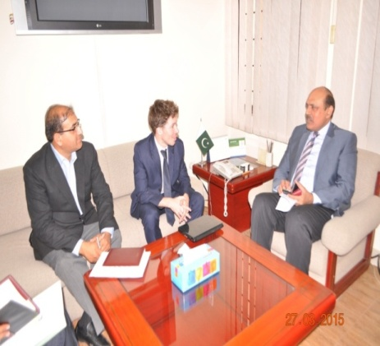
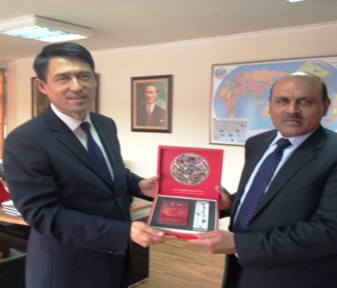
Prof. Dr. Muhammad Ashraf, Chairman PSF, presents the Foundation insignia to H.E. Sadik Babür Girgin, Ambassador of Turkey on May 27, 2015
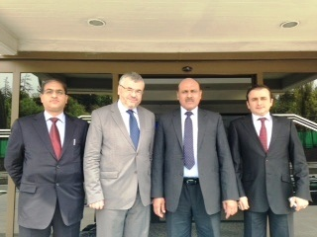
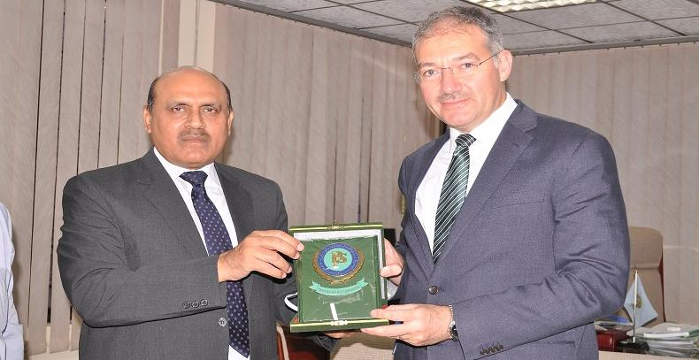
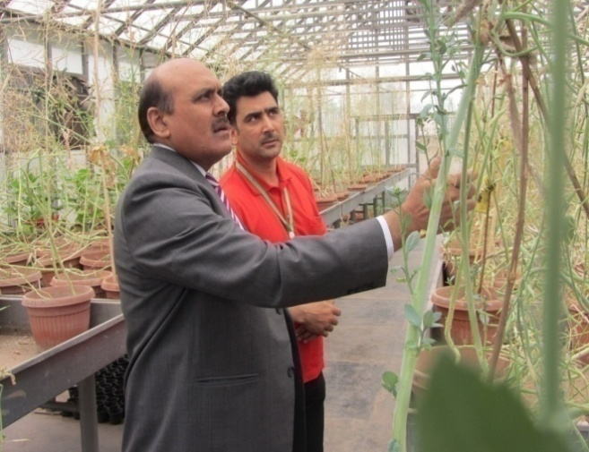  Prof. Dr. Muhammad Ashraf, Chairman PSF visiting  project site at IBGE, Peshawar | 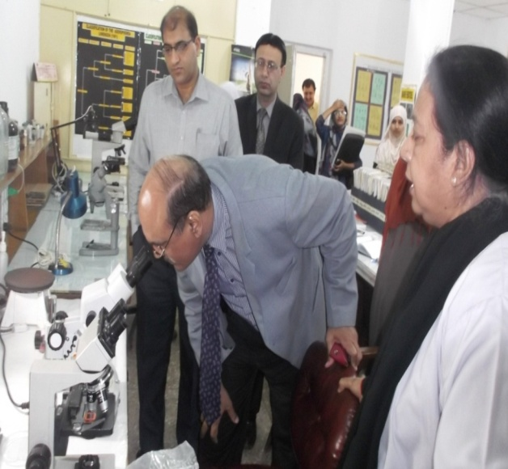  Prof. Dr. Muhammad Ashraf, Chairman PSF visiting project site at NNRC, Karachi
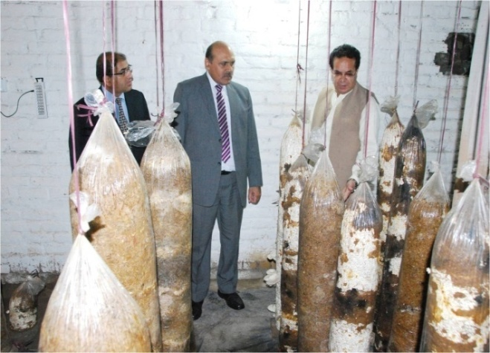  Prof. Dr. Muhammad Ashraf, Chairman PSF visiting  project site for mushroom production at NIFA,  Peshawar | 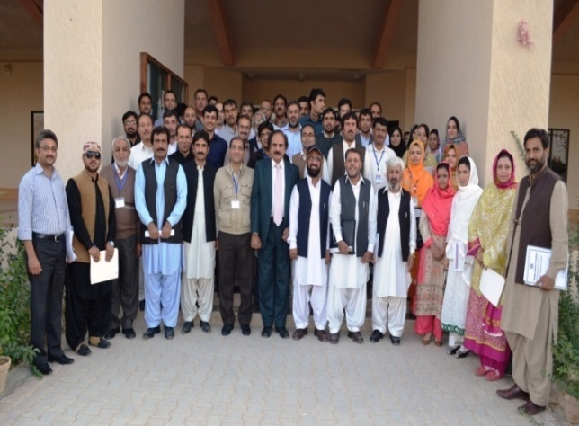  Dr. Mirza Habib Ali, Director Research with participants of Project Formulation Workshop at BUITEMS, Quetta
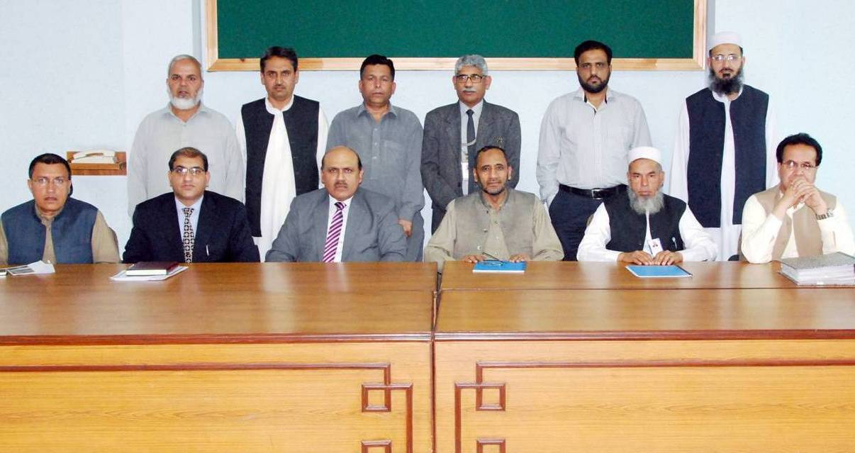  Prof. Dr. Muhammad Ashraf, Chairman PSF during Monitoring of Project at NIFA, Peshawar | 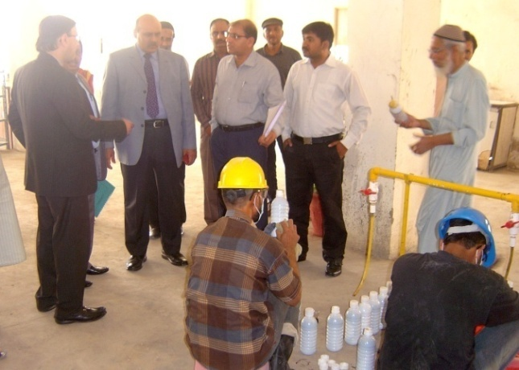  Prof. Dr. Muhammad Ashraf, Chairman PSF visiting Humic Acid Production Unit at FRC, PCSIR, Karachi

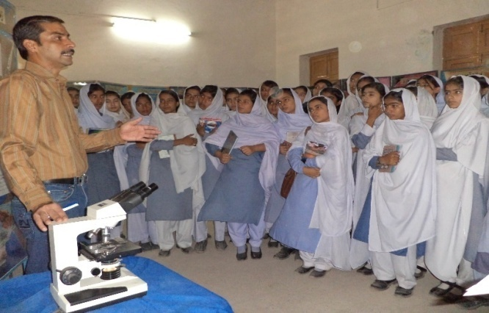  Students being briefed about Scientific models at Badin arranged by Tandojam Unit | 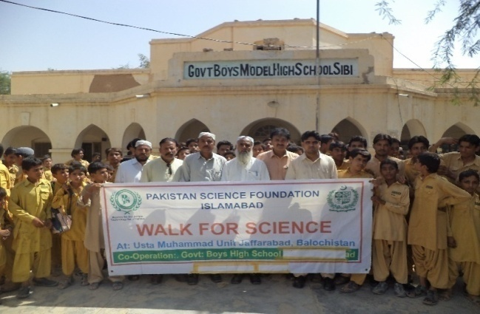  Glimpse of walk for Science at arranged by Jaffarabad Unit Sibbi
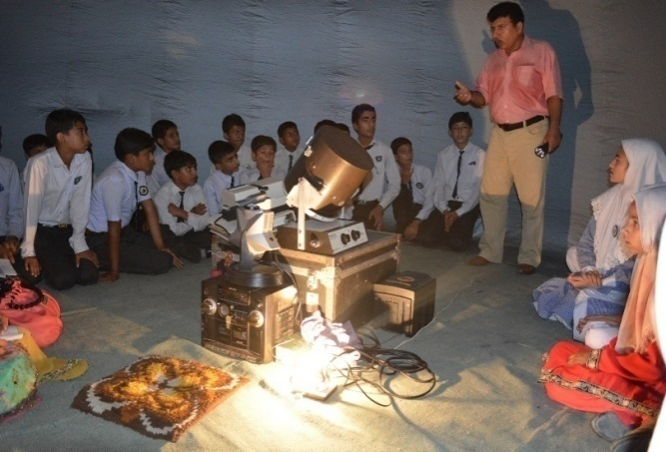  An inside view of planetarium show at Wah Cantt  arranged by Federal Unit | 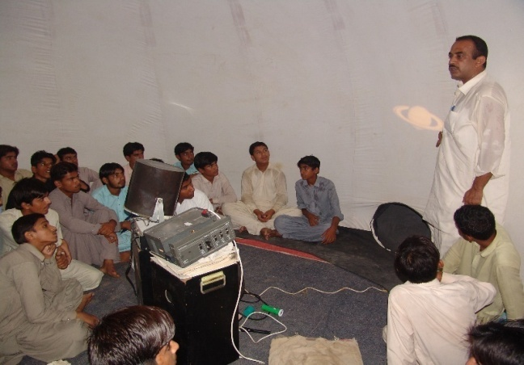  View of slide show inside the planetarium arranged by Sukkur unit
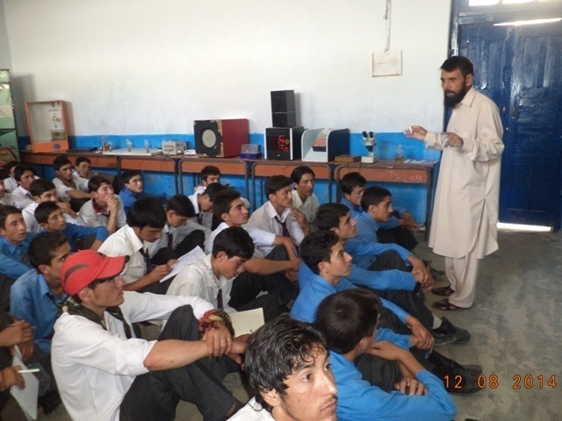  Students are being briefed about scientific models during caravan exhibition arranged by KP Unit | 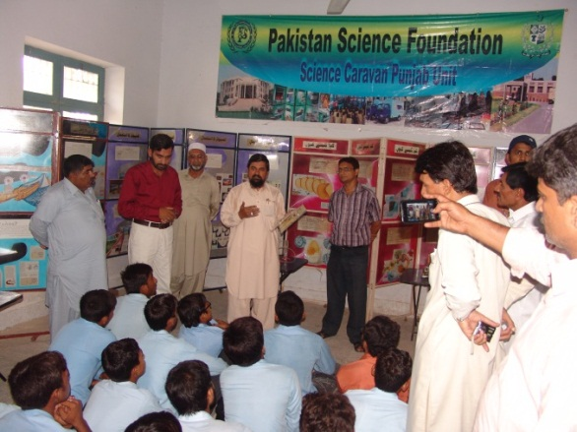  Students are being briefed about Science Caravan activities during exhibition arranged by Punjab Unit

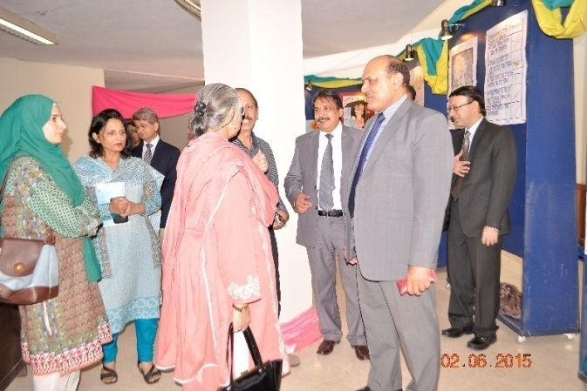  Prof. Dr. Muhammad Ashraf, Chairman PSF interacting  with jury members of 24th Inter Board Science  Poster Competition | 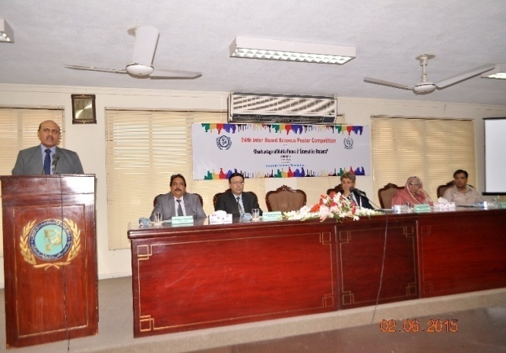  Prof. Dr. Muhammad Ashraf, Chairman PSF addressing the ceremony of 24th Inter Board Science Poster Competition
S&T Float on Pakistan Day Parade 23rd March 2015 | 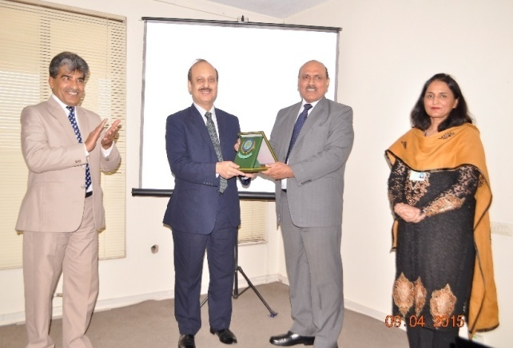  Prof. Dr. Muhammad Ashraf, Chairman PSF presenting PSF Crest to Secretary MoST on the occasion of award distribution ceremony among the officials involved in S&T Float for Pakistan Day Parade
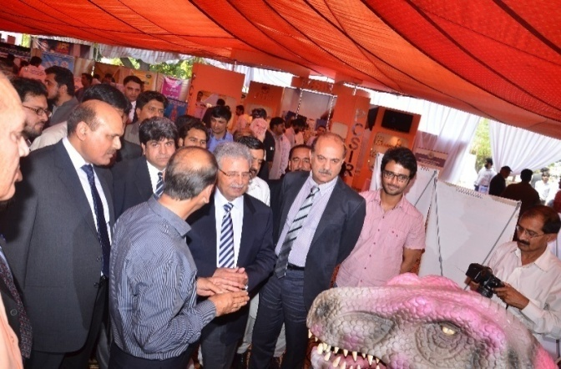  Federal Minister for S&T and Chairman PSF visitin  The stall of PSF during S&T Expo in Lahore | 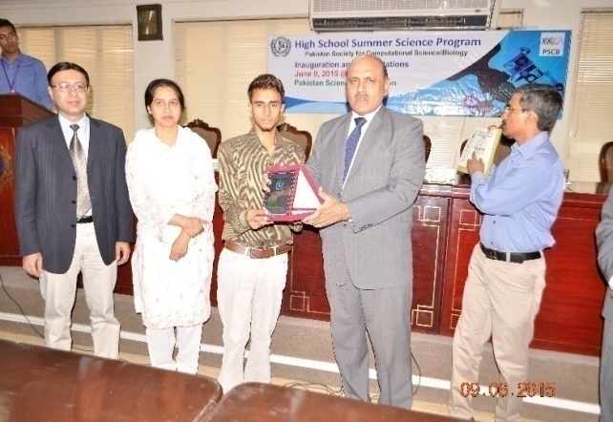  Prof. Dr. Muhammad Ashraf, Chairman PSF awarding shield to winner of HSSSRP-14

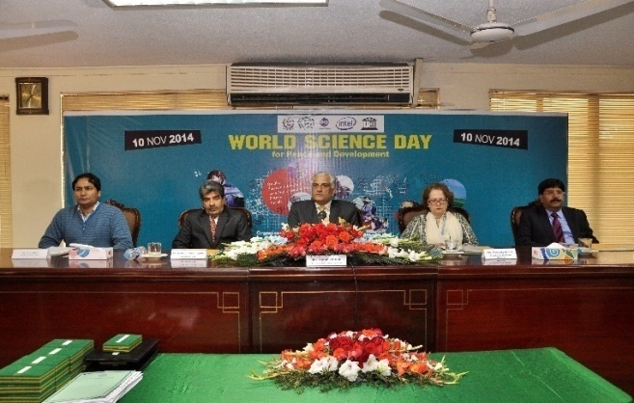  Federal Minister for S&T Mr. Zahid Hamid,Ms. Berverlyjones, UNESCO & Dr. Rai Niaz Ahmed VC AAUR and PSF Officers during the inaugural session of WSDPD-2014 | 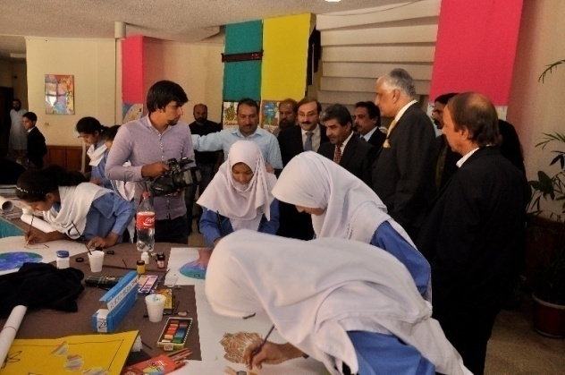  Federal Minister for S&T Mr. Zahid Hamid and other guests visiting the projects and poster competition on occasion of WSDPD-2014
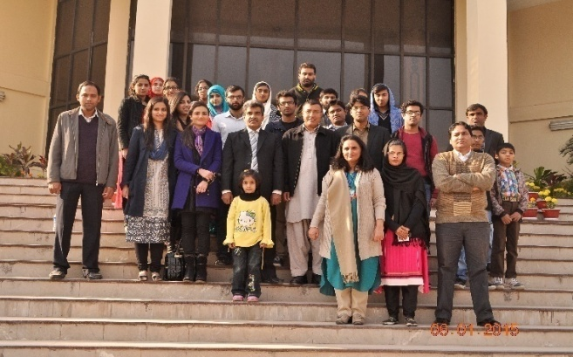  Group Photo of students and Senior Officer of PSF  along with PTV News Team | 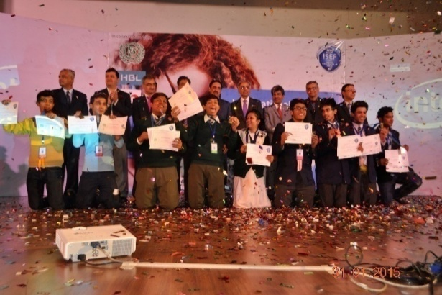  Group photo of Grand winners of Intel National  Science Fair with distinguished guests
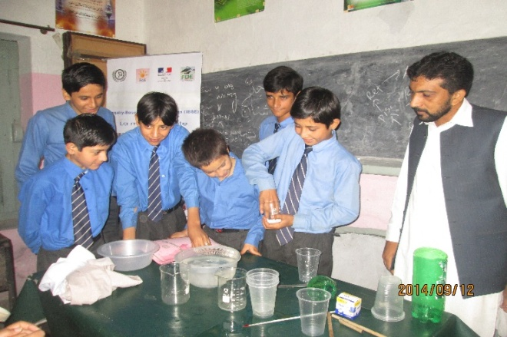  Students are performing hands on activities under IBSE | 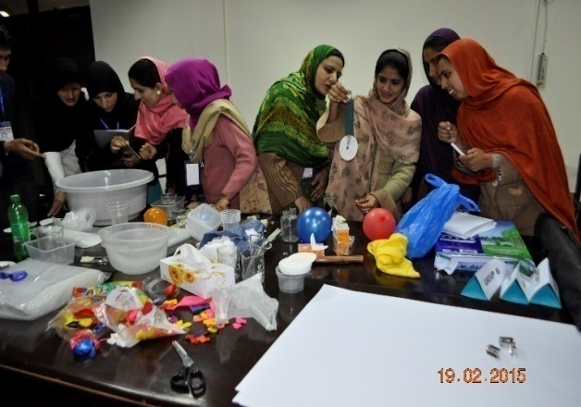  View of training workshop on IBSE conducted at PSF

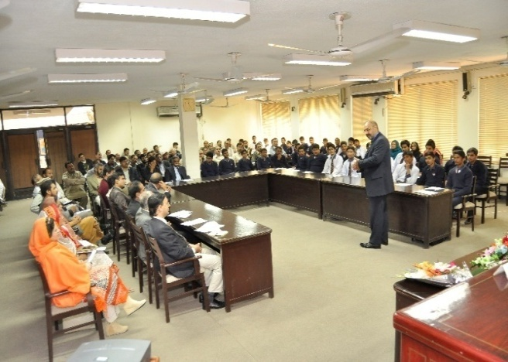  Popular Science Lecture on” From effectiveness to greatness”held at PSF | 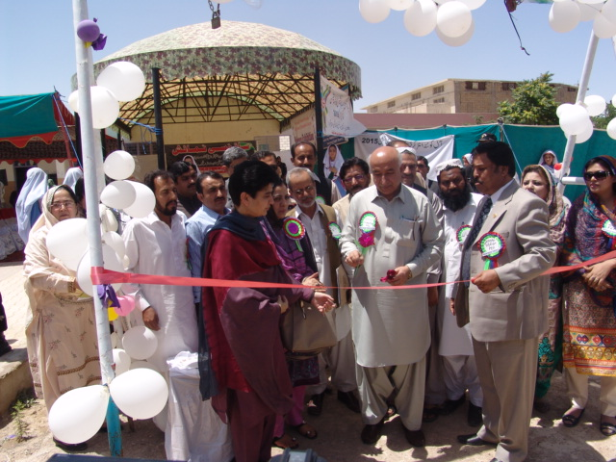  Dr. Abdul Malik Baloch, Chief Minister Balochistan  inaugurating Science Exhibition organized by PEF in  collaboration with PSF
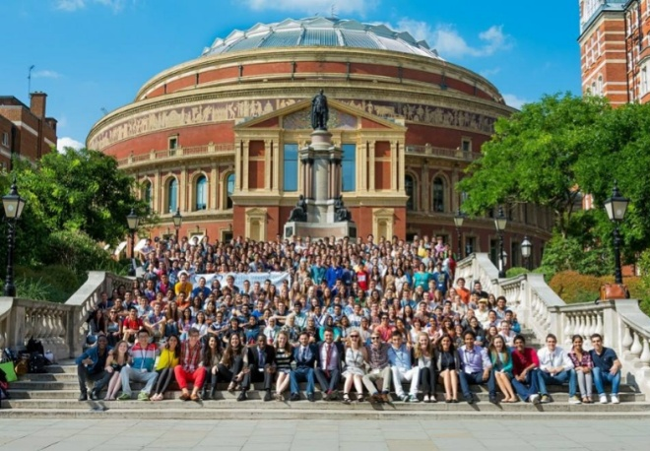  Group photo of participating students in LIYSF-2014 | 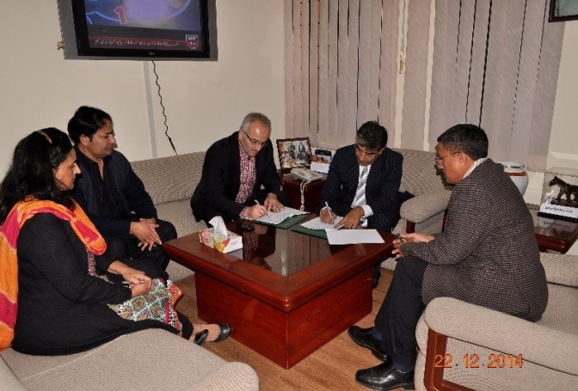  Signing of MoU with PakTurk ICEF
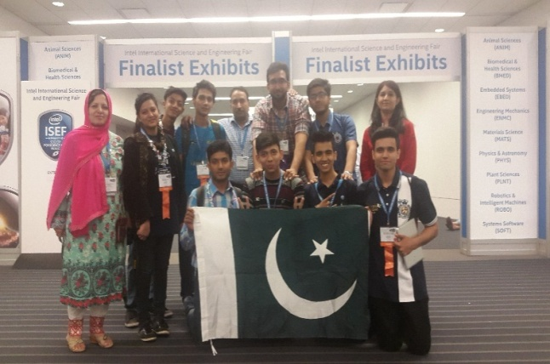  A group photo of Pakistan students during Intel ISEF | 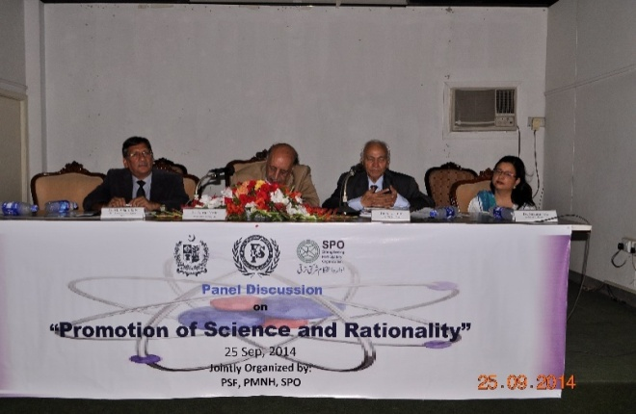  Panelists during panel discussion on Promotion of  Science and Rationality

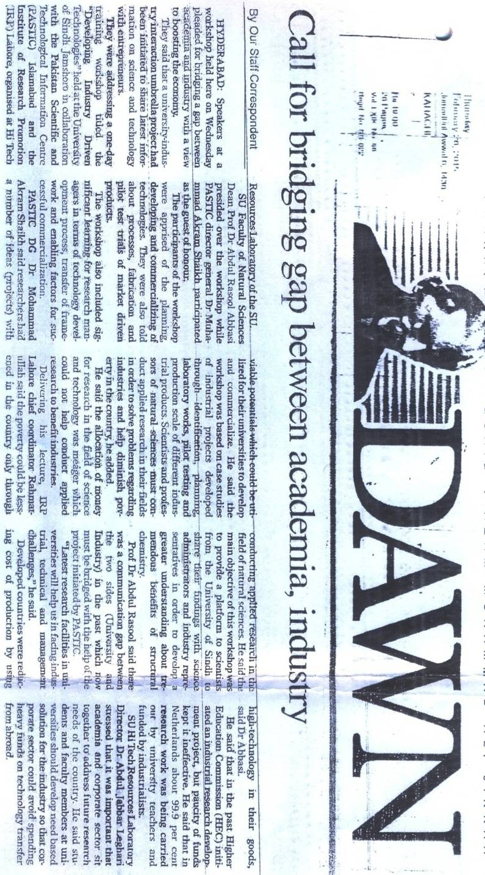

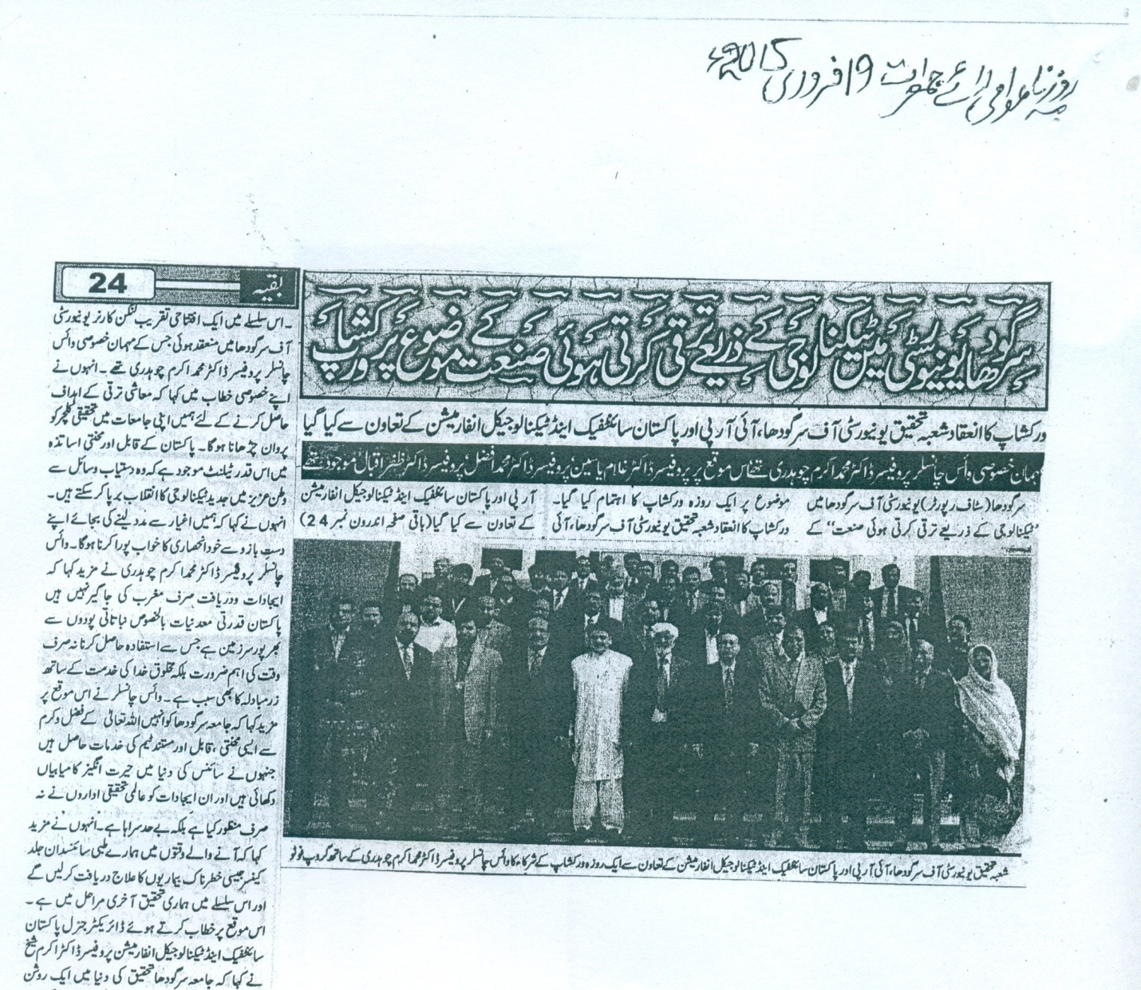

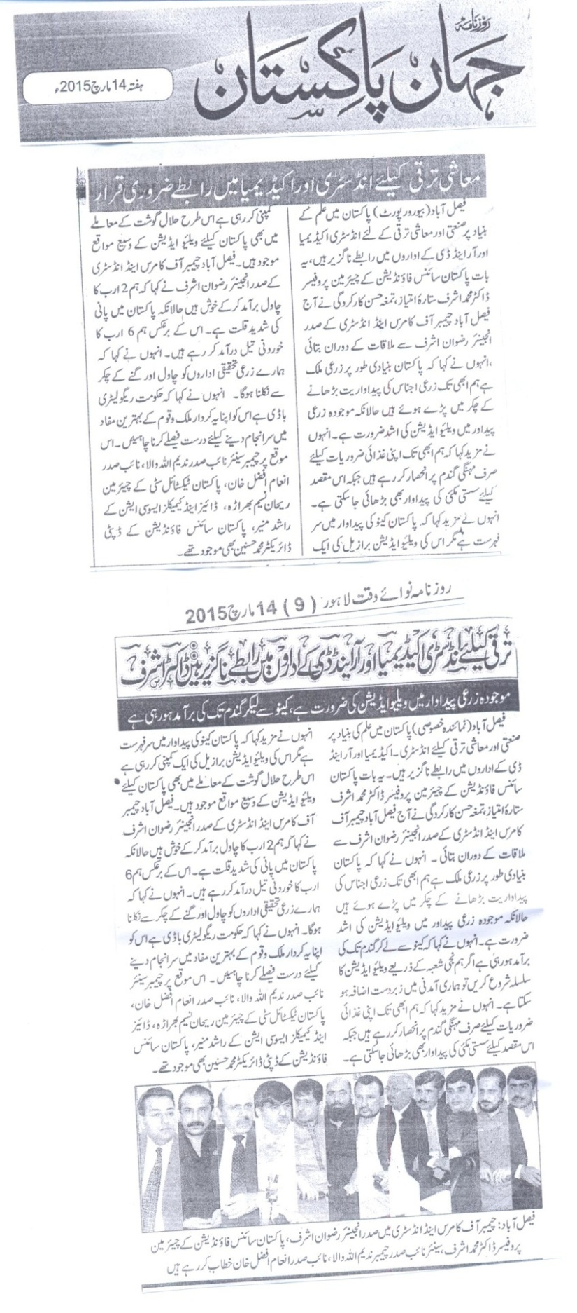

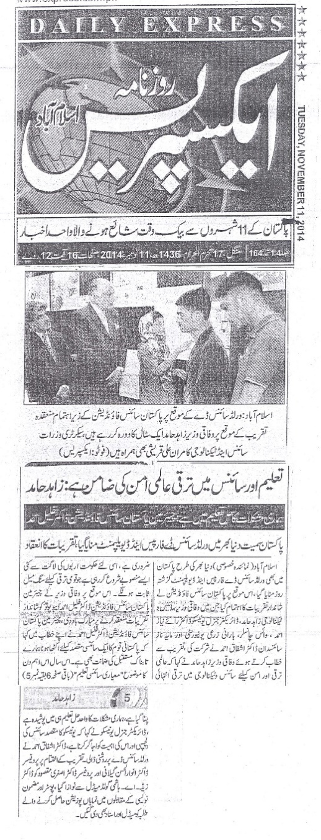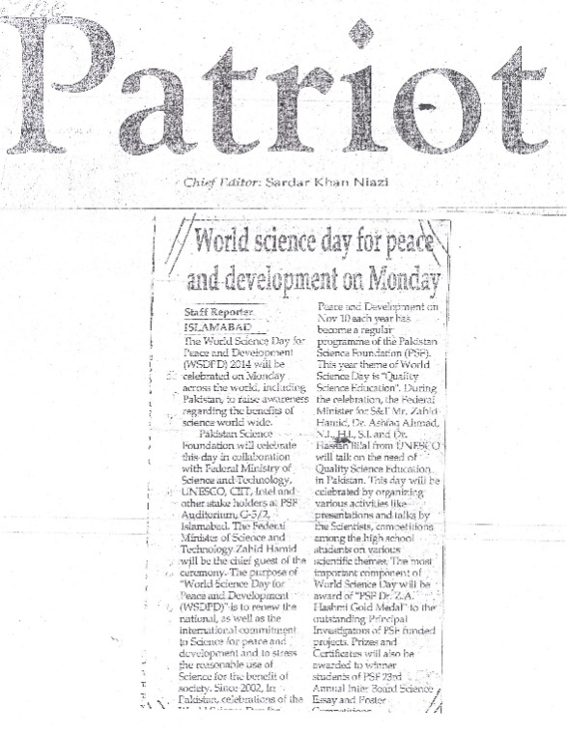

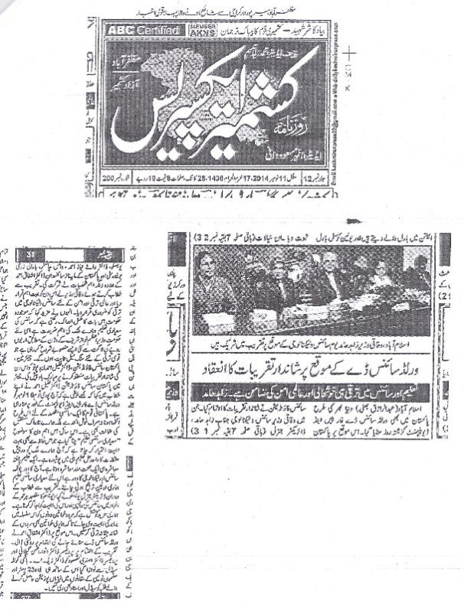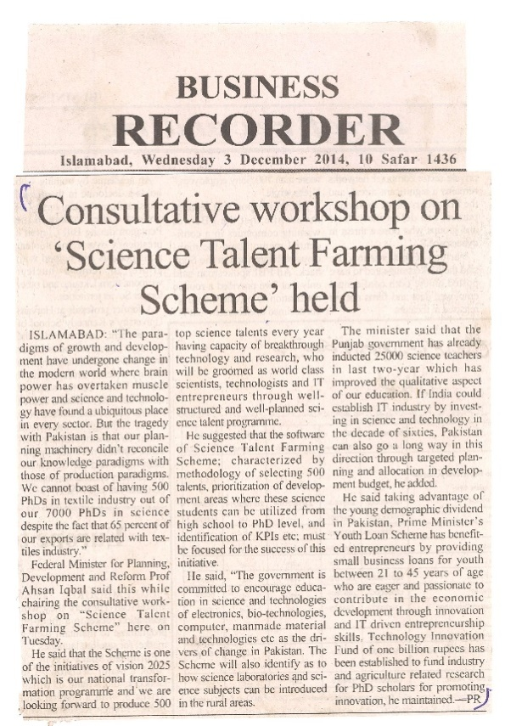

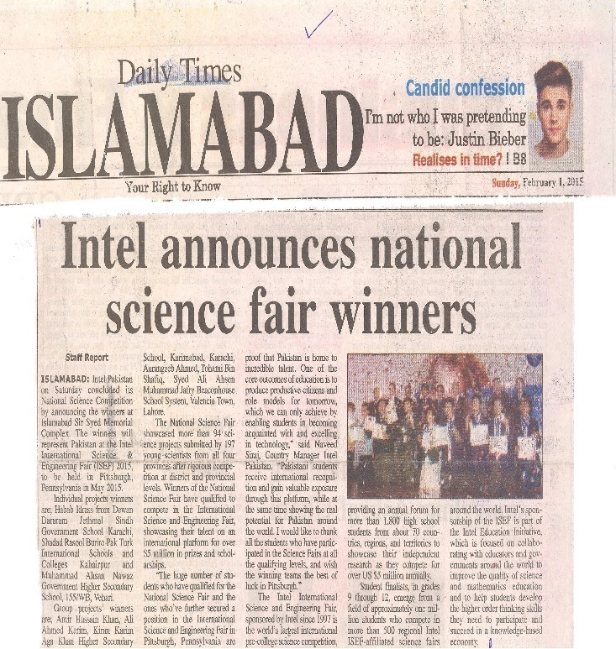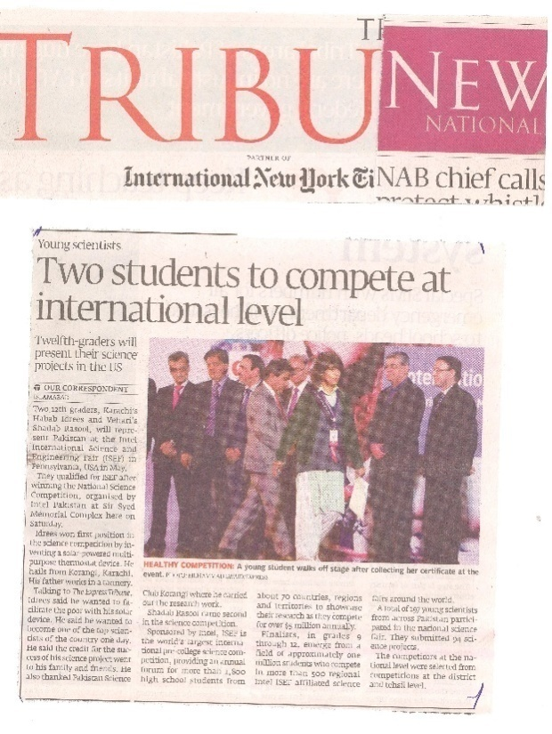

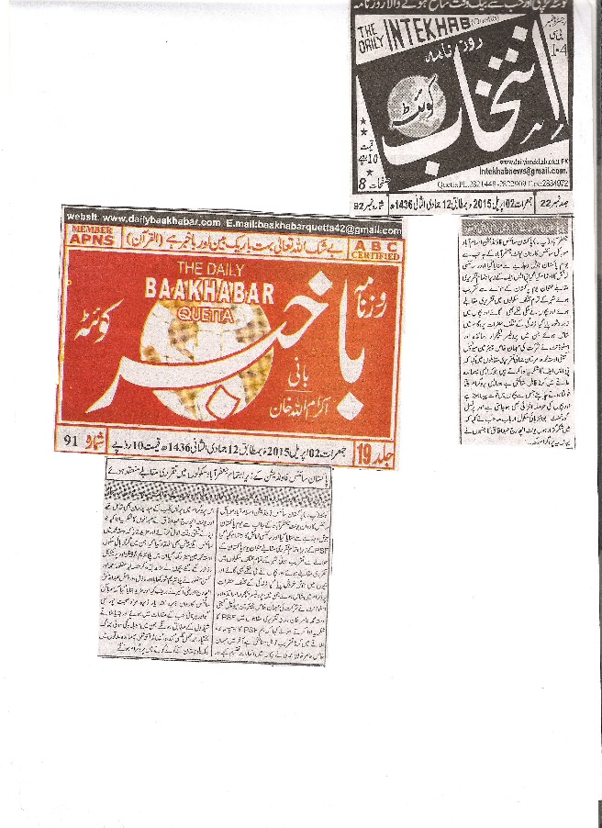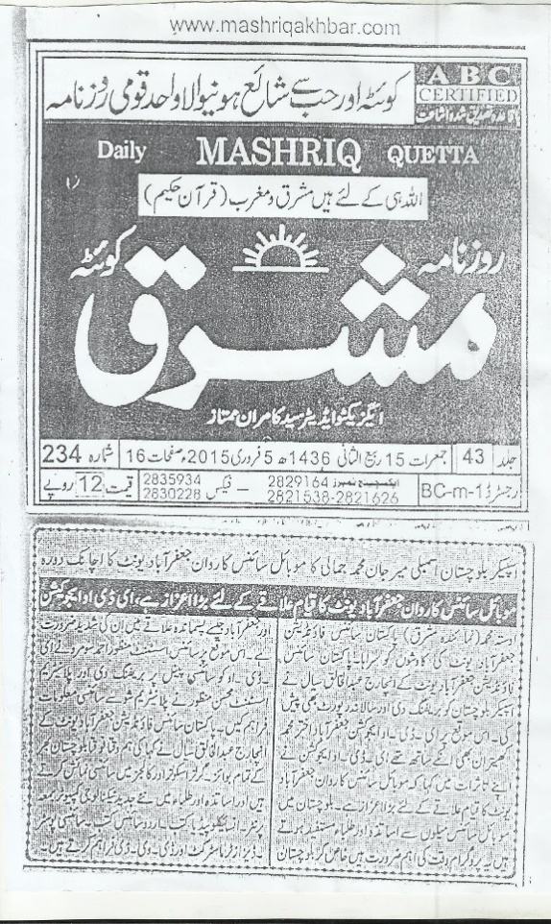

2.0 PMNH Photo Gallery

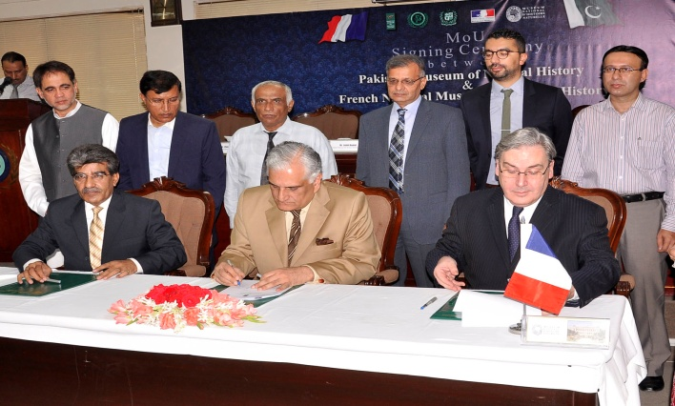  MoU Signing Ceremony between Pakistan Museum  of Natural History and French National Museum  of Natural History Held at Pakistan Science  Foundation on 23 July 2014 | 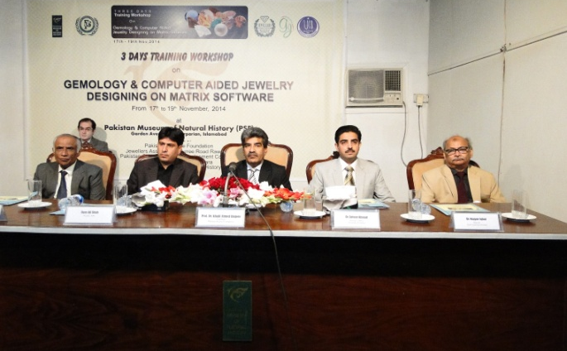  Earth Sciences Division, Pakistan Museum of Natural History organized three days training workshop on Gemology and Computer Aided Jewelry Designing on Matrix Software from 17-19 November 2014
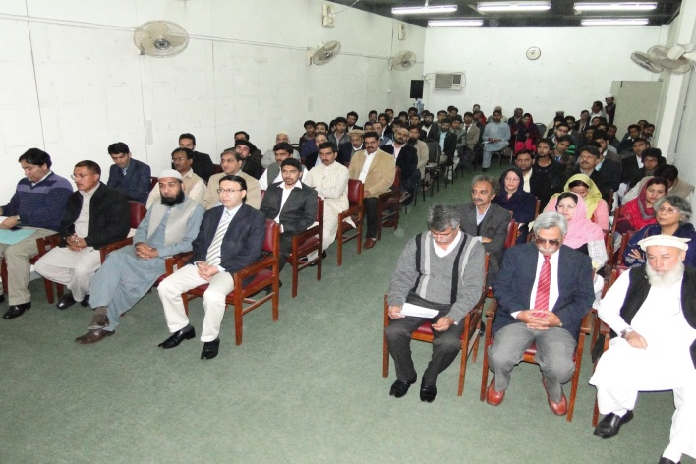  Participants of the workshop on Gemology and Computer Aided Jewelry Designing on Matrix Software from  17-19 November 2014 | 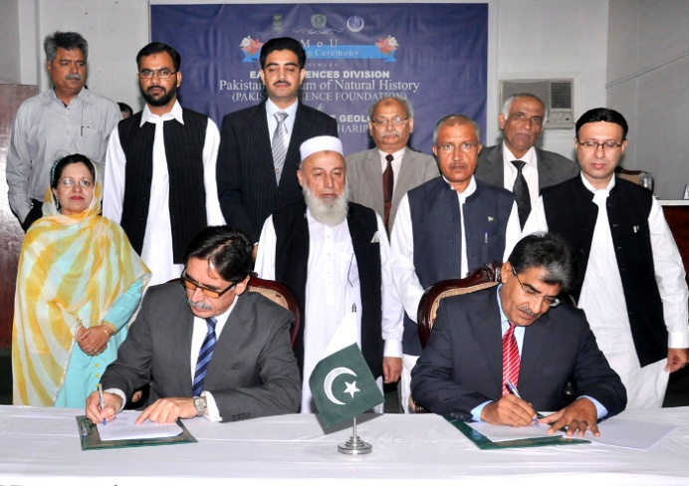  MoU Signing Ceremony between Earth Sciences Division, Pakistan Museum of natural History and Department of Geology, University of Haripur  held on 31 October 2014
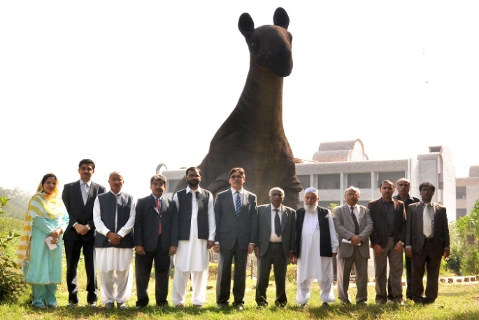  Group photo after MoU Signing Ceremony between Earth Sciences Division, Pakistan Museum of Natural History  and Department of Geology, University of Haripur  held on 31 October 2014 | 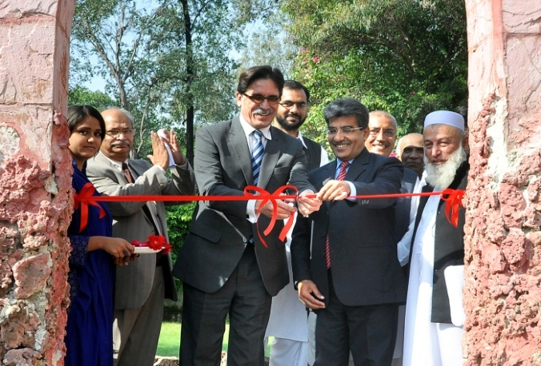  Prof. Dr. Naseer Ali Khan, Vice Chacellor, University  of Haripur, Inaugurating the “Rock Garden” at Pakistan Museum of Natural History, Islamabad  on 31st October 2015

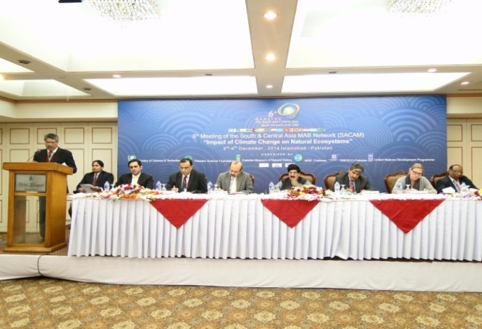  6th Meeting of South and Central Asia MAB Network  (SACAM) on “ Impact of Climate Change on Natural Eco System” organized by Pakistan Museum of Natural  History, Islamabad on 3-5 December 2014 | 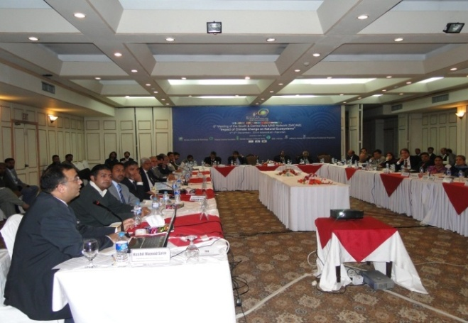  Delegates from Different Countries during the session on 6th Meeting of South and Central Asia MAB Network (SACAM) on “Impact of Climate Change on Natural Eco System” organized by Pakistan Museum of Natural History, Islamabad on 3-5 December 2014
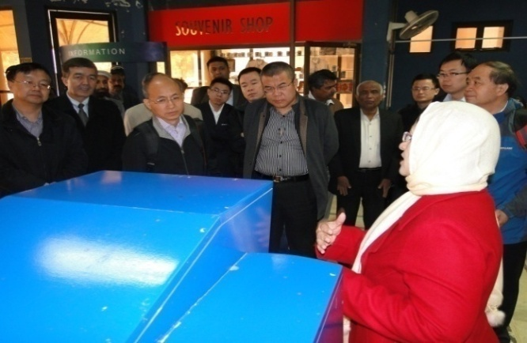  14 member delegation from Chinese Academy of Sciences (CAS) headed by the Vice President of CAS on 21st December 2014 visited Pakistan Museum of Natural History | 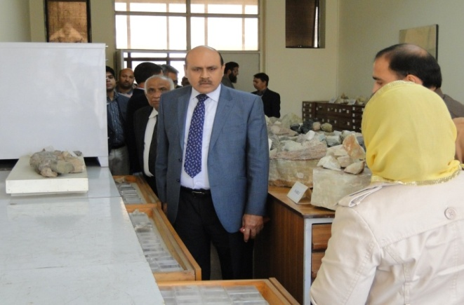  Charmin, Pakistan Science Foundation 1st visit to Pakistan Museum of Natural History on 6th March 2015
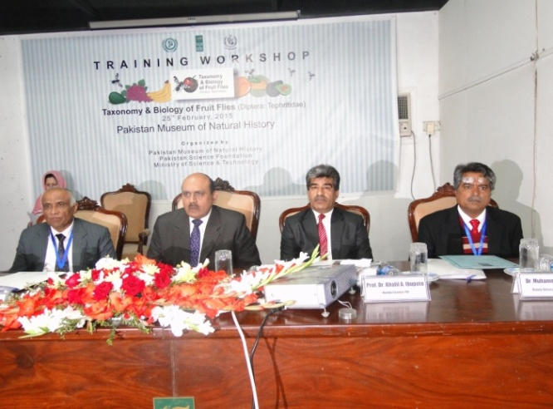  Pakistan Museum of Natural History organized a training workshop on “Taxonomy and Biology of Fruit Flies on 25th Feb 2015 | 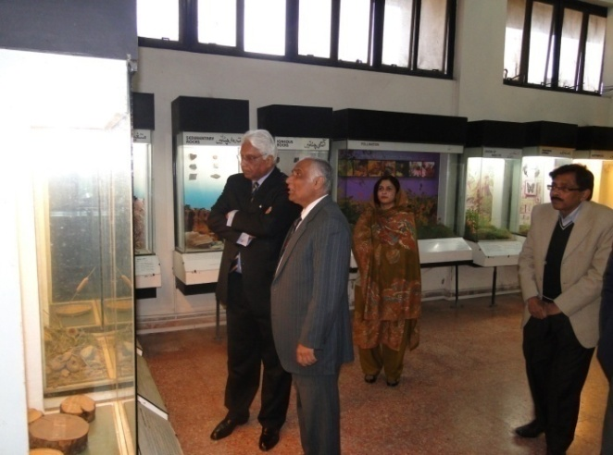  Pakistani High Commissioner to Lithuania visits Pakistan Museum of Natural History on 14 January 2015

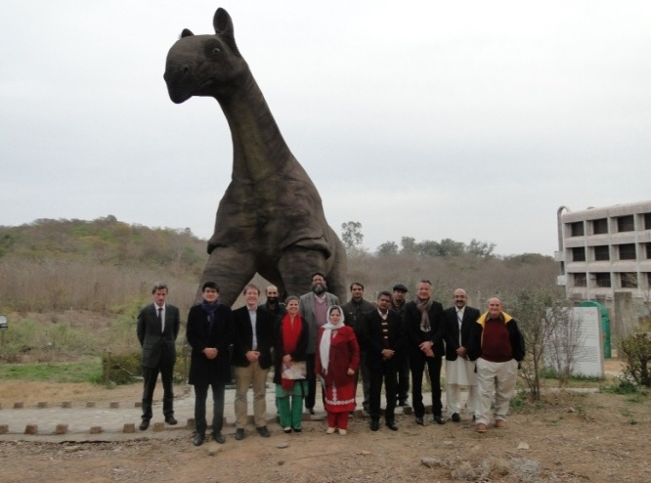  Delegates from Austria visits Pakistan Museum of Natural History on January 2015 | 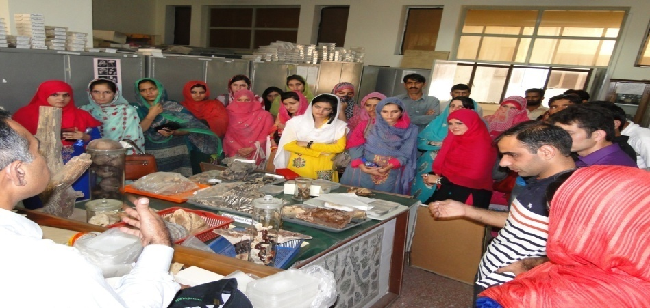  Students from Department of Plant Sciences visits Pakistan Museum of Natural History on 24 September 2014
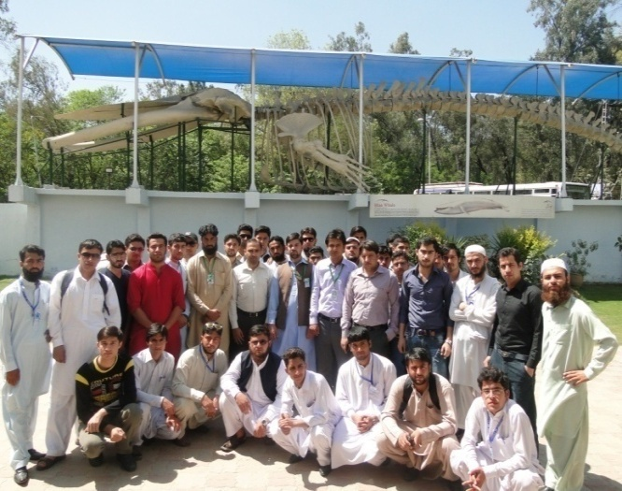 | 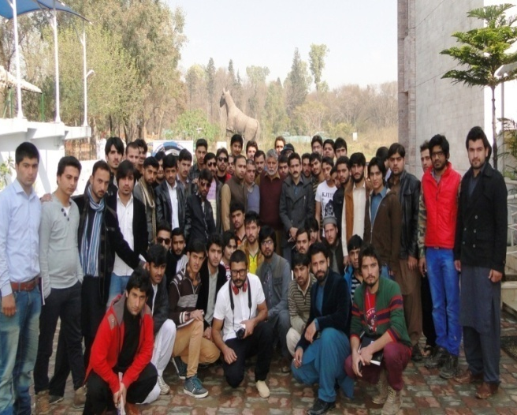
Students from Department of Geology, University of Swabi visits Pakistan Museum of Natural History on 2nd May 2015 | Students from Department of Geology, University of Azad Jammu and Kashmir visits Pakistan Museum of Natual History in the month of April 2015

3.0 PASTIC Photo Gallery and Press Clipping

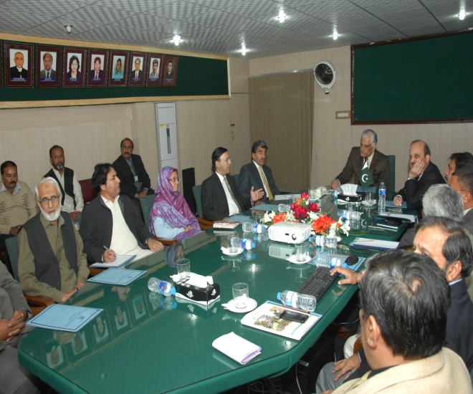  Federal Minister, Science & Technology in the meeting with Senior Officers of PASTIC and PSF during his visit to PASTIC | 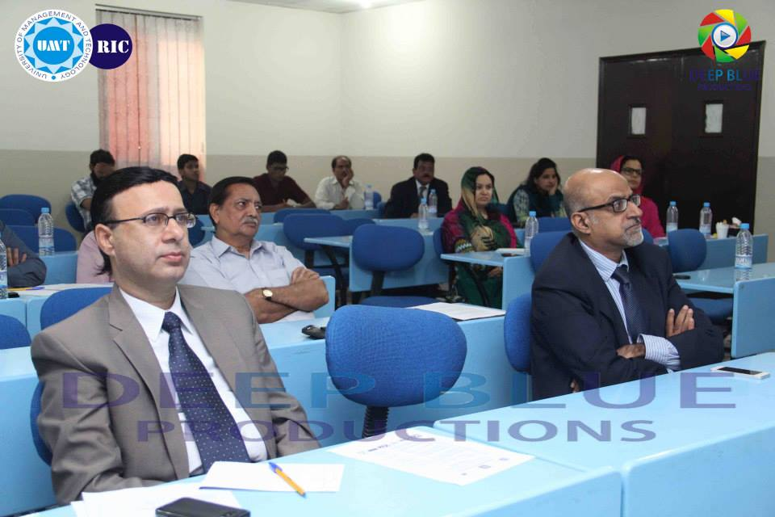  Dr. Muhammad Akram Shaikh Director General, PASTIC attending the 1st workshop on “Industry Driven Technologies” at Lahore
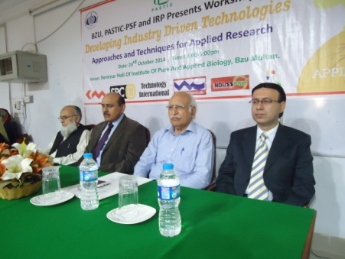  Prof. Dr. Muhammad Akram Shaikh, D.G., PASTIC, Mian Muhammad Iqbal, President, MCCI, Prof. Dr. Muhammad Ashraf, V.C., MNSUA, Multan and Prof. Dr. Saeed A Malik, Dean Faculty of Sciences, BZU, Multan at the inaugural ceremony of workshop on “Developing Industry Driven Technologies” at Faisalabad | 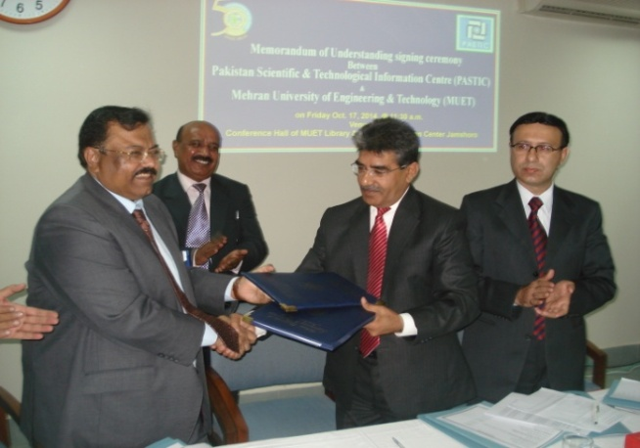  Dr. Khalil Ahmad Ibupoto, Chairman, PSF, Dr. Muhammad Akram Shaikh, D.G., PASTIC and Prof. Dr. Muhammad Aslam Uqaili, Vice Chancellor, MUET exchanging MoU documents
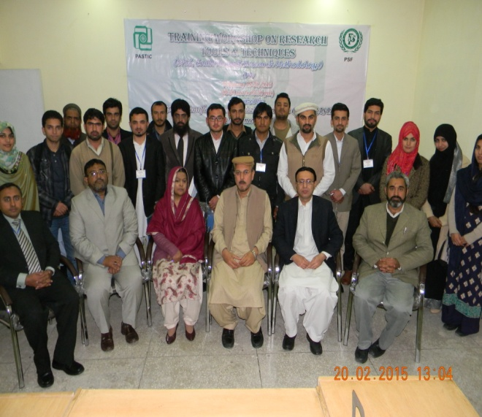  Group photo with Dr. Zabta Khan Shinwari, Secretary General, Pakistan Academy of Sciences, Dr Akram Shaikh, D.G., PASTIC along with resource persons and participants of the workshop on “Research Tools and Techniques” at PASTIC | 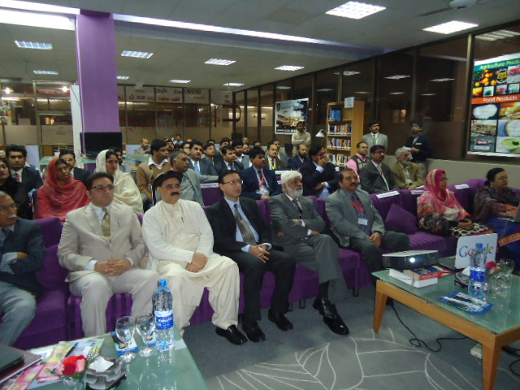  Dr. Muhammad Akram Shaikh, Director General, PASTIC attending the workshop on “Industry Driven Technologies” at University of Sargodha
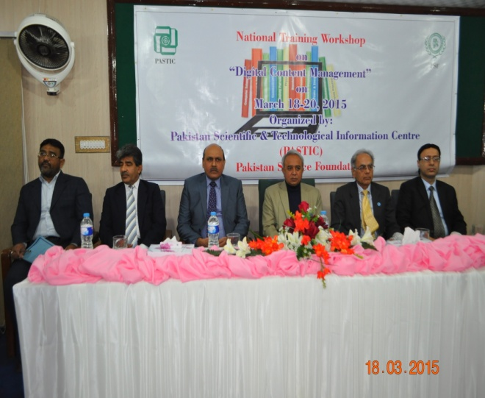  Prof. Dr. Ghulam Raza Bhatti, Member HRD, HEC, Dr. Muhammad Ashraf, Chairman, PSF, Dr. Khalil Ahmed Ibupoto, Member Science, PSF, Prof. Dr. Manzoor H. Soomro, President, ECO-SF, Prof. Dr. M. Akram Shaikh, DG, PASTIC, Syed Habib Akhter Jaffri, Sr. Librarian at the inaugural ceremony of the workshop on “Digital Content Management” | 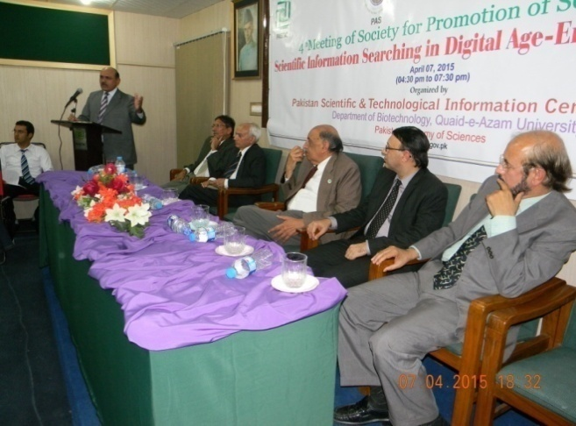  Prof. Dr. Muhammad Ashraf, Chairman PSF, addressing the audience of the 4th Meeting of Society for Promotion of Science on “Scientific Information Searching in Digital Age –Emerging Challenges”
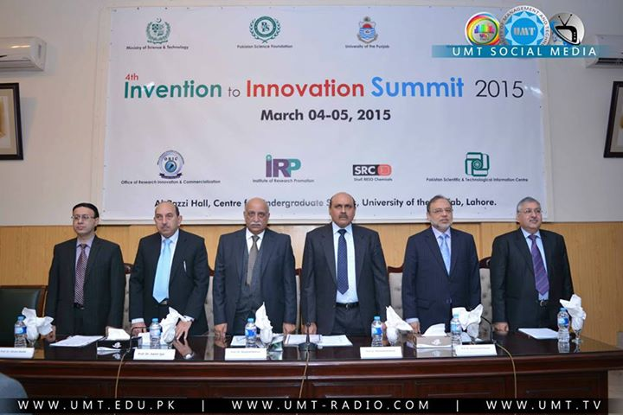  Inaugural Ceremony at 4th Invention to Innovation Summit, 2015, Lahore | 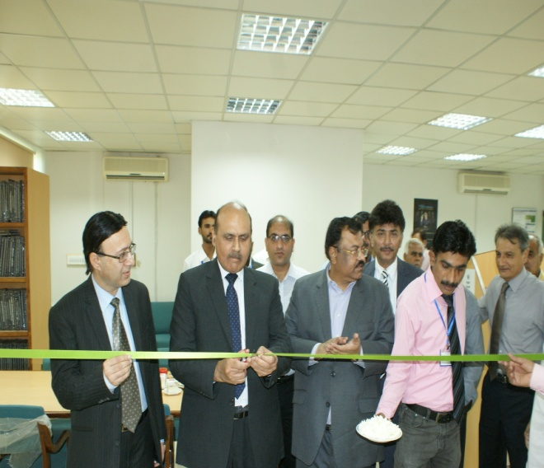  Prof. Dr. Muhammad Ashraf, Chairman, PSF inaugurating the PASTIC Desk at MUET Library
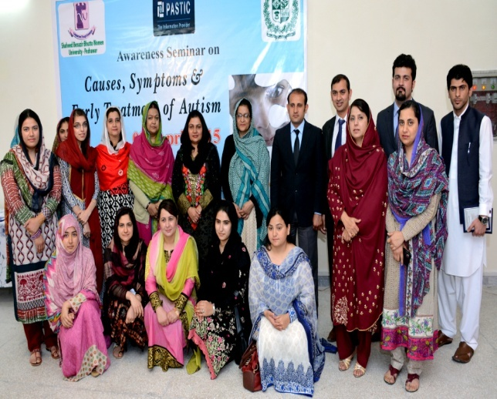  Prof. Dr. Razia Sultana, VC, SBBW University Peshawar,  Ms. Nageen Aniuddin, Director, PASTIC along with  resource persons at one day awareness seminar on “Causes, Symptoms and Early Treatment of Autism” at Peshawar | 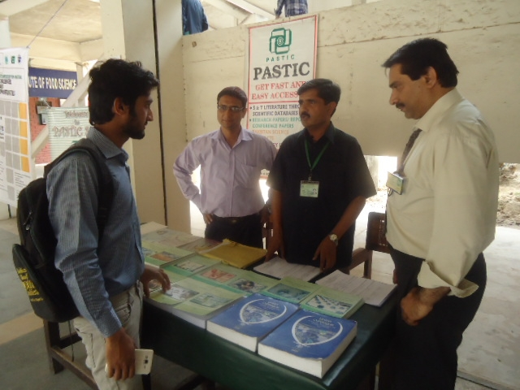  PASTIC services stall at NIFST-Agriculture, University of Agriculture, Faisalabad.

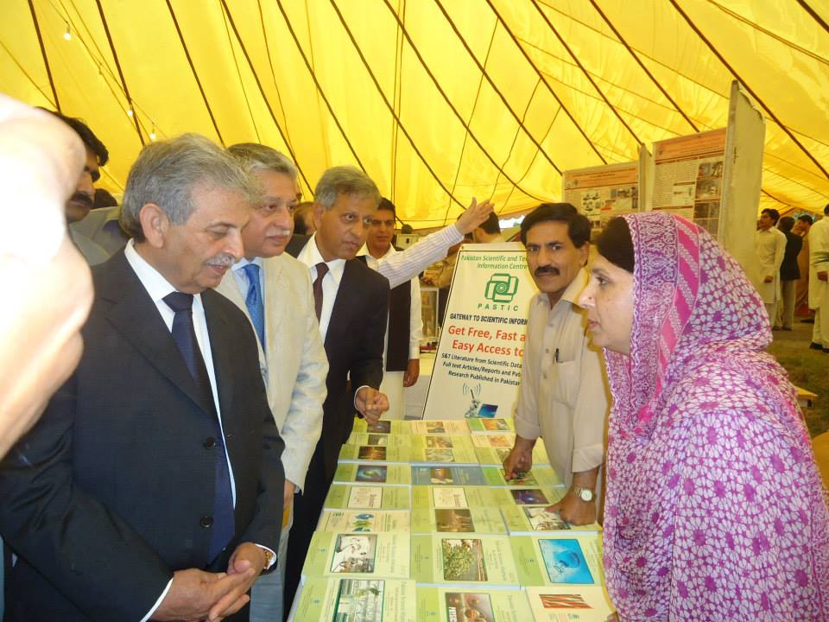  Federal Minister for Science & Technology, Rana Tanveer Hussain visited PASTIC stall during one day Science and Technology Exhibition at PCSIR Labs. Peshawar | 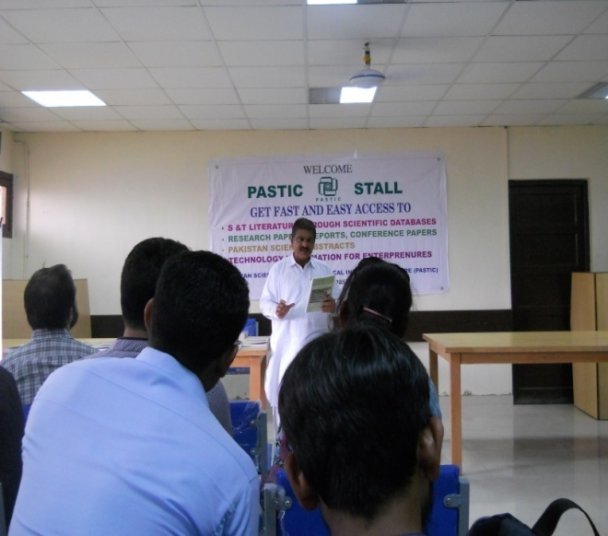  Mr. Abdul Fateh Shaikh, Sr. Scientific Information Officer, Karachi Sub Center delivered a lecture to students of Sindh Madersah Tul Islam University Karachi
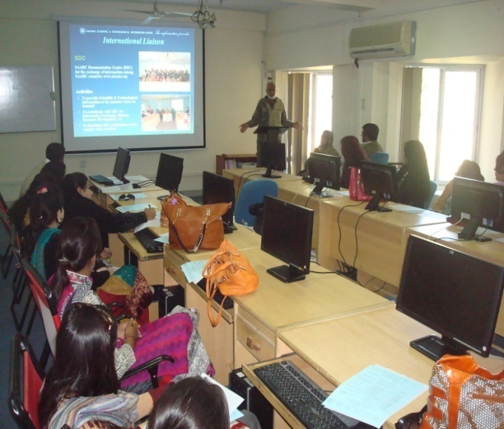  Mr. Muhammad Aqil Khan, Additional Director (STI) delivering a presentation on PASTIC Services during the students and faculty members of Sindh Agriculture University, Tandojam visit to PASTIC | 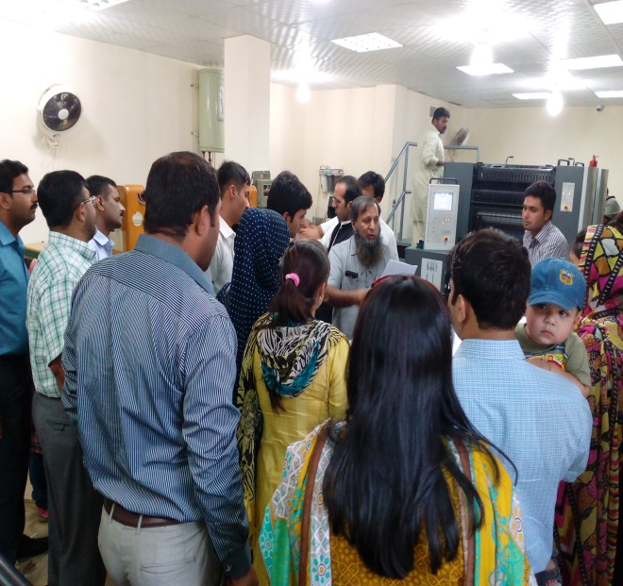  Students and faculty members of Department of Library & Information Science, Islamia University, Bahawalpur during visit to PASTIC Reprography Section

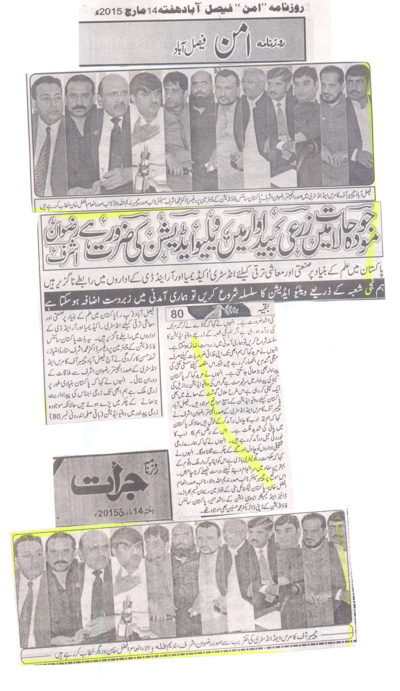
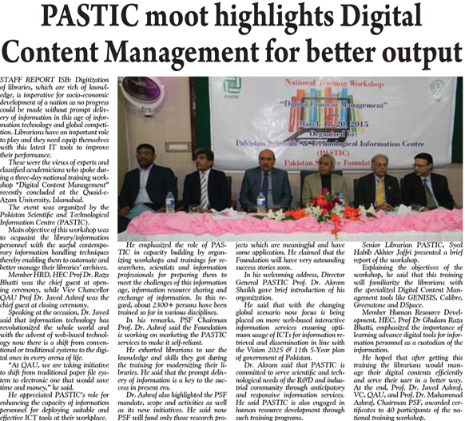

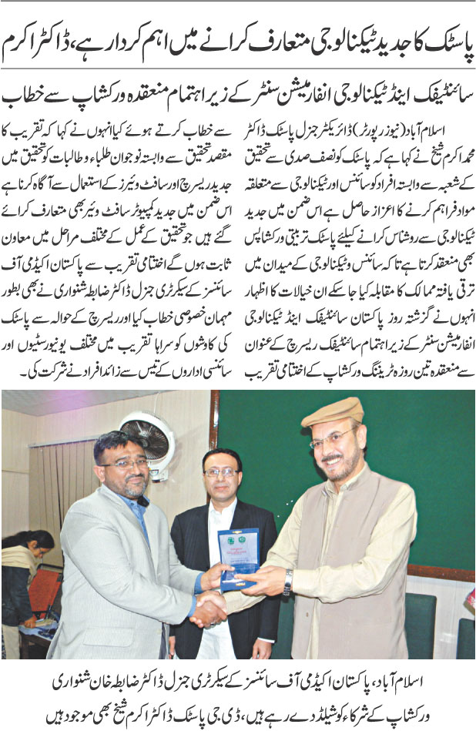

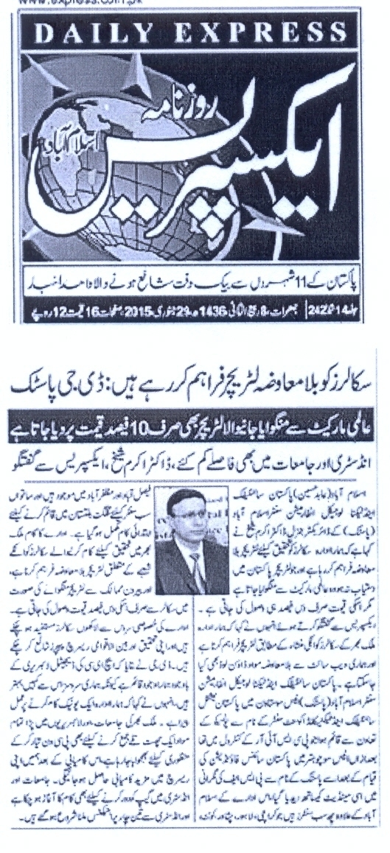

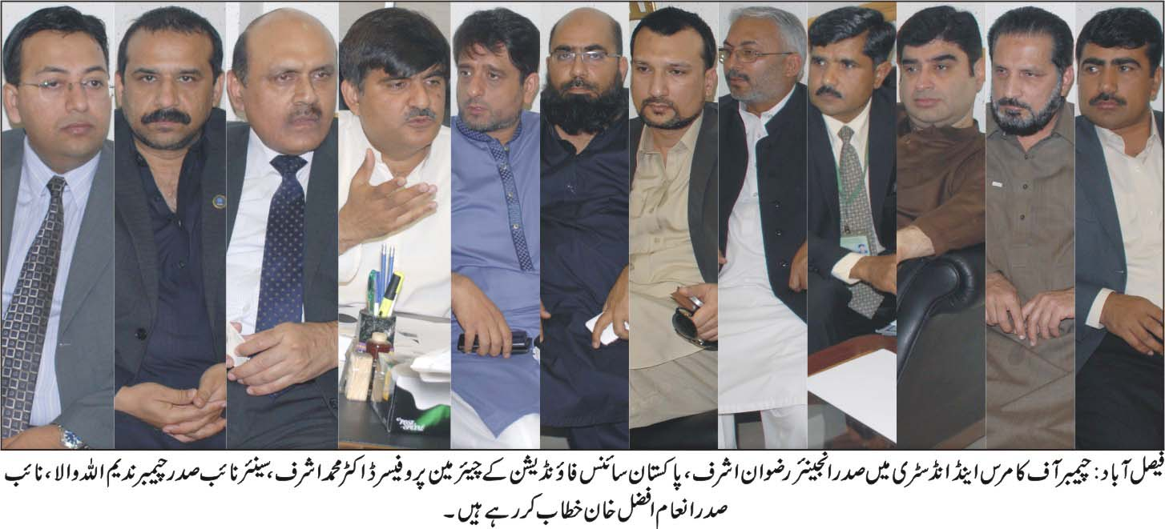

Error! Bokmark not defined.

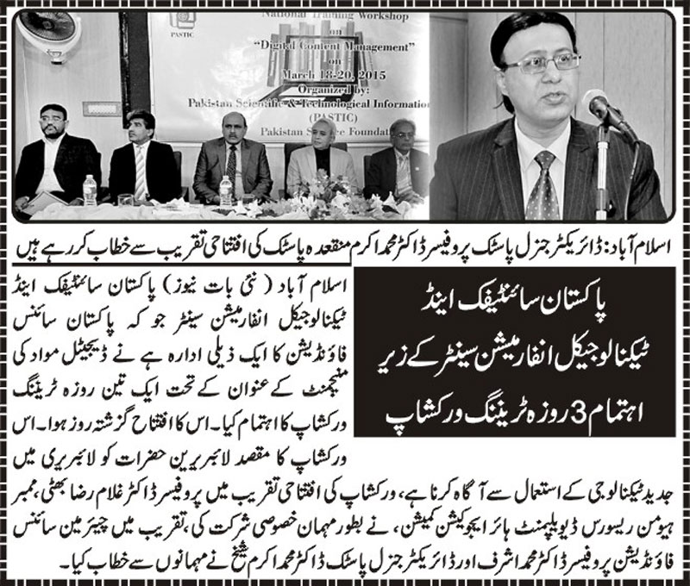

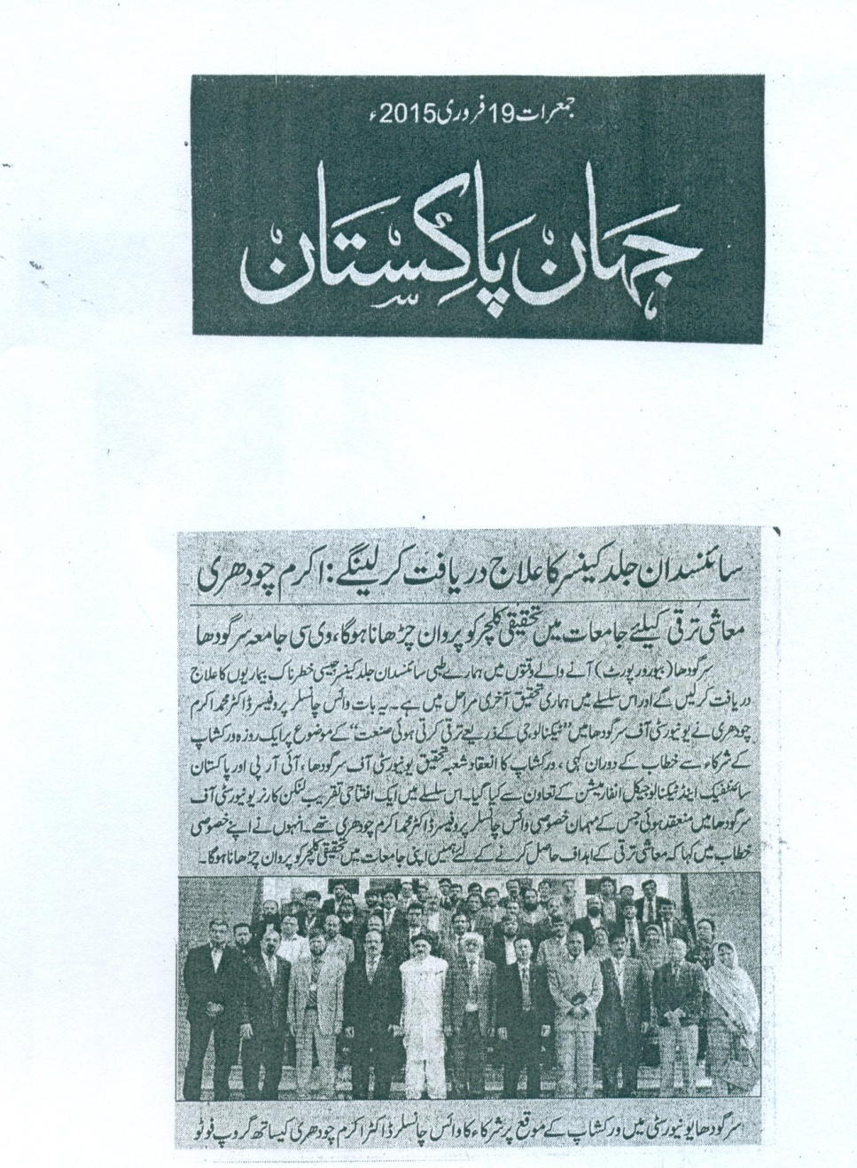

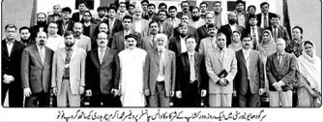a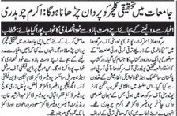

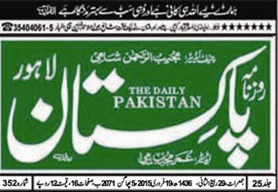
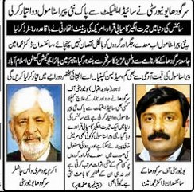

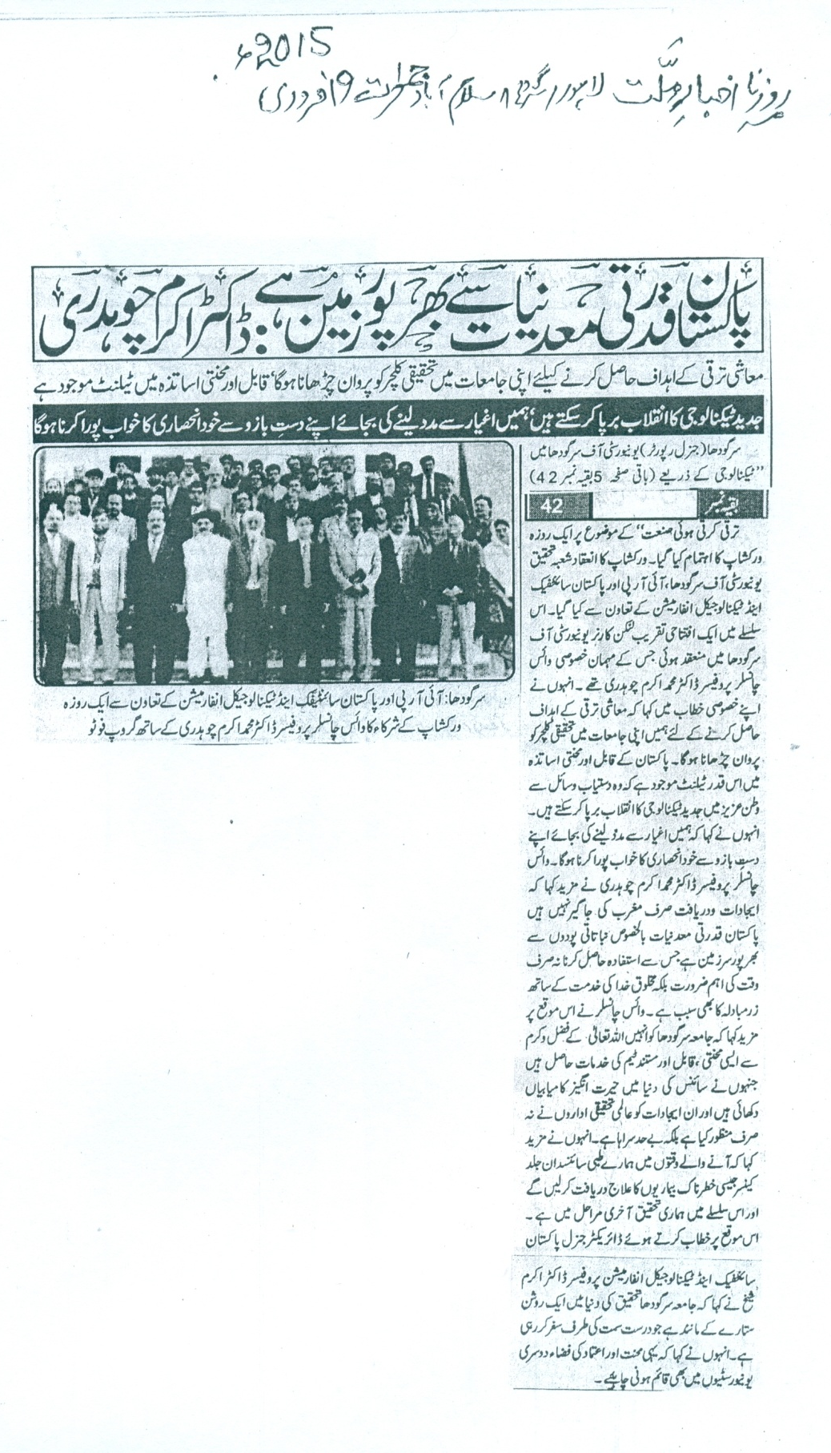

VI. AUDITOR`S REPORTS

    - PAKISTAN SCIENCE FOUNDATION

Financial Statement
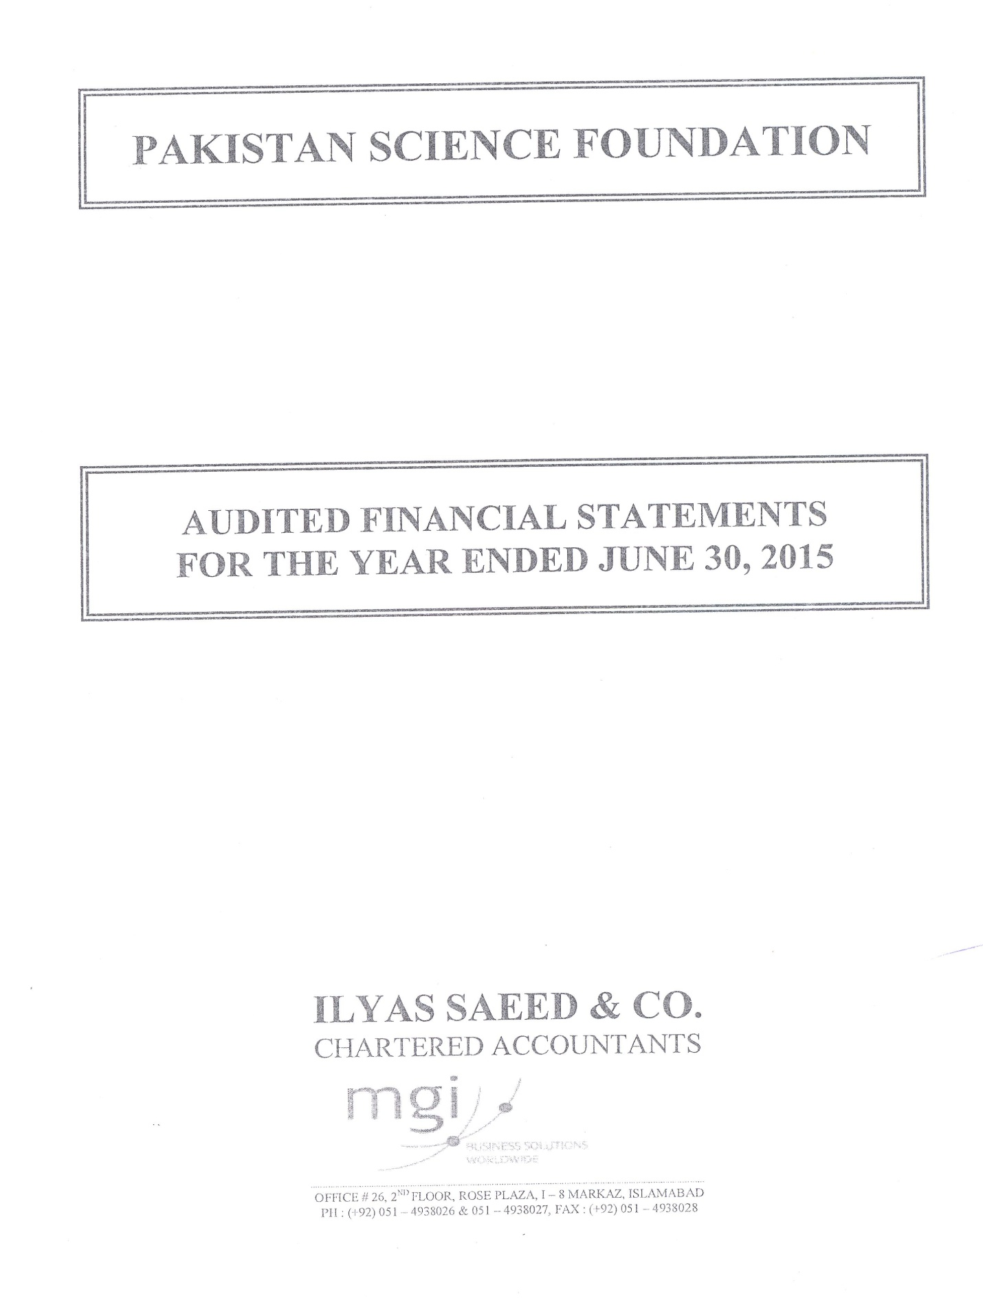

ANNEXURES

ANNEXURE-I

Pakistan Science Foundation Act 1973

National Assembly of Pakistan

Islamabad, the 2nd February, 1973

The following Acts of the National Assembly received the assent of the President on the 31st January, 1973, and are hereby published for general information:-

ACT NO. III OF 1973

An Act to provide for the establishment of the Pakistan Science Foundation

WHEREAS it is expedient to provide for the establishment of the Pakistan Science Foundation and for matters ancillary thereto;

It is hereby enacted as follows:-

1. Short title, extent and commencement.-(1) This Act may be called the Pakistan Science Foundation Act, 1973.

(2) It extends to the whole of Pakistan.
(3) It shall come into force at once.

2. Definitions – In this Act, unless there is anything repugnant in the subject or context,-

a). “Board” means the Board of Trustees of the Foundation;
(b). “Chairman” means the Chairman of the Foundation; and
(c) “Foundation” means the Pakistan Science Foundation established
under this Act.

8 THE GAZETTE O F PAKISTAN, EXTRA., FEB. 2, 1973 [PART 1

3. Establishment of the Foundation.-- (1) As soon as may be after the commencement of this Act, the Federal Government may, by notification in the official Gazette, establish a Pakistan Science Foundation to promote and finance scientific activities having a bearing on the socio-economic needs of the country.

(2) The Foundation shall be a body corporate by the name of the Pakis-tan Science Foundation, having perpetual succession and a common seal, with power, subject to the provisions of this Act, to acquire, hold and dispose of pro-perty, both movable and immovable, and shall by the said name sue and be sued.

(3) The head office of the Foundation shall be at Islamabad.

4. Functions of the Foundation.-(1) The Foundation shall function as a financing agency for –

(i) | the establishment of comprehensive scientific and technological in-formation and dissemination centres;
(ii) | the promotion of basic and fundamental research in the universities and other institutions on scientific problems relevant to the socio-economic development of the country;
(iii) | the utilization of the results of scientific and technological research including pilot plant studies to prove the technical and economic feasibility of processes found to be promising on a laboratory scale;
(iv) | the establishment of science centres, clubs, museums, herbaria and planetaria;
(v) | the promotion of scientific societies, associations and academies engaged in spreading the cause of scientific knowledge in general or in the pursuit of a specific scientific discipline or technology in particular;
(vi) | the organization of periodical science conferences, symposia and seminars;
(vii) | the exchange of visits of scientists and technologists with other countries;
(viii) | the grant of awards, prizes and fellowships to individuals engaged in developing processes, products and inventions of consequence to the economy of the country ; and
(ix) | special scientific surveys not undertaken by any other organization and collection of scientific statistics related to the scientific effort of the country.

(2) The Foundation shall also—

(i) | review the progress of scientific research sponsored by it and evaluate  the results of such research;
(ii) | maintain a National Register of highly qualified and talented  scientists of Pakistan, including engineers and doctors, in or outside  the country and to assist them, in collaboration with the concerned  agencies in finding appropriate employment; and
(iii) | establish liaison with similar bodies in other countries.
(3) In the performance of its functions, the Foundation shall be guided on questions of policy by the instructions, if any, given to it by the Federal Govern-
ment which shall be the sole judge as to whether a question is a question of policy.

Part I] THE GAZETTE OF PAKISTAN, EXTRA, FEB., 2, 1973 9
============================================================
5. Board of Trustees.- (1) The general direction, conduct and management of the affairs of the Foundation, including administration of its funds, shall vest in a Board of Trustees consisting of the following members, namely:-

Whole-time members

- the Chairman;
- one eminent scientist;
- the Director of Finance;

to be appointed by the President;

Part-time members

- the Chairman of the National Science Council;
- four scientists to be nominated by the National Science Council; and
- eleven eminent scientists to be nominated by the President.

(2) The remuneration and other terms and conditions of service of Chair-
man and the two other whole-time members of the Board shall be such as
may be determined by the President.

6. Chairman of the Foundation.- (1) The Chairman of the Board shall be the Chairman of the Foundation and shall be appointed from amongst eminent scientists of the country having experience of research and scientific administration

(2) The Chairman shall, subject to sub-section (3), hold office for a term not exceeding three years and shall be eligible for re-appointment.

(3) The President may at any time terminate the appointment of the Chairman without notice and without assigning any reason.

7. Members of the Board.- (1) The members of the Board, other than the ex-officio member shall, subject to sub-section (3), hold office for a term not exceeding three years and shall be eligible for re-appointment or re-nomination, as the case may be.

(2) A member, other than an ex-officio member, may at any time resign his office by writing under his hand addressed to the President but shall continue to perform his functions until his resignation has been accepted.

(3) The President may at any time terminate the appointment or, as the case may be, nomination of any member of the Board without notice and with out assigning any reason
______________________________________________________________________
(As amended vide Ordinance No XIII of 1979, published in the
Gazette of Pakistan, Extra, Feb, 24, 1979) Part I,

10 THE GAZETTE OF PAKISTAN, EXTRA., FEB. 2, 1973 [PART 1
============================================================

8. Meetings of the Board.---(1) The meetings of the Board shall be held at least twice a year and shall be presided over by the Chairman or, in his absence by its whole-time scientist member.

(2) All decisions at a meeting of the Board shall be taken by a majority of the votes of the members present and voting.

9. Quorum at the meeting of the Board.—To constitute a quorum at a meeting of the Board not less than nine members shall be present.

10. Executive Committee.- There shall be an Executive Committee consisting of the Chairman and the two other whole-time members of the Board.

11. Delegation of powers.—The Board may, from time to time, delegates to the Chairman or the Executive Committee such of its powers and functions as it may consider necessary.

12. Adhoc Committees.—The Foundation may set up ad hoc committees consisting of university professors and other leading scientists and experts to scrutinize applications for financial assistance for carrying out scientific research submitted to the Foundation by the universities or other institutions or by individual scientific workers or groups of scientific workers and to review ;and evaluate the results of research sponsored by the Foundation.

13. Funds.—The funds of the Foundation shall consist of—

(a) grants made by the Federal Government and the Provincial Government
donations and endowments ; and income from other sources.

14. Budget.—The Foundation shall cause to be prepared and approve a statement
of its receipt and expenditure for each financial year.

15. Accounts and audit.—(1) The funds of the Foundation shall be kept in a personal ledger account of the Foundation with the State Bank of Pakistan or with any Branch of the National Bank of Pakistan acting as an agent of the State Bank.

(2). The accounts of the Foundation shall be maintained in such form and manner as the Auditor-General of Pakistan may determine in consultation with the Federal Government.

(3) The accounts of the Foundation shall be audited by one or more auditors who are chartered accountants within the meaning of the Chartered Accountants Ordinance, 1961 (X of 1961), and are appointed by the Foundation in consultation with the Auditor-General of Pakistan.

THE GAZETTE OF PAKISTAN, EXTRA., FEB. 2, 1973 [PART 1
============================================================

16. Appointment of officers and servants.—(1) The Foundation may appoint such officers and servants, and engage such consultants or experts, as it may consider necessary for the efficient performance of its functions, on such terms and conditions as it may deem fit.

(2) In fixing the terms and conditions of service of its officers and servants, the Foundation shall as nearly as may be conform to the scales of pay, allowances and conditions of service applicable to the corresponding class of employees of the Federal Government.

17. Annual report.—(1) The annual repot of the Foundation, which shall, among other things, clearly bring out the benefits accruing to the nation as a result of the activities sponsored by the Foundation, shall be prepared by the Chairman and submitted, through the Board, to the Federal Government alongwith the audited accounts of the Foundation.

(2) The annual report alongwith the audited accounts of the Foundation shall be laid before the National Assembly.

18. Regulations.—The Foundation may make Regulations for the efficient conduct of its affairs.

19. Repeal.—The Pakistan Science Foundation Ordinance, 1972 (LII of 1972), is hereby repealed.

ANNEXURE-II

List of Projects Recommended by Technical Committees in 2014-15

S. # |  | Project Title & No. |  | P.I. Name, Designation & Address
1 |  | PSF/Res/ P-UA/ Bio (478)  Exploitation of Wild Edible Plant Diversity of the Punjab |  | Prof. Dr. Mumtaz Hussain  Department of Botany  University of Agriculture  Faisalabad
2 |  | PSF/Res/ P-UVAS/Bio (544)  The Development and Evaluation of Thermostable Vaccine against Peste des Petits Ruminants |  | Prof. Dr. Tahir Yaqub  Director, Quality Operations Lab / Institute of Biochemistry and Biotechnology  University of Veterinary and Animal Sciences, Lahore
3. |  | PSF/Res/C-NUST/Engg (136)  Plasmons Effects in Nano-Structures of Inorganic Polycrystalline Materials (ZnS, CdTe, CdS) by Embedding Different Metallic Nano-Particles (Ag, Au, Cu) for Improving Photovoltaic Efficiency in Photovoltaic Industry. |  | Dr. Iftikhar Hussain Gul  Associate Professor  Materials Engineering Department  School of Chemical & Materials Engineering (SCME)  National University of Sciences and Technology  Islamabad.
4. |  | PSF/Res/P-HITECU/Engg (113)  Compressed Air Powered Bike. |  | Prof. Dr. Syed Kamran Afaq  Chairman  Head of Department of Mechanical Engineering  HITEC University  Taxila
 | 5. | PSF/Res/KPK-UP/Bio (484)  Modification of Egg Cholesterol Content through Medicinal Plants | Dr. Naila Chand  Assistant Professor  Department of Poultry Science, Faculty of Animal Husbandry and Veterinary Science  KPK Agricultural University  Peshawar
 | 6. | PSF/Res/S-KU/Bio (550)  Pollen Morphological Studies of Rare, Enemic and Medicinally Important Plants of the Family Compositae from Pakistan and Kashmir. | Prof. Dr. Anjum Perveen  Director , Centre for Plant Conservation  Department of Botany  University of Karachi  Karachi

ANNEXURE-III

Detail of Monitoring and Evaluation of On-Going Projects in 2014-2015

- Non Development Budget

- Semi Annual Technical Reports

S. No. | Project No. | Project Title | Reports
1. | PSF/Res/S-AKU/Med (336) | Vitamin D Binding Protein to (VDPP) Gene Polymorphism and Diabetes mellitus in a Pakistan Population. | 2nd
2. | PSF/Res/ S-KU/Med (282) | New Approaches to Effective Pain Management: Clinical Potential of GABA Receptors Modulators in the Development of Chronic Pain. | 2nd
3. | PSF/Res/S-MUET/Engg (121) | Design & Implementation of Intelligent Energy Efficient Industrial Process Control System Using Conveyor Belts via Robotic Arm. | 1st

- First Annual Technical Reports

S.# | Project No. | Project Title
1. | PSF/Res/B-FGDC/Bio (458) | Parasites of Foxes and Jackels in Eastern Balochistan, with Special Emphasis on Disease of Veterinary and Zoonotic Importance.
2. | PSF/Res/P-UHS/ Biotech (107) | Molecular Genetic Studies in Pakistani Families with Autosomal Recessive Primary Microcephaly (MCPH)

c. Second Annual Technical Reports

S.# | Project No. | Project Title
1. | PSF/Res/P-AU/Agr (394) | Evaluation of Dried Citrus Pulp as a Concentrate Source and its Effect on Growth Performance and Milk Yield in Ruminant Animals.
2. | PSF/Res/P-PMAS.AAU/Agr (395) | Utilization of Plant Growth Promoting Rhizobacteria for the Inducvation of Systemic Resistance in Potato Seed against Bacterial Rot Disease.
3. | PSF/Res/P-AU/Bio (352) | Molecular epidemiology and immunehistochemistry of Enteropathogenic Escherichia coli (EPEC) in bovine and human neonates.
4. | PSF/Res/P-AU/Bio (431) | Molecular Epidemiological Study on Paratuberculosis alongwith Pathology of Mesentric Lymphnodes and Intestine in Buffalo and Cattle
5. | PSF/Res/P-PMAS.AAU /Bio (446) | Biodiversity and Ecology of Bats and Rodents in the Thorn Forests and Croplands of the Potohar Plateau
6. | PSF/Res/C-CIIT/ Bio (447) | Proteome Alterations Associated with Banana Bunchy Top Virus Infection in Banana
7. | PSF/Res/S-KU/Bio (454) | Study of Cysts of Dinoflagellates, Causing Harmful Algal Bloom (Red Tide) in Sediments of Coastal Areas of Pakistan, North Arabian Sea
8. | P-AU/Phys (151) | Synthesis of Soft and Hard Ferrites and their Characterization using Laser Induced Breakdown Spectroscopy.

d. Final Technical Reports
S.# | Project No. | Project Title
1. | PSF/Res/P-UET/Agr (376) | Assessment of Agricultural Drought Prone Areas ofPothwar and Agro-Ecological Zoning (AEZ) Using Remote Sensing Techniques.
2. | PSF/Res/P-PMAS-/Agr (396) | Studies on Characterization and Management of Leaf Crinkle Virus Infecting Black Gram.
3. | PSF/Res/P-AU/Agr (381) | Entomopathogenic Fungi and Diatomaceous Earths for the Control of Triboliumcastaneum (Herbst.) (Coleoptera: Tenebrionidae) on Stored Wheat.
4. | PSF/Res/P-AU/Bio (356) | Pigeon Newcastle Disease Virus: Surveillance and pathogenicity for chickens and Development of Vaccine for Control.
5. | PSF/Res/S-SALU/Bio (382) | Comparative Characterization and Recombinant Study of Indigenous Keratinase Enzymes.
6. | PSF/Res/P-UAAR/Bio (397) | Detection of multiple anthelmintic resistances of nematodes in small ruminants grazing Barani region.
7. | PSF/Res/KPK-AU/Bio (403) | Effect of sperm concentration, season and extenders on goats semen integrity and fertility.
8. | PSF/Res/P-AU/Bio (412) | Evaluation of Sugarcane Polysaccharides and Glycoprotein as Biological Response Modifiers and their Therapeutic Effects on Eimeria Infection in Chickens.
9. | PSF/Res/P-UVAS/Bio (416) | Estimation of Aflatoxins in Milk and its Control Measures.
10. | PSF/Res/P-PMASAAU /Bio (418) | Ethnobotanical Survey of Thal Desert, Punjab, Pakistan.
11. | PSF/Res/C-QU/Bio (419) | Functional Analysis of a Proteinase Inhibitor Gene Construct for Insect Resistance.
12. | PSF/Res/S-KU/Bio (422) | Marine Gastropods: Species Identification, Chemotaxonomy and Biochemical Characterization of Medicinally Important Proteins- Hemocyanins.
13. | PSF/Res/P-FCC/Bio (434) | Influence of Family History of Type 2 Diabetes Mellitus (T2DM) on Pituitary Gonadal Axis in Adolescent and Young Males.
14. | PSF/Res/P-GCU/Bio (436) | Enhanced Production of L-Lysine by Bacteria in Stirred Fermenter for Chick Feed Industry.
15. | PSF/Res/P-GCU/Bio (437) | Cloning and Characterization of Alpha Amylase from Thermotoga petrophilla for Textile Industry.
16. | PSF/Res/C-QU/Bio (455) | Collection, Evaluation and Sustainable Utilization of Crucifer Biodiversity in Pakistan.
17. | PSF/Res/ P-PMAS-UAAR/Biotech (93) | Determination of Biological Activities and Micropropagation of Polygonum amplexicaulis: a Popular Medicinal Plant in North Pakistan.
18. | PSF/Res/C-QU/Biotech (99) | Cloning and Characterization of Plastic Degrading Microbial Isolates.
19. | PSF/Res/S-HEJ/Chem(425) | Synthesis of Novel Piperidine like Compounds for Anticancer Activity.
20. | PSF/Res/P-CIIT/Chem(416) | Synthesis and Characterization of Novel Composites Based on Carbon Nanotubes and Carbonated Hydroxyapatite.
21. | PSF/Res/ C-NUST/Comp (37) | Enhancing the Scope of Pakistan Science Abstracts (PSA) to Improve Research Infrastructure in Pakistan
22. | PSF/Res/F-UET/Engg (104) | Design and Development of a Solar Energy Air Type heating system for warming up farm structures and poultry houses in KPK, Pakistan.
23. | PSF/R&D/F-KPK/Engg (216) | Design and Fabrication of a Laboratory Size Single Screw Extruder for Conversion of Agro-Based Materials into Value Added Food and Feed Products.
24. | PSF/Res/S-KU/Med (261) | Computer Aided Identification of Cholinesterase Inhibitors for the Treatment of Alzheimer’s Disease and Related Dementias.
25. | PSF/Res/S-KU/Med (282) | New Approaches to Effective Pain Management: Clinical Potential of GABA Receptors Modulators in the Development of Chronic Pain.
26. | PSF/Res/C-QU/Med (272) | Analysis of Association between TNF-Alpha Gene Polymorphism and Coronary Heart Disease in a Pakistani Population.

ANNEXURE-IV

List of Scientific Publications Produced through PSF Supported Completed
Projects in 2014-15
Sr. No | Project No. | Publication
1. | PSF/Res/P-NIAB/Bio (353) | - Amjad Hameed, Madiha Gohar and Nayyer Iqbal. Evaluation of seedling survivability and growth response as selection criteria for breeding drought tolerance in wheat. Cereal research Communications, 33(2):193-203, 2010.  - Amjad Hameed, Madiha Gohar and Nayyer Iqbal.Heat Stress induced Cell Death, changes in Antioxidants, Lipid Peroxidation, and Protease Activity in Wheat Leaves.Journal of Plant Growth Regulation (DOI 10.1007/s00344-011-9238-4)  - Amjad Hameed, Madiha Gohar and Nayyer Iqbal. Drought induced programmed cell death and associated changes in antioxidants, proteases, and lipid peroxidation in wheat leaves.(Submitted)
2. | PSF/Res/S-SU/Bio (423) | - Waheed A. P, Riffat S. , Wagan M. S and Snatosh K. 2013. Notes on the distribution and morphological description of Glyphonotus sinensis Uvarov, 1939 (Orthoptera: Tettigoniinae: Glyphonotini) from Pakistan. Int. J. Adv. Res. 1(9) 679-682.  - Waheed A.P , Riffat S, Wagan M. S and Santosh K. 2013. On the distribution and taxonomy of Conocephalus species (Orthoptera: Tettigonioidea: Conocephalinae) from Pakistan. Jour. Bio. Div & Envi. Sci. 3(11): 171-176.  - Riffat S, Waheed, A. P. and Wagan, M.S. 2012. Distribution and incidence of Tettigonioidea (Ensifera) Orthoptera from Sindh Pakistan. Pak. J. Ent Kar. 27 (2): 117-122.  - Panhwar W.A, Riffat S, Wagan M.S, Imran k and kumar S. Key for identification of Long-horned grasshoppers (Tettigonioidea) occurring in Pakistan. Pak. Jour. Ent.
3. | PSF/Res/Biotech /P-NIBGE/Ind (47) | - Akhtar K., Mudassar M., Ghauri M. A., Anwar M. A. and Khalid A. M. Development of hyperproducer cephalosporin C producing strain of Acremonium chrysogenum by RNA interference technique. Paper presented at the First National Conference on Industrial and Environmental Biotechnology held on 29-30 September, .2004, Islamabad, Pakistan. P. 18.  - Akhtar K., Muddassar M., Rehman M., Ghauri M. A, Anwar M. A. and Khalid A. M.Fungal RNAi vector construction for knockdown of CahB gene in Acremoniumchrysogenum fungus for hyper production of cephalosporin C. Poster presentation in the l^{st} International Conference on Environmental, Industrial and Applied Microbiology (BioMicroWorld-2005), March 15-18th 2005, Badajoz, Spain. Code no. 536.
4. | PSF/Res/S-KU/Biotech (92) | - Ahmed, N. Khan, I. and Salim, A. Effect of oxygen deprivation on the expression levels of mesenchymal markers in neonatal cardiomyocytes. (Submitted to Acta Cardiologica).
5. | KPK-KUST/Chem (409) | - Javid Hussain, Zia Muhammad, Farmanullah Khan (2010). “Nutrient evaluation and elemental analysis of selected medicinal plants of Pakistan”, Journal of Medicinal Plant Research 4(17), 1815-1821.  - Javid Hussain, Zia Muhammad, Farmanullah Khan (2010). “Evaluation of the Chemical Composition of Genus Sonchus and Sonchus Asper”, Journal of American Sciences, 6(9), 231-235.  - Javid Hussain, Zia Muhammad,, Jamila N,  Farmanullah Khan, U. Nishan, S.Ahmad, S. Ayaz and M. Tahir (2011). “Carbonic anhydrase II inhibition,urease inhibition and antioxidant activity of crude extract of Sonchus eruca”, Journal of Pharmacy Research, 4(4), 967-969  - A. Jameel Khader, Farman Ullah, Muhammad Ullah, Riazullah, Naser M. AbdEIslam,(2013). “Phytochemical and Antimicrobial Activity of Sonchus eruca” Journal of Pure And Applied Microbiology, 7(1), p. 249-252.
6. | S-SU/Chem (437) | - Rabel Soomro, Najma Memon, Muhammad Iqbal Bhanger, Muhammad Kashif Samoon (2013). “Microemulsion based organogel -silica composite as feasible matrix for immobilization of horseradish peroxidase: Application to oxidative removal of phenol from aqueous system” Journal Chemical Society of Pakistan, 35(3) 938-946.  - Rabel Soomro, Işık Perçin, Najma Memon, Muhammad Iqbal Bhanger and Adil Denizli (2015). “Gelatin-loaded p (HEMA-GMA) cryogel for high-capacity immobilization of horseradish peroxidase”, Artificial cells, nanomedicine, and biotechnology, 1-6
7. | S-SU/Chem (441) | - Muhammad Ali Mallah, S.T.H. Sherazi, Sarfaraz A. Mahesar and Abdul Rauf (2012). “Assessment of azithromycin in pharmaceutical formulations by Fourier-transform infrared (FT-IR) transmission spectroscopy”. Pakistan Journal of Analytical and Environmental Chemistry, 12(1 & 2) 61-67.  - Muhammad Ali Mallah, Syed Tufail Hussain Sherazi, Sarfaraz Ahmed Mahesar (2012). “Simultaneous Quantification of Ibuprofen and Paracetamol in Tablet Formulations using Transmission Fourier Transform Infrared Spectroscopy”. American Journal of Analytical Chemistry, 3(8), 503-511.  - Muhammad Ali Mallah, S.T.H. Sherazi, S. A. Mahesar and Abdul Rauf (2012). “Development and validation of green method for the assessment of clarithromycin in pharmaceutical formulations by Fourier-transform infrared (FT-IR) transmission spectroscopy”. Journal of the Chemical Society of Pakistan, 34(3), 656-662.  - Muhammad Ali, S. T. H. Sherazi, S. A. Mahesar (2014). “Appraisal of Erythromycin in Pharmaceutical Formulations by Transmission Fourier Transform Infrared (FT-IR) Spectroscopy”. Arabian Journal of Chemistry, 7(6), 1104-1109.
8. | PSF/Res/ S-AKU/Med (232) | - Rai, M.A., et al., Evidence for a "Founder Effect" among HIV-infected injection drug users (IOUs) in Pakistan. BMC Infect Dis, 2010. 10: p. 7.  - Khanani, M.R., et al., Prevalence of single, double, and triple infections of HIV, HCV and HBV among the MSM community in Pakistan. J Infect, 2010. 61(6): p. 507-9.  - Khanani, M.R., et al., Concentrated epidemics of HIV, HCV, and HBV among Afghan refugees. J Infect, 2010.61(5):434-7.  - Rajabali, A., et al., Communicable disease among displaced Afghans: refuge without shelter. Nature reviews. Microbiology, 2009. 7(8): p. 609-14.  - Ansari, A.S., et al., Patterns of HIV infection among native and refugee Afghans. AIDS. 25(11): p. 1427-30.  - Khanani, M.R., et al., The spread of HIV in Pakistan: bridging of the epidemic between populations. PLoS One, 2011. 6(7): 22449.

ANNEXURE-V

List of NSLP Projects Recommended by Technical Committees in 2014-2015
Sr.  No. | Project No. and Title | Name, Designation & Address of PI | Cost (Rs.)
 | Entomocidal Studies of Plant Materials against Maize Weevil (Sitophilus oryza) and Side Effect on Parasitoid Anisoptromanlous Calandareae (Howard)  PSF/NSLP/KP-GU(424) | Dr. Muhammad Mamoon-ul Rashid  Assistant Professor, Department of Entomology, Gomal University, D.I.Khan. | 1,622,927/-
 | Genetic Transformation of Brassica Carinata for Low Viscosity Biodiesel Production  PSF/NSLP/KP-AU (270) | Dr. Iqbal Munir  Associate Professor, IBGE,  University of Agriculture, Peshawar. | 3,447,192/-
 | Developing a Sustainable Formulation for Biological Control of Rice Bacterial Blight and Yield Increase Using Native Growth Promoting Bioantagonists  PSF/NSLP/P-NIBGE (319) | Dr. Sumera Yasmin, Senior Scientist, National Institute of Biotechnology & Genetic Engineering, Faisalabad. 0300-7610660 | 2,200,956/-
 | Cloning and Expression of Endopolygalacturonase Gene in E.Coli for Industrial Application  PSF/NSLP/P-UAAR (327) | Dr. Muhammad Javaid Asad  Associate Professor,  Dept. of Biochemistry, PMAS Arid Agriculture University, Rawalpindi | 3,551,819/-
 | Physiological and Molecular Investigation for the Development of Phyto Extraction Technology for Remediation for Heavy Metal Contaminated Soil  PSF/NSLP/KP-UM(432) | Dr. Fazal Hadi  Assistant Professor, Department of Biotechnology, University of Malakand, Lower Dir. | 1,134,648/-
 | Assessment of Maize Legume Multiple Intercropping System for Sustainable Production in Gilgit Baltistan  PSF/NSLP/GB-KU(478) | Dr. Muhammad Arshad  Assistant Professor, Dept. of Agriculture and Food Technology, Karakorum International University, Gilgit. | 3,057,144/-
 | Analysis of Endogenous Resistance in Monocotyledonous Plants and Heterologous Transgenic Expression in Plastids  PSF/NSLP/P-AU (343) | Prof. Dr. Muhammad Sarwar Khan  Centre of Agricultural Biochemistry & Biotechnology (CABB), University of Agriculture, Faisalabad. | 3,622,428/-
 | Nutritional Profiling and Antioxidant Potential of Selected Vegetables Waste and its Utilization for the Production of Value Added Foods  PSF/NSLP/P-BZU (394) | Dr. Saeed Akhtar  Associate Professor, Department of Food Sciences, Bahauddin Zakariya University, Multan | 2,165,897/-
 | Assessment of function composition and development of value added products from mulberry fruits of Gilgit Baltistan.  PSF/NSLP/GB-KU(449) | Sartaj Ali  Assistant Professor  Department of Food & applied science chemical technology, Karakoram International University, Gilgit | 3,880,284/-
 | Management of Root Knot Nematodes with organic extracts and agricultural wastes, and popularization of organic agriculture in Pakistan  PSF/NSLP/KP-AU(491) | Prof. Dr. SaifUllah  Chairman  Department of Plant Pathology  The University of Agriculture Peshawar | 3,394,611/-
 | Breeding high Yielding Mungbean (Vigna Radiata) L.Wilczek) genotypes for the agroclimatic conditions of Kuram Agency”  PSF/NSLP/KP-NIFA(492) | Dr. Gul Sanat Shah  Nuclear Institute for Food and Agriculture (NIFA) Tarnab, Peshawar | 2,218,704/-
 | Investigation of resistance breakdown of cotton leaf curl disease  PSF/NSLP/KP-US(515) | Dr. Fazal Akbar  Assistant Professor  Institute of Biotechnology and Microbiology  University of Swat | 3,187,245/-
 | Evaluation and Enhancement of Thermotolerance in Summer Vegetables  PSF/NSLP/P-AU (529) | Dr. Ch. Muhammad Ayoub  Associate Professor  Institute of Horticultural Sciences, University of Agriculture, Faisalabad | 3,411,084/-
 | Delivery of Protien and Micronutritients to School going Children through Shelf Stable Ready to Eat Crispy Nutribars  PSF/NSLP/P-AU (531) | Dr. Mian Kamran Sharif  Assistant Professor, National Institute of Food Science & Technology, University of Agriculture, Faisalabad | 2,270,316/-
 | Deciphering disease resistance potential of wheat verities and pathvar Diversity Using Molecular Diagnostic.  PSF/NSLP/B-BUITEMS(534) | Dr. Nazeer Ahmad  Associate Professor  Faculty of life Sciences & Informatics, BUITEMS, Quetta | 2,594,115/-
 | Pilot scale demonstration and popularization of dual technology of Bio-geyser with agro waste composting.  PSF/NSLP/KP-NIFA(536) | Dr. Amir Raza  Senior Scientist  Nuclear Institute for Food and Agriculture, Peshawar | 3,531,668/-
 | Exploitation of available new Chemistry Insecticides for their Nematicidal Potential against Root Knot Nematode and their Possible Integration with Bioagent (Pateuria penetrans) to Develop a Sustainable Management Strategy  PSF/NSLP/P-AU (569) | Prof. Dr. Nazir Javed  Department of Plant Pathology  University of Agriculture  Faisalabad | 2,969,424/-
 | Selection and development of chili varieties from indigenous and Exotic material in Lower Sindh  PSF/NSLP/S-PARC(603) | Dr. Attaullah Khan  Director Arid Zone Research Institute, Omer Kot, Sindh | 2,334,984/-

ANNEXURE-VI
Detail of Monitoring and Evaluation of NSLP On-Going Projects in 2014-2015
- Semi Annual Technical Reports
Sr. No. | Project No. | Project Title | Reports
 | PSF/NSLP/KP-AU(271) | Development of Abiotic Stress Tolerant Rice | 1st
 | PSF/NSLP/KP-AU(293) | Utilization of Maggots as an Alternative Animal Origin Protein on the Production Performance of Meat and Egg-Type Bird | 1st
 | PSF/NSLP/S-HEJ (290) | Synthesis of Combinatorial Libraries of Cyclic Peptides in Search of Novel Medicinal Agents | 1st
 | PSF/NSLP/KP-AU (281) | Genetic Engineering of Sugarcane with the Rice Tonoplast H⁺ PPase Gene to Improve Sucrose Content and Salt Tolerance | 1st
 | PSF/NSLP/S-SAU (236) | Biological Control of Okra Mealy Bug by Fungal Bio-Control Agents | 1st
 | PSF/NSLP/KP-AU (424) | Entomocidal Studies of Plant Materials against Maize Weevil (Sitophilus oryza) and Side Effect on Parasitoid Anisoptromanlous Calandareae (Howard) | 1st
 | PSF/NSLP/KP-AU (421) | Isolation and Structural Elucidation of the Antimicrobial Compounds Effective against the Wilt Pathogens from Penicillum sp. EU0013 | 1st
 | PSF/NSLP/P-UAAR(308) | Development of Genetic Evaluation Model for Dhanni Cattle as Potential Beef Cattle in Potohar Region of Punjab | 1st
 | PSF/NSLP/P-UAAR(501) | Surveillance & Characterization of Pathogens Infecting Loquat in Pakistan | 1st
 | PSF/NSLP/P-NIAB (155) | Isolation, Characterization & Bioremediation Potential of the EPS-Producing Bio-film Bacteria from Brackish & Polluted Irrigation Waters | 2nd
 | PSF/NSLP/P-AU(167) | Development of Information Management System for Commercial Broiler and Layer Farm Data. | 2nd
 | PSF/NSLP/KP-NIFA (253) | Nutrient Management of Deciduous Orchards (Plum) Through Foliar Feeding | 2nd
 | PSF/NSLP/S-SAU (242) | Integrated Pest Management in Organic Cotton and its Impact on Yield and Lint Quality Characteristics | 2nd
 | PSF/NSLP/P-AU (185) | Evaluation of Some Cereal Derived Polysaccharides and Natural Biological Response Modifiers and their Therapeutic Efficacy Against Ciccidiosis in Chicken | 2nd
 | PSF/NSLP/C-IU (249) | Molecular Characterization and Antibiotic Susceptibility Testing of Clostridium Perfringens Local Isolates from Healthy and Diseased Animals | 2nd
 | PSF/NSLP/P-AU(245) | Effect of Protein, Probiotics, Vitamin-C & E, on Semen Quantity & Quality, Health Biomarkers and Immunological Status of Retired Male Layer Breeders after Molting | 2nd
 | PSF/NSLP/P-UAAR (147) | Biotreatment of Industrially Discharged Azo Dye Contaminants Using Bioaugmentation | 3rd
 | PSF/ NSLP/P-PU (196) | Development of Gluten Free Flour from Indegenous Sources and its Biological Evaluation on Celiec Patients” | 3rd
 | PSF/ NSLP/KP-NIFA (178) | Development of Innovative Nutraceuticals Products from Indigenous Herbal Ingredients for Improving Socio-Economic Status of the Communities” | 3rd
 | PSF/NSLP/KP-NIFA (202) | Development of locally adapted canola (brassica napus l.) F1 hybrid using induced mutations and double haploidy techniques” | 3rd
 | PSF/NSLP/C-NARC (213) | Investigation on Fertility-Related Biomarkers in Buffalo Semen to Reduce Male Factor Loss (MFLs) | 3rd
 | PSF/NSLP/P-NIAB (149) | Improvement of Low Phytate Basmati Rice | 3rd
 | PSF/NSLP/P-PCSIR (195) | Biosynthetic Pathway and the Appearance of Anthocynins in small Tropical Fruits of Nutraceutical Significance Grown in Pakistan | 3rd
- First Annual Technical Reports
Sr. No. | Project No. | Project Title
 | PSF/NSLP/S-SAU (242) | Integrated Pest Management in Organic Cotton and its Impact on Yield and Lint Quality Characteristics
 | PSF/NSLP/KP-NIFA (253) | Nutrient Management of Deciduous Orchards (Plum) Through Foliar Feeding
 | PSF/NSLP/S-KU (240) | Studies on Modification and Food Applications of Modified White Sorghum (Sorghum bicolor) Starch
 | PSF/ NSLP/GB-PCSIR (437) | Processing of Fruits and Vegetables and its Utilization in the Development of Value Added Products
 | PSF/NSLP/P-UAAR(209) | Integrated Management of Brinjal Shoot & Fruit Borer, Leucinades Orbonalis (Lepidoptera: Pyralidae)
 | PSF/NSLP/P-UAAR (311) | Mosquito Fauna of Pothwar Region: A Resource-Based Approach
 | PSF/NSLP/P-UAAR (313) | Ants – Aphid’s Mutulistic Association, its Impact on Biological Parameters of Aphids and Predation of Coccinelids
 | PSF/NSLP/S-HEJ (290) | Synthesis of Combinatorial Libraries of Cyclic Peptides in Search of Novel Medicinal Agents
 | PSF/NSLP/KP-AU (293) | Utilization of Maggots as an Alternative Animal Origin Protein on the Production Performance of Meat and Egg-Type Bird
 | PSF/NSLP/P- AU(168) | Engineering Maize with Heat Shock Proteins
 | PSF/NSLP/KP-AU (271) | Development of Abiotic Stress Tolerant Rice
- Second Annual Technical Reports
Sr. No. | Project No. | Project Title
 | PSF/NSLP/C-NARC (213) | Investigation on Fertility-Related Biomarkers in Buffalo Semen to Reduce Male Factor Loss (MFLs)
 | PSF/NSLP/P-PCSIR (195) | Biosynthetic Pathway and the Appearance of Anthocynins in small Tropical Fruits of Nutraceutical Significance Grown in Pakistan
 | PSF/ NSLP/KP-NIFA (178) | Development of Innovative Nutraceuticals Products from Indigenous Herbal Ingredients for Improving Socio-Economic Status of the Communities
 | PSF/NSLP/KP-NIFA (202) | Development of locally adapted canola (brassica napus l.) F1 hybrid using induced mutations and double haploidy techniques
 | PSF/NSLP/P-NIAB (149) | Improvement of Low Phytate Basmati Rice
 | PSF/NSLP/S-SAU (142) | Study of the Long Term Impact of Farmer’s Field School for Cotton Regarding Integrated Pest Management Practices in Sindh & Punjab Provinces of Pakistan
 | PSF/NSLP/P-NIAB (164) | Development of High Yielding and Disease Resistant Hybrids of Tomato
 | PSF/NSLP/P-BZU (130) | Breeding for impact of different temperatures on bt cruciferous crops and development of resistance to insecticides in plutella xylostella”
 | PSF/NSLP/KP-NIFA (203) | Development & Validation of Technologies for Pesticide Residue Management in Fruit and Vegetable Produce
 | PSF/NSLP/P-NIAB (155) | Isolation, Characterization & Bioremediation Potential of the EPS-Producing Bio-film Bacteria from Brackish & Polluted Irrigation Waters

- Final Technical Reports
Sr. No. | Project No. | Project Title
 | PSF/NSLP/S-KU (134) | AM Fungi as Potential Biocontrol Agent for Crop Improvement and Bioprotectant Against Root-Knot Nematodes
 | NSLP/KP-NIFA (171) | Integrated Management of Peach Flat-Headed Borer, sphenoptera dadkhani (Oben.) Damaging Trees of Stone Fruit Orchards
 | PSF/NSLP/P-AU(78) | Escalating the Feed Value of Wheat Straw through Ensiling with Rumen Digesta as an Inoculant in Ruminant Animals
 | PSF/NSLP/KP-CIIT(51) | Wheat Improvement by the use of Targeted Genomic Approaches
 | PSF/NSLP/KP- NIFA (160) | Improvement of Stevia (Stevia rebaudiana Bertoni) through Induced Mutations and in Vitro Somaclonal Variations
 | PSF/NSLP/P-AU(245) | Effect of Protein, Probiotics, Vitamin-C & E, on Semen Quantity & Quality, Health Biomarkers and Immunological Status of Retired Male Layer Breeders after Molting
 | PSF/ NSLP/P-FCCU (179) | Phytochemical and Biotechnological Studies on Antioxidant and Antimicrobial compounds in Lagenaria siceraria (Molina) Standl
 | PSF/ NSLP/P-LPRI (151) | Sero-Prevalence and Molecular Diagnosis of Caprine Mycoplasmosis in Different Districts of Punjab”
 | PSF/NSLP/P-PU (196) | Development of Gluten Free Flour from Indegenous Sources and its Biological Evaluation on Celiec Patients”
 | PSF/NSLP/S-KU(140) | Assesment of Groundwater Quality and Soil Salinity in Parts of Thatta District, Sindh: Impact of Recent Floods on Agricultural Productivity and Options to Manage Salinity in Irrigated Lands
 | PSF/NSLP/S-SAU (252) | Population Biology and Management of Papaya Mealybug, Paracoccus marginatus- A Threat to Papaya Cultivation in Coastal Areas of Pakistan

ANNEXURE-VII
List of NSLP On-Going Projects Monitored On-Site in 2014-15
On-Going Projects in Karachi

Sr.  No. | Project Title and No. | Name of Principal Investigator and organization. | Area of Research
 | Application of Biopesticides Entomopathogenic Nematodes in Vegetable Fields Affected with Root Knot Nematodes PSF/NSLP/S-KU(65) | Dr. Shahina Fayyaz, Director, National Nematological Research Centre, University of Karachi, Karachi | Plant Pathology (Nematology)
 | To Speed up the Pilot Plant Production of Humic Acid PSF/NSLP/S-PCSIR (272) | Mr. Gulzar Hussain Jhatial Director, Fuel Research Centre, PCSIR, Karachi. | Agri. Engineering
 | AM Fungi as Potential Biocontrol Agent for Crop Improvement and Bioprotectant Against Root-Knot Nematodes PSF/NSLP/S-KU (134) | Dr. Feroza Kazi, National Nematological Research Center, University of Karachi, Karachi | Plant Pathology , Nematology
 | Nematodes Associated with Almond (Prunus amygdalus Batsch) and Pomegranate (Punica granatum L.) and their Management using Oil-Cakes in Khuzdar and Kalat Districts  NSLP/S-PARC (1) | Dr. Aly Khan, Director/Principal Scientific Officer, Crop Diseases Research Institute, Pakistan Agricultural Research Council, University of Karachi, Karachi | Plant Pathology , Nematology
 | Occurrence and Control of Nematodes Associated with Fruit Nurseries in Balochistan  PSF/NSLP/S-PARC (187) | Dr. Aly Khan, Director, Crop Disease Research Institute, PARC, University of Karachi, Karachi.  0300-9231131, 021-99261564 | Plant Pathology , Nematology
 | Assesment of Groundwater Quality and Soil Salinity in Parts of Thatta District, Sindh: Impact of Recent Floods on Agricultural Productivity and Options to Manage Salinity in Irrigated Lands PSF/NSLP/S-KU(140) | Prof. Dr. Viqar Husain, Department of Geology, University of Karachi  0321-2157938  021-99261300-26 Ext 2540 | Soil Science
 | Synthesis of Combinatorial Libraries of Cyclic Peptides in Search of Novel Medicinal Agents  PSF/NSLP/S-HEJ (290) | Dr. Farzana Shaheen  Associate Professor, H.E.J Research institute of Chemistry international centre of chemical Science University of Karachi. 0300-2848287. | Biochemistry

On-Going Projects in Peshawar

Sr.  No. | Project Title and No. | Name of Principal Investigator and organization. | Area of Research
 | Improvement of Stevia (Stevia rebaudiana bertoni) through Induced Mutations and in Vitro Somaclonal Variations PSF/NSLP/KP- NIFA (160) | Shahid Akbar Khalil, Nuclear Institute for Food and Agriculture (NIFA) Tarnab, Peshawar. | Plant Breeding and Genetics
 | Integrated Management of Peach Flat-Headed Borer, Sphenoptera dadkhani (Oben.) Damaging Trees of Stone Fruit Orchards PSF/NSLP/KP-NIFA (171) | Muhammad Zahid, Senior Scientist, Nuclear Institute for Food & Agriculture, Tarnab, Peshawar | Entomology
 | Development of Innovative Nutraceuticals Products from Indigenous Herbal Ingredients for Improving Socio-Economic Status of the Communities  PSF/NSLP/KP-NIFA (178) | Dr. Ihsanullah  Deputy Chief Scientist  Nuclear Institute for Food & Agriculture  Peshawar | Food Sciences
 | Development of locally adapted canola (brassica napus l.) F1 hybrid using induced mutations and double haploidy techniques  PSF/ NSLP/KP-NIFA (202) | Mr. Iftikhar Ali, Principal Scientist, Nuclear Institute for Food & Agriculture, Tarnab, Peshawar | Plant Breeding and Genetics
 | Development & Validation of Technologies for Pesticide Residue Management in Fruit and Vegetable Produce  PSF/NSLP/KP-NIFA (203) | Dr. Azhar Rashid, Senior Scientist, Nuclear Institute for Food & Agriculture, Peshawar | Food Toxicology
 | Nutrient Management of Deciduous Orchards (Plum) Through Foliar Feeding  PSF/NSLP/KP-NIFA (253) | Dr. Syed Azam Shah  Senior Scientist, NIFA, Peshawar | Soil science
 | Prevalence & Molecular Characterization of Contagious Caprine pleuropneumonia in small Ruminants in Khyber Pakhtunkhwa PSF/NSLP/KP-AU (219) | Dr. Umar Siddique, Chairman, Department of Animal Health, The University of Agriuculture, Peshawar. | Animal Health
 | Development of Abiotic Stress Tolerant Rice  PSF/NSLP/KP-AU (271) | Dr. Asad Jan  Associate Professor, IBGE, KP Agricultural University, Peshawar. | Plant Biotechnology
 | Genetic Engineering of Sugarcane with the Rice Tonoplast H⁺ PPase Gene to Improve Sucrose Content and Salt Tolerance  PSF/NSLP/KP-AU (281) | Dr. Sayyar Khan Kazi,  Assistant Professor, Institute of Biotechnology & Genetic Engineering, The University of Agriculture, Peshawar | Plant Biotechnology
 | Utilization of Maggots as an Alternative Animal Origin Protein on the Production Performance of Meat and Egg-Type Bird  PSF/NSLP/KP-AU (293) | Prof. Dr. Sarzamin Khan  Chairman, Department of Poultry Sciences, The University of Agriculture, Peshawar | Animal nutrition
 | Isolation and Structural Elucidation of the Antimicrobial Compounds Effective against the Wilt Pathogens from Penicillum sp. EU0013  PSF/NSLP/KP-AU (421) | Dr. Zafar Iqbal  Assistant Professor Department of Agricultural Chemistry, The University of Agriculture, Peshawar. | Plant pathology
 | Genetic Transformation of Brassica Carinata for Low Viscosity Biodiesel Production  PSF/NSLP/KP-AU (270) | Dr. Iqbal Munir  Associate Professor,  IBGE, The University of Agriculture, Peshawar | Plant biotechnology

ANNEXURE-VIII
List of Scientific Publications through NSLP Supported Projects in 2014-15
Sr. No | Project No. | Publication
01. | PSF/NSLP/P-AU (120) | Naveed MR, Ahmad N, Ahmad I, Akhtar N, Ali S, Zubair M, Murtaza S.2014. Effects of FSH extracted from in vitro cultured anterior pituitary cells of male buffalo calves on body and testes weight, serum FSH and total cholesterol and hematological variables in male rabbits. J. of Animal Reproduction Science.150(3-4)125–129
02. | PSF/NSLP/KP-NIFA (160) | N. Aman, F. Hadi, S. A. Khalil, R. Zamir and N. Ahmad. 2013. Efficient regeneration for enhanced Steviol Glycosides production in Stevia rebaudiana (Bertoni). Comptes Rendus Biologies. 336(10): 486-492  S. A. Khalil, R. Zamir and N. Ahmad. 2014. Selection of suitable propagation method for consistent plantlets production in Stevia rebaudiana (Bertoni). Saudi Journal of Biological Sciences. 21: 566- S. A. Khalil, R. Zamir and N. Ahmad. 2014.  Effect of Different Propagation Techniques and Gamma Irradiation on Major Steviol Glycoside’s Content in Stevia rebaudiana. The Journal of Animal and Plant Sciences. 24(6): 1743-1751573
03. | PSF/NSLP/KP-NIFA (171) | Integrated control of Peach flat-headed borer, Sphenoptera dadkhani (Oben.) in plum orchard” in 32nd Pak. Cong. Zoology (International) held on March 6-8, 2012 at G.C. Univ., Lahore.
04. | PSF/NSLP/P-PU(196) | Comparative efficiency of different methods of gluten extraction in indigenous varieties of wheat Authors: Samra Imran, Zaib Hussain, Farkhanda Ghafoor, Saeed Ahmad Nagra, Naheeda Ashbeal Ziai.Journal: ALLAN vol 63 (2)180-187, 2014  Effect of Formulated Gluten Free Flour on the Nutritional Status of Celiac Patients Authors: Samra Imran, Tahir Javed, and Saeed Ahmad Nagra . Journal: Journal of Nutritional Ecology and Food Research Vol. 2, 1–10, 2014

05. | PSF/NSLP/P-FCCU(179) | Parsa D., Ahmed D., Waqas U., Saeed R. and Chaudhery R., 2014. Comaparative Analysis of Antimicrobial potential of Peel and Mesocarp of Lagenaria Sicerarai fruit extracts in various solvents against clinincally important pathogens. Pharmacology online.Vol.3,100-105.  A. Dildar, Fatima M. and Saeed S.,2014, Phenolic and flavonoid contents and anto-oxidative potential of epicarp an mesocarp of Lagenaria siceraria fruit: a comparative study. Asain Pacific J. of Tropical Medicine.doi 10.1016/s/1995-7645(14)60241-8  C. Raza, Ahmed D., Liaqat I., Dar P. and Shahban M., 2014. Study of bioactivities of lipid content of fresh Lagenaria Siceraria seeds pulp and identification of its chemical constituents. J. ofmedicinalplantresearch.Doi01.5897/JMPR2013.5391.
06. | PSF/NSLP/S-PARC(187) | Khan, A., Khatoon, N., Shaukat, S.S. 2013. Plant nematodes associated with apple (Malus pumila (Mill.). Int. J. Biol. Res., 1(1): 11–14.  Khan,A., Shaukat, S.S. and Khatoon, N. 2013. An analysis of phyto-nematodes associated with peach (Prunus persica L.) seedling in Balochistan, Pakistan. Pak. J. Nematology, 31(2): 153–156  Khan, A., Shaukat, S.S., N. Khatoon, J. Akhtar and A.K. Rizwana, 2014. Plant nematodes associated with grapevine seedlings and rootstock in Balochistan. Pakistan Journal of Nematology, 32: 237–240.  Khan, A., Shaukat, S.S. and Khatoon, N., 2014. Effect of organic amendments on nematode population associated with apple seedlings. Indian Journal of Nematology, 44: 6–8.  Khan, A., Shaukat, S.S. and Handoo, Z.A., 2014. Efficacy of several amendments for the control of Xiphinema index and Meloidogyne javanica on grapevine seedlings in Pakistan. International Journal of Nematology (England), 24: 149–152.  Sultana, N., Khan, A., Khanzada, K.A., Khatoon, N. and Shaukat, S.S., 2015. Histology of infected almond roots (Prunus amygdalus Batsch) seedlings with root-knot nematode (Meloidogyne javanica (Treub, Chitwood) and a fungus Plasmodiophora brassicae Woronin. Int. J. Biol. Biotech., 12(1): 63–68.  Khan, A., Shaukat, S.S., Khanzada, K.A. and Khan, M.S., 2015. Effect of amendments for the control of nematodes on peach seedlings. Pak. J. Nematology, 33(1): 93–98
07. | PSF/NSLP/P-UAAR(74) | Ali. I., A.Abbasi and I. A hafiz.2013. Physiological Response and quality attributes of peach fruit cv. Florda king as effected by different treatm,ents of calcium chloride, putrscine and salicyic acid.
08. | PSF/NSLP/S-KU(134) | Hajra,N., F. Shahaina and K. Firoza (2013). Biocontrol of root Knot Nematode by arbuscular mycorrhizal fungi in Luffa cylindrica. Pakistan Journal of Nematology, 31 (1):77-84.
09. | PSF/NSLP/KP-AU(161) | Khan, I., Khan, M.S., Khan, M.I., Rajab, H., Shah, S.H., and Jalal, A. (2013). Genetic transformation of Brassica napus with the antifungal chitinase gene. Int. J. Agric. Biol., 15: 933-938

ANNEXURE-IX

Detail of Caravan Exhibitions during 2014-15

Sr. No | Unit | Place of Visit | Dates | No.of schools | No. of students
1. | Tandojam | i. TandoBago  ii. Matli  iii. Daulatpur  iv. Kunri  v. Khudaabad (Dadu)  vi. Digri (Mirpur Khas) | 19.08.14 to 28.08.14  09.09.14 to 20.09.14  13.10.14 to 24.10.14  10.11.14 to 25.11.14  20.04.15 to 02.05.15  18.05.15 to 30.05.15 | 11  20  15  18  06  15  85 | 2740  3774  3019  3698  1000  2003  16234
2. | Sukkur | i. Dokri  ii. KandhKot  iii. NousheroFeroze  iv. Jacobabad  v. Bhiria City  vi. Gambat  vii. Mehrabpur | 19.08.14 to 29.08.14  09.09.14 to 25.09.14  13.10.14 to 28.10.14  06.11.14 to 26.11.14  08.12.14 to 20.12.14  21.04.15 to 0 5.05.15  13.05.15 to 26.05.15 | 13  17  16  22  14  24  12  118 | 2700  2835  2950  3850  2775  2700  2180  19990
3. | KPK Peshawar | i. GaramChashma  ii. Batgram  iii.Mughdarzai,Peshawar  iv. Akora Khattak  v. New Islamic Cadet  College, KPK.  vi. Rajjar, Charssada  vii. Khairabad (Mardan)  viii. Swabi  ix. SaiduSharif Swat  x. Khanpur Dir Lower | 06.08.14 to 01.09.14  15.09.14 to 27.09.14  13.10.14 to 18.10.14  23.10.14 to 01.11.14  6.11.14 to 08.11.14  17.11. 14 to 28.11.14  08.12.14 to 19.12.14  20.4.15 to 30.4.15  20.4.15 to 30.4.15  18.5.15 to 27.5.15 | 41  10  17  14  09  11  13  15  12  22  165 | 5192  5619  1751  1566  1512  950  1840  2460  1738  3577  27600
4. | Punjab unit Faisalabad | i. Bhowana  ii. Lalian  iii. Jahania/ Khanewal  iv Multan  v. MianChannu  vi. Jinnah cadet school  vii. Bakhar | 02.09.14 to 12.09.14  14.10.14 to 24.10.14  10.11.14 to 20.11.14  22.09.14 to 02.10.14  09.12.14 to 20.12.14  17.09.14 to 18.09.14  26.05.15 to 06.06.15 | 15  10  18  05  02  09  12  71 | 5900  5000  [[[[[  4800  4200  500  3051  3731  21282
5. | Jaffarabad/  Quetta | i. Sibbi  ii. Hub  iii. Suhbatpur  iv.Usta Muhammad  v. Lasbella | 17.09.14 to 03.10.14  06.11.14 to 23.11.14  08.12.14 to 20.12.14  23.03.15 to 10.04.15  12.04.15 to 01.05.15 | 20  18  21  16  11  86 | 5383  2354  4828  5500  2950  21015
6. | Federal | i. Murree  ii. WahCantt, Taxila  iii.Hill Crest, Abbotabad  iv.Cadet College Batrasi  v. IST, Islamabad  vi. ThobaRawalpind  vii. Jinnah Convention  Centre, Islamabad  viii. Roots international School, Islamabad  ix. BaharaKahu, Islamabad.  x. GHSS, Paryal  xi. GHSS, Kalas | 08.09.14 to 13.09.14  15.09.14 to 19.09.14  20.10.14 to 25.10.14  26.10.14 to 31.10.14  06.11.15 to 08.11.15  06.04.15 to 10.04.15  18.4.15 to 19.04.15  29.04.15  06.05.15 to 07.05.15  11.05.15 to 16.05.15  18.05.15 to 22.05.15 | 11  8  7  6  20  7  2  10  3  6  16  94 | 1121  1950  1950  1850  4000  950  2000  2000  678  2000  1450  19949
 |  |  | Grand Total | 619 | 126170

ANNEXURE-X

Detail of 24th Intra Board Science Essay Competition 2014-15

Theme: Why Students Feel Difficulty in Science Education

- BISE MALAKAND
Sr. # | Students Name | School Name | Board | Medium | Position | Prize Money
 | Ayesha Mahmood | Cambridge Public School Khar Batkhela Distt Malakand | Malakand | English | 1st | Rs.5000/-
 | Waseem Abbas | The educator School Thana, DisttMalakand | Malakand | English | 2nd | Rs.3000/-
 | Israr Ahmad | Pak Education Academy Alladad, DisttMalakand | Malakand | English | 3rd | Rs.2000/-

- SAHIWAL
Sr. # | Students Name | School Name | Board | Medium | Position | Prize Money
 | Fizza Ahmed D/O Zulfiqar Ahmed | Govt. Binatul Islam HS Sahiwal | Sahiwal | English | 1st | Rs.5000/-
 | Hira D/O Muhammad Akram | GGHS 90/9-L Sahiwal | Sahiwal | English | 2nd | Rs.3000/-
 | MalihaZahid D/O ZahidMahmood | GG Model Pilot Secondary School Sahiwal | Sahiwal | English | 3rd | Rs.2000/-
 | Iram Nawaz D/O Muhammad Nawaz | Govt. Girls Higher Secondary School 134/9-L, Sahiwal | Sahiwal | Urdu | 1st | Rs.5000/-
 | Fatima Shokat D/O Shakot Ali | Govt. Girls Higher Secondary School 120/9-L Sahiwal | Sahiwal | Urdu | 2nd | Rs.3000/-
 | Maria Arshad D/O Arshad Jang | Govt. Banat-ul-Islam High School Sahiwal | Sahiwal | Urdu | 3rd | Rs.2000/-

- BISE BANNU
Sr. # | Students Name | School Name | Board | Medium | Position | Prize Money
 | Shah Abdul Latif | Akram Khan Durrani College, Bannu | Bannu | English | 1st | Rs.5000/-
 | Muhammad Esa | Akram Khan Durrani College, Bannu | Bannu | Urdu | 2nd | Rs.3000/-
 | Muhammad Kashif | Govt. High School No.1, Bannu | Bannu | Urdu | 3rd | Rs.2000/-

- BISE SUKKUR
Sr. # | Students Name | School Name | Board | Medium | Position | Prize Money
 | Lariab Khan | Apwa High School Sukkur | Sukkur | English | 1st | Rs.5000/-
 | Murk MuneerShaikh | Iqra Public Higher Secondary School Gambat | Sukkur | English | 2nd | Rs.3000/-
 | Sana Allah Wadhayo | Govt. girls High School New PindSukkur | Sukkur | English | 3rd | Rs.2000/-

- BISE LARKANA
Sr. # | Students Name | School Name | Board | Medium | Position | Prize Money
 | FarazHussainKourejo | Govt. Pilot Higher Secondary School Larkana | Larkana | English | 1st | Rs.5000/-
 | Asma Hassan Solangi | Govt. Girls English Model High School Larkana | Larkana | English | 2nd | Rs.3000/-
 | Kamran Gul Hassan | Cadet College, Larkana | Larkana | English | 2nd | Rs.3000/-
 | Kashif Nawaz | Cadet College, Larkana | Larkana | English | 3rd | Rs.2000/-
 | Muhammad Ayoub | Govt. Pilot Higher Secondary School Larkana | Larkana | Sindhi | 1st | Rs.5000/-
 | Saeed Ahmed | Govt. Pilot Higher Secondary School Larkana | Larkana | Sindhi | 2nd | Rs.3000/-
 | Shahzaib | Govt. Saint Joseph High School Larkana | Larkana | Sindhi | 3rd | Rs.2000/-
 | Miss Sapna | Govt. Saint Joseph High School Larkana | Larkana | Urdu | 1st | Rs.5000/-
 | Shahid Ali | Govt. Pilot Higher Secondary School Larkana | Larkana | Urdu | 2nd | Rs.3000/-
 | Naveed Raja | Govt. Saint Joseph High School Larkana | Larkana | Urdu | 3rd | Rs.2000/-
- BISE GUJRANWALA
Sr. # | Students Name | School Name | Board | Medium | Position | Prize Money
 | AleenaShahid | Jinnah Public School, Gujrat | Gujranwala | Urdu | 1st | Rs.5000/-
 | SaniaAkram | Punjab Grammar High School, Gujranwala | Gujranwala | Urdu | 2nd | Rs.3000/-
 | Iqra | Govt. Girls High School, Kashmir Colony, Gujranwala | Gujranwala | Urdu | 3rd | Rs.2000/-
 | RimshaShahzadi | The City School, Daska | Gujranwala | English | 1st | Rs.5000/-
 | UsmanJavedSahi | The City School, Daska | Gujranwala | English | 2nd | Rs.3000/-
 | Fatima Ali Dayal | Jinnah Public School, Gujrat | Gujranwala | English | 3rd | Rs.2000/-

- BISE HYDERABAD
Sr. # | Students Name | School Name | Board | Medium | Position | Prize Money
 | Syed Farhad Ali Shah | Govt. Higher School SUS Jamsho | Hyderabad | English | 1st | Rs.5000/-
 | Bisma Khan | AWPA Girls High School Latifabad | Hyderabad | English | 2nd | Rs.3000/-
 | SumanMemon | Army Public School Petaro | Hyderabad | English | 3rd | Rs.2000/-
 | Maryam | Dawood Memorial High School Hyderabad | Hyderabad | Urdu | 1st | Rs.5000/-
 | Abdullah | Fauji Foundation Model School Hyderabad | Hyderabad | Urdu | 2nd | Rs.3000/-
 | Humaria | Happy Home High School Kotri | Hyderabad | Urdu | 3rd | Rs.2000/-
 | NajmaGul | Govt. Girls Higher Secondary School, Hussainabad | Hyderabad | Sindhi | 1st | Rs.5000/-
 | Jameela | Govt. Girls High School Kotri | Hyderabad | Sindhi | 2nd | Rs.3000/-
 | Kashan Ali | Bright Future High School Hyderabad | Hyderabad | Sindhi | 3rd | Rs.2000/-

- BISE SARGODHA
Sr. # | Students Name | School Name | Board | Medium | Position | Prize Money
 | UmairInayat | Islamic Alta vista Boys High School Sargodha | Sargodha | English | 1st | Rs.5000/-
 | Mahnoor Fatima | The Leadership Girls High School 29/9 Stt Town Sargodha | Sargodha | English | 2nd | Rs.3000/-
 | Rafi Ullah | Comprehensive Model Boys High School Khayaban-e-Nawab, Sargodha | Sargodha | English | 3rd | Rs.2000/-
 | IqraBajwa | Govt. Girls Comprehensive High school Sargodha | Sargodha | Urdu | 1st | Rs.5000/-
 | Jaweria Ashraf | Islamic Alta vista Boys High School Sargodha | Sargodha | Urdu | 2nd | Rs.3000/-
 | Rubab Jahangir | GG Pilot Secondary School Sargodha | Sargodha | Urdu | 3rd | Rs.2000/-
- BISEMIRPUR AJK
Sr. # | Students Name | School Name | Board | Medium | Position | Prize Money
 | AemanQayyum | Govt. Girls High School Sahang, Mirpur AJK | Mirpur  (AJK) | English | 1st | Rs.5000/-
 | Malik UsamaArshad | Govt. Pilot Secondary School DadyalMirpur AJK | Mirpur  (AJK) | English | 2nd | Rs.3000/-
 | Fatima Aftab | Kashmir Model College Defense Road Sector D/4 Mirpur AJK | Mirpur  (AJK) | English | 3rd | Rs.2000/-
 | RimshaHafeez | Govt. Girls Higher Secondary School Chitter Pari P/O Chatter PariMirpur AJK | Mirpur  (AJK) | Urdu | 1st | Rs.5000/-
 | Muhammad Ikraam | Govt. Boys Inter College KatharDadyal, Mirpur AJK | Mirpur  (AJK) | Urdu | 2nd | Rs.3000/-
 | AminaKazmi | Govt. Degree College for Women ThothalMirpur AJK | Mirpur  (AJK) | Urdu | 3rd | Rs.2000/-

- BISE BAHAWALPUR
Sr. # | Students Name | School Name | Board | Medium | Position | Prize Money
 | ArsheenQuraishi | GGHS ChahFeteh Khan | Bahawalpur | English | 1st | Rs.5000/-
 | Ahmed Mehmood | GHSS Abbasia | Bahawalpur | English | 2nd | Rs.3000/-
 | SaadUllah Malik | GHS Sadiq Abbas APE | Bahawalpur | English | 3rd | Rs.2000/-
 | Hafiz Same-Ul-Hassan | GHS Fazil APE | Bahawalpur | Urdu | 1st | Rs.5000/-
 | Muhammad Awais | GHS Sahlan | Bahawalpur | Urdu | 2nd | Rs.3000/-

- BISE FAISALABAD
Sr. # | Students Name | School Name | Board | Medium | Position | Prize Money
 | Muhammad Uzair | Divisional Public School & College, Faisalabad | Faisalabad | English | 1st | Rs.5000/-
 | BurhanAfzal | ChiniotIslamia School & College Faisal Town, Faisalabad | Faisalabad | English | 2nd | Rs.3000/-
 | MahnoorSaqib | City Star Public Girls High School 424-A Peoples Colony No.1, Faisalabad | Faisalabad | English | 3rd | Rs.2000/-

- BISE KARACHI
Sr. # | Students Name | School Name | Board | Medium | Position | Prize Money
 | Zil-e-HumaAfzal | Customs Public School 29-C, Block-2, P.E.C.H.S, Karachi | Karachi | English | 1st | Rs.5000/-
 | UroojBint-e-Ahmed | Zubair Public Girls Higher Sec School, Gulshan-e-Iqbal Karachi | Karachi | English | 2nd | Rs.3000/-
 | HafizaLaiba Fatima Khan | IqraHuffaz Girls Sec School, Block-B, North Nazimabad, Karachi | Karachi | English | 3rd | Rs.2000/-
 | Mahnoor Mustafa | Bahria Model School Campus-1,, Majeed SRE Karachi | Karachi | Urdu | 1st | Rs.5000/-
 | MaleehaRiaz | Hayat-ul-Islam Model Secondary School Orangi Town, Karachi | Karachi | Urdu | 2nd | Rs.3000/-
 | MusfirahShoaib | IqraHuffaz Girls Sec School, Block-B, Al-amra Society, Karachi | Karachi | Urdu | 3rd | Rs.2000/-
 | Neha Khan | Bahria Model School Campus-2, Majeed SRE Stadium Road Karachi | Karachi | Sindhi | 1st | Rs.5000/-
 | JaveriaJalil | Zubair Public Girls Higher Sec School, Gulshan-e-Iqbal Karachi | Karachi | Sindhi | 2nd | Rs.3000/-
 | Urooba | IqraHuffaz Girls Sec School, Block-B, North Nazimabad, Karachi | Karachi | Sindhi | 3rd | Rs.2000/-

- BISE KOHAT
Sr. # | Students Name | School Name | Board | Medium | Position | Prize Money
 | Muhammad SaadBangash | Cadet College Kohat | Kohat | English | 1st | Rs.5000
 | Syed Muttahar Shah | Cadet College Kohat | Kohat | English | 2nd | Rs.3000/-
 | Haris Khan | St. Joseph Convent S/C Kohat | Kohat | English | 3rd | Rs.2000/-

ANNEXURE-XI

Detail of 24th Intra Board Science Poster Competition 2014-15

Theme: Disadvantages of Mobil Phones and Internet for Students

- BISE MALAKAND
SR. # | STUDENTS NAME | SCHOOL NAME | POSITION | PRIZE MONEY
 | Muhammad Waleed | GCMHS TimergaraDistt.DirLower | 1st | Rs.5000/-
 | MustaqeemAnjum | Govt. High School ShawaDistt. Dir Lower | 2nd | Rs.3000/-
 | Muhammad Zubair | Govt. High School No.1 AllahDad , DisttMalakand | 3rd | Rs.2000/-

- BISE SAHIWAL
SR. # | STUDENTS NAME | SCHOOL NAME | POSITION | PRIZE MONEY
 | IqraHabib D/O M. Habib | Govt. Banat-ul-Isla High School Sahiwal | 1st | Rs.5000/-
 | Sana Gull D/O Mushtaq Ahmad | Govt. Girls Higher Secondary School Comper 120/9-L Sahiwal | 2nd | Rs.3000/-
 | RamshaAsif D/O Muhammad Asif | Govt. Girls Higher Secondary School 134/9-L Sahiwal | 3rd | Rs.2000/-

- BISE LARKANA
SR. # | STUDENTS NAME | SCHOOL NAME | POSITION | PRIZE MONEY
 | Miss Shaherbano D/O Ahmed Baloch | Ahmed Ali Grammar High School Larkana | 1st | Rs.5000/-
 | Ravander Kumar Oad S/O Ramesh Kumar Oad | Govt. Boys High School Nasirabad | 2nd | Rs.3000/-
 | Miss Qosulnhiar D/O RaheemBux | Govt Girls High School LahoriMuhallaLarkana | 3rd | Rs.2000/-

- BISE SUKKUR
SR. # | STUDENTS NAME | SCHOOL NAME | POSITION | PRIZE MONEY
 | Shobha Rajput | Govt M.K High School Sukkur | 1st | Rs.5000/-
 | RamshaAsmat | Model School (S. A. L. U) Khairpur | 2nd | Rs.3000/-
 | KainatJawaidShaikh | Govt Girls Higher Secondary School Old Sukkur | 3rd | Rs.2000/-

- BISE GUJRANWALA
SR. # | STUDENTS NAME | SCHOOL NAME | POSITION | PRIZE MONEY
 | HadiaEjaz | The City School, Daska | 1st | Rs.5000/-
 | Muhammad Naeem | The City School, Daska | 2nd | Rs.3000/-
 | Noor Fatima | Dar-ul- Islam Science Girls H/S, MandiBahudin | 3rd | Rs.2000/-

- BISE HYDERABAD
SR. # | STUDENTS NAME | SCHOOL NAME | POSITION | PRIZE MONEY
 | Hamna Imran | St. Mary’s Convent High School | 1st | Rs.5000/-
 | Muhammad Muzammil | The Citizens Foundation  Secondary School RashidabadTando Allah Yar | 2nd | Rs.3000/-
 | Samiullah | Govt. High School Talib-ul-MoulaDadu | 3rd | Rs.2000/-
- BISE BANNU
SR. # | STUDENTS NAME | SCHOOL NAME | POSITION | PRIZE MONEY
 | Bushra Imran | Govt. Girls Higher Secondary School S. K. Bala, Bannu | 1st | Rs.5000/-
 | KashifSiddiq | Akram Khan Durrani College, Bannu | 2nd | Rs.3000/-
 | Shah Abdul Latif | Akram Khan Durrani College, Bannu | 3rd | Rs.2000/-

- BISE SARGODHA
SR. # | STUDENTS NAME | SCHOOL NAME | POSITION | PRIZE MONEY
 | ZartashaRana | Islamic Alta Vesta Girls High School, Sargodha | 1st | Rs.5000/-
 | Amna Tariq | Dar-e-Arqam Schools 138-C Satellite Town Sargodha | 2nd | Rs.3000/-
 | Moeza | GG Pilot Secondary School Sargodha | 3rd | Rs.2000/-

- BISE MIRPUR AJK
SR. # | STUDENTS NAME | SCHOOL NAME | POSITION | PRIZE MONEY
 | Samar Khalid | Govt. Girls High School Kalyal, Mirpur AJK | 1st | Rs.5000/-
 | Muhammad AzlanHaider | Kashmir Model College Defence Road Sector D-4 Mirpur AJK | 2nd | Rs.3000/-
 | JunaidIshaq | Govt. Boys Inter College KatharDadyal, Mirpur AJK | 2nd | Rs.3000/-
 | Saleema Fatima | Govt. Girls Degree College, PanjeriBhimber AJK | 3rd | Rs.2000/-
 | Tayyab Khalil | Govt. Pilot Secondary School DadyalMirpur AJK | 3rd | Rs.2000/-

- BISE BAHAWALPUR
SR. # | STUDENTS NAME | SCHOOL NAME | POSITION | PRIZE MONEY
 | MahmoodBhatti | GHS S.D Bahawalpur | 1st | Rs.5000/-
 | NomanShoukatBhatti | GHSS Abbasia Bahawalpur | 2nd | Rs.3000/-
 | NimraHabib | GGHS Model Town (A) Bahawalpur | 3rd | Rs.2000/-

- BISE FAISALABAD
SR. # | STUDENTS NAME | SCHOOL NAME | POSITION | PRIZE MONEY
 | Muneeb Ahmad Siddiqui | Govt. Comp. Model Higher Secondary School Samanabad, Faisalabad | 1st | Rs.5000/-
 | Yasir Ali | Divisional Public School & College Faisalabad | 2nd | Rs.3000/-
 | Muhammad Bilal | Joint Forces Higher Secondary School JhangSadar | 3rd | Rs.2000/-

- BISE KARACHI
SR. # | STUDENTS NAME | SCHOOL NAME | POSITION | PRIZE MONEY
 | Umm-e-Kulsoom | Ida Rieu School, for blind & Deaf, Karachi | 1st | Rs.5000/-
 | Abdul Wajid | Govt. S. M. Public Boys Sec. School Nazimabad, No.3, Karachi | 2nd | Rs.3000/-
 | FaizanHameed | Bahria model school II Majeed S.R.E. Karachi | 3rd | Rs.2000/-

- BISE KOHAT
SR. # | STUDENTS NAME | SCHOOL NAME | POSITION | PRIZE MONEY
 | JonikaRiaz | St. Joseph Convent S/C, Kohat | 1st | Rs.5000/-
 | AdeelGhouri | St. Joseph Convent S/C, Kohat | 2nd | Rs.3000/-
 | Kainat Bashir | St. Joseph Convent S/C, Kohat | 3rd | Rs.2000/-

24th ^{TH} Inter Board Science Poster Competition 2014-15

Sr. No | Name Of Winner Students | School Name | Board | Position
1 | ZartashaRana | Islamic Alta Vesta Girls High School, Sargodha | Sargodha | 1st
2 | Amna Tariq | Dar-e-Arqam Schools 138-C Satellite Town Sargodha | Sargodha | 2nd
3 | Muhammad Muzammil | The Citizens Foundation  Secondary School RashidabadTando Allah Yar | Hyderabad | 3rd
4 | Yasir Ali | Divisional Public School & College Faisalabad | Faisalabad | 3rd

ANNEXURE-XII

Lit of Schools/Organizations Provided Financial Assistance in 2014-15

Sr. No | File No | File Title | Amount | Purpose
1 | PSF/Sc-Pr/760/14-15 | Financial Assistance to Govt. Khoja Memorial Library Nawabshah | Rs.25,000/- | Books and Reading Materials
2 | PSF/Sc-Pr/732/14-15 | Financial Assistance to Pakistan Education Foundation Quetta | Rs.47,000/- | Prize Money for the winners of Science Exhibition
3 | PSF/Sc-Pr/751/14-15 | Financial Assistance to PakTurk International Schools and Colleges, Islamabad | Rs.120,000/- | Prize Money for the winners of 10th ISMO
4 | PSF/Sc-Pr/730/14-15 | Financial Assistance to National Museum of Science and Technology, Lahore | Rs.50,000/- | Prize Money for winners of 27th Annual Science Competition, 2014
5 | PSF/Sc-Pr/713/14-15 | Financial Assistance to Community Research and Development Organization, Peshawar | Rs.10,000/- | Prize Money
6 | PSF/Sc-Pr/740/14-15 | Financial Assistance to Institute of Space Technology, Islamabad | Rs.25,000/- | Prize Money
TOTAL |  |  | 277,000/-

ANNEXURE-XIII
List of Scientists Availed Travel Grants under Development Budget in 2014-15

Sr. No. |  | Name of the Applicant | Title of the Conference / Workshop / Seminar / Meeting / Sympoium / Training Course | Amount Released  (Rs.)
 |  | Dr. Ramesh Kumar  Instructor  Health Service Academy  Islamabad  TG-II(1289)/14 | “46th Asia pacific Academic Consortium for Public Health Conference ” from 17-19 October, 2014 at Kuala Lumpur, Malaysia  “effectiveness of Intensive Health care Waste management Model Among Health Professionals at Teaching Hospitals of Pakistan: Quasi-Experiment Study” | Rs. 75,000/-
 |  | Mr. Faisal Gulzar  Ph.D scholar  Faculty of Pharmacy  University of Sargodha, Sargodha  TG-II(1300)/14 | “Advances in Prostate and Breast Cancer Research” from 13 – 17 October, 2014 at Cape town, South Africa.  Training | Rs. 150,000/-
 |  | Mr. Akhtar Nadhman Shams  Ph.D scholar  Department of Biotechnology  Quaid-i-Azam University  Islamabad  TG-II(1294)/14 | “Molecular Biology of Leishmania” from 22 – 24 October, 2014 at Trieste, Italy.  “PEGylated Silver Doped Zinc Oxide Nanoparticles as Novel Photosensitizers for Photodynamics Therapy against Leishmania. | Rs. 110,426/-
 |  | Dr. Muhammad Ishfaq Khan  Assistant Professor  Department of Weed Sciences  The Agriculture University  Peshawar  TG-II(1284)/14 | “International Conference on Chemical, Environment & Biological Sciences” from 15-16 October, 2014 at Dubai, UAE  “Response of Wheat (Triticum aestivum L.) Biotypes Towards Weeds Allelopathy” | Rs. 80,000/-
 |  | Ms. Shan-e-Fatima  Junior Engineer  SES Department  Pakistan Atomic Energy Commission  Islamabad  TG-II(1316)/14 | “International Conference on Advances in Mechanical and Robotics Engineering” from 25-26 October, 2014 at Zurich, Switzerland  “Investigation of fusion zone microstructure and micro hardness in plasma arc welding of austenitic stainless steel (SS-304 L) with Low carbon Steel (a-360 with or without filler alloy” | Rs. 140,000/-
 |  | Dr. Riaz Hussain  Assistant Professor  University College of Veterinary and Animal Sciences  The Islamia University of Bahawalpur  TG-II(1330)/14 | “18th Federation of Asian Veterinary Associations (FAVA) Congress Marina Bay Sands” from 28-30 October, 2014 at Singapore  “Geno-toxic and pathological effects of Malathion in Male Japanese Quail (Coturnix japonica)” | Rs. 100,000/-
 |  | Dr. Mona Aftab jafri  Medical Officer  Department of Nuclear Medicine  Rawalpindi Institute of Cardiology  Rawalpindi  TG-II(1310)/14 | “The 13th Annual General meeting of ARCCNM” from 05-06 November, 2014 at Osaka, Japan  “Diagnostic accuracy of Tc-99m Ceftizoxime in Diagnosis of Bone Infection’ | Rs. 147,000/-
8. |  | Mr. Muhammad Ateeq  Ph.D scholar  Institute of Chemical Sciences  University of Peshawar  Peshawar  TG-II(1323)/14 | “6th International AESOP-Sustainable Food Planning Conference” from 5-7 November, 2014 at Leeuwarden, Netherland  “Biochemical Stochastic Modeling of Heavy Metal Impact in the Environmental Media of Tannery Effluent” | Rs. 150,000/-
9. |  | Dr. Muhammad Riaz  Scientific Officer  Insect Pest Management Programme  Department of Plant and Environmental Protection National Agricultural Research Council  Park Road Islamabad  TG-II(1309)/14 | “The 11th Arab Congress of Plant Protection” from 09-13 November, 2014 at Amman, Jordan  “Interaction of Aphids and predators on Different genotypes of rapeseed in Islamabad, Pakistan ” | Rs. 70,000/-
10. |  | Mr. Muhammad Saqib Qayyum  Simulation Engineer  Foundry Service Centre  Lahore  TG-II(1347)/14 | “8th International Conference on Metallurgy and Materials Science” from 15-16 December, 2014 at Bangkok, Thailand  “Cost Effective Production of a Permanent Mold Gravity Die Cast A356.0 Aluminum Alloy Motorbike Shock Absorber using Casting Simulation” | Rs. 100,000/-
11. |  | Mr. Saleem Abdullah  Ph.D Scholar  Department of Mathematics  Quaid-i-Azam University  Islamabad  TG-II(1343)/14 | “The 2nd International Conference on mathematics and Statistical Modeling (ICMSM 2014)” from 15-17 December, 2014 at Pattaya, Thailand  “A New Type of interval Valued Fuzzy Normal Subgroups of Groups” | Rs. 150,000/-
12. |  | Dr. Arshad Mahmood  Deputy Chief Scientist  Nano Devices Laboratories  National Institute of Lasers & Optronics, Islamabad  TG-II(1352)/14 | “11th International Conference on High Capacity Optical Networks and Enabling/Emerging Technologies” from 15-17 December, 2014 at Charlotte, NC, USA  “Implantation Effects of Transition Metal in GaN Epitaxial Films Prepared by RF-Plasma Assisted MBE ” | Rs. 149,300/-
13. |  | Dr. Ayesha Sohail  Assistant Professor  Department of Mathematics  COMSATS Institute of Information Technology  Lahore Campus  TG-II(1354)/14 | “International Conference on Infectious Diseases” from 26-27 January, 2015 at Jeddah, Saudi Arabia  “Numerical Modeling of Effective Diffusivity in Bone Tissue Engineering” | Rs. 120,000/-
14. |  | Dr. Abdul Latif Qureshi  Professor (BS-21)  Institute of Water Resources Engineering & Management  Mehran University of Engineering & Technology Jamshoro  TG-II(1360)/14 | “ICANRE 2015: XIII International Conference on Agricultural and Natural Resources Engineering” from 26-27 January, 2015 at Jeddah, Saudi Arabia  “Effect of Marginal Quality Groundwater on Yield of Cotton Crop and Soil Salinity Status” | Rs. 125,000/-
15. |  | Ms. Jagul Huma Lashari  PhD Scholar  Mehran University Institute of Science and Technology  Mehran University of Engineering and Technology Jamshoro  TG-II(1383)/15 | International Training Course on “ Design of Science, technology and Innovation Policies for OIC Members States ” from 22-26 February, 2015 at Yazd, Iran  Training | Rs. 64,871/-
16. |  | Dr. Imtiaz Khan  Assistant Professor  Department of Weed Science  The University of Agriculture  Peshawar  TG-II(1365)/14 | “International Conference on Chemical, Environmental and Biological Sciences” from 18-19 March, 2014 at Dubai, UAE.  “Environment Friendly (Allelopathetic Extract) Weed Control techniques in Wheat Crop” | Rs. 120,000/-
17. |  | Mr. Asif  Lecturer  Department of Geography  University of Peshawar  Peshawar  TG-II(1392)/15 | “2015 SRSA Conference ” from 26-28th March, 2015 at Alabama, USA  “GIS based Probabilistic Hazard Vulnerability and Risk Assessment of Flood in Swat and Kabul Rivers ” | Rs. 200,000/-
18. |  | Dr. Abid Hussain  Lecturer  Faculty of Veterinary and Animal Sciences  The University of Poonch  Rawalakot, AJ & K  TG-II(1387)/15 | “VIII Asian Buffalo Congress” from 21-25 April, 2015 at Istanbul, Turkey  “Sequencing Analysis of Virulent Gene for Fibronectin Binding Protein A (fnbA) of Staphylococcus aureus Isolated from River Buffaloes in Pakistan” | Rs. 150,000/-
19. |  | Dr. Abdul Ghaffar  Planning Officer  Department of Health  Civil Secretariat  Quetta  TG-II(1369)/14 | “3rd Annual International Conference on Health & Medicinal Sciences” from 4-07 May, 2015 at Athens, Greece  “Factors Associated with Utilization of Antenatal Care Services in Baluchistan, Pakistan: An Analysis of the Multiple Indicator Cluster Survey (MICS) Baluchistan ” | Rs. 150,000/-
20. |  | Dr. Alia Bano Munshi  Chief Scientific Officer  Centre for Environmental Study PCSIR Labs. Complex Karachi  TG-II(1336)/14 | “International Conference on Civil and Environmental Engineering” from 20-23rd May, 2015 at Nevesehir, Turkey  “Efforts for chemical approach to environmental assessment of oil pollution due to Tasman oil spill Clifton beach Karachi” | Rs. 145,000/-
21. |  | Dr. Mushtaq Ahmad  Deputy Chief Scientist  National Institute of Lasers and Optronics (NILOP)  Islamabad  TG-II(1411)/15 | “SPIE: Biophotonics South America ” from 23-25th May, 2015 at Rio de Janiero, Brazil  “Raman spectroscopic investigation of HCV infection in human blood sera” | Rs. 150,000/-
22. |  | Mr. M. Khubaib Abuzar  Assistant Professor  Department of Earth and Environmental Sciences  Bahria University, Islamabad  TG-II(1406)/15 | “2015 International Conference on Waste Management, Ecology and Biological Science” from 13-14 May, 2015 at Kuala Lumpur, Malaysia  “Utilization of Geo-spatial Technology for Solid Waste Management: A Case Study-Islamabad, Pakistan ” | Rs. 120,000/-
23. |  | Dr. Tanveer Hussain  Assistant Professor  Department of Bioinformatics & Computational Biology  Virtual University of Pakistan  Lahore  TG-II(1367)/14 | “4th ISOCARD Conference Silk Road Camel: The Main A Stakes for Sustainable Development” from 08-12 June, 2015 at Almaty, Kazakhstan  “Sequence Diversity of Interferon Beta 1 gene in Dromedary Camel Breeds of Pakistan” | Rs. 150,000/-
 | 24. | Ms. Meha Fatima Aftab  PhD Scholar  HEJ Research Institute of Chemistry  University of Karachi  Karachi  TG-II(1386)/15 | “5th Conference of the Mediterranean Neuroscience Society (MNS) ” from 12-15 June, 2015 at Sardinia, Italy  “Development of Diabetes Associated Alzheimer’s Disease Model in Balb/c Mice ” | Rs. 125,000/-
 | 25. | Dr. Sohail Waheed  Medical Officer  Civil Hospital  Thana Malakand KPK  TG-II(1413)/15 | “23rd World Congress Dermatology ” from 08-13th June, 2015 at Vancouver, Canada  “Association Between Lipid Profile and Serum Testosterone in patient with Hirsutism Disease” | Rs. 150,000/-
 | 26. | Dr. Shaukat Ali  Assistant Professor  Department of Entomology  Muhammad Nawaz Shareef University of Agriculture  Multan  TG-II(1438)/15 | “The 5th International Symposium on Insect Physiology, Biochemistry and Molecular Biology” from 15-18 June, 2015 at Guangzhou, China  “The Role of Diamond back Moth Cuticle Surface Compounds in Pre-penetration Growth of the Entomopathogenic Fungi” | Rs. 150,000/-
 | 27. | Dr. Shahroz Sakhawat  Principal Engineer  Pakistan Welding Institute  Pakistan Atomic Energy Commission, Islamabad  TG-II(1449)/15 | “The 3rd IIW South East European Welding Congress” from 3-5 June, 2015 at Timisoara, Romania  “Investigation of Precipitation in Two Different Types of Precipitation Hardening Stainless Steels” | Rs. 150,000/-
 | 28. | Dr. Bilal Saeed Khan  Lecturer  Department of Entomology  University of Agriculture  Faisalabad  TG-II(1456)/15 | “Agricultural Acarology” from 29 June-10 July, 2015 at Ohio, USA  Training | Rs. 150,000/-
 | 29. | Dr. Samina Mehnaz  Chairperson/Professor  Department of Biological Sciences,  Forman Christian College University, Lahore  TG-II(1439)/15 | “10th International PGPR Workshop” from  16-19 June, 2015 at Liege, Belgium  “Identification of secondary metabolites produced by Pseudomonas chlororaphis and P.aurantiaca Strains from Cactus, Corn and Paragrass” | Rs. 150,000/-
 | 30. | Dr. Mukhtar Alam  Professor  Department of Agriculture  The University of Swabi  Swabi KPK  TG-II(1479)/15 | “2nd International Conference on Advances in Environment, Agriculture & Medical Sciences (UCAEAM’15” from 11-12 June, 2015 at Antalya (Turkeys)  “G X E Interaction in the Expression of Heritability For Simplification of Selection in Spring Wheat Genotype” | Rs. 148,000/-
 | 31. | Dr. M. Akbar Anjum  Professor  Department of Horticulture Bahauddin Zakariya University Multan  TG-II(1484)/15 | International Training Workshop on “Modern Fruit Industry and the Production Techniques” from June 25, 2015 to July 10, 2015 at Xingcheng, China  Training | Rs. 107,000/-
 | 32. | Dr. Amjad Riaz  Assistant Professor  Department of Theriogenology  University of Veterinary & Animal Sciences, Lahore.  TG-II(1494)/15 | “International Training Course on Dairy Herd Improvement by the use of Reproductive Biotechnologies” from 13-22 July, 2015 at Nueva Ecija, Philippines  Training | Rs. 126,398/-
 | 33. | Ms. Hadia Noor  Assistant Professor  Centre of Excellence in Solid State Physics  University of the Punjab  Lahore  TG-II(1480)/15 | “International Conference on Sustainable Materials Science and Technology” from 15-17 July, 2015 at Paris, France  “Surface Studies of La doped Bismuth Iron Oxide Nano-Particles by scanning Kelvin Probe System” | Rs. 150,000/-
 | 34. | Miss. Anam Abid  Lecturer & PhD Scholar  Mechatronics Department  University of Engineering and Technology  Peshawar.  TG-II(1517)/15  11.06.2015 | IEEE 10th International Conference on Computer Science & Education” from 22 – 24 July 2015 at Cambridge, UK,  “Fault Detection in Mobile Robots using Sensor Fusion” | Rs. 96,809/-
Total

